CIS 2023-Linux-Final-Project

# Project Description

This repository contains the final project for CIS 2023 - Linux. The project demonstrates basic Git repository management and Bash scripting skills by creating a script that prints numbers from 1 to 50 using a loop in the terminal.

## Repository Contents

Number_counter.sh

README.md

## Bash Script: number_counter.sh

The script uses a simple while loop to count from 1 to 50 and print each number to the terminal. The script is efficient and follows best practices for Bash scripting.

## Running the script

1. Clone the GitHub repository

*git clone* [*https://github.com/amroflayyih/CIS-2023-Linux-Final-Project*](https://github.com/amroflayyih/CIS-2023-Linux-Final-Project)

**

*cd CIS-2023-Linux-Final-Project*

**

1. Make sure the script has execute permissions:

*chmod +x number_counter.sh*

1. Execute the script:

*./number_counter.sh*

## Expected Output

The script will output numbers from 1 through 50, each on a new line.

## Screenshots

Screenshots documenting the development process have been submitted separately, showing:

* Git commands used to create and maintain the repository
* Creating the GitHub Repository

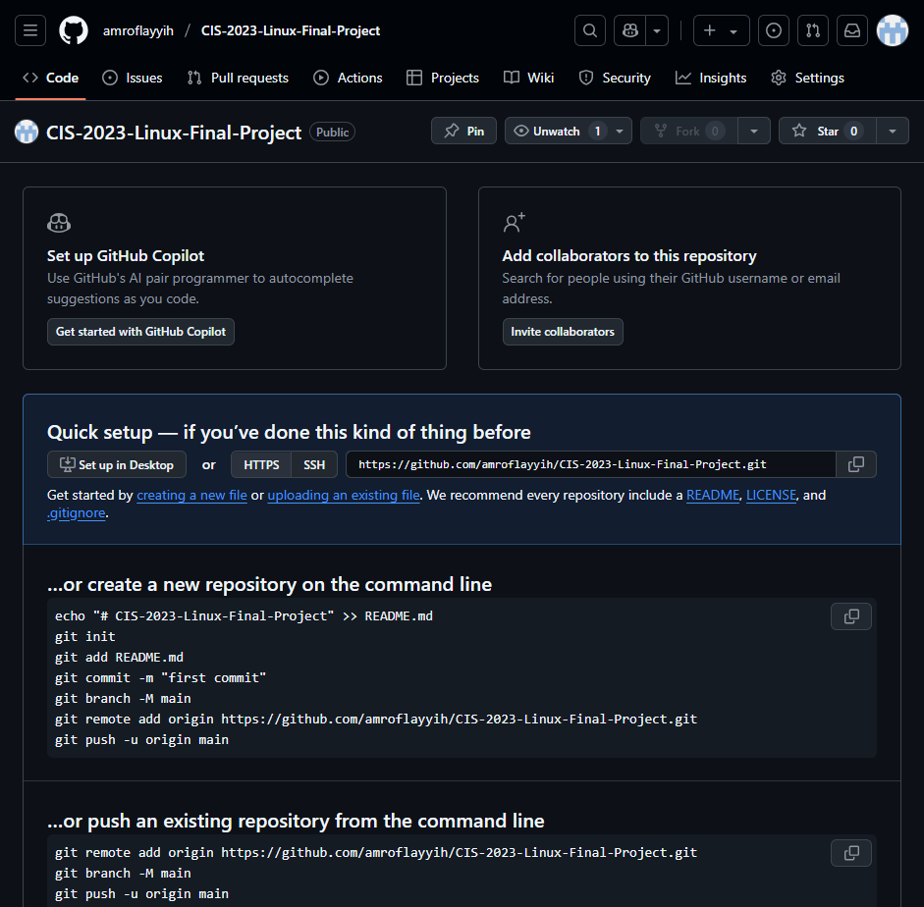

* Creating the number_counter.sh file



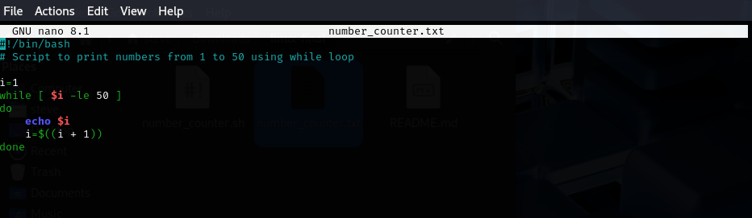

* Running the file





* Initialize a Local Git Repository



* Stage Files for Commit



* Commit Changes



* Link Local Repo to GitHub



* Push to GitHub

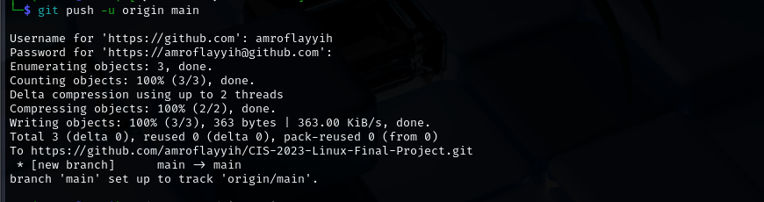

* Creating README.md file



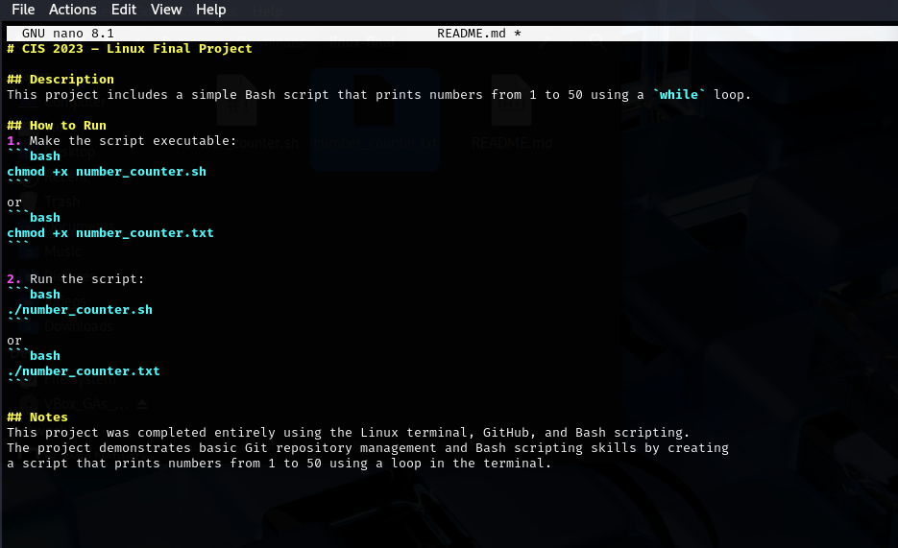

* Committing and pushing the README.md file





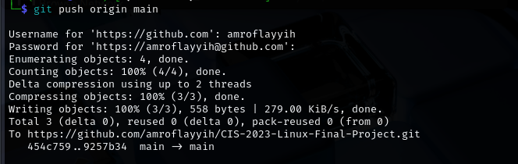

* README.md file and its contents
* The script execution and output

## Submission

The project was submitted via D2L with:

1. Link to this public GitHub repository

[Linux-Final-Project-Repository](https://github.com/amroflayyih/CIS-2023-Linux-Final-Project)

1. Screenshots of terminal interactions
2. The Bash script as a text file attachment

Number_counter.sh