ADEL ABU TUREKEI inc
Company Profile
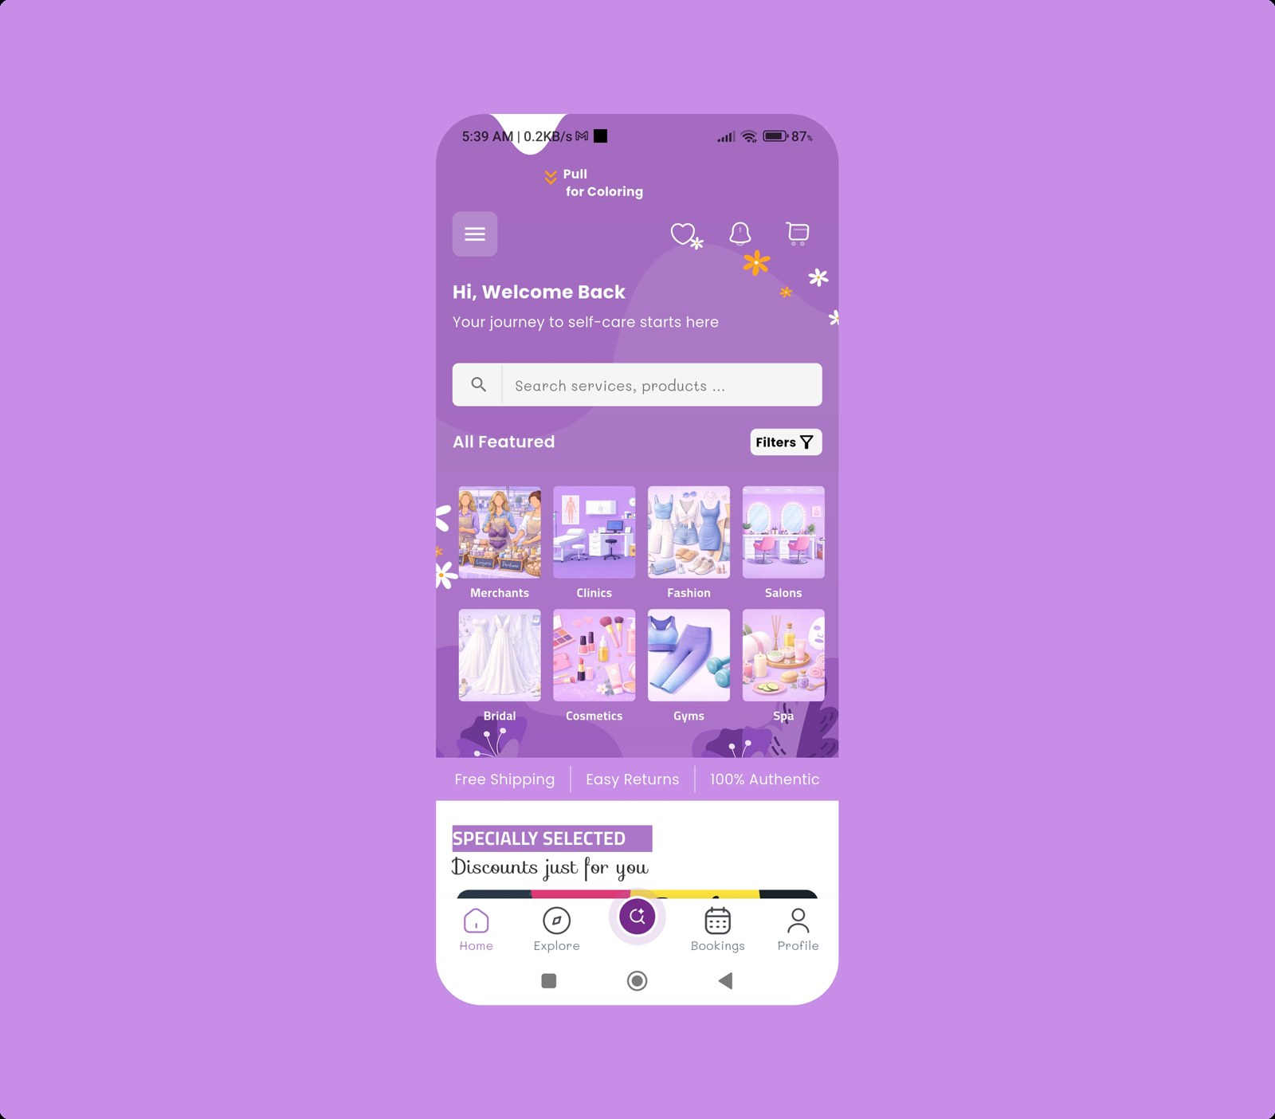
Programming, design, marketing, and social media solutions for modern digital products.

Company Definition / Who We Are
ADEL ABU TUREKEI inc is a digital delivery company focused on building modern apps, websites, dashboards, and brand experiences for clients who need practical products ready for launch and growth.
Our work combines product thinking, design execution, and marketing support so each project moves from idea to release with a clear, usable result.

What We Do
We provide end-to-end digital services that cover product planning, interface design, technical delivery, and growth support.
- Mobile App Development
- Website Development
- Dashboard Development
- Database Design
- UI/UX Design
- Branding & Visual Identity
- Graphic & Marketing Design
- Social Media Management & Advertising

How We Work
Our workflow keeps the client involved from discovery to publishing so scope, feedback, and delivery stay aligned.
Step | Details
Meet | Start with a discovery meeting to understand the client needs, identify their goals, and gather the full project requirements.
Send Proposal | Send a professional proposal to the client that includes the key highlights, main ideas, project scope, expected deliverables, timeline, and pricing details.
Get Approval | Wait for the client to review and consider the proposal, then schedule a final meeting to discuss feedback, confirm the project details, and move forward with the next steps.
Start Working | We start working on the project based on the client preferences, turning their goals and vision into a real, practical solution.
Demo | Demonstrate the progress achieved so far in stages or batches to ensure the client is satisfied and aligned with the project direction.
Publish to Store | Prepare the final release build, complete the listing assets, and publish the product to the stores so the app is ready for distribution.

Selected Projects
These projects reflect the range of products we build across marketplaces, food delivery, education, and real estate.

GlowLabs
 | GlowLabs is a multivendor marketplace application with modern dashboard screens, storefront flows, and commerce management experiences built for production use.

Nicosia Food
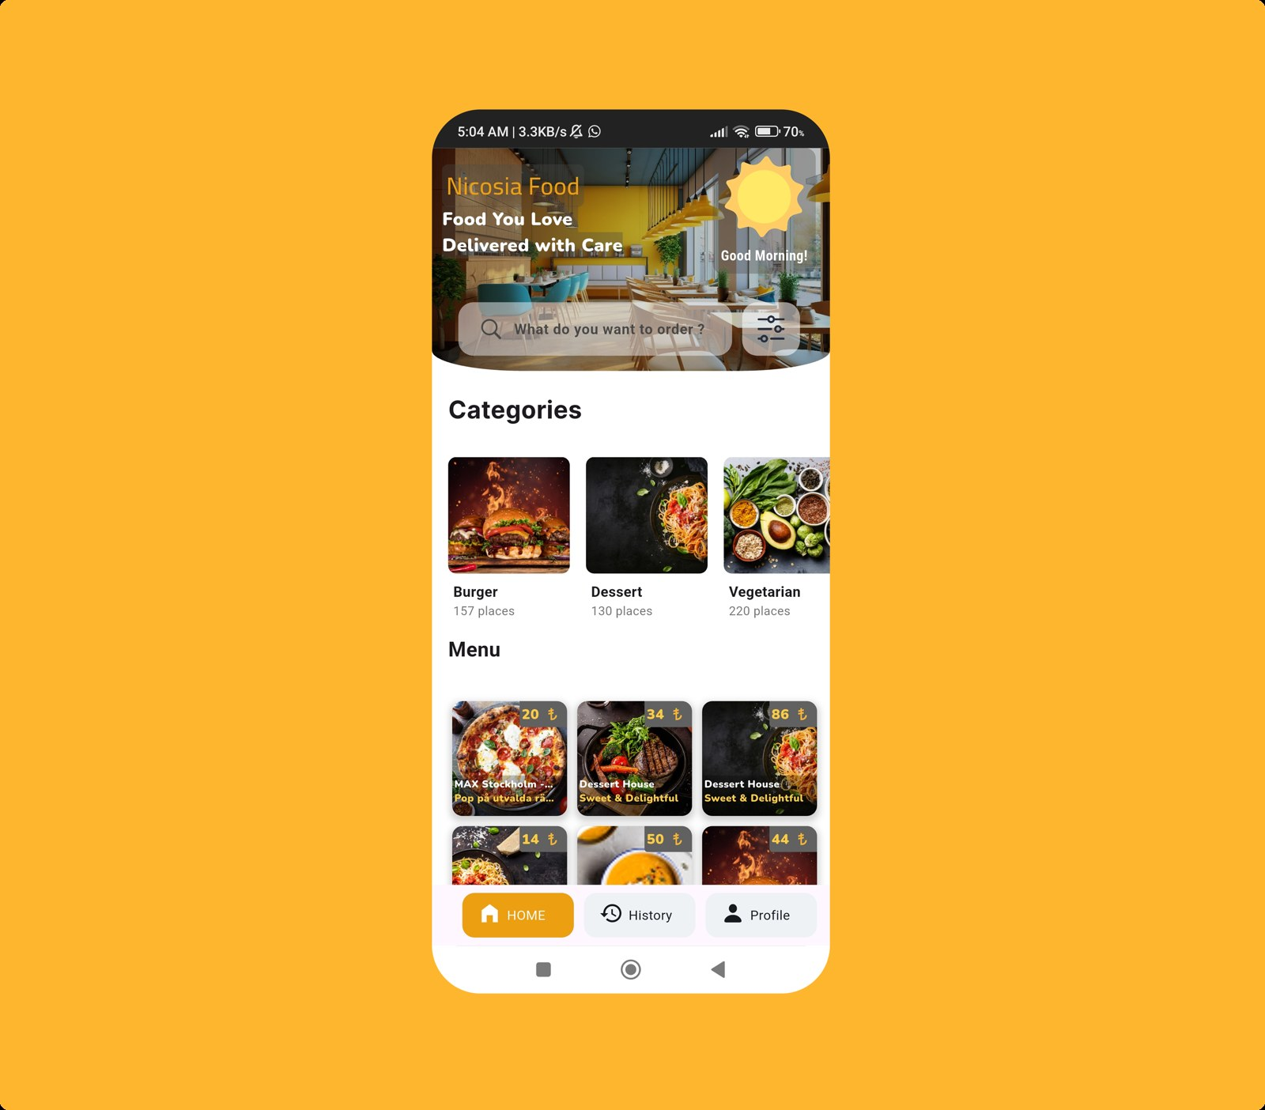 | A food delivery app designed to showcase store catalogs and food listings to customers in Nicosia through a rich, modern, and user-friendly interface.

Oschool
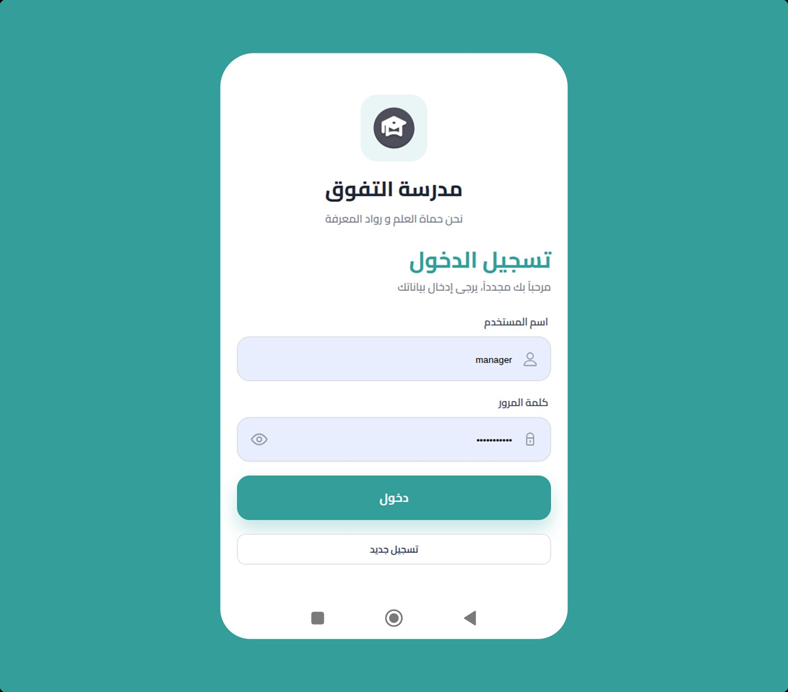 | Electronic School for digital learning and school management developed using modern web technologies to streamline and enhance traditional school administration and educational work.

Magellan
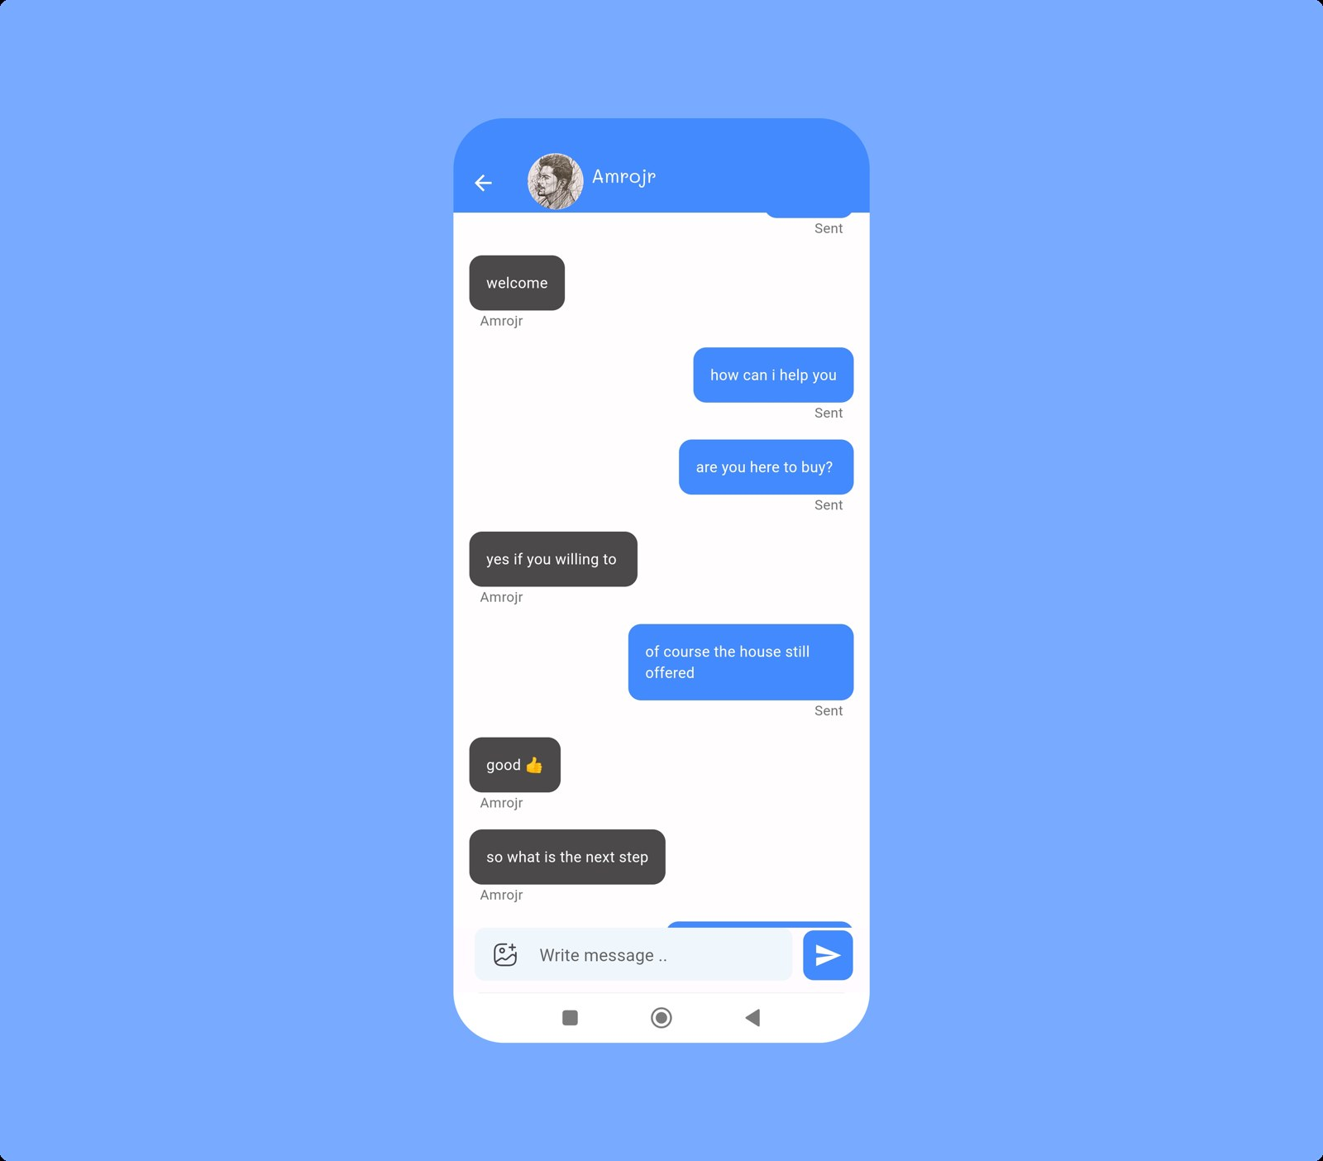 | An advanced real estate application designed to list properties and connect buyers with sellers through interactive, social-style chatroom interfaces. The app includes powerful search and filtering features to reduce browsing time and help buyers easily find the most suitable property options.

Pricing
Project pricing is based on size and delivery complexity. The ranges below are starting guidance for discussion.
Project Size | Price Range (AED)
Small project | 1500 - 6000 AED
Medium project | 6000 - 15000 AED
Large project | 15000 - 30000 AED
All prices are negotiable.

Contact Details
Tell us about your product, launch timeline, or redesign goals and we will shape the right delivery plan with you.
Address | University St., UAE, Ajman, Jerf
Phone | +971-556-441-299

