Exercise 3

Math foundation of   
computer graphics and vision

_____________________________________________________________________________________

Amrollah Seifoddini

**Task1)**

For this task I followed the algorithm of BnB described in lecture. The formulas are derived in task 2. The implementation is straightforward and can be run with main.m script. A function for linear programming computation and also two functions for convex and concave envelop calculations are implemented separately. For visualization I used a changed version of showMatchedFeatures2.m function.

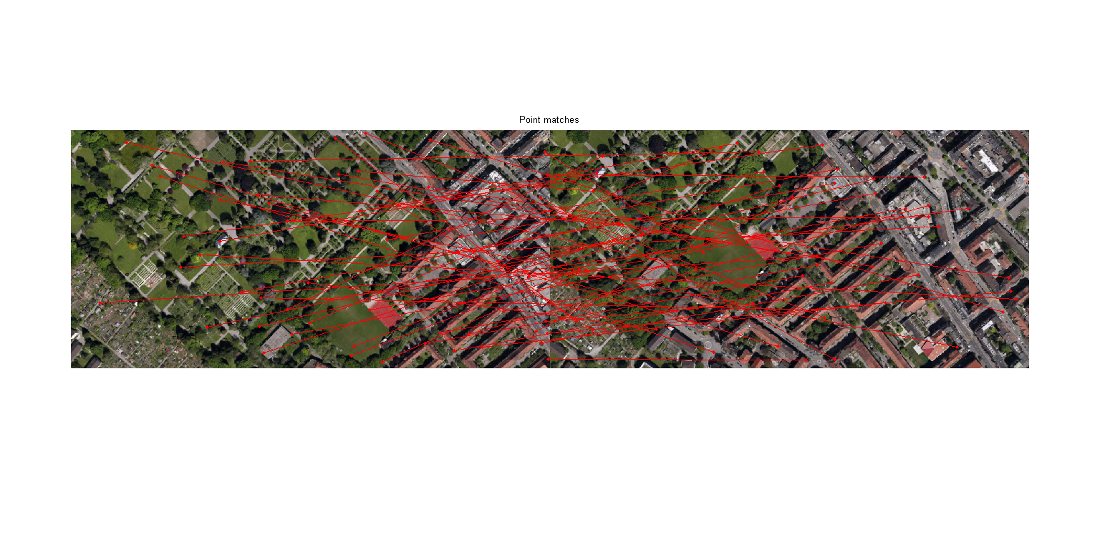

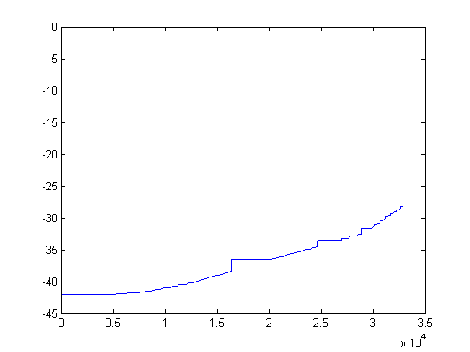

**Task2)**

For this task, I followed the guidelines of exercise sheet and lecture to formulate the problem as canonical linear programming with relaxed constraints. The steps to do that are depicted in this image.

