EMPLOYEE TURNOVER
ANALYTICS
Machine Learning
━━━━━━━━━━━━━━━━━━━━━━━━━━━━━━━━━━━━
Predicting Employee Turnover and Designing Targeted Retention Strategies
Prepared by: Amro Salman
Python • Pandas • Scikit-learn • SMOTE • K-Means

Report Contents
1. Executive Summary
2. Business Problem and Project Objectives
3. Dataset Overview
4. Data Quality and Preparation
5. Exploratory Data Analysis
6. Employee Clustering
7. Class Imbalance and SMOTE
8. Machine-Learning Methodology
9. Model Evaluation and Comparison
10. Best Model Selection
11. Employee Risk Zones and Retention Strategies
12. Limitations, Ethics, and Future Improvements
13. Final Conclusion
Appendix A. Technical Environment and Reproducibility

Project at a Glance
Original dataset | 14,999 employee records and 10 variables
Cleaned dataset | 11,991 unique employee records after removing 3,008 exact duplicates
Target variable | left: 0 = stayed, 1 = left
Models evaluated | Logistic Regression, Random Forest, Gradient Boosting
Best overall model | Random Forest
Best-model test accuracy | 97.12%
Employees prioritized | 375 employees in Medium- or High-Risk zones

1. Executive Summary
Portobello Tech requires a machine-learning solution that can identify employees who may be at risk of leaving the organization. This project analyzed employee characteristics, identified turnover patterns, compared multiple classification models, and translated model outputs into targeted retention strategies.
The original dataset contained 14,999 employee records and 10 variables. No missing values were found. A total of 3,008 exact duplicate rows were identified and removed, leaving 11,991 unique employee records for analysis.
Exploratory analysis showed that employee satisfaction had the strongest numerical relationship with turnover. The project-count analysis also revealed a nonlinear pattern: employees assigned very low or very high numbers of projects showed greater turnover than employees with moderate workloads.
Three models were evaluated using leakage-safe five-fold cross-validation and an untouched test set: Logistic Regression, Random Forest, and Gradient Boosting. Random Forest was selected as the best overall model because it achieved the strongest practical balance of accuracy, precision, recall, F1 score, and ROC-AUC.

Key Findings
Best model  Random Forest | Test accuracy  97.12% | Test F1 score  91.28%
Test ROC-AUC  97.35% | High-risk employees  330 | Medium + High risk  375

The selected model was used to place test employees into four turnover-risk zones. A total of 375 employees were categorized as Medium- or High-Risk and should receive prioritized retention support. The final recommendations emphasize manager check-ins, workload reviews, stay interviews, career development, compensation review, promotion opportunities, recognition, and personalized retention plans.

2. Business Problem and Project Objectives

2.1 Business Problem
Employee turnover creates direct and indirect costs through recruitment, onboarding, lost productivity, operational disruption, and loss of organizational knowledge. Portobello Tech collects data on employee satisfaction, performance evaluations, project workload, monthly hours, tenure, work accidents, promotions, department, and salary. The HR department wants to use this information to detect patterns associated with turnover and identify employees who may benefit from retention support.

2.2 Project Objectives
- Perform data-quality checks for missing and duplicate records.
- Identify employee factors associated with turnover through exploratory data analysis.
- Analyze satisfaction, evaluation, and monthly-hours distributions.
- Compare project workloads for employees who stayed and employees who left.
- Cluster employees who left using satisfaction and evaluation scores.
- Convert categorical variables into numerical features.
- Perform an 80:20 stratified train-test split using random_state=123.
- Handle target-class imbalance using SMOTE.
- Train Logistic Regression, Random Forest, and Gradient Boosting models using five-fold cross-validation.
- Compare models using accuracy, precision, recall, F1 score, ROC-AUC, and confusion matrices.
- Select the best model and use it to assign employee risk zones.
- Recommend retention strategies for each risk zone.

3. Dataset Overview
The project used the HR_comma_sep.csv employee-turnover dataset provided with the course project. The department column was originally named sales, although it contained multiple department values. It was renamed to Department immediately after loading so that the label matched its actual meaning and the project specification.
The original dataset contained 14,999 employee observations and 10 variables. The target variable was left, where 0 indicates an employee stayed and 1 indicates an employee left.
Variable | Description | Type
satisfaction_level | Employee satisfaction level, measured from 0 to 1 | Numeric
last_evaluation | Most recent employee evaluation score, measured from 0 to 1 | Numeric
number_project | Number of projects assigned to the employee | Numeric
average_montly_hours | Average number of hours worked per month | Numeric
time_spend_company | Number of years at the company | Numeric
Work_accident | 1 if a work accident occurred; otherwise 0 | Binary
left | 1 if the employee left; otherwise 0 | Target
promotion_last_5years | 1 if the employee received a promotion in the last five years; otherwise 0 | Binary
Department | Employee department | Categorical
salary | Salary category: low, medium, or high | Categorical

3.1 Initial Descriptive Profile
Measure | Result
Average satisfaction level | 0.613
Average evaluation score | 0.716
Average number of projects | 3.80
Average monthly hours | 201.05
Average company tenure | 3.50 years
Original turnover rate | 23.81%
Promotion rate in last five years | 2.13%

The descriptive profile suggested potential concerns around workload variation, limited promotion opportunities, and employee satisfaction. These patterns were examined more closely during exploratory analysis.

4. Data Quality and Preparation

4.1 Missing Values
All 10 variables contained 14,999 non-null observations. The formal missing-value check returned zero missing values, so no imputation or row deletion was required for missing data.

4.2 Duplicate Records
The dataset contained 3,008 exact duplicate rows. Because no unique employee identifier was available, it was not possible to prove whether every repeated row represented the same person. For this course analysis, exact matches across all fields were treated as duplicate observations and removed to prevent repeated records from disproportionately influencing visualizations and model training.
Rows before duplicate removal | 14,999
Exact duplicates removed | 3,008
Rows after duplicate removal | 11,991
Duplicates remaining | 0

4.3 Value and Range Validation
Categorical and binary fields contained only expected values. Department contained 10 valid categories, salary contained low, medium, and high, and all binary variables contained only 0 and 1. Numerical ranges were also reasonable: satisfaction ranged from 0.09 to 1.00, evaluation from 0.36 to 1.00, projects from 2 to 7, monthly hours from 96 to 310, and tenure from 2 to 10 years.

4.4 Preprocessing
The categorical variables Department and salary were converted to dummy variables using one-hot encoding with drop_first=True. Seven original numerical predictors and 11 dummy variables produced a final feature matrix containing 18 numeric inputs. The target variable left was stored separately.
An 80:20 stratified train-test split was performed using random_state=123. The training set contained 9,592 records and the testing set contained 2,399 records. Stratification preserved the turnover-class proportions in both datasets.

5. Exploratory Data Analysis

5.1 Correlation Analysis
The correlation heatmap showed that satisfaction_level had the strongest linear relationship with turnover, with a correlation of -0.35. This indicates that employees with lower satisfaction were more likely to leave. Company tenure had a weaker positive correlation of 0.17, while work accidents had a weak negative correlation of -0.13. Other variables showed only weak linear correlations with turnover.
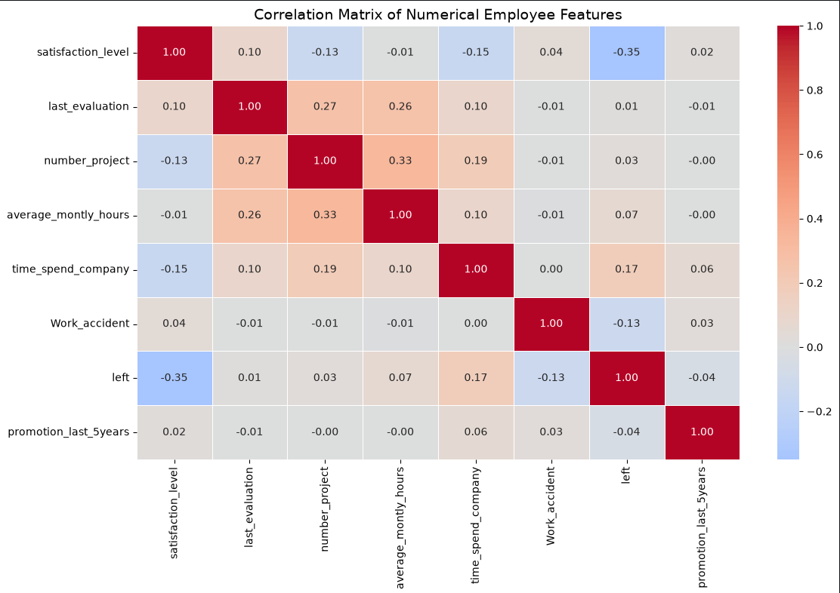
Figure 1. Correlation matrix of numerical employee features.
Correlation measures linear association and does not prove causation. Variables with weak overall correlations may still be important when their relationships are nonlinear or depend on interactions with other features.

5.2 Distribution Analysis
The satisfaction, evaluation, and monthly-hours distributions were multimodal, indicating that the workforce contained several distinct employee groups. Satisfaction showed a clear low-satisfaction segment and a larger moderate-to-high-satisfaction segment. Evaluation scores showed concentrations around moderate and high performance. Monthly hours showed one concentration near 140-170 hours and another around 240-270 hours, suggesting different workload patterns.
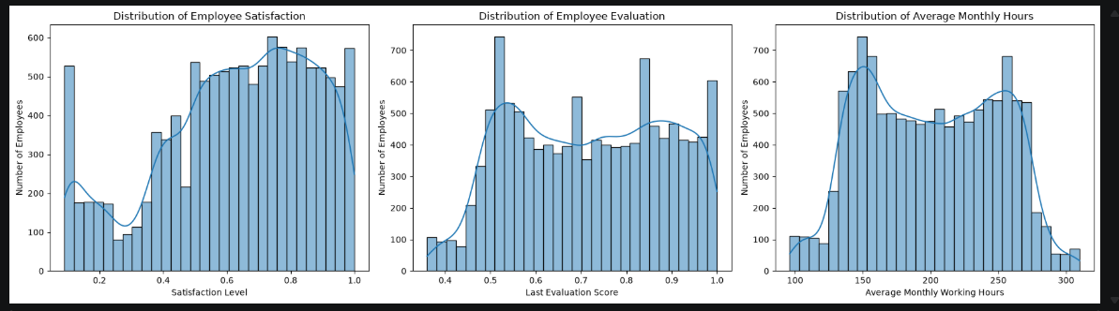
Figure 2. Distributions of employee satisfaction, evaluation, and average monthly working hours.

5.3 Project Workload and Turnover
The project-count comparison revealed a U-shaped relationship between workload and turnover. Employees assigned three or four projects were much more likely to stay. Employees assigned only two projects had high turnover, potentially reflecting underutilization or disengagement. Turnover also increased among employees with six projects, and all employees assigned seven projects in the cleaned data had left, suggesting possible overwork or burnout.
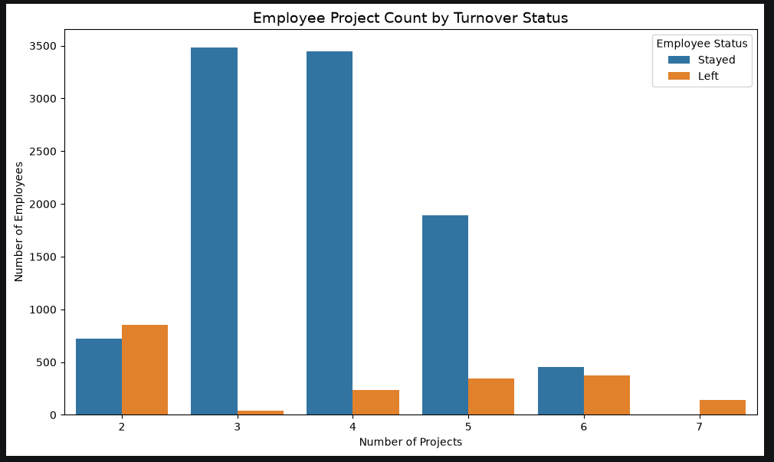
Figure 3. Employee project count by turnover status.

5.4 EDA Summary
- Employee satisfaction was the strongest numerical indicator associated with turnover.
- Both underutilization and excessive project workload were associated with higher turnover.
- Very high monthly working hours may signal workload pressure or burnout.
- Low promotion rates and salary differences may contribute to risk but require multivariate modeling for proper assessment.

6. Employee Clustering
K-means clustering was applied to the 1,991 employees who left the company. The clustering used satisfaction_level and last_evaluation. The left field was retained for filtering but was not used as a clustering feature because it had the same value for every selected employee.
Cluster | Employees | Avg. Satisfaction | Avg. Evaluation | Interpretation
0 | 534 | 0.111 | 0.869 | Highly dissatisfied, high-performing employees
1 | 555 | 0.806 | 0.913 | Highly satisfied, high-performing employees who still left
2 | 902 | 0.410 | 0.517 | Moderately dissatisfied employees with lower evaluations

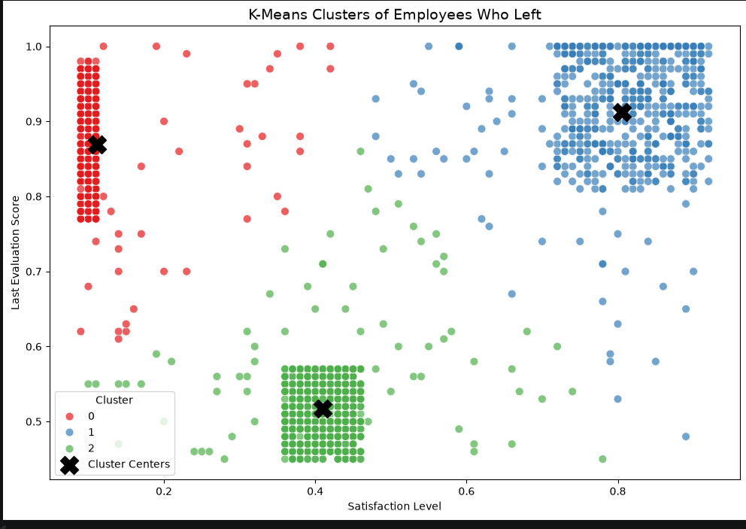
Figure 4. K-means clusters of employees who left.
The clusters demonstrate that turnover is not limited to one employee profile. Some strong performers left with extremely low satisfaction, while another high-performing group left despite high satisfaction. The largest cluster combined lower satisfaction with lower evaluations. These findings support differentiated retention strategies rather than one universal intervention.

7. Class Imbalance and SMOTE
After duplicate removal, employees who left represented approximately 16.6% of the stratified training data. This imbalance could cause a model to favor the majority class and fail to identify employees at risk of leaving.
SMOTE was applied only to the training data. It increased the minority class from 1,593 to 7,999 records, producing a balanced training dataset with 7,999 stayers and 7,999 leavers. The testing data remained unchanged with 2,001 stayers and 398 leavers.
Training rows before SMOTE | 9,592
Training rows after SMOTE | 15,998
Stayed after SMOTE | 7,999 (50%)
Left after SMOTE | 7,999 (50%)
Test set modified? | No

8. Machine-Learning Methodology

8.1 Models
Model | Purpose and Characteristics
Logistic Regression | A linear probabilistic classifier. StandardScaler was used because the features had different numerical ranges.
Random Forest | An ensemble of decision trees that can capture nonlinear relationships and interactions among employee characteristics.
Gradient Boosting | A sequential ensemble of decision trees in which each new tree focuses on correcting prior errors.

8.2 Leakage-Safe Cross-Validation
Five-fold stratified cross-validation was used for all three models. SMOTE was placed inside an imbalanced-learn pipeline, ensuring that synthetic records were created only from the training portion of each fold. The validation portion remained untouched. This sequencing prevented data leakage and produced more realistic validation estimates.
For Logistic Regression, scaling was performed before SMOTE so that the distance-based synthetic-sample calculation used standardized features. Random Forest and Gradient Boosting did not require feature scaling.

8.3 Evaluation Metrics
Metric | Interpretation
Accuracy | Proportion of all test predictions that were correct.
Precision | Of employees predicted to leave, the proportion who actually left.
Recall | Of employees who actually left, the proportion correctly identified.
F1 score | Harmonic balance between precision and recall.
ROC-AUC | Overall ability to distinguish employees who left from employees who stayed across thresholds.
Confusion matrix | Counts of true negatives, false positives, false negatives, and true positives.

9. Model Evaluation and Comparison

9.1 Leakage-Safe Five-Fold Cross-Validation Results
Model | Accuracy | Precision | Recall | F1 Score | ROC-AUC
Logistic Regression | 77.78% | 41.55% | 82.80% | 55.32% | 84.04%
Random Forest | 97.90% | 95.70% | 91.53% | 93.56% | 98.10%
Gradient Boosting | 96.73% | 87.70% | 93.41% | 90.46% | 98.36%

Random Forest produced the highest cross-validation accuracy, precision, and F1 score. Gradient Boosting achieved the highest cross-validation recall and ROC-AUC. Logistic Regression achieved strong recall but substantially lower precision and F1 score.

9.2 Final Test Results
Model | Accuracy | Precision | Recall | F1 Score | ROC-AUC
Logistic Regression | 77.57% | 41.21% | 82.41% | 54.94% | 83.18%
Random Forest | 97.12% | 91.86% | 90.70% | 91.28% | 97.35%
Gradient Boosting | 95.96% | 85.08% | 91.71% | 88.27% | 97.71%

9.3 ROC Curve Analysis
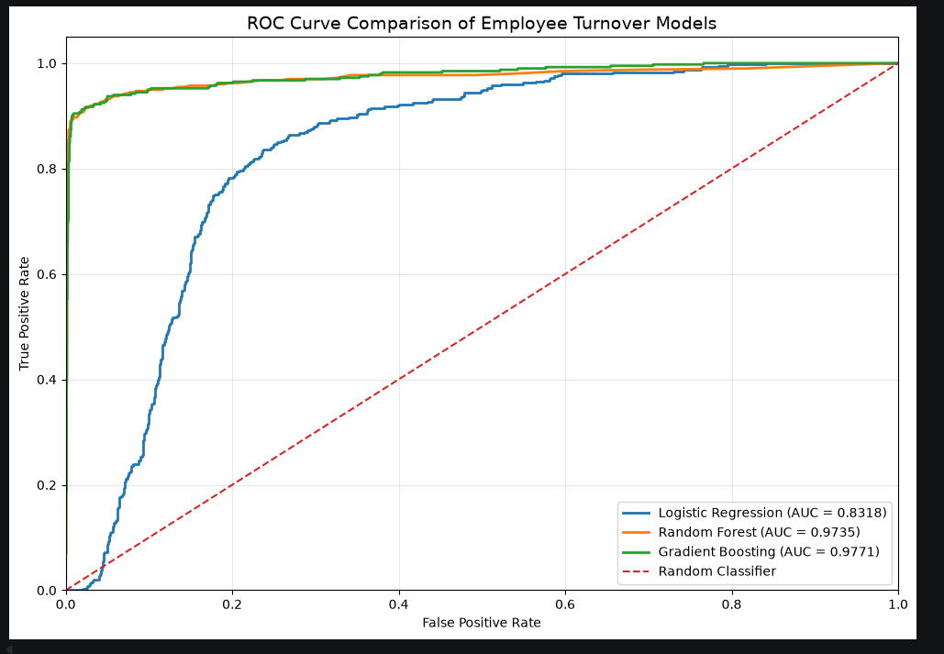
Figure 5. ROC curve comparison of the three turnover models.
Gradient Boosting achieved the highest test ROC-AUC at 0.9771, followed closely by Random Forest at 0.9735. Logistic Regression achieved 0.8318. Both tree-based models demonstrated excellent discrimination and clearly outperformed Logistic Regression.

9.4 Confusion Matrix Analysis
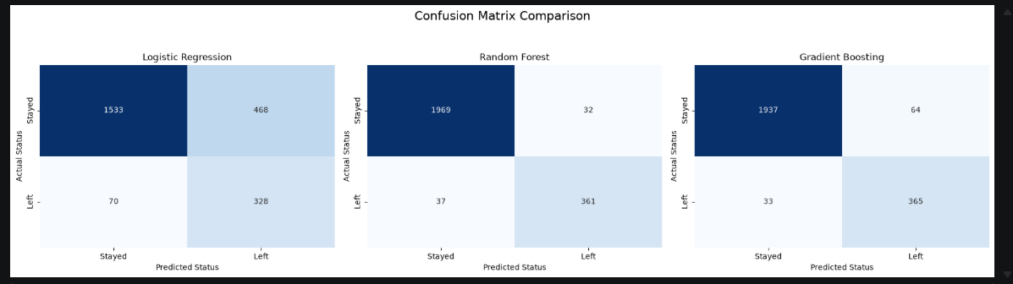
Figure 6. Confusion-matrix comparison for Logistic Regression, Random Forest, and Gradient Boosting.
Model | True Negatives | False Positives | False Negatives | True Positives
Logistic Regression | 1,533 | 468 | 70 | 328
Random Forest | 1,969 | 32 | 37 | 361
Gradient Boosting | 1,937 | 64 | 33 | 365

Gradient Boosting missed four fewer leavers than Random Forest, but it produced 32 additional false-positive alerts. Random Forest therefore provided the stronger practical balance between identifying leavers and avoiding unnecessary interventions.

9.5 Precision or Recall?
Recall is the most important individual metric for turnover detection because a false negative represents an employee who actually leaves but was not identified for possible retention action. However, precision also matters because low precision causes unnecessary HR investigations and may reduce trust in the model. The best operational choice should therefore prioritize recall while using precision and F1 score to ensure that the alert volume remains manageable.

10. Best Model Selection
Random Forest was selected as the best overall model. It achieved the highest test accuracy (97.12%), precision (91.86%), and F1 score (91.28%), while maintaining strong recall (90.70%) and ROC-AUC (97.35%).
Gradient Boosting achieved slightly higher recall (91.71%) and ROC-AUC (97.71%), identifying four additional leavers. However, it generated 64 false positives compared with only 32 for Random Forest. In practical terms, Gradient Boosting doubled the number of unnecessary alerts to identify four additional departures. Random Forest therefore provided the strongest overall balance for HR use.

Criterion | Leading Model | Result
Accuracy | Random Forest | 97.12%
Precision | Random Forest | 91.86%
Recall | Gradient Boosting | 91.71%
F1 Score | Random Forest | 91.28%
ROC-AUC | Gradient Boosting | 97.71%
Fewest false positives | Random Forest | 32

11. Employee Risk Zones and Retention Strategies

11.1 Risk-Zone Definitions
The Random Forest model generated a turnover probability for each of the 2,399 employees in the test set. Each probability was converted to a percentage and assigned to one of four risk zones.
Risk Zone | Probability Range | Response Level
Safe Zone | < 20% | Routine engagement and recognition
Low-Risk Zone | 20% to < 60% | Monitor satisfaction, workload, and career development
Medium-Risk Zone | 60% to < 90% | Targeted stay interview and structured retention plan
High-Risk Zone | ≥ 90% | Immediate personalized retention intervention

11.2 Risk-Zone Distribution
Risk Zone | Employees | Percentage of Test Employees
Safe Zone | 1,836 | 76.53%
Low-Risk Zone | 188 | 7.84%
Medium-Risk Zone | 45 | 1.88%
High-Risk Zone | 330 | 13.76%

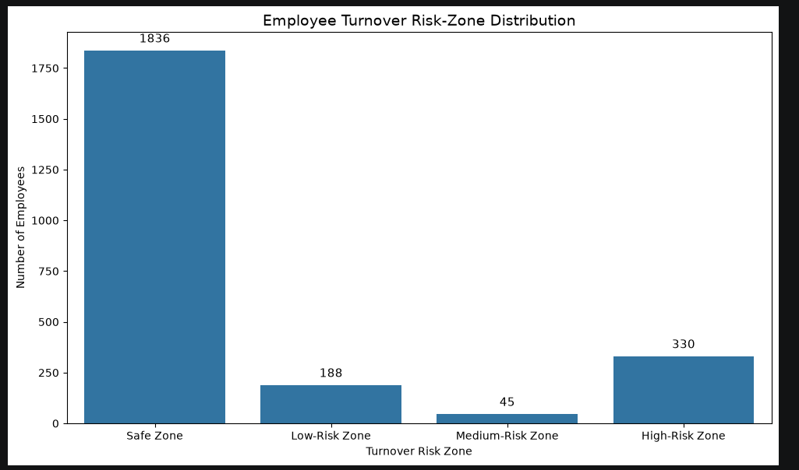
Figure 7. Distribution of employees across turnover-risk zones.
A total of 375 employees were classified in the Medium- or High-Risk zones. These employees represent the highest-priority population for retention review.

11.3 Recommended Retention Strategies
Risk Zone | Recommended Actions
Safe Zone | Maintain regular engagement, recognition, development opportunities, and periodic feedback. Avoid neglecting strong employees simply because their current risk is low.
Low-Risk Zone | Monitor satisfaction and workload, conduct manager check-ins, clarify career paths, and recognize contributions before risk increases.
Medium-Risk Zone | Conduct targeted stay interviews; review workload, compensation, management relationships, and role alignment; create a documented development plan.
High-Risk Zone | Begin immediate confidential intervention; review compensation and promotion opportunities; adjust workload where appropriate; address manager or role concerns; create a personalized retention plan with executive or HR sponsorship.

11.4 Cluster-Informed Interventions
Employee Profile | Targeted Intervention
Highly dissatisfied, high-performing | Prioritize stay interviews, manager review, recognition, workload and compensation assessment, and advancement discussions.
Highly satisfied, high-performing | Investigate career mobility, external opportunities, compensation competitiveness, succession planning, and specialized retention incentives.
Moderately dissatisfied, lower-performing | Provide coaching, clearer performance expectations, role-fit assessment, training, mentoring, and manageable development goals.

11.5 Practical Use of the Model
- Use risk scores as a decision-support signal, not as an automatic employment decision.
- Combine model output with manager knowledge, engagement data, and confidential employee conversations.
- Review high-risk alerts regularly and document actions taken.
- Track retention outcomes to determine which interventions are most effective.
- Recalibrate or retrain the model as workforce conditions change.

12. Limitations, Ethics, and Future Improvements

12.1 Limitations
- The dataset did not include a unique employee identifier. Exact duplicate rows were removed, but some may have represented distinct employees with identical attributes.
- The analysis identified associations and predictive patterns; it did not prove that any factor directly caused turnover.
- The dataset omitted potentially important variables such as manager quality, commute distance, benefits, job level, employee comments, external opportunities, and personal reasons for leaving.
- The model was evaluated on a single historical dataset and may not generalize automatically to other organizations or future workforce conditions.
- The risk-zone thresholds were defined by the project specification and were not optimized for HR capacity or intervention cost.

12.2 Ethical and Responsible Use
Turnover predictions can affect how employees are perceived and treated. The model should support, not replace, professional HR judgment. Risk scores should not be used for termination, exclusion from opportunities, adverse performance decisions, or intrusive monitoring. Access to individual predictions should be restricted, and employee information should be protected according to applicable privacy and employment requirements.
Fairness testing should be conducted before operational deployment. Although the supplied dataset does not include protected characteristics, future implementations should evaluate whether error rates differ across legally protected or organizationally sensitive groups.

12.3 Future Improvements
- Perform hyperparameter tuning for Random Forest and Gradient Boosting.
- Calibrate predicted probabilities so risk scores more closely reflect observed turnover rates.
- Evaluate threshold choices based on HR capacity and the relative costs of false positives and false negatives.
- Add engagement, manager, benefits, job-level, location, and career-mobility features.
- Test model fairness and explainability using feature-importance or SHAP analysis.
- Monitor drift and retrain the model as workforce behavior changes.
- Measure which retention actions produce the strongest real-world outcomes.

13. Final Conclusion
This project demonstrated that employee turnover can be predicted with strong performance using workforce data. Data-quality checks produced a clean dataset of 11,991 unique records. Exploratory analysis identified satisfaction and workload patterns, while K-means clustering revealed multiple distinct employee profiles among those who left.
Random Forest was selected as the best overall model, achieving 97.12% test accuracy, 91.86% precision, 90.70% recall, a 91.28% F1 score, and 97.35% ROC-AUC. The model correctly identified 361 of the 398 employees who left while producing only 32 false-positive alerts.
The final risk-zone analysis identified 375 employees in the Medium- or High-Risk zones. These predictions can help HR prioritize stay interviews, workload and compensation reviews, career-development discussions, recognition, and personalized retention plans.
The strongest value of the solution is not simply predicting who may leave. Its value is enabling earlier, more focused, and evidence-based conversations that can improve employee experience and reduce preventable turnover. The model should be implemented responsibly as one input within a broader human-centered retention process.

Appendix A. Technical Environment and Reproducibility

A.1 Development Environment
Component | Value
Development tool | Visual Studio Code with Jupyter extension
Programming language | Python 3.13
Pandas | 3.0.3
NumPy | 2.4.6
Scikit-learn | 1.9.0
Imbalanced-learn | 0.14.2
Primary notebook | Employee_Turnover_Analytics.ipynb
Risk-output file | employee_turnover_risk_results.csv

A.2 Reproducibility Controls
- The train-test split used random_state=123 and stratify=y.
- SMOTE used random_state=123.
- K-means used random_state=123 and n_init=10.
- All classification models used fixed random states where supported.
- SMOTE was placed inside cross-validation pipelines to prevent leakage.
- The notebook was restarted and run from beginning to end; all final validation checks passed.

A.3 Final Deliverables
- Employee_Turnover_Analytics.ipynb — complete source notebook.
- Employee_Turnover_Project_Writeup.docx — project report.
- Employee_Turnover_Project_Screenshots.zip — required screenshots.
- employee_turnover_risk_results.csv — detailed employee risk scores and retention strategies.

A.4 Final Validation Results
Validation Check | Status
Cleaned dataset available | Passed
Feature dataset available | Passed
Training dataset available | Passed
SMOTE dataset available | Passed
Logistic Regression results available | Passed
Random Forest results available | Passed
Gradient Boosting results available | Passed
Model comparison available | Passed
Employee risk results available | Passed
Risk-output CSV created | Passed

Final cleaned dataset shape: (11,991, 10). Final feature dataset shape: (11,991, 18). Test employee risk records: 2,399.

