START ACTUAL ANALYSIS (OBJECTIVE 1)
Grade-wise Outstanding Fees
SELECT TOP 20
student_id,
total,
received,
outstanding,
(total - (received + outstanding)) AS difference
FROM dbo.fee_transactions
WHERE ABS(total - (received + outstanding)) > 1
ORDER BY difference DESC;
GO



OBJECTIVE 2 — FEES COLLECTED vs PENDING
🔹 Overall Collection Status
SELECT
SUM(total) AS total_fee,
SUM(received) AS total_received,
SUM(outstanding) AS total_outstanding,
ROUND(SUM(received) * 100.0 / NULLIF(SUM(total), 0), 2) AS collection_percentage
FROM dbo.fee_transactions;

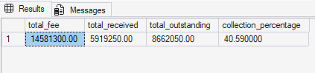

OBJECTIVE 3 — HIGH-RISK DEFAULTERS
🔹 Top Pending Students
SELECT TOP 20
s.student_id,
s.grade,
s.class,
f.outstanding,
f.last_paid_month
FROM dbo.students s
JOIN dbo.fee_transactions f
ON s.student_id = f.student_id
WHERE f.outstanding > 0
ORDER BY f.outstanding DESC;

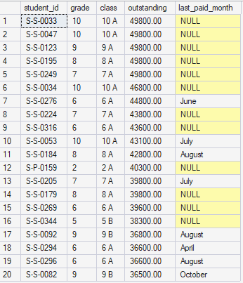

🔹 Very High-Risk (Big Amount + No Recent Payment)
SELECT TOP 20
s.student_id,
s.grade,
s.class,
f.outstanding,
f.last_paid_month
FROM dbo.students s
JOIN dbo.fee_transactions f
ON s.student_id = f.student_id
WHERE f.outstanding >= 15000
AND (f.last_paid_month IS NULL OR LTRIM(RTRIM(f.last_paid_month)) = '')
ORDER BY f.outstanding DESC;

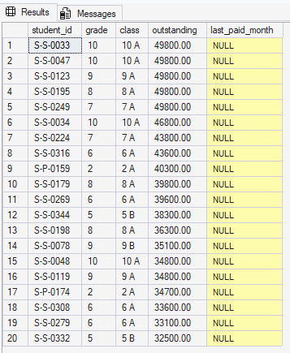

🎯 OBJECTIVE 4 — MONTHLY PAYMENT PATTERN
SELECT
last_paid_month,
SUM(received) AS total_received
FROM dbo.fee_transactions
WHERE last_paid_month IS NOT NULL
GROUP BY last_paid_month
ORDER BY total_received DESC;
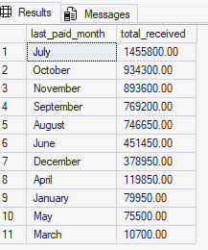

BJECTIVE 5 — FEE COMPLETION RATE
SELECT
s.grade,
SUM(CASE WHEN f.outstanding = 0 THEN 1 ELSE 0 END) AS completed_students,
SUM(CASE WHEN f.outstanding > 0 THEN 1 ELSE 0 END) AS pending_students
FROM dbo.students s
JOIN dbo.fee_transactions f
ON s.student_id = f.student_id
GROUP BY s.grade
ORDER BY s.grade;

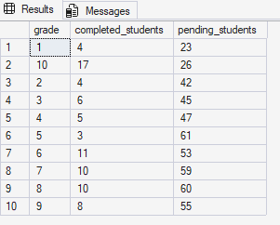

🎯 OBJECTIVE 6 — CONTACT DATA QUALITY
SELECT
COUNT(*) AS total_students,
SUM(CASE WHEN contact IS NULL OR LTRIM(RTRIM(contact)) = '' THEN 1 ELSE 0 END) AS missing_contact,
SUM(CASE WHEN contact_valid = 'No' THEN 1 ELSE 0 END) AS invalid_contact
FROM dbo.students;
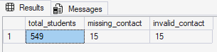

Optional Objective 7 — Section-wise Performance
Which school section (Primary/Secondary) performs better?
SELECT
s.school_section,
SUM(f.total) AS total_fee,
SUM(f.received) AS received_fee,
ROUND(SUM(f.received)*100.0 / NULLIF(SUM(f.total),0),2) AS collection_pct
FROM dbo.students s
JOIN dbo.fee_transactions f
ON s.student_id = f.student_id
GROUP BY s.school_section;
