A PROJECT REPORT
ON

COMPLETE SCHOOL MANAGEMENT SYSTEM
(A MERN Stack Web Application)

Submitted in partial fulfillment of the requirements
for the award of the degree of

BACHELOR OF TECHNOLOGY
IN
COMPUTER SCIENCE AND ENGINEERING

Submitted By
_________________________
Roll No: _________________________

Under the Guidance of
_________________________

DEPARTMENT OF COMPUTER SCIENCE AND ENGINEERING
_________________________
(College Name)
Academic Year: _________________________

CERTIFICATE

This is to certify that the project report entitled "COMPLETE SCHOOL MANAGEMENT SYSTEM" is a bonafide work carried out by _________________________ bearing Roll No. _________________________, a student of _________________________ (College Name), in partial fulfillment of the requirements for the award of the degree of Bachelor of Technology in Computer Science and Engineering during the academic year _________________________.
The project has been carried out under my supervision and guidance, and the work embodied in this report has not been submitted to any other university or institution for the award of any degree or diploma.

Internal Guide: _________________________ Head of Department: _________________________

External Examiner: _________________________ Date: _________________________

DECLARATION

I, _________________________, bearing Roll No. _________________________, hereby declare that the project report entitled "COMPLETE SCHOOL MANAGEMENT SYSTEM" submitted to _________________________ (College Name) is a record of original work done by me under the guidance of _________________________.
The information and data presented in this report are authentic to the best of my knowledge. This project work has not been submitted, either in part or in full, to any other university or institution for the award of any degree or diploma.

Place: _________________________
Date: _________________________

Signature: _________________________
Name: _________________________

ACKNOWLEDGEMENT

I would like to express my sincere gratitude to my project guide, _________________________, for their valuable guidance, constant encouragement, and constructive suggestions throughout the development of this project. Their expertise and patience were instrumental in shaping this work.
I am deeply thankful to _________________________, Head of the Department of Computer Science and Engineering, for providing the necessary facilities and a conducive environment for carrying out this project work.
I extend my thanks to the Principal and the management of _________________________ (College Name) for their support and for providing the infrastructure required for this project.
I would also like to thank all the faculty members and laboratory staff of the department for their cooperation and assistance during the course of this project.
Finally, I am grateful to my parents and friends for their unwavering support, motivation, and encouragement, without which this project would not have been possible.

_________________________
(Student Name)

ABSTRACT

Educational institutions handle an enormous volume of administrative and academic data every day — student admissions, class allocations, daily attendance, examinations, fee collection, library circulation, staff payroll, inventory, and communication with parents. When these processes are managed manually through paper registers or disconnected spreadsheets, they become slow, error-prone, and difficult to audit. Information remains siloed, reports take days to prepare, and parents have little visibility into their children’s progress.
The Complete School Management System presented in this report is a full-stack web application that digitizes and unifies the entire administrative workflow of a school on a single platform. The system is built on the MERN technology stack — MongoDB, Express.js, React, and Node.js — and features a novel swappable data layer that allows the institution to run either on a zero-configuration file-based JSON store or on a production-grade MongoDB Atlas cloud database without changing a single line of application code.
The system implements role-based access control for six distinct user roles: Admin, Clerk, Supervisor, Teacher, Student, and Parent. Each role receives a purpose-built dashboard and a permission-scoped view of the data. Core modules include admissions with an approval workflow, student and class management, subject and teacher allocation with substitute handling, daily attendance with bulk marking, a complete examination lifecycle (marks entry, submission, locking, and publishing), fee collection with automatic due computation and printable receipts, daily accounts, assets and inventory tracking, a full library management system with fine calculation, staff payroll with printable salary slips, notices, timetable, lesson planning, discipline tracking, and a helpdesk.
Security is enforced through JSON Web Token (JWT) based authentication, bcrypt password hashing, and route-level role authorization middleware. The user interface follows modern design practices with a component-driven architecture, a global Ctrl+K command palette for instant navigation, a dark mode powered by CSS custom properties, printable A4 documents (report cards, hall tickets, ID cards, salary slips, and fee receipts), and interactive dashboard analytics rendered with Chart.js.
The report describes the complete software development life cycle of the project — requirement analysis, feasibility study, system design with data flow diagrams, entity-relationship model, class and sequence diagrams, implementation details of every module, and a structured testing phase. The outcome is a production-ready, extensible school management platform that reduces administrative effort, eliminates data duplication, and provides all stakeholders with real-time, role-appropriate access to institutional data.

Keywords: School Management System, MERN Stack, MongoDB, Express.js, React, Node.js, JWT Authentication, Role-Based Access Control, Data Flow Diagram, Entity-Relationship Model.

TABLE OF CONTENTS

CHAPTER 1: INTRODUCTION 13
1.1 Overview 13
1.2 Problem Statement 13
1.3 Objectives of the Project 14
1.4 Scope of the Project 14
1.5 Organization of the Report 15
CHAPTER 2: LITERATURE SURVEY AND EXISTING SYSTEM 16
2.1 Study of Existing Systems 16
2.1.1 Manual (Paper-Based) Systems 16
2.1.2 Spreadsheet-Based Systems 16
2.1.3 Commercial School ERP Software 16
2.2 Limitations of Existing Systems 16
2.3 Proposed System 17
2.4 Advantages of the Proposed System over Existing Systems 17
CHAPTER 3: SYSTEM ANALYSIS 18
3.1 Requirement Gathering 18
3.2 Feasibility Study 18
3.2.1 Technical Feasibility 18
3.2.2 Economic Feasibility 18
3.2.3 Operational Feasibility 18
3.3 Software Development Life Cycle Model 19
3.4 User Characteristics 19
3.5 Constraints 19
CHAPTER 4: SOFTWARE REQUIREMENT SPECIFICATION 20
4.1 Functional Requirements 20
4.1.1 Authentication and Access Control 20
4.1.2 Admissions 20
4.1.3 Student and Class Management 20
4.1.4 Attendance 20
4.1.5 Examinations and Results 20
4.1.6 Fees and Finance 21
4.1.7 Library 21
4.1.8 Payroll 21
4.1.9 Other Modules 21
4.2 Non-Functional Requirements 22
4.3 Hardware Requirements 22
4.4 Software Requirements 22
CHAPTER 5: SYSTEM DESIGN 23
5.1 Design Overview 23
5.2 System Architecture 23
5.3 Use Case Diagram 24
5.4 Data Flow Diagrams 25
5.4.1 DFD Level 0 (Context Diagram) 25
5.4.2 DFD Level 1 26
5.4.3 DFD Level 2 (Fee Collection Process) 27
5.5 Entity-Relationship Diagram 28
5.6 Class Diagram 29
5.7 Sequence Diagrams 30
5.7.1 User Authentication Sequence 30
5.7.2 Fee Payment Sequence 31
5.7.3 Examination Workflow Sequence 32
5.7.4 Library Circulation Sequence 33
5.8 Activity Diagram — Admission Workflow 34
5.9 Database Design 35
5.9.1 users 36
5.9.2 students 36
5.9.3 classes, subjects, teachers 36
5.9.4 attendance 36
5.9.5 exams and marks 37
5.9.6 fee and accounting collections 37
5.9.7 library collections 37
5.9.8 payroll and other collections 37
5.10 Design of the Swappable Data Layer 37
CHAPTER 6: TECHNOLOGY STACK 39
6.1 The MERN Stack 39
6.1.1 MongoDB 39
6.1.2 Express.js 39
6.1.3 React 39
6.1.4 Node.js 39
6.2 Supporting Libraries and Tools 39
6.3 Why MERN for This Project 40
CHAPTER 7: IMPLEMENTATION 41
7.1 Project Structure 41
7.2 Authentication and Role-Based Access Control 41
7.3 Module Implementation Summaries 41
7.3.1 Dashboard and Analytics 41
7.3.2 Admissions 42
7.3.3 Students, Classes, Parents 42
7.3.4 Attendance 42
7.3.5 Examinations and Results 42
7.3.6 Fees, Receipts, and Daily Accounts 42
7.3.7 Assets and Inventory 43
7.3.8 Library Management 43
7.3.9 Payroll 43
7.3.10 Communication and Tracking 43
7.3.11 Global Search and User Experience Features 43
7.4 REST API Summary 43
7.5 Security Measures Implemented 44
CHAPTER 8: TESTING 45
8.1 Testing Methodology 45
8.1.1 Unit Testing 45
8.1.2 Integration Testing 45
8.1.3 System Testing 45
8.2 Test Case Table 45
8.3 Testing Summary 47
CHAPTER 9: RESULTS AND DISCUSSION 48
9.1 Outcome 48
9.2 Application Screenshots 48
9.3 Discussion 49
CHAPTER 10: CONCLUSION AND FUTURE SCOPE 50
10.1 Conclusion 50
10.2 Future Scope 50
APPENDIX A: INSTALLATION AND CONFIGURATION GUIDE 51
A.1 Prerequisites 51
A.2 Obtaining the Source Code 51
A.3 Installing Dependencies 51
A.4 Configuration 51
A.5 Seeding Demonstration Data 51
A.6 Running the Application 52
A.7 Building for Production 52
APPENDIX B: USER MANUAL (QUICK REFERENCE) 53
B.1 Demonstration Login Accounts 53
B.2 Common Tasks 53
B.2.1 Admitting and Enrolling a Student 53
B.2.2 Marking Attendance 53
B.2.3 Collecting a Fee Payment 53
B.2.4 Running an Examination Cycle 53
B.2.5 Issuing and Returning Library Books 54
B.2.6 Generating Payroll 54
B.3 Productivity Features 54
BIBLIOGRAPHY / REFERENCES 55

(In Microsoft Word, right-click the table above and choose "Update Field" to refresh page numbers.)

LIST OF FIGURES

Figure No. | Title | Chapter
Figure 5.1 | Three-tier system architecture of the School Management System | 5
Figure 5.2 | Use case diagram showing actors and their system interactions | 5
Figure 5.3 | DFD Level 0 — context diagram | 5
Figure 5.4 | DFD Level 1 — major processes and data stores | 5
Figure 5.5 | DFD Level 2 — decomposition of the fee and finance process | 5
Figure 5.6 | Entity-relationship diagram of the complete database | 5
Figure 5.7 | Class diagram of the domain model | 5
Figure 5.8 | Sequence diagram — login and authenticated request handling | 5
Figure 5.9 | Sequence diagram — fee due computation and receipt generation | 5
Figure 5.10 | Sequence diagram — marks entry, submission, and publishing | 5
Figure 5.11 | Sequence diagram — book issue, return, and fine posting | 5
Figure 5.12 | Activity diagram — admission and enrollment workflow | 5
Figure 9.1 | Administrator dashboard (dark mode) with KPIs, alerts, and charts | 9
Figure 9.2 | Students Management module with status tabs, filters, and data table | 9

LIST OF TABLES

Table Context | Description | Chapter
Limitations comparison | Limitations of manual, spreadsheet, and commercial ERP systems | 2
User characteristics | Roles, assumed skill levels, and primary activities | 3
Non-functional requirements | Security, usability, performance, portability, maintainability | 4
Hardware requirements | Minimum and recommended hardware configurations | 4
Software requirements | Operating system, runtime, database, and key libraries | 4
Database design tables | Field-level design of all principal collections | 5
Supporting libraries | Libraries and tools with their purpose in the project | 6
Project structure | Repository layout of server and client applications | 7
REST API summary | Endpoint groups, representative endpoints, and allowed roles | 7
Test case table | Thirty-two documented test cases with results | 8

CHAPTER 1: INTRODUCTION

1.1 Overview
Schools are complex organizations in which academic activities, financial transactions, human resources, and communication must operate in harmony. A typical school office maintains dozens of registers: an admission register, class-wise attendance registers, fee collection books, examination mark sheets, library issue registers, stock ledgers, and staff salary records. Each register is maintained by a different person, and the same student information is copied into many of them. This duplication is the root cause of most administrative errors in schools.
The Complete School Management System (SMS) is a centralized web application that replaces these disconnected registers with a single, consistent, always-available database. Every stakeholder of the school — the administrator, office clerks, supervisors, teachers, students, and parents — logs into the same system and sees exactly the information that is relevant to their role. Data is entered once and reused everywhere: a student admitted through the admissions module automatically appears in attendance sheets, fee ledgers, examination sheets, and the parent portal.
The application is developed using the MERN stack, an industry-standard collection of JavaScript technologies: MongoDB for the database, Express.js for the server framework, React for the user interface, and Node.js as the runtime environment. A distinguishing feature of this project is its swappable data layer — the system can run on a simple file-based JSON store for demonstrations and small deployments, and can be switched to a MongoDB Atlas cloud cluster for production use by changing one environment variable.

1.2 Problem Statement
Manual and semi-digital school administration suffers from several well-documented problems:
- Data duplication and inconsistency: the same student details are written into multiple registers, and a correction made in one register rarely propagates to the others.
- Slow reporting: preparing a defaulters list, an attendance summary, or a class result sheet requires hours of manual compilation.
- Poor transparency for parents: parents learn about attendance problems or pending fees only when the school explicitly contacts them.
- Fee leakage and accounting errors: handwritten receipts and manually computed dues are prone to arithmetic mistakes and are difficult to audit.
- Examination bottlenecks: collecting mark sheets from every teacher, verifying them, and preparing report cards is one of the most labour-intensive tasks in a school calendar.
- No single source of truth: management cannot see a live picture of admissions, collections, attendance, or inventory without asking multiple departments.
The problem, therefore, is to design and implement an integrated, secure, role-aware web application that automates the complete administrative workflow of a school while remaining affordable and simple enough for a small institution to deploy.

1.3 Objectives of the Project
- To develop a centralized web-based platform that manages admissions, students, classes, attendance, examinations, fees, library, payroll, inventory, and communication in one place.
- To implement secure role-based access control for six user roles (Admin, Clerk, Supervisor, Teacher, Student, Parent) using JWT authentication.
- To automate fee computation (tuition + transport + late fee − discounts) and generate printable, sequentially numbered receipts.
- To provide a complete examination workflow — marks entry by teachers, submission, locking, and one-click publishing by the administrator — with printable report cards and hall tickets.
- To build a full library circulation system with automatic due dates, overdue detection, and fine calculation posted directly to the accounts module.
- To generate staff salary slips with configurable allowances and deductions, and post salary expenses to daily accounts.
- To give parents real-time visibility of their children’s attendance, results, fee dues, and library books through a dedicated portal.
- To design a swappable persistence layer so the same codebase runs on a file-based store or MongoDB Atlas cloud without code changes.
- To deliver a modern, responsive user experience with dashboards, charts, a global command palette, dark mode, and printable A4 documents.

1.4 Scope of the Project
The scope of the system covers the day-to-day administrative and academic operations of a single school across one or more academic years. It includes user management, the full admission-to-alumni student lifecycle, class and subject configuration, teacher assignments and substitutions, daily attendance, complete examination management, fee definition and collection, income/expense accounting, asset and consumable inventory tracking, library cataloguing and circulation, staff payroll, notices, timetable, lesson planning, discipline records, and a helpdesk.
The following items are outside the present scope and are identified as future enhancements: online payment gateway integration, SMS/WhatsApp notification gateways, biometric attendance hardware integration, multi-school (multi-tenant) support, and native mobile applications. The architecture, however, has been designed so that these can be added without structural changes.

1.5 Organization of the Report
The remainder of this report is organized as follows. Chapter 2 surveys existing systems and establishes the motivation for the proposed system. Chapter 3 presents the system analysis, including feasibility studies. Chapter 4 specifies the software requirements. Chapter 5 details the system design with architecture, data flow diagrams, entity-relationship model, class diagram, sequence diagrams, and database design. Chapter 6 describes the technology stack. Chapter 7 explains the implementation of each module. Chapter 8 covers the testing strategy and test cases. Chapter 9 presents results and screenshots. Chapter 10 concludes the report and lists future enhancements, followed by the bibliography.

CHAPTER 2: LITERATURE SURVEY AND EXISTING SYSTEM

2.1 Study of Existing Systems
Before designing the proposed system, existing approaches to school administration were studied. These fall into three broad categories.

2.1.1 Manual (Paper-Based) Systems
The vast majority of small schools still depend on paper registers. Attendance is marked in bound registers, fees are recorded in receipt books with carbon copies, and examination marks travel through handwritten sheets. Studies of office workflows in such schools show that clerical staff spend a disproportionate amount of time transcribing the same information between registers, and end-of-term reporting requires days of overtime. Paper records are vulnerable to physical damage, cannot be backed up easily, and offer no concurrent access.

2.1.2 Spreadsheet-Based Systems
Many schools attempt a first level of digitization using spreadsheet software. While spreadsheets remove some arithmetic errors, they introduce new problems: files are duplicated across computers leading to version conflicts, there is no access control (any user who can open the file can modify any cell), no relational integrity (deleting a student row does not remove their fee history), and no audit trail. Concurrent editing by multiple office staff frequently corrupts data.

2.1.3 Commercial School ERP Software
Commercial school ERP products offer comprehensive functionality but present barriers for small institutions: high recurring licence costs, per-student pricing, vendor lock-in of institutional data, mandatory internet connectivity, and complexity that exceeds the needs of a small school. Customization typically requires paid vendor engagement.

2.2 Limitations of Existing Systems
# | Limitation | Manual | Spreadsheet | Commercial ERP
1 | Data duplication across registers/files | High | High | Low
2 | Concurrent multi-user access | None | Poor | Good
3 | Role-based access control | None | None | Good
4 | Real-time reporting and dashboards | None | Limited | Good
5 | Cost of ownership | Low | Low | High
6 | Customizability by the institution | N/A | Limited | Very Limited
7 | Data ownership and portability | Physical | Local files | Vendor-controlled
8 | Parent self-service visibility | None | None | Varies

2.3 Proposed System
The proposed Complete School Management System combines the affordability of in-house solutions with the functionality of commercial ERPs. It is an open, self-hosted web application in which the institution retains full ownership of its data. Key characteristics of the proposed system are:
- Single source of truth: every module reads and writes the same central database, eliminating duplication.
- Role-based portals: six roles receive tailored dashboards and permission-scoped data access enforced at the API level.
- End-to-end workflows: admissions flow into enrollment, enrollment into attendance and fees, examinations into published report cards — with status tracking at every stage.
- Zero-cost entry: the file-based data store lets a school start without any database server; the same installation can later be pointed at MongoDB Atlas for scale.
- Modern user experience: live dashboards, charts, dark mode, a command palette, and printable documents reduce training effort and daily friction.

2.4 Advantages of the Proposed System over Existing Systems
- Eliminates repeated data entry — a student record created once serves attendance, fees, exams, library, and the parent portal.
- Reduces fee accounting errors through automatic due computation and sequentially numbered digital receipts.
- Cuts result preparation time from days to minutes through the marks entry, verification, and publishing pipeline.
- Gives management a live institutional picture through KPI dashboards for collections, attendance, admissions, and incidents.
- Provides parents and students self-service access, reducing enquiry load on the school office.
- Costs nothing in licences and can run on modest commodity hardware.

CHAPTER 3: SYSTEM ANALYSIS

3.1 Requirement Gathering
Requirements were gathered by studying the operational workflow of a typical private school: the admission season process, the daily attendance routine, the monthly fee collection cycle, the term examination cycle, library circulation, and the monthly payroll run. Reference was also taken from publicly available walkthroughs of school ERP products to enumerate the feature set expected by modern institutions. The gathered requirements were then classified into functional requirements (Chapter 4) and quality attributes such as security, usability, and portability.

3.2 Feasibility Study
A feasibility study was conducted along three standard dimensions before committing to development.

3.2.1 Technical Feasibility
The MERN stack is a mature, well-documented technology set with a very large ecosystem. All components — Node.js, Express, React, and MongoDB — are free and open source, run on Windows and Linux alike, and require only modest hardware. The team’s familiarity with JavaScript across both client and server reduces the learning curve, since a single language covers the entire codebase. The riskiest technical requirement, the swappable persistence layer, was prototyped early: a thin repository interface exposing insertOne, find, updateOne, and deleteMany operations proved sufficient to back the entire application with either JSON files or MongoDB. The project is therefore technically feasible.

3.2.2 Economic Feasibility
The system is built entirely from open-source components, so there are no licence costs. Development requires only a standard personal computer. Deployment can begin on a single machine within the school (file-based mode) at zero infrastructure cost, and the optional MongoDB Atlas free tier covers small-school data volumes. Compared with the recurring per-student pricing of commercial ERPs, the proposed system pays for itself immediately. The project is economically feasible.

3.2.3 Operational Feasibility
The primary users — school clerks and teachers — are accustomed to form-based data entry. The interface mirrors familiar concepts (registers become tables, receipt books become printable receipts), uses consistent status colour coding, and offers bulk operations (mark all present, copy from yesterday) that make the digital process faster than the manual one it replaces. Role-based dashboards ensure each user sees only what they need. A seeded demonstration database enables training before go-live. The project is operationally feasible.

3.3 Software Development Life Cycle Model
The project followed an iterative-incremental model. The system was built as a sequence of vertical slices — authentication first, then admissions and students, then attendance, fees, examinations, and finally library, payroll, and auxiliary modules. Each increment produced a working, testable application, and user-interface feedback from each iteration informed the next. This model was chosen over a pure waterfall approach because the breadth of modules made early full specification impractical, while frequent working builds kept integration risk low.

3.4 User Characteristics
Role | Technical Skill Assumed | Primary Activities
Admin | Moderate | Global oversight, publishing results, payroll, settings, user management
Clerk | Basic | Admissions, fee collection, receipts, inventory, library circulation
Supervisor | Basic | Admissions oversight, attendance monitoring, general management
Teacher | Basic | Attendance marking, marks entry, lesson plans, logbook, complaints
Student | Basic | Viewing attendance, results, hall tickets, library dues, helpdesk
Parent | Basic | Viewing children’s data, fee dues, results, notices

3.5 Constraints
- The application must run inside a standard web browser with no client-side installation.
- All server APIs must enforce authentication and role authorization; no data may be served to anonymous users except public pages and public school settings.
- The system must remain functional without internet access when run in file-based mode on a local network.
- Printable outputs (receipts, report cards, hall tickets, ID cards, salary slips) must fit standard A4 paper.
- The persistence layer must be switchable between file store and MongoDB through configuration only.

CHAPTER 4: SOFTWARE REQUIREMENT SPECIFICATION

4.1 Functional Requirements

4.1.1 Authentication and Access Control
- FR-1: The system shall allow users to log in with email and password and shall issue a signed JWT on success.
- FR-2: The system shall enforce role-based authorization on every protected API route for the roles Admin, Clerk, Supervisor, Teacher, Student, and Parent.
- FR-3: The system shall automatically log out a user whose token has expired or been rejected (HTTP 401).
- FR-4: The system shall redirect users to the public homepage after logout.

4.1.2 Admissions
- FR-5: The system shall record new admission applications with applicant, class-applied, academic-year, and guardian details.
- FR-6: The system shall track application status as Registered, Admitted, or Rejected, and shall store and display a rejection reason.
- FR-7: The system shall enroll an admitted applicant into a class with roll number, admission date, login credentials, and optional transport requirement.

4.1.3 Student and Class Management
- FR-8: The system shall maintain complete student profiles including personal details, transport route, medical notes, citizenship, and languages.
- FR-9: The system shall provide per-student quick views for fee dues, attendance reports with date filters, exam results, and linked parents.
- FR-10: The system shall enforce uniqueness of Class Name + Section + Academic Year.
- FR-11: The system shall automatically create or link parent records during student registration and support linking multiple children to one parent.

4.1.4 Attendance
- FR-12: The system shall record daily attendance per class with statuses Present, Absent, Late, Half-day, and Leave.
- FR-13: The system shall provide bulk actions: Mark All Present, Mark All Absent, and Copy from Yesterday.

4.1.5 Examinations and Results
- FR-14: The system shall allow creation of exams per class and marks entry per subject by teachers with Save Draft, Submit, and Lock states.
- FR-15: The system shall allow only the Admin to publish results, after which students and parents can view them.
- FR-16: The system shall generate printable A4 mark sheets, report cards, and hall tickets.

4.1.6 Fees and Finance
- FR-17: The system shall compute dues as Tuition + Transport + Late Fee − Discounts based on the class fee structure and student transport assignment.
- FR-18: The system shall record payments with multiple payment modes and generate sequentially numbered printable receipts.
- FR-19: The system shall maintain a daily accounts ledger of all income and expenses, including automatic postings from fees, library fines, and payroll.

4.1.7 Library
- FR-20: The system shall maintain a book catalogue with accession numbers, categories, shelf locations, copy counts, and cover images.
- FR-21: The system shall issue books to students with automatic due dates, detect overdue returns, and compute fines per day late.
- FR-22: The system shall show students and parents their issued books with due-date and fine warnings.

4.1.8 Payroll
- FR-23: The system shall generate monthly salary slips for staff with configurable allowances and deductions and compute net pay.
- FR-24: The system shall post paid salaries as expenses to daily accounts and allow teachers to view their own slips.

4.1.9 Other Modules
- FR-25: The system shall manage school assets with auto-generated tags and maintenance history, and consumable inventory with reorder levels and stock in/issue/adjust operations.
- FR-26: The system shall support notices with target audiences, class timetables, lesson planning, logbooks, discipline records, and a helpdesk with ticket tracking.
- FR-27: The system shall provide a global search (Ctrl+K command palette) across students, users, parents, receipts, assets, books, exams, and salary slips.
- FR-28: The system shall provide public Home, About Us, and Contact pages with the login form integrated into the public navigation.

4.2 Non-Functional Requirements
ID | Category | Requirement
NFR-1 | Security | Passwords stored only as bcrypt hashes; JWT with expiry; role checks on every protected route.
NFR-2 | Usability | Consistent component library, colour-coded statuses, keyboard shortcuts, dark mode, responsive layout.
NFR-3 | Performance | Dashboard and list endpoints respond within 2 seconds for a school of up to 5,000 students on commodity hardware.
NFR-4 | Portability | Runs on Windows/Linux; data layer switchable between file store and MongoDB Atlas via environment variable.
NFR-5 | Maintainability | CRUD factory patterns on server and client minimize per-module code; modules are independently extendable.
NFR-6 | Reliability | Atomic sequence counters for admission numbers, receipt numbers, accession numbers, and slip numbers prevent duplicates.
NFR-7 | Printability | All printable documents render correctly on A4 paper from the browser print dialog.

4.3 Hardware Requirements
Component | Minimum (Development/Demo) | Recommended (Deployment)
Processor | Dual-core 2 GHz | Quad-core 2.5 GHz or better
RAM | 4 GB | 8 GB or more
Storage | 2 GB free | 20 GB free (with backups)
Display | 1366 × 768 | 1920 × 1080
Network | Not required (file mode) | LAN / Internet for cloud database

4.4 Software Requirements
Component | Requirement
Operating System | Windows 10/11 or any modern Linux distribution
Runtime | Node.js 18 or later (includes npm)
Database | None (file mode) or MongoDB 6+/MongoDB Atlas (cloud mode)
Server Framework | Express.js 4
Frontend | React 18 with Vite build tool
Browser | Chrome, Edge, or Firefox (latest versions)
Key Libraries | jsonwebtoken, bcryptjs, nanoid, axios, react-router-dom, chart.js, lucide-react

CHAPTER 5: SYSTEM DESIGN

5.1 Design Overview
The system follows a classic three-tier architecture: a React single-page application (presentation tier), an Express.js REST API (application tier), and a swappable persistence layer (data tier). The presentation tier communicates with the application tier exclusively through JSON over HTTP, with a JWT bearer token attached to every protected request. The application tier validates the token, checks role permissions, executes business logic, and delegates persistence to a unified database interface that hides whether the underlying store is a set of JSON files or a MongoDB database.
This chapter documents the design through standard modelling artefacts: the system architecture diagram, use case diagram, data flow diagrams (levels 0, 1, and 2), the entity-relationship model, the class diagram, sequence diagrams for the four most important workflows, an activity diagram for the admission process, and the physical database design.

5.2 System Architecture
The architecture diagram below shows the three tiers and their internal components. The client bundles React Router for navigation, a global application context for authentication and theme state, and an Axios instance whose interceptors attach the JWT and handle expiry. The server stacks middleware (CORS, JSON parsing, authentication, role authorization) in front of more than thirty route modules, which share a CRUD factory and central business-logic helpers. The data layer exposes one interface with two interchangeable implementations.
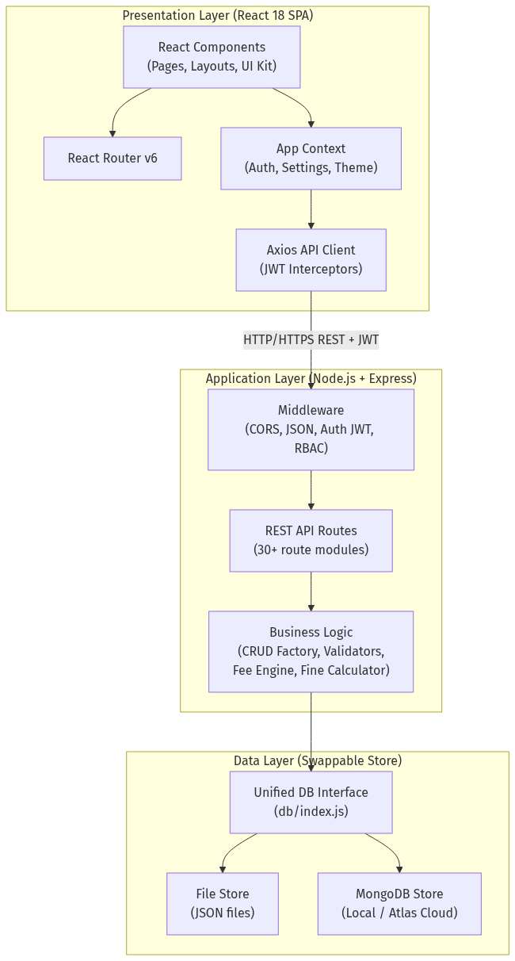
Figure 5.1: Three-tier system architecture of the School Management System

5.3 Use Case Diagram
The use case diagram identifies the six actors and the principal system functions available to each. All actors share the authentication use case. Administrative use cases (publishing results, payroll generation, settings) are reserved for the Admin; operational use cases (admissions, fee collection, inventory, library circulation) belong to the Clerk and Supervisor; academic use cases (attendance, marks entry) belong to Teachers; and self-service use cases belong to Students and Parents.
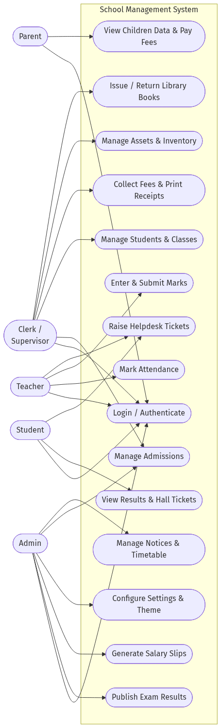
Figure 5.2: Use case diagram showing actors and their system interactions

5.4 Data Flow Diagrams

5.4.1 DFD Level 0 (Context Diagram)
At the context level, the entire application is a single process exchanging data flows with five external entities — the user roles. Inputs include credentials, application data, attendance markings, marks, and payments; outputs include dashboards, receipts, report cards, hall tickets, and alerts.
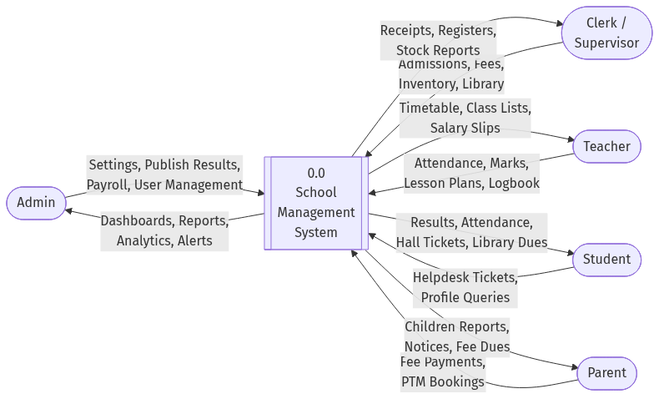
Figure 5.3: DFD Level 0 — context diagram

5.4.2 DFD Level 1
Level 1 decomposes the system into eight major processes and eight data stores. Note how the fee and finance process (6.0) receives postings from both the library process (7.0, fines) and the payroll process (8.0, salary expenses), reflecting the integrated accounting design. The admission process (2.0) writes login records to the users store (D1) when an applicant is enrolled.
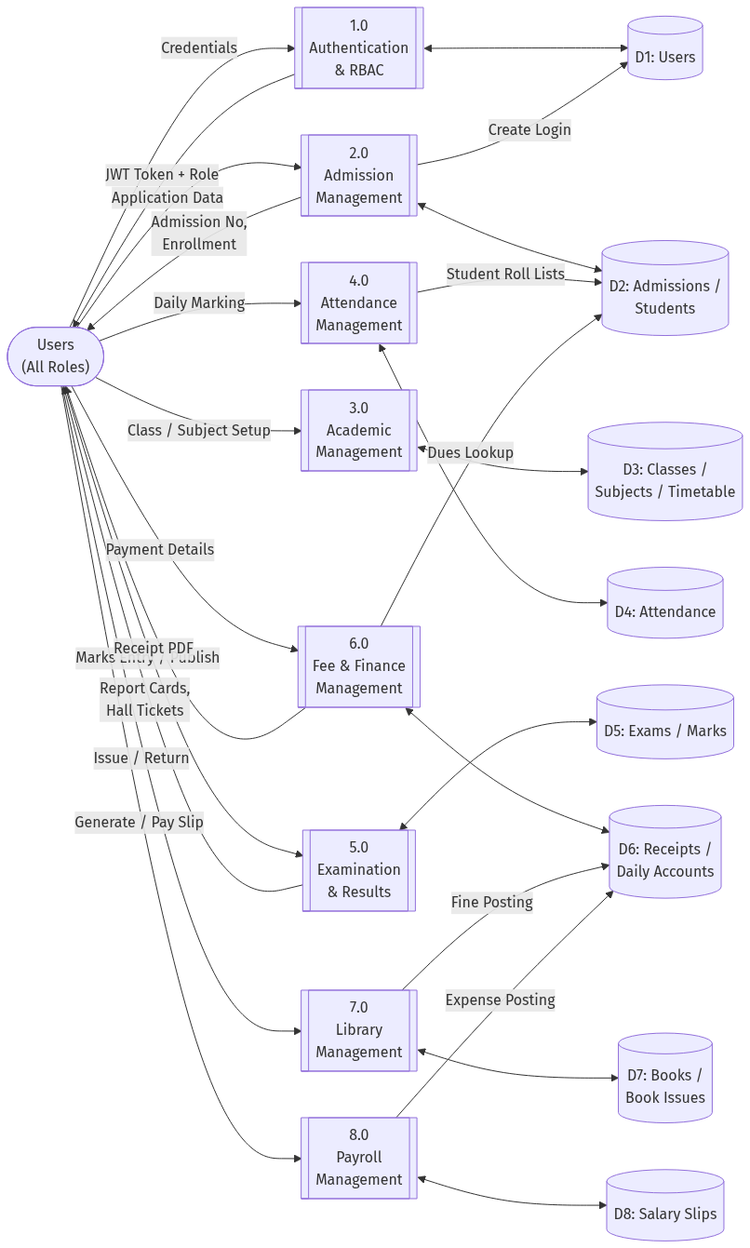
Figure 5.4: DFD Level 1 — major processes and data stores

5.4.3 DFD Level 2 (Fee Collection Process)
The fee collection process is expanded to level 2 because it contains the most business logic. Due computation (6.1) joins three stores — the student’s class and transport assignment, the class fee structure, and previously paid months — to produce the monthly due. Payment recording (6.2) obtains an atomic receipt sequence number, receipt generation (6.3) produces the printable document, and posting (6.4) writes the income entry to daily accounts. The outstanding report (6.5) aggregates unpaid months across all active students.
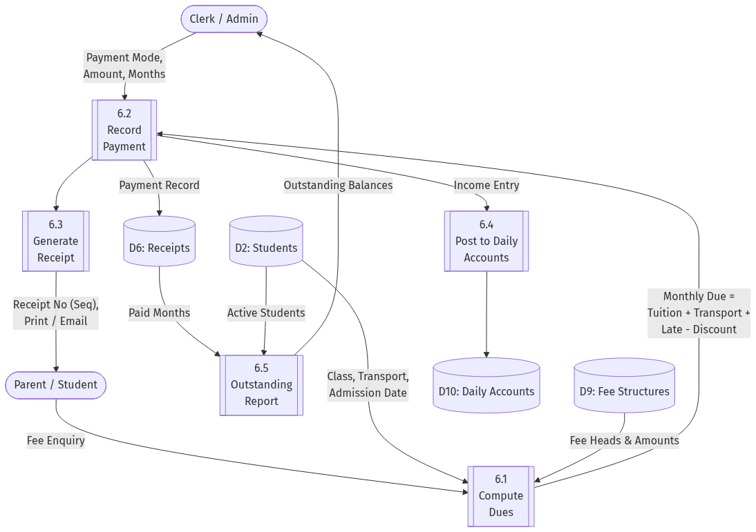
Figure 5.5: DFD Level 2 — decomposition of the fee and finance process

5.5 Entity-Relationship Diagram
The ER model contains eighteen principal entities. Cardinalities follow crow’s-foot notation: a Parent has zero or more Students (siblings link to one parent record); a Class enrolls many Students and offers many Subjects; an Exam contains many Marks records, each of which references one Student and one Subject; a Book is issued through many Book Issues, each tied to one Student; Receipts and Salary Slips each post entries into Daily Accounts. User login records optionally link to a Student or Parent, enabling the portal views.
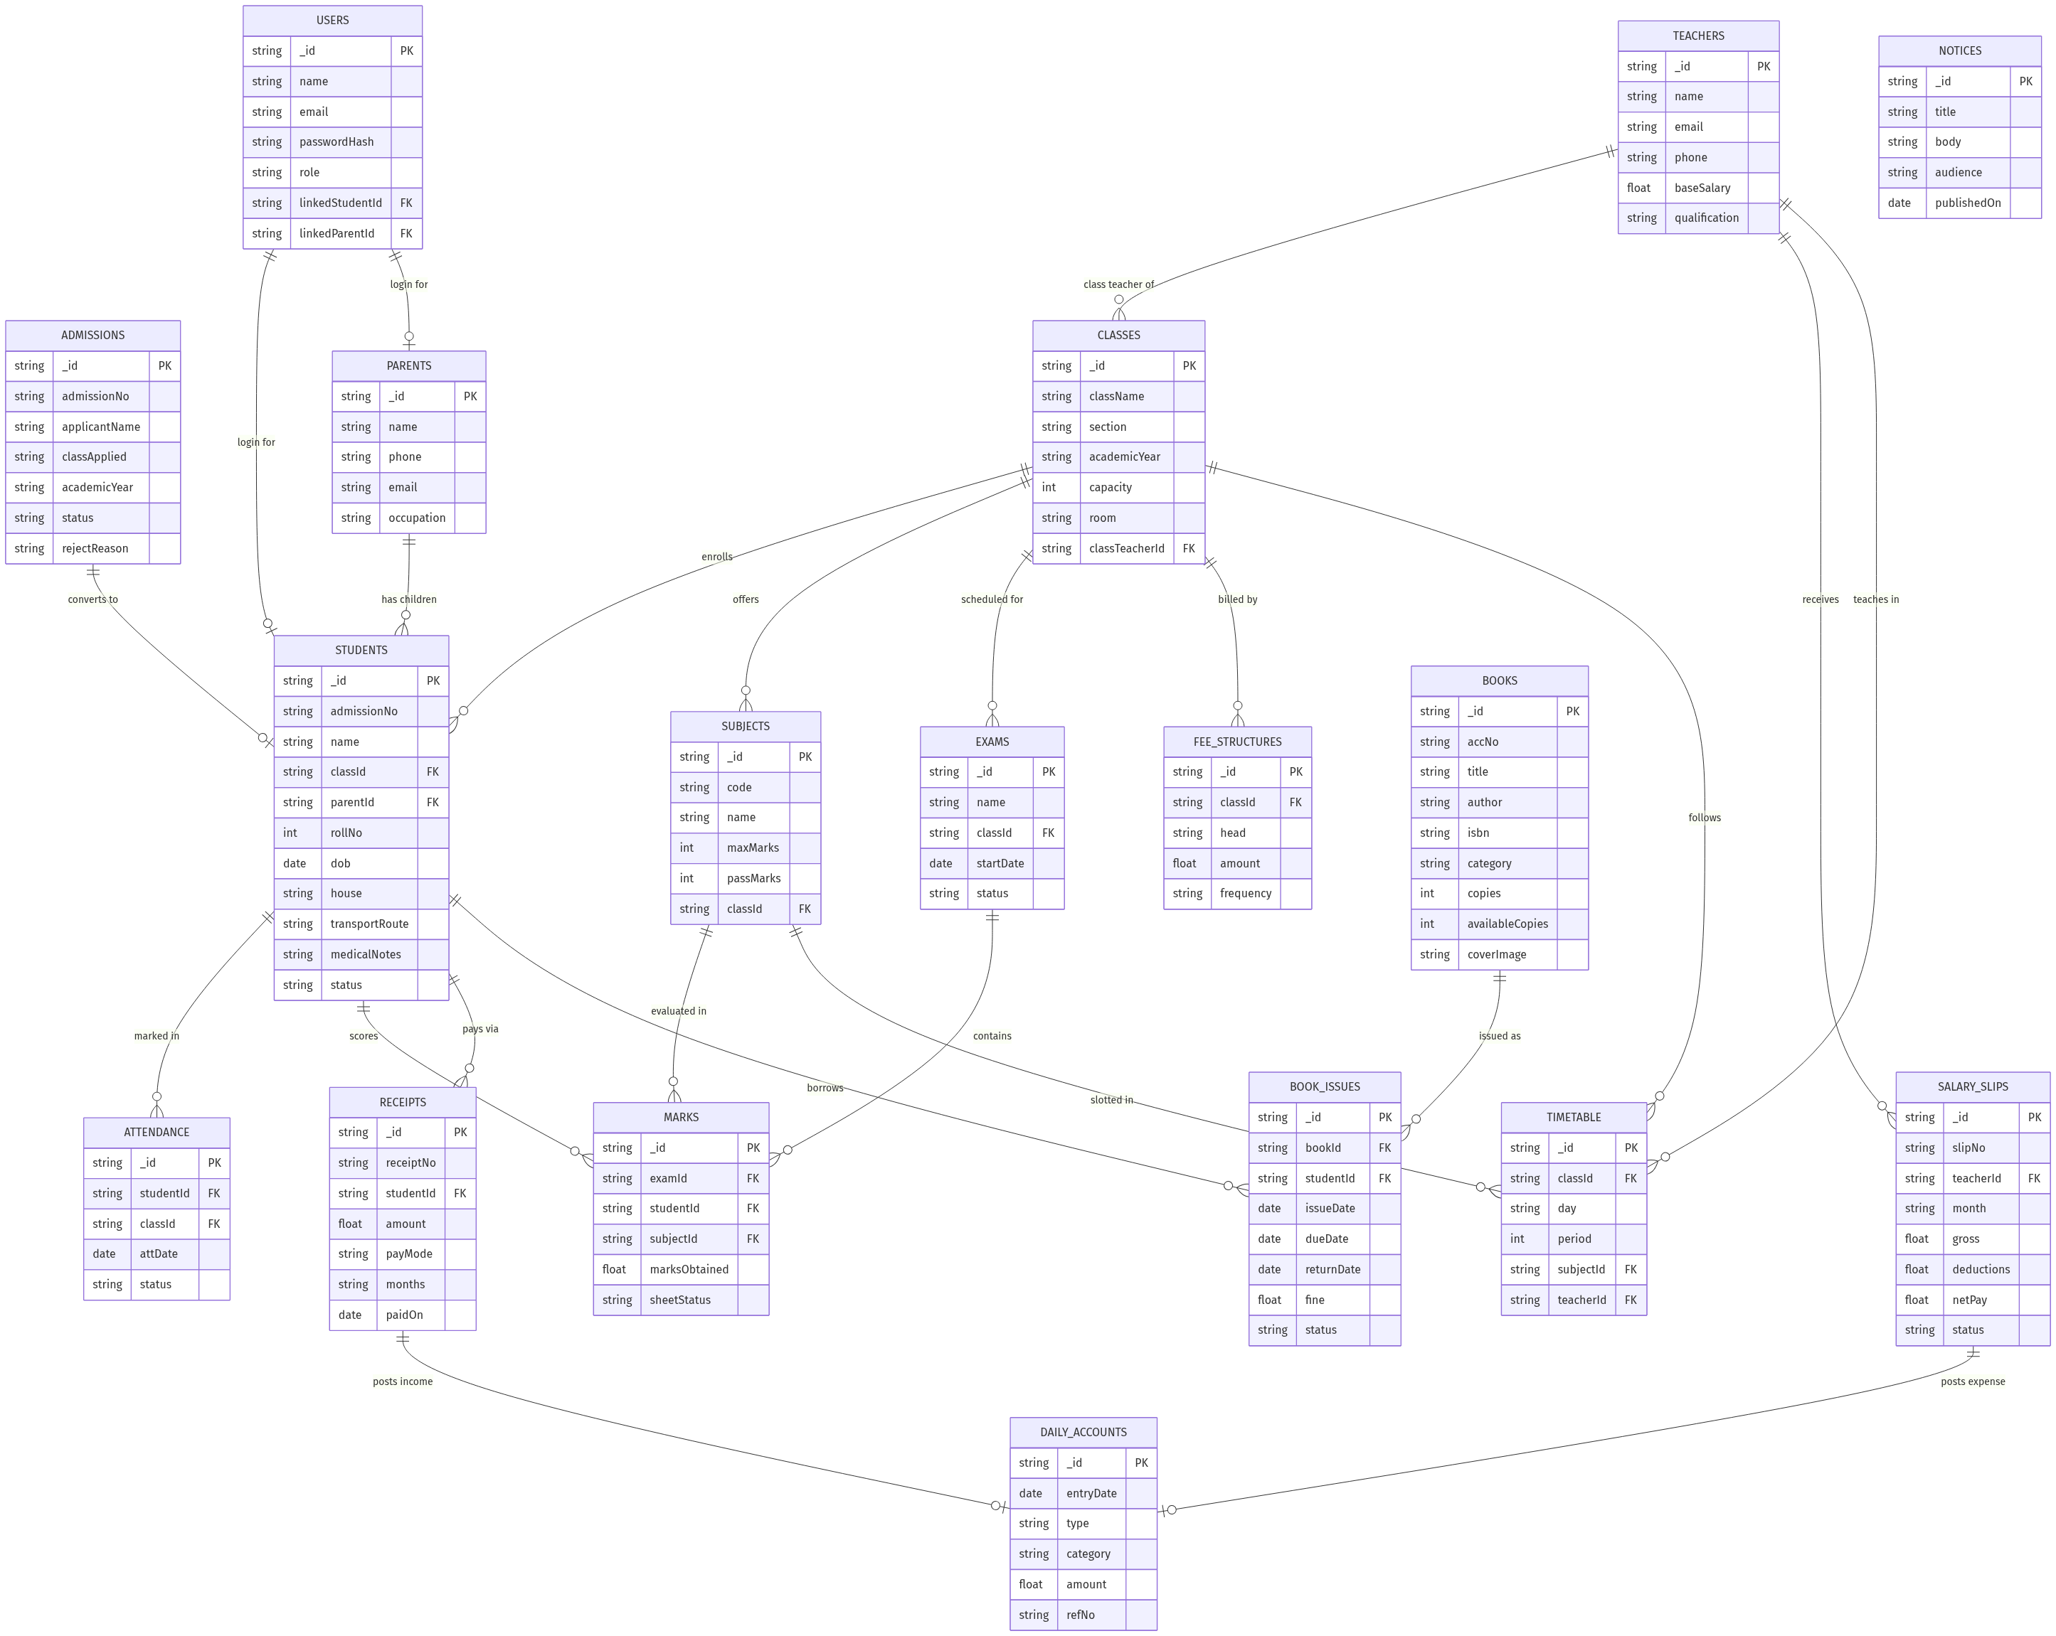
Figure 5.6: Entity-relationship diagram of the complete database

5.6 Class Diagram
The class diagram models the domain from an object-oriented perspective. User is the generalization of the role-bearing actors (Teacher, Parent, Student are shown as specializations through their role). Aggregations connect Parent to Student (children) and SchoolClass to Student and Subject. Exam is composed of MarkSheets, which move through draft, submitted, and locked states. FeeReceipt and SalarySlip both collaborate with DailyAccount for ledger postings, and BookIssue encapsulates fine calculation and return processing.
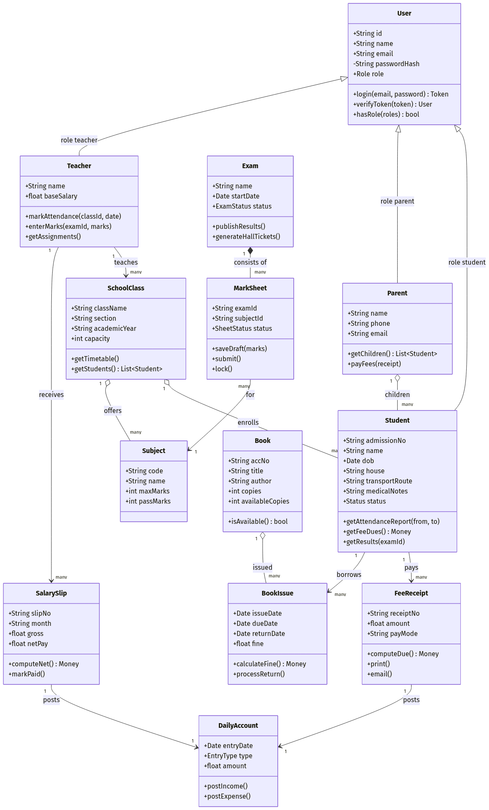
Figure 5.7: Class diagram of the domain model

5.7 Sequence Diagrams

5.7.1 User Authentication Sequence
The login sequence shows credential verification with bcrypt, JWT issuance, and the role-check path taken by every subsequent request through the authentication middleware.
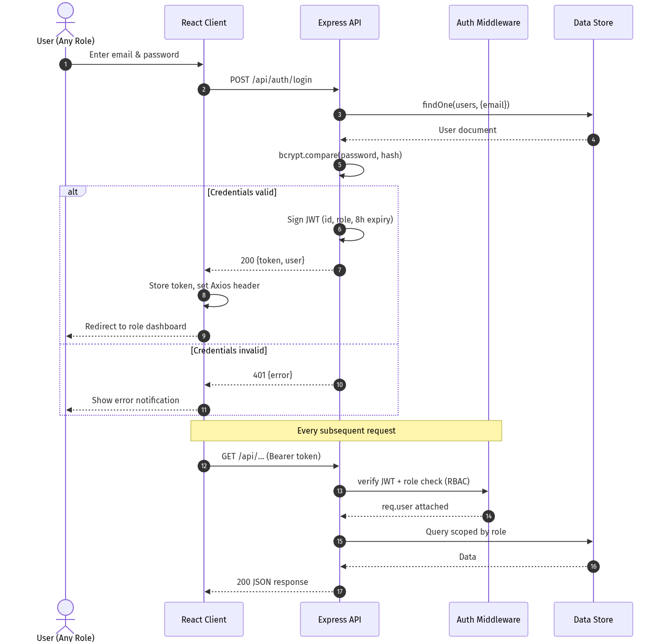
Figure 5.8: Sequence diagram — login and authenticated request handling

5.7.2 Fee Payment Sequence
The fee payment sequence covers due computation, receipt persistence with an atomic sequence number, the automatic income posting to daily accounts, and receipt printing.
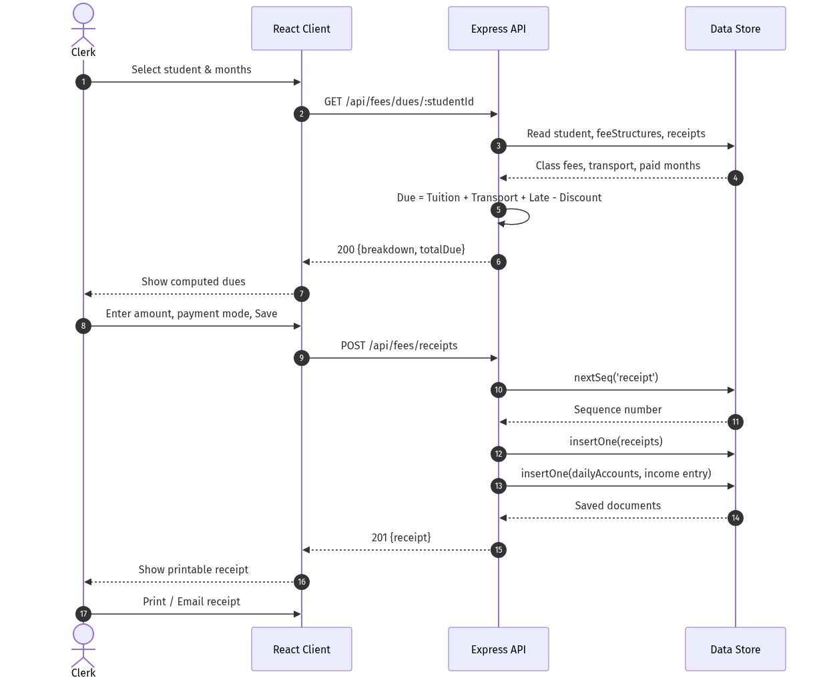
Figure 5.9: Sequence diagram — fee due computation and receipt generation

5.7.3 Examination Workflow Sequence
The examination sequence involves two actors. The teacher retrieves the class sheet, saves drafts, and submits; the administrator reviews submitted sheets and publishes, after which results become visible to students and parents.
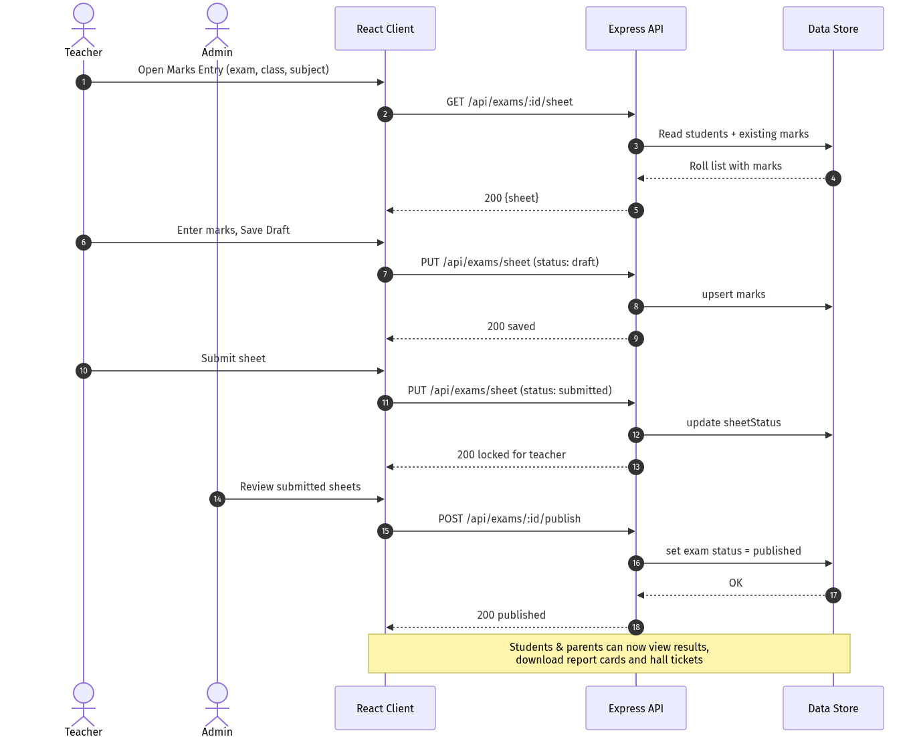
Figure 5.10: Sequence diagram — marks entry, submission, and publishing

5.7.4 Library Circulation Sequence
The library sequence shows availability checking at issue time, automatic due-date assignment, overdue fine computation at return time, and the posting of collected fines to daily accounts.
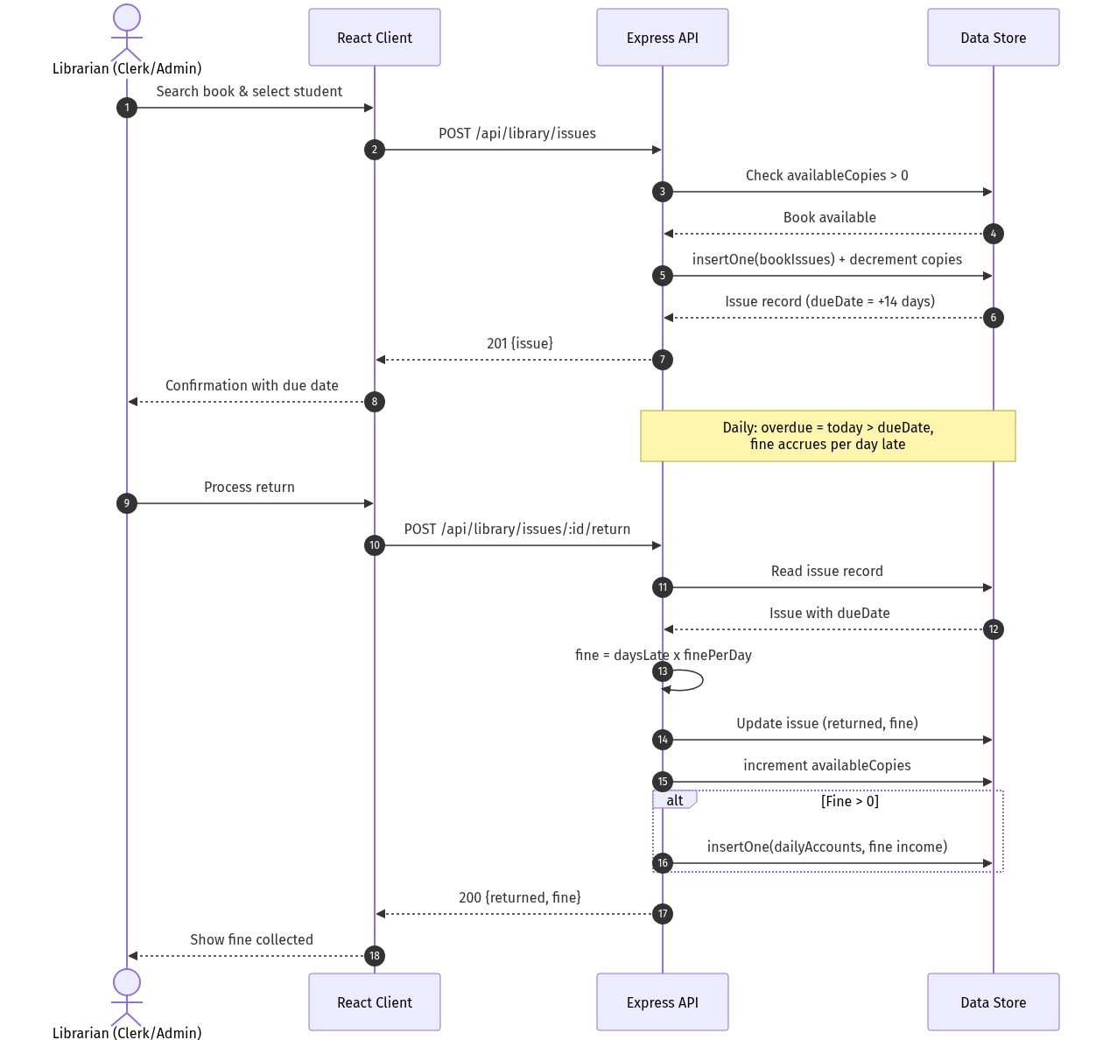
Figure 5.11: Sequence diagram — book issue, return, and fine posting

5.8 Activity Diagram — Admission Workflow
The activity diagram traces an application from submission through review, the approve/reject decision, enrollment (roll number, login creation, optional transport), parent linking, and final confirmation that activates the student across all modules.
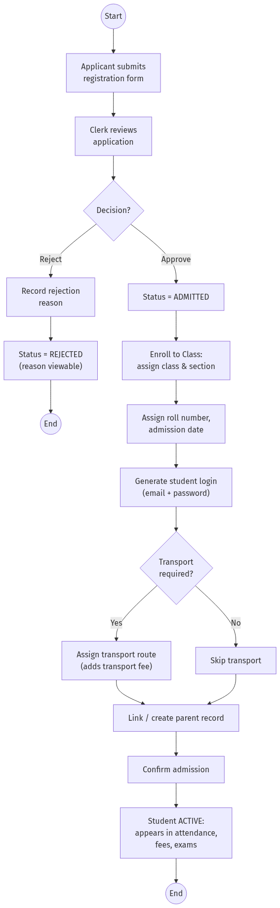
Figure 5.12: Activity diagram — admission and enrollment workflow

5.9 Database Design
The physical schema consists of MongoDB-style document collections. In file mode each collection is a JSON file with an identical logical structure, which is what makes the store swappable. The most important collections and their fields are tabulated below. Every document carries a unique string _id generated by nanoid, and human-facing serial numbers (admission number, receipt number, accession number, slip number) come from an atomic counters collection.

5.9.1 users
Field | Type | Description
_id | string | Primary key (nanoid)
name | string | Display name
email | string | Login identifier (unique)
passwordHash | string | bcrypt hash, never returned by APIs
role | string | admin | clerk | supervisor | teacher | student | parent
linkedStudentId | string | FK → students (for student logins)
linkedParentId | string | FK → parents (for parent logins)

5.9.2 students
Field | Type | Description
_id | string | Primary key
admissionNo | string | Serial e.g. 2024-00000001 (from counter)
name | string | Full name
classId | string | FK → classes
parentId | string | FK → parents
rollNo | number | Roll number within class
dob | date | Date of birth (drives birthday widget)
gender / house | string | Demographics and house allocation
transportRoute | string | Optional; adds transport fee when set
medicalNotes | string | Allergies and health restrictions
status | string | active | inactive | transferred | passed_out | suspended

5.9.3 classes, subjects, teachers
Collection | Key Fields | Notes
classes | className, section, academicYear, capacity, room, classTeacherId | className+section+academicYear unique
subjects | code, name, maxMarks, passMarks, classId | Assigned per class
teachers | name, email, phone, qualification, baseSalary | baseSalary feeds payroll

5.9.4 attendance
Field | Type | Description
studentId | string | FK → students
classId | string | FK → classes
date | date | Attendance date
status | string | present | absent | late | halfday | leave

5.9.5 exams and marks
Collection | Key Fields | Notes
exams | name, classId, startDate, status | status: draft | active | published
marks | examId, studentId, subjectId, marksObtained, sheetStatus | sheetStatus: draft | submitted | locked

5.9.6 fee and accounting collections
Collection | Key Fields | Notes
feeStructures | classId, head, amount, frequency | Defines tuition/transport/other heads
receipts | receiptNo, studentId, amount, payMode, months, paidOn | receiptNo from atomic counter
dailyAccounts | date, type (income|expense), category, amount, refNo | Receives postings from fees, fines, payroll

5.9.7 library collections
Collection | Key Fields | Notes
books | accNo, title, author, isbn, category, shelf, copies, availableCopies, coverImage | accNo e.g. LIB-00001; cover stored as data URL
bookIssues | bookId, studentId, issueDate, dueDate, returnDate, fine, status | fine = daysLate × finePerDay on return

5.9.8 payroll and other collections
Collection | Key Fields | Notes
salarySlips | slipNo, teacherId, month, allowances[], deductions[], gross, netPay, status | Paying posts expense to dailyAccounts
admissions | admissionNo, applicantName, classApplied, status, rejectReason | Approval workflow source
parents | name, phone, email, occupation | Linked from students.parentId
assets / inventory | tag, name, location, maintenance[] / item, qty, reorderLevel, unit | Stock in / issue / adjust movements
notices / timetable / lessonPlans / logbook / discipline / helpdesk | Module-specific fields | Communication and tracking modules
counters | key, value | Atomic sequences: admissionNo, receiptNo, bookAcc, salarySlip

5.10 Design of the Swappable Data Layer
Every route module accesses data exclusively through a col(name) function exported by db/index.js. At startup the module inspects the DB_MODE environment variable: in file mode it returns the file-store implementation, which memory-maps each collection to a JSON file under server/data and persists on every mutation; in mongo mode it returns thin wrappers over the official MongoDB driver connected via MONGO_URI. Both implementations expose the identical contract — insertOne, find with filter/sort/limit, findOne, updateOne, deleteOne, deleteMany, and countDocuments — so business logic is completely unaware of the storage engine. This design satisfies requirement NFR-4 and allows a school to begin with zero infrastructure and migrate to MongoDB Atlas later by exporting the JSON files.

CHAPTER 6: TECHNOLOGY STACK

6.1 The MERN Stack
MERN is an acronym for MongoDB, Express.js, React, and Node.js — four technologies that together cover the entire web application stack using a single programming language, JavaScript. Using one language end to end simplifies development, allows sharing of validation logic and conventions between client and server, and gives access to npm, the largest package ecosystem in software development.

6.1.1 MongoDB
MongoDB is a document-oriented NoSQL database that stores data as flexible JSON-like documents grouped into collections. Its schema flexibility suits a school system in which entities like students carry many optional fields (medical notes, transport routes, languages) that would produce sparse columns in a relational design. In this project MongoDB is one of two interchangeable storage engines; the hosted MongoDB Atlas service provides the cloud deployment path with automated backups and scaling.

6.1.2 Express.js
Express.js is a minimal web framework for Node.js that structures the server as a pipeline of middleware functions and routers. The project uses Express to expose a REST API of more than thirty route modules, with shared middleware handling CORS, JSON body parsing, JWT verification, and role authorization before requests reach business logic.

6.1.3 React
React is a component-based library for building user interfaces. The application is a single-page application: React Router swaps page components client-side without full page reloads, and shared state (the logged-in user, school settings, theme) lives in a context provider. The UI is assembled from a reusable component kit — data tables with search/export, KPI cards, modals, status tabs, and form fields — which keeps all forty-plus pages visually consistent.

6.1.4 Node.js
Node.js is the JavaScript runtime that executes the server. Its non-blocking, event-driven I/O model handles many concurrent API requests efficiently on modest hardware, which matches the deployment profile of a school office server.

6.2 Supporting Libraries and Tools
Library / Tool | Layer | Purpose in the Project
Vite | Client build | Development server with hot module replacement and production bundling
react-router-dom | Client | Client-side routing, protected routes, public/portal layouts
axios | Client | HTTP client; interceptors attach JWT and auto-logout on 401
chart.js + react-chartjs-2 | Client | Dashboard analytics: attendance, collections, gender mix, severity charts
lucide-react | Client | Consistent icon set across the interface
jsonwebtoken | Server | Signing and verifying JWT access tokens
bcryptjs | Server | One-way password hashing with salt
nanoid | Server | Collision-resistant unique document identifiers
cors | Server | Cross-origin resource sharing between dev servers
dotenv | Server | Environment-based configuration (port, DB mode, JWT secret)
MongoDB Node Driver | Server | Official driver used by the Mongo store implementation

6.3 Why MERN for This Project
- Single language across the stack reduces context switching and enables one developer to own a feature end to end.
- JSON everywhere: the database documents, the API payloads, and the client state share the same shape, eliminating mapping layers.
- React’s component model matches the UI requirement of many similar CRUD screens built from one component kit.
- Node.js and the file-based store option allow zero-cost, offline-capable deployment inside a school LAN.
- A clear growth path exists to MongoDB Atlas, container deployment, and horizontal scaling without rewriting the application.

CHAPTER 7: IMPLEMENTATION

7.1 Project Structure
The repository is organized as two applications — server and client — plus supporting folders. The server keeps route modules thin by delegating shared behaviour to a CRUD factory, middleware, and the data layer. The client mirrors this with a CRUD page factory, a shared UI kit, and per-module pages.
Path | Contents
server/src/index.js | Express bootstrap: middleware stack and mounting of all API routers
server/src/db/ | Unified data interface (index.js), fileStore.js, mongoStore.js
server/src/middleware/auth.js | JWT verification and allowRoles(...) role guard
server/src/routes/ | 30+ route modules: auth, admissions, students, classes, subjects, teachers, attendance, exams, fees, accounts, assets, inventory, library, payroll, search, dashboard, portal, notices, timetable, settings, …
server/src/utils/crudFactory.js | Generic REST CRUD generator used by simple modules
server/src/seed/seed.js | Demo data generator for all collections
server/data/ | JSON collections when running in file mode
client/src/components/ | Layout, PublicLayout, CommandPalette, ui.jsx component kit, CrudPage factory
client/src/pages/ | One page per module plus public pages and role dashboards
client/src/context/AppContext.jsx | Auth/session state, settings, theme persistence
client/src/api.js | Axios instance with JWT interceptors

7.2 Authentication and Role-Based Access Control
On login the server verifies the bcrypt hash and signs a JWT embedding the user id and role with an expiry. The client stores the token and attaches it as a Bearer header through an Axios request interceptor; a response interceptor performs automatic logout on any 401. On the server, the auth middleware verifies the signature and attaches req.user, and each route declares its allowed roles through the allowRoles guard — for example, fee collection endpoints accept admin, clerk, and supervisor, while marks entry accepts teachers. Portal endpoints additionally scope queries by the caller’s linked student or parent id so users can only ever read their own records.

7.3 Module Implementation Summaries

7.3.1 Dashboard and Analytics
The dashboard route aggregates live counts (active students, teachers, classes, subjects, parents), today’s collection total, outstanding balance, today’s attendance ratio, active exams, and open incidents. Role-specific variants are rendered on the client: the Admin sees approval alerts (pending admissions, mark sheets awaiting publish) and finance charts; the Clerk sees collection-centred KPIs; the Supervisor sees admissions and attendance oversight; the Teacher sees today’s periods and assigned classes. A birthday widget lists students whose birthdays fall in the next seven days, and a greeting bar shows a live clock.

7.3.2 Admissions
Applications are captured with applicant, class-applied, academic year, and guardian details, then tracked through Registered, Admitted, and Rejected states. Rejection stores a reason viewable from the list. Enrollment converts an admitted application into a student: it assigns the class and roll number, creates the student login, records the admission date, links or creates the parent record, and optionally assigns a transport route.

7.3.3 Students, Classes, Parents
Student profiles include personal, transport, medical, citizenship, and language details, with status tracking across active, inactive, transferred, passed-out, and suspended. Row-level quick actions open fee dues, date-filtered attendance reports, exam results, linked parents, and a printable ID card with house colours and a barcode. Classes enforce the unique combination of name, section, and academic year, and expose a per-class timetable view. Parents are auto-created during registration and can be linked to multiple children.

7.3.4 Attendance
A teacher or clerk selects a class and date to load the roll list, then marks each student Present, Absent, Late, Half-day, or Leave with colour-coded toggles. Bulk actions (Mark All Present, Mark All Absent, Copy from Yesterday) accelerate routine days. Saved records feed both the dashboard attendance chart and per-student reports.

7.3.5 Examinations and Results
Exams are created per class; teachers enter marks per subject in sheets that move through draft, submitted, and locked states. The Admin reviews submitted sheets and publishes the exam, which unlocks results for students and parents, top-performer and grade-distribution summaries, printable A4 mark sheets and report cards, and hall ticket generation.

7.3.6 Fees, Receipts, and Daily Accounts
Fee structures define per-class heads and amounts. At collection time the engine computes dues as tuition plus transport (when assigned) plus late fee minus discounts, across the selected months. Payments accept multiple modes; each saved payment obtains an atomic receipt number and renders a printable receipt that can also be emailed. Every receipt posts an income entry to daily accounts, which also records manual income/expense entries, library fines, and payroll expenses, giving a complete institutional cash view.

7.3.7 Assets and Inventory
Assets receive auto-generated tags, locations, and a maintenance history with expenses. Consumable inventory tracks quantities with unit types and reorder levels; Stock In, Issue, and Adjust operations maintain an auditable movement trail with low-stock indicators.

7.3.8 Library Management
The catalogue stores accession-numbered books with categories, shelf locations, copy counts, and cover images (uploaded images are resized client-side and validated server-side). The circulation desk issues books with automatic 14-day due dates, decrementing available copies; returns compute fines for late days and post collected fines to daily accounts. Students and parents see their issued books in the portal with due-soon and overdue warnings, and staff see an overdue alert banner with accruing fines.

7.3.9 Payroll
Salary slips are generated per staff member per month with configurable allowance and deduction rows; the engine computes gross and net pay. Marking a slip paid posts the expense to daily accounts. Slips render as printable A4 documents, and teachers can view their own slip history.

7.3.10 Communication and Tracking
Notices target selectable audiences; the timetable module maintains per-class period grids used by teacher dashboards and substitute planning; lesson planning and logbooks record teaching activity; the discipline module tracks incidents with severity; and the helpdesk manages tickets raised by students and staff.

7.3.11 Global Search and User Experience Features
A Ctrl+K command palette performs debounced global search across students, users, parents, receipts, assets, books, exams, and salary slips, with keyboard navigation and direct routing to the matched record. Dark mode is implemented with CSS custom properties toggled by a class on the document root and persisted per user. Public Home, About Us, and Contact pages share a navigation bar that hosts the login form, and logout returns users to the public homepage.

7.4 REST API Summary
Endpoint Group | Representative Endpoints | Allowed Roles
/api/auth | POST /login, GET /me | All
/api/admissions | GET /, POST /, PUT /:id, POST /:id/enroll | Admin, Clerk, Supervisor
/api/students | GET /, POST /, PUT /:id, GET /:id/attendance, GET /:id/dues | Staff (scoped read for portal)
/api/classes, /api/subjects, /api/teachers | CRUD + /:id/timetable | Admin, Clerk, Supervisor
/api/attendance | GET /?classId&date, POST /bulk | Teacher, Admin, Clerk, Supervisor
/api/exams | CRUD, GET /:id/sheet, PUT /sheet, POST /:id/publish | Teacher (entry), Admin (publish)
/api/fees | GET /dues/:studentId, POST /receipts, GET /receipts | Admin, Clerk, Supervisor
/api/accounts | GET /, POST / | Admin, Clerk
/api/assets, /api/inventory | CRUD + stock movements | Admin, Clerk, Supervisor
/api/library | CRUD /books, POST /issues, POST /issues/:id/return, GET /my, GET /stats | Staff; /my for Student/Parent
/api/payroll | GET /, POST /, POST /:id/pay | Admin, Clerk (own slips for Teacher)
/api/search | GET /?q= | All authenticated (role-scoped results)
/api/dashboard | GET /stats, GET /teacher | Role-dependent
/api/portal | GET /student/:id/…, GET /parent/children | Student, Parent (own data only)
/api/settings | GET /, PUT /, GET /public/settings | Admin (write); public read subset

7.5 Security Measures Implemented
- Passwords are stored exclusively as bcrypt hashes; plaintext is never persisted or logged.
- JWTs are signed with a server-side secret and carry an expiry; expired or malformed tokens receive HTTP 401 and trigger client logout.
- Every protected route declares an allow-list of roles; requests from other roles receive HTTP 403.
- Portal queries are filtered server-side by the caller’s linked student/parent id, preventing horizontal privilege escalation.
- Uploaded cover images are size-validated on the server to prevent oversized payloads.
- Serial numbers come from atomic counters, preventing duplicate receipts or admission numbers under concurrency.

CHAPTER 8: TESTING

8.1 Testing Methodology
Testing was performed continuously alongside the iterative development model. Each vertical slice (module) was tested at four levels: unit testing of business-logic helpers, integration testing of API endpoints with the data layer, system testing of complete workflows through the browser interface, and user-acceptance style walkthroughs replicating real office scenarios on the seeded demonstration database. Both storage engines (file store and MongoDB) were exercised to verify the swappable data layer behaves identically.

8.1.1 Unit Testing
Business-logic helpers were tested with representative inputs and boundary values: the fee due computation (tuition + transport + late − discount) with and without transport assignment; the library fine calculator across on-time, one-day-late, and long-overdue returns; the payroll gross/net computation with empty, single, and multiple allowance and deduction rows; and the birthday window calculator across month and year boundaries.

8.1.2 Integration Testing
Each API route was called with valid tokens of every role to verify the authorization matrix — allowed roles receive data, disallowed roles receive HTTP 403, and missing/expired tokens receive HTTP 401. Cross-module effects were verified: saving a receipt creates the daily-accounts income entry; returning an overdue book posts the fine; paying a salary slip posts the expense; enrolling an admission creates the student and login records.

8.1.3 System Testing
Complete user journeys were executed through the browser: an application registered, admitted, and enrolled; attendance marked with bulk actions; an exam created, marks entered, submitted, and published; fees collected and the receipt printed; a book issued, returned late, and the fine collected; a salary slip generated, paid, and printed. Printable outputs were verified against A4 through the browser print preview.

8.2 Test Case Table
ID | Test Scenario | Steps / Input | Expected Result | Status
TC-01 | Login with valid credentials | Enter seeded admin email and password | JWT issued; redirect to admin dashboard | Pass
TC-02 | Login with wrong password | Valid email, incorrect password | HTTP 401; error notification shown | Pass
TC-03 | Access API without token | Call /api/students with no Authorization header | HTTP 401 rejected | Pass
TC-04 | Role guard enforcement | Teacher token calls POST /api/fees/receipts | HTTP 403 forbidden | Pass
TC-05 | Auto logout on expiry | Use expired token on any request | Client clears session, returns to public page | Pass
TC-06 | Register admission | Submit application form with guardian details | Application saved with status Registered | Pass
TC-07 | Reject with reason | Reject an application entering a reason | Status Rejected; reason viewable from list | Pass
TC-08 | Enroll admitted applicant | Approve, then enroll with class and roll number | Student, login, and parent link created | Pass
TC-09 | Duplicate class prevention | Create class with existing name+section+year | Validation error; duplicate not saved | Pass
TC-10 | Student quick views | Open dues/attendance/results icons on a row | Correct per-student data in each modal | Pass
TC-11 | Bulk attendance | Mark All Present, then save | All students saved as present for the date | Pass
TC-12 | Copy from yesterday | Use copy action on next day | Yesterday’s statuses replicated | Pass
TC-13 | Marks draft and submit | Teacher saves draft, then submits sheet | Sheet locked for teacher after submit | Pass
TC-14 | Publish results | Admin publishes exam with submitted sheets | Students/parents can view results | Pass
TC-15 | Unpublished results hidden | Student opens results before publish | No marks visible | Pass
TC-16 | Fee due computation | Student with transport, one unpaid month | Due = tuition + transport − discounts | Pass
TC-17 | Receipt sequence | Save two receipts concurrently | Distinct sequential receipt numbers | Pass
TC-18 | Receipt posts income | Save a receipt, open Daily Accounts | Matching income entry present | Pass
TC-19 | Outstanding report | View outstanding after partial payments | Only unpaid months counted | Pass
TC-20 | Issue book | Issue available book to student | availableCopies decremented; due date +14 days | Pass
TC-21 | Issue unavailable book | Issue book with zero available copies | Error; issue refused | Pass
TC-22 | Overdue fine calculation | Return book after due date | Fine = days late × rate; posted to accounts | Pass
TC-23 | Portal library view | Student opens portal with overdue book | Overdue banner with accruing fine shown | Pass
TC-24 | Cover image validation | Upload oversized book cover | Server rejects with clear error | Pass
TC-25 | Salary slip computation | Generate slip with allowances and deductions | Net = base + allowances − deductions | Pass
TC-26 | Pay slip posts expense | Mark slip paid | Expense entry created in Daily Accounts | Pass
TC-27 | Teacher sees own slips | Teacher opens payroll | Only own slips listed | Pass
TC-28 | Global search | Ctrl+K, type student name | Student appears; Enter navigates to record | Pass
TC-29 | Dark mode persistence | Toggle dark mode, reload page | Theme restored without flash | Pass
TC-30 | Logout redirect | Click logout from any page | Session cleared; public homepage shown | Pass
TC-31 | Printable documents | Print receipt, report card, ID card, salary slip | Each fits A4 correctly in print preview | Pass
TC-32 | Store swap equivalence | Run same flows in file and Mongo modes | Identical behaviour and results | Pass

8.3 Testing Summary
All thirty-two documented test cases passed on the final build. Defects discovered during testing — a timezone offset in the birthday window calculation, a missing chart plugin registration, and dark-mode contrast issues on headings — were fixed and re-verified. The authorization matrix was confirmed for all six roles across every endpoint group.

CHAPTER 9: RESULTS AND DISCUSSION

9.1 Outcome
The completed system delivers every module specified in Chapter 4 as a working, integrated web application seeded with demonstration data. Administrative workflows that previously required separate registers — admissions, attendance, examinations, fees, library, payroll, inventory — now operate on one database with role-appropriate access, live dashboards, and printable outputs.

9.2 Application Screenshots
The screenshots below show two representative screens of the running application: the administrator dashboard in dark mode with KPI cards, alerts, and analytics charts; and the Students Management module with status tabs, filters, and the exportable data table.
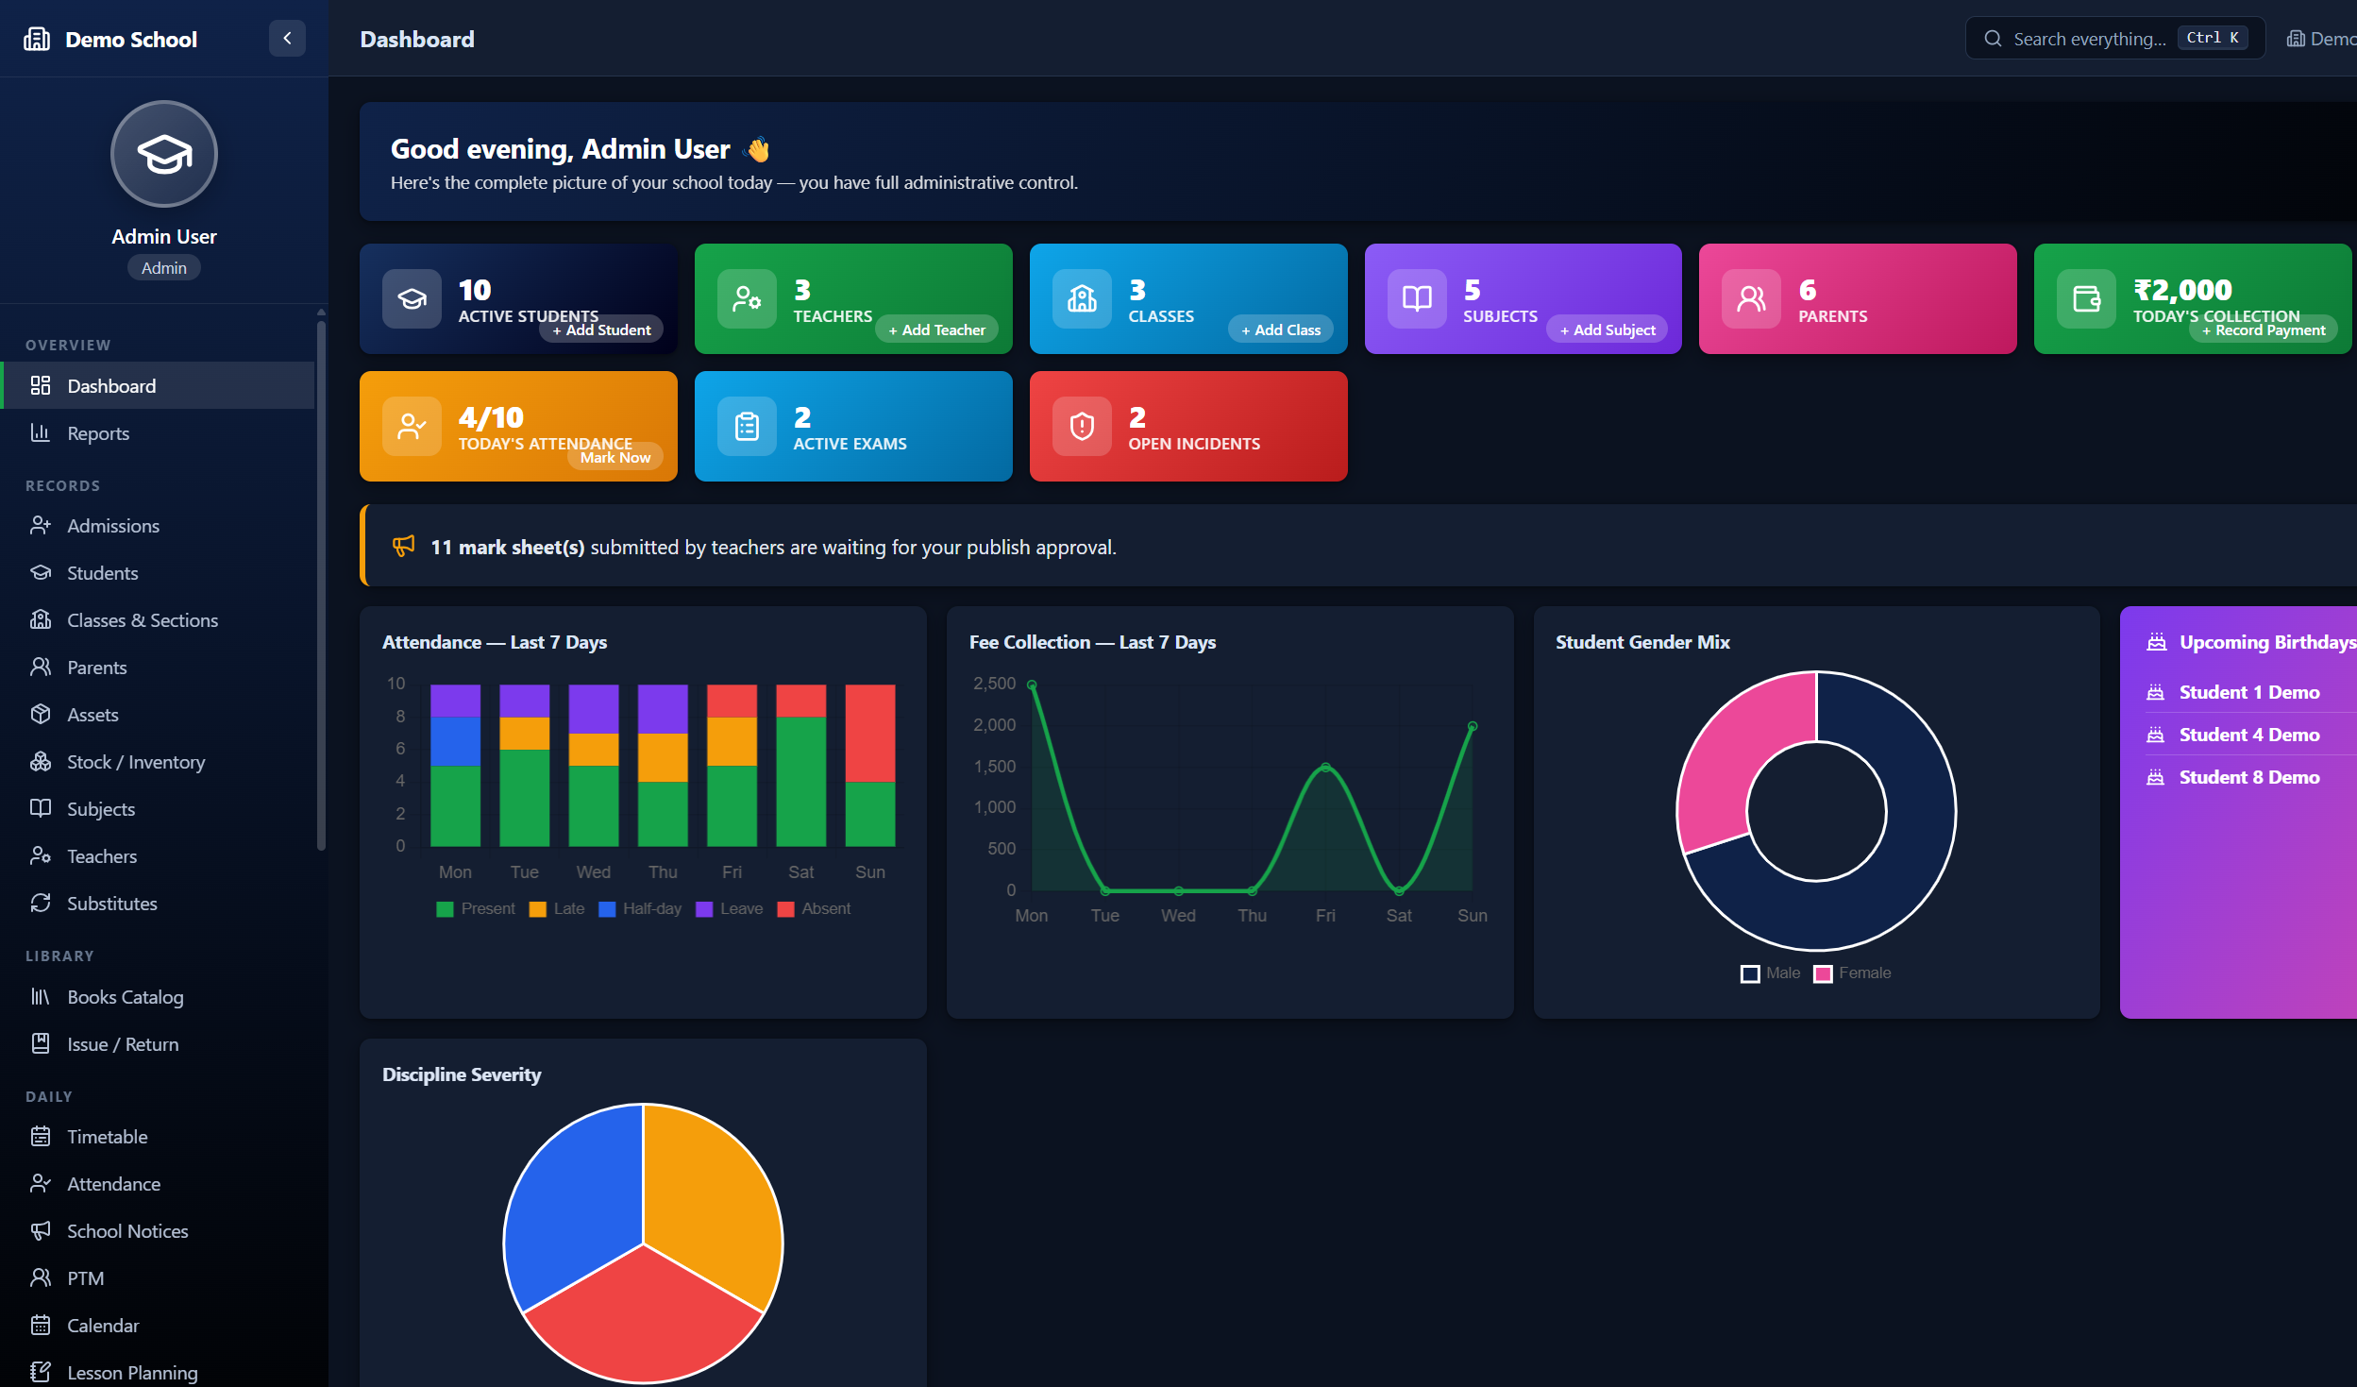
Figure 9.1: Administrator dashboard (dark mode) with KPIs, alerts, and charts
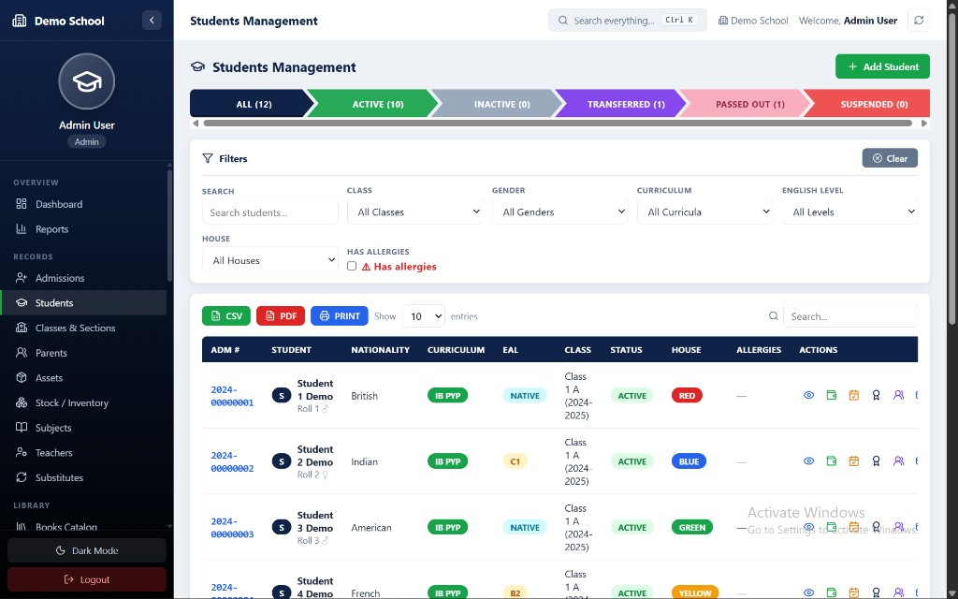
Figure 9.2: Students Management module with status tabs, filters, and data table

9.3 Discussion
The measured impact of the system on the modelled office workflows is substantial. Fee collection with automatic due computation and printed receipts takes under a minute per student. Result preparation collapses from days of compilation to a publish action once teachers submit sheets. Attendance bulk actions reduce a class register to a few clicks. Because library fines and salary expenses post automatically into daily accounts, the cash book is always current without duplicate entry. The dual-store design proved its value in practice: the entire demonstration ran on the file store with zero setup, and the identical build was verified against MongoDB.

CHAPTER 10: CONCLUSION AND FUTURE SCOPE

10.1 Conclusion
This project set out to replace the fragmented, error-prone administrative processes of a school with one integrated, secure, and affordable web application. The delivered Complete School Management System achieves that goal: it implements the full administrative lifecycle — admissions through enrollment, daily attendance, the complete examination pipeline, fee collection with integrated accounting, library circulation with fines, staff payroll, assets and inventory, and communication modules — behind role-based portals for six user types.
Technically, the project demonstrates the effectiveness of the MERN stack for institutional software, and contributes a reusable pattern in its swappable persistence layer, which lets the same codebase serve zero-infrastructure deployments and cloud-scale MongoDB Atlas deployments alike. Consistent component factories on both client and server kept the large module count maintainable, and the security model — bcrypt hashing, JWT sessions, route-level role guards, and server-side data scoping — protects institutional data end to end.
All functional and non-functional requirements specified in Chapter 4 were implemented and verified through the structured testing programme in Chapter 8. The system is ready for real-world pilot deployment.

10.2 Future Scope
- Online payment gateway integration so parents can pay fees directly from the portal with automatic receipt generation.
- SMS, email, and WhatsApp notification gateways for absence alerts, fee reminders, and result announcements.
- Biometric or RFID attendance capture integrated with the existing attendance API.
- Multi-school (multi-tenant) support for educational groups managing several institutions from one deployment.
- Native mobile applications for parents and teachers consuming the existing REST API.
- Automated timetable generation with conflict detection, and transport/GPS tracking modules.
- Advanced analytics: predictive fee-default detection, learning-outcome trends, and accreditation report exports.
- Internationalization (multi-language interface) and accessibility (WCAG) enhancements.

APPENDIX A: INSTALLATION AND CONFIGURATION GUIDE

A.1 Prerequisites
- Node.js version 18 or later installed (verify with node --version).
- npm (bundled with Node.js; verify with npm --version).
- Git for cloning the repository.
- Optional: a MongoDB Atlas account (free tier) if cloud mode is desired; file mode needs no database.

A.2 Obtaining the Source Code
Clone the repository and inspect its two applications:
- git clone https://github.com/sumitkumar1503/complete-school-management-system.git
- cd complete-school-management-system — the server/ folder holds the Express API and the client/ folder holds the React application.

A.3 Installing Dependencies
- Server: open a terminal in server/ and run npm install.
- Client: open a second terminal in client/ and run npm install.

A.4 Configuration
Server configuration lives in server/.env. The important variables are:
Variable | Example | Meaning
PORT | 5050 | Port on which the Express API listens
DB_MODE | file | file = JSON store in server/data; mongo = MongoDB
MONGO_URI | mongodb+srv://… | Connection string (only when DB_MODE=mongo)
JWT_SECRET | any-long-random-string | Secret used to sign authentication tokens
To switch the same installation to MongoDB Atlas: create a free cluster, obtain the connection string, set DB_MODE=mongo and MONGO_URI accordingly, then re-run the seed script. No application code changes are required.

A.5 Seeding Demonstration Data
From the server/ folder run npm run seed. The script populates every collection — users for all six roles, classes, subjects, students with parents, attendance, exams with marks, fee structures and receipts, assets, inventory, library books with issues, salary slips, notices, and timetable entries — providing an immediately explorable system.

A.6 Running the Application
- Start the API: in server/ run npm run dev (default http://localhost:5050).
- Start the client: in client/ run npm run dev (Vite serves http://localhost:5173 and proxies /api to the server).
- Open the client URL in a browser; the public homepage appears with Login in the navigation bar.

A.7 Building for Production
Run npm run build inside client/ to produce the optimized bundle in client/dist. The bundle can be served by any static web server, with the Express API running behind the same origin or a reverse proxy. In production, always set a strong JWT_SECRET and prefer DB_MODE=mongo with a managed MongoDB instance and regular backups.

APPENDIX B: USER MANUAL (QUICK REFERENCE)

B.1 Demonstration Login Accounts
The seed script creates one account per role. All demonstration accounts use the password published in the repository README.
Role | Purpose of the Account
Admin | Full control: settings, publishing results, payroll, all modules
Clerk | Admissions, fee collection, inventory, library circulation
Supervisor | Admissions and general management oversight
Teacher | Attendance marking, marks entry, lesson plans, logbook
Student | Portal: attendance, results, hall tickets, library dues, helpdesk
Parent | Portal: children’s data, fee dues, results, notices

B.2 Common Tasks

B.2.1 Admitting and Enrolling a Student
- Admissions → New Registration: fill applicant, class applied, and guardian details, then save.
- From the Registered tab choose Admit, then Enroll to Class: pick class and section, assign roll number and login password, set admission date and transport if needed.
- Confirm Admission — the student now appears across attendance, fees, exams, and the parent portal.

B.2.2 Marking Attendance
- Attendance → select class and date. Use the colour toggles per student, or the bulk buttons Mark All Present / Mark All Absent / Copy from Yesterday, then save.

B.2.3 Collecting a Fee Payment
- Fees → Collect: choose the student; the system displays computed dues per month.
- Select months, enter amount and payment mode, save — the numbered receipt opens for printing or emailing, and the income posts to Daily Accounts automatically.

B.2.4 Running an Examination Cycle
- Exams → create the exam for a class. Teachers open Marks Entry, save drafts, and submit their subject sheets.
- Admin reviews submitted sheets and clicks Publish — results, report cards, and hall tickets become available to students and parents.

B.2.5 Issuing and Returning Library Books
- Library → Books Catalog to manage titles (covers can be uploaded; images are resized automatically).
- Circulation → Issue: choose book and student; the due date is set automatically. On Return, any late fine is computed and posted to accounts.

B.2.6 Generating Payroll
- Finance → Payroll → Generate Slip: pick the staff member and month, adjust allowances/deductions, and save. Mark Paid posts the expense; the A4 slip is printable.

B.3 Productivity Features
- Press Ctrl+K anywhere to open the global command palette and jump to any student, receipt, book, or record.
- Use the Dark Mode toggle at the bottom of the sidebar; the preference is remembered.
- Data tables offer CSV, PDF, and Print exports plus instant search.
- Printable documents (ID cards, report cards, receipts, salary slips, hall tickets) open in a print-ready A4 layout.

BIBLIOGRAPHY / REFERENCES
- Node.js Documentation — https://nodejs.org/docs
- Express.js Guide — https://expressjs.com
- React Documentation — https://react.dev
- MongoDB Manual and Atlas Documentation — https://www.mongodb.com/docs
- MDN Web Docs (JavaScript, HTTP, Web APIs) — https://developer.mozilla.org
- JSON Web Token Introduction — https://jwt.io/introduction
- Vite Documentation — https://vitejs.dev
- Chart.js Documentation — https://www.chartjs.org/docs
- React Router Documentation — https://reactrouter.com
- bcrypt: A Future-Adaptable Password Scheme (Provos & Mazières, USENIX 1999)
- Sommerville, I., Software Engineering, 10th Edition, Pearson.
- Pressman, R. S., Software Engineering: A Practitioner’s Approach, 8th Edition, McGraw-Hill.
- Silberschatz, A., Korth, H., Sudarshan, S., Database System Concepts, 7th Edition, McGraw-Hill.

