

**04170207**

**Software Engineering**

Phase 2: Software Design Document Muscles Monsters(fitness club)

Zeyad Mohamed Hammad Hassan 203052

Amr Samy Rizkallah Obaid Rizkallah 203086

GitHub link:<https://github.com/amrs12145/softwareEngineering-project>

**Dec 2020**

**Contents**

Team 1

Document Purpose and Audience 3

System Models 4

1. Class diagrams 4
2. Sequence diagrams 7

Class - Sequence Usage Table 10

1. Physical Entity-Relationship Diagram --------
2. User Interface Design Phase-2
3. Algorithms and Data Structures Phase-2

Ownership Report Phase-2

Policy Regarding Plagiarism 10

Team

|  |  |  |  |
| --- | --- | --- | --- |
| **ID** | **Name** | **Email** | **Mobile** |
| 203086 | Amr Samy | sim.amrsamy3086@alexu.edu.eg | 01286969796 |
| 203052 | zeyad mohamed hammad hassan |  |  |

## Document Purpose and Audience

Depending on this Document we can help Technical Staff Solving and Developing the required software Throw displaying useful diagrams and representing it in multi forms (UML, sequence, Database ,Algorithm) to ease the implementation process.

**target audience**

**1-** CEO , Software Architect ,Chief Software Officer

**2-** UI/UX Designer

**3-** Back-end/Front-end Developers

## System Models

### Class diagrams

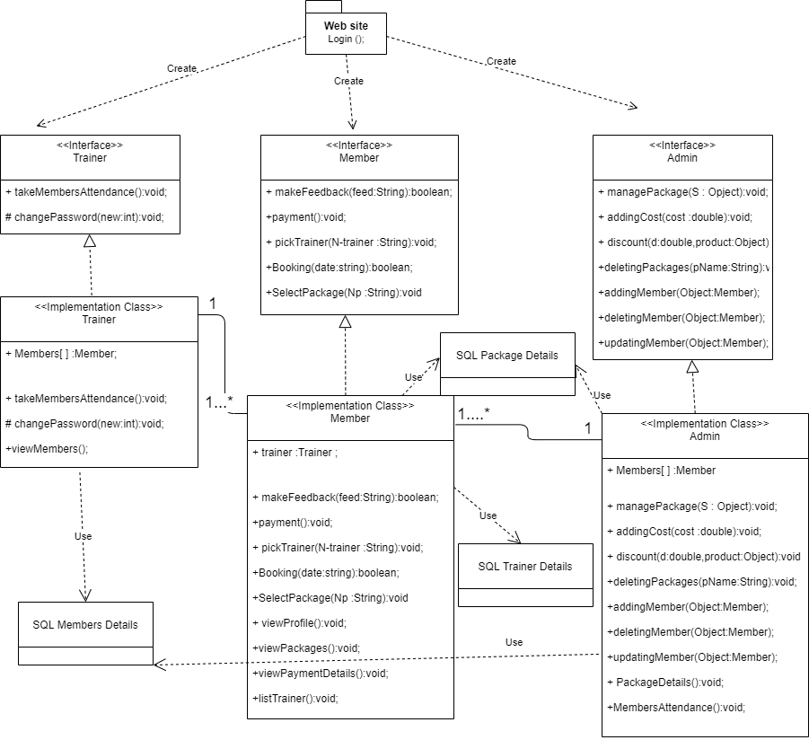

**subsystem 1 refers to the employees of the gym and subsystem 2 refers to the members and customers**

|  |  |  |  |
| --- | --- | --- | --- |
| **Class ID** | **Class Name** | **Subsystem ID** | **Description & Responsibility** |
| 1 | Admin | 1 | 1- Admin of the the gym have the permission to add  new members, upgrade their information or delete expired subscribers. |
| 1 | Admin | 1 | 2- in addition to attracting new customers throw new discounts on packages as they can add new packages or even adding special promo codes for special members |
| 2 | Trainer | 1 | 1- Trainers of the gym can customize their private profile so when members watch it can easily pick them depending on their portfolio. |
| 2 | Trainer | 1 | 2- Trainers can also take attences for members so lazy members can not find a place in this gym or working-out harder and more seriously.. |
| 2 | Trainer | 1 | 3- Viewing members history and packages they subscribed to and adding a rating for them |
| 2 | Trainer | 1 | 4-changing their current password or profile picture |
| 3 | Member | 2 | Logging into the system and adding their private portfolio |
| 3 | Member | 2 | 1- Viewing Top-Rated Trainer’s portfolio and selecting whatever they want depending on the trainer plan and previous ratings |
| 3 | Member | 2 | 2-Booking and choosing the package which goes with the membre condition |
| 3 | Member | 2 | 3- Selecting the Payment method  ( MasterCard,Meeza,Cash ) |
| 3 | Member | 2 | 3- Giving Feedback to trainers so the gym administration can reward trainers and giving a bounce to them  ( it’s considered as the most important process ) |

### Sequence diagrams

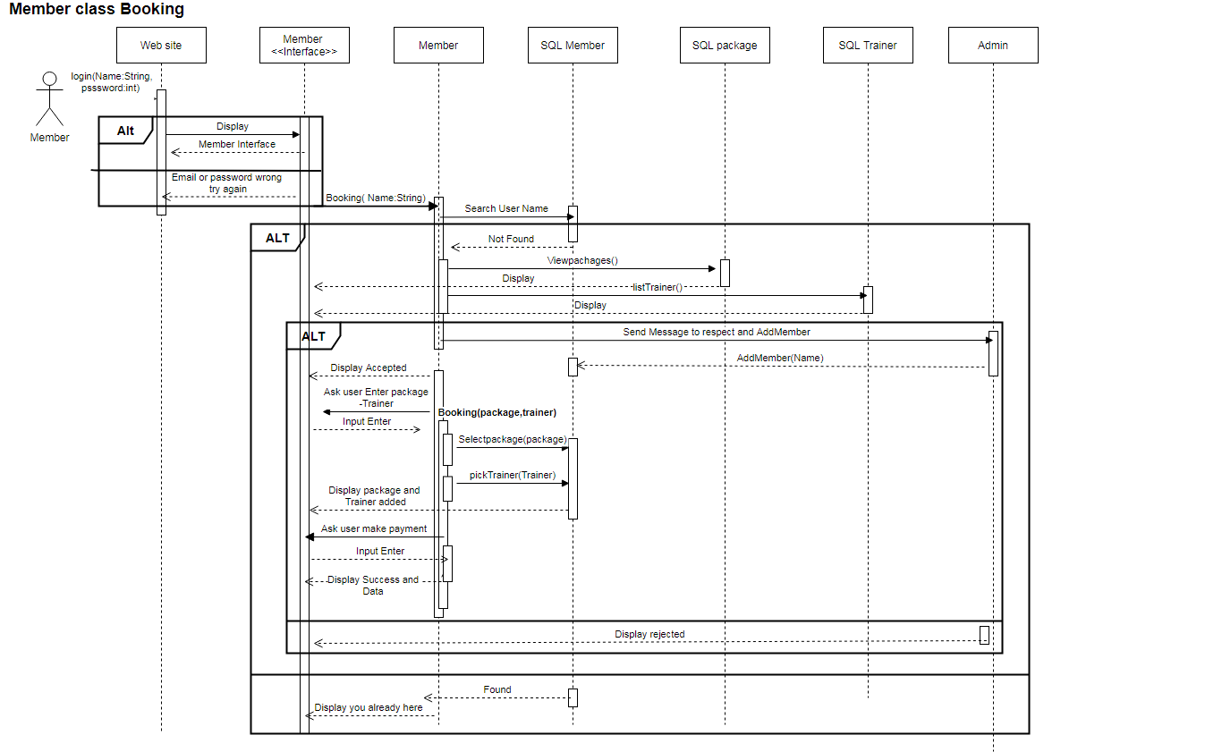

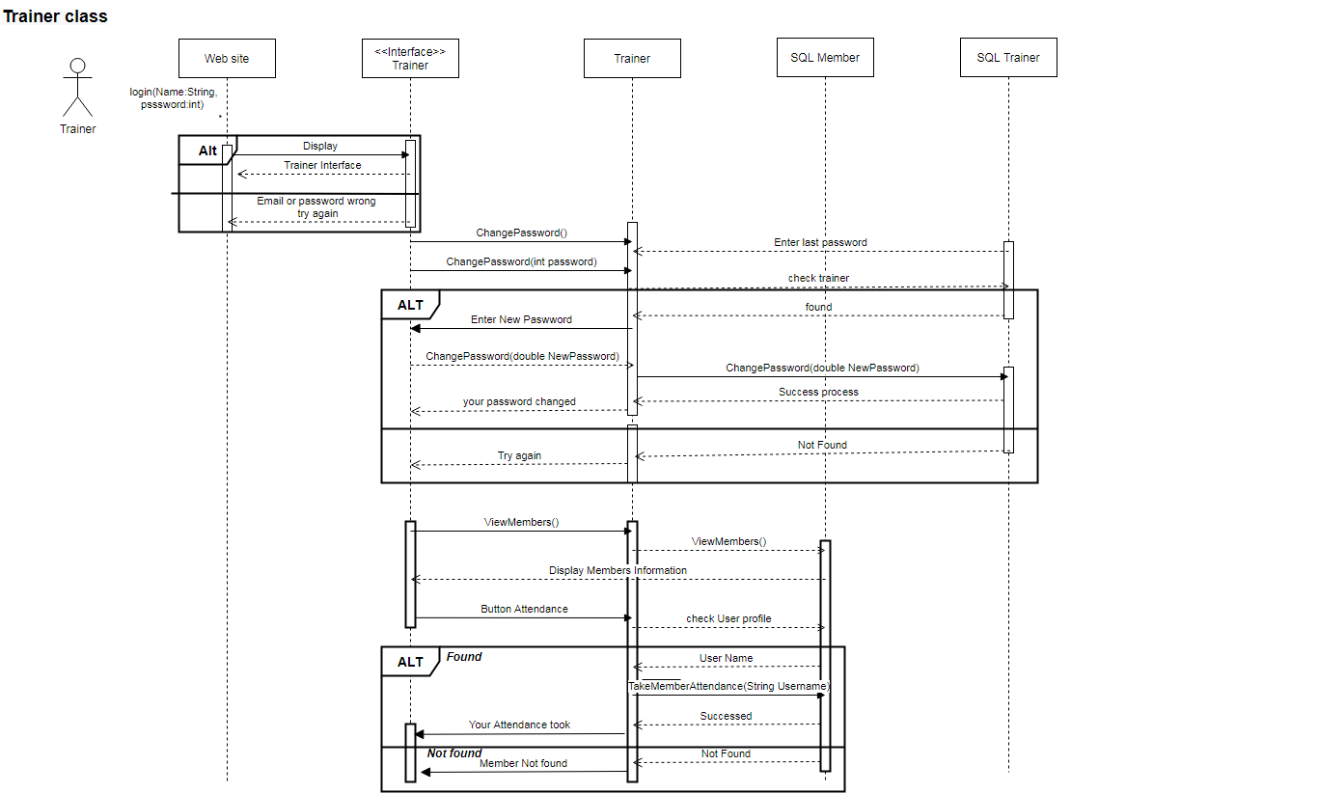

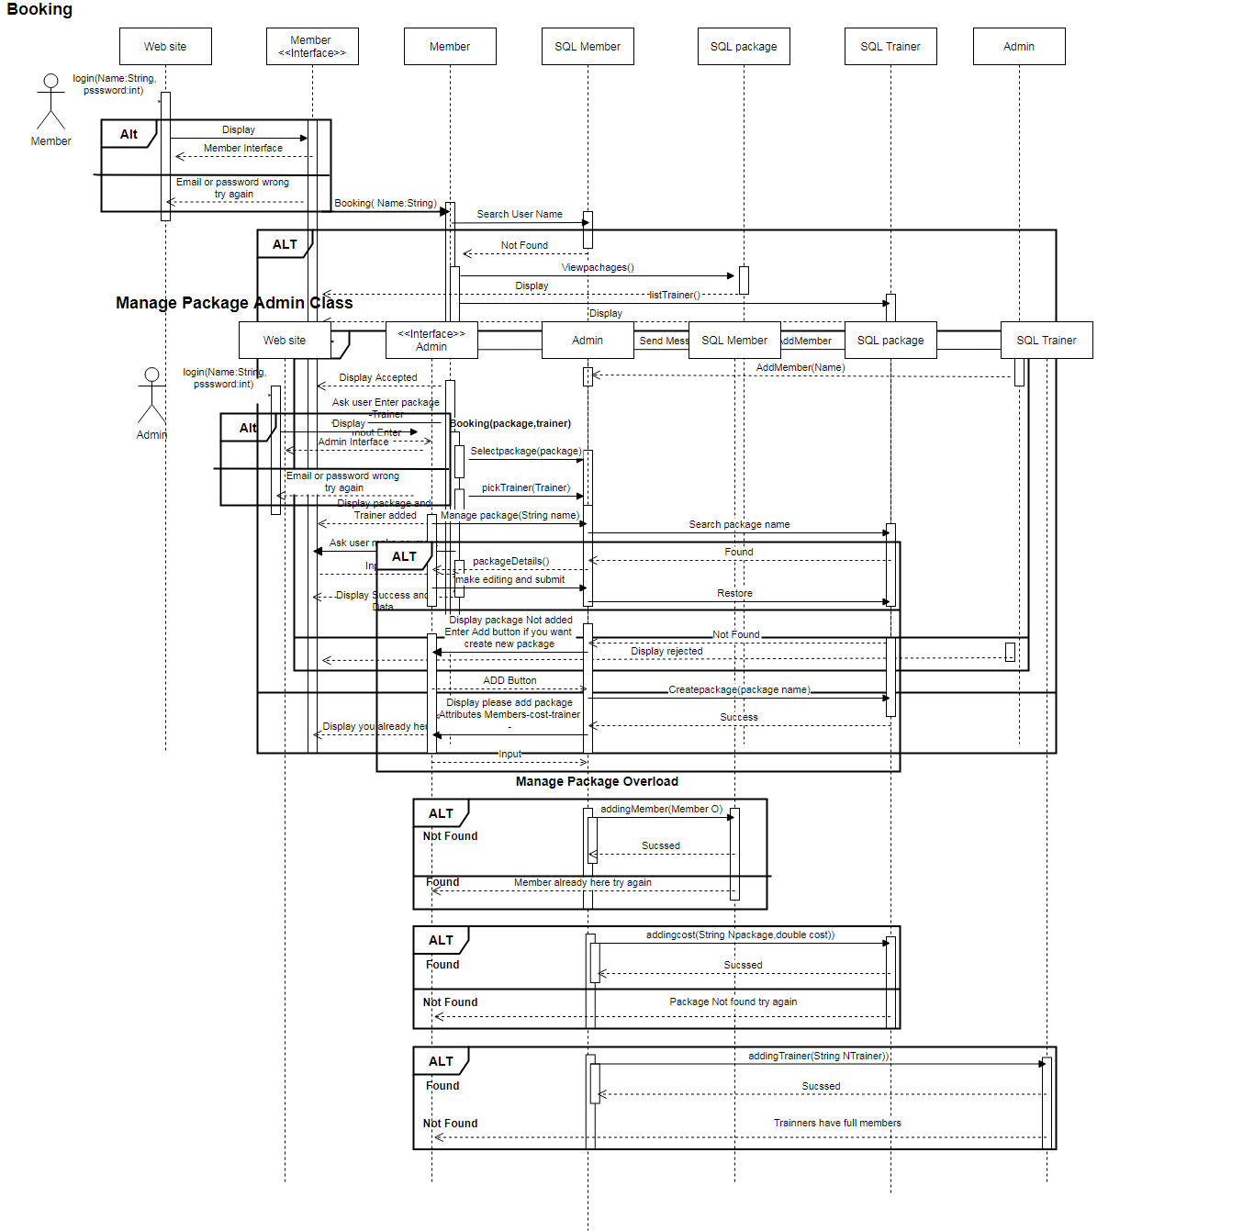

**Class - Sequence Usage Table**

|  |  |  |
| --- | --- | --- |
| **Class Name** | **Sequence Diagrams** | **Overall used methods** |
| **Admin.** | 1- Continuous checking for absent members and trainer’s rating so that deciding who gonna take bounce or fired  2- Adding new discounts and low-income pakges ending with attracting new members demanding bigger databases  3- Deleting lazy members in case of skipping continuous 5 absent days | AddPackage  delete, upgradePackage  addMember, deleteMember,  updateMember, ViewAttendance  addPaymentMethod |
| **Trainers** | 1- Customizing his portfolio career  2-Taking members attendance  3- Adding new private plans for low-income users | takeAttendance  customizePortfolio  Login, changePassword |
| **Members** | 1-member try to book a package with a topRated trainer  getting trainers sorted from the database with discounts  2-admin verify the member or reject with a failed message  3-if verified the member can specify his Payment method  4-cybersecurity engineers job is to prevent hacking in this process giving memberes a smooth paying process | Login, changePassword  viewTrainers , viewToprated  viewPackages, viewDiscounts  paybill,viewSubscription |

### Physical Entity-Relationship Diagram

* + **Provide the ERD Diagram**
  + **All entity classes on the class diagram that need to be stored permanently, convert them and their relationships into ERD diagram.**
  + **Don’t list any boundary or control entities!**
  + **Use a suitable notation for representing ER diagram, e.g., the one proposed on the book or an alternative version. Build qit using a tool.**
  + **Following is an example of ER diagram, using different notation.**

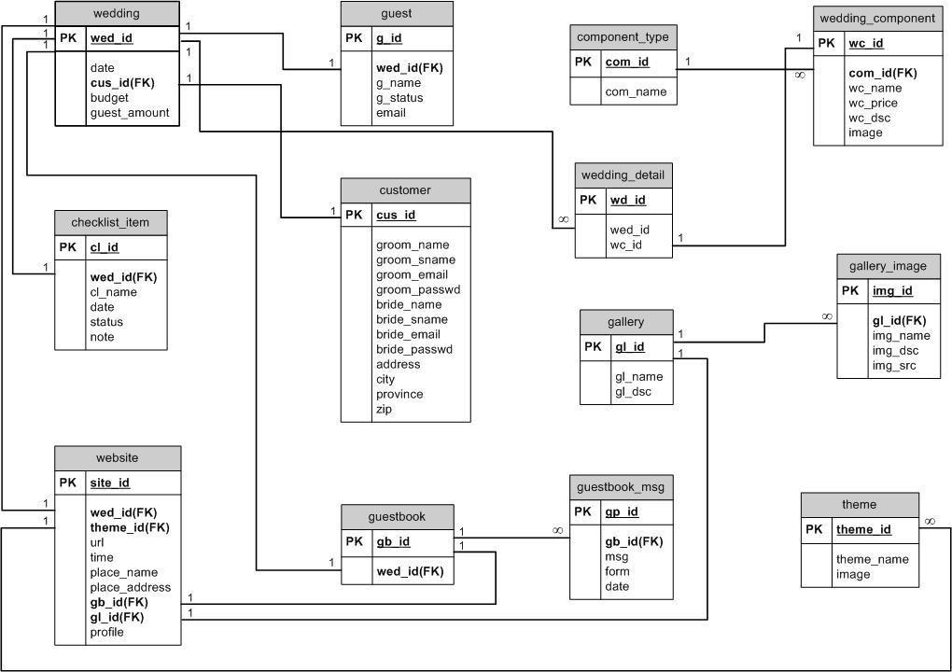

### 

### User Interface Design

**////To be Done in Phase 2**

### Data Flow diagram (DFD)

* + **////To be Done in Phase 2**

### Algorithms and Data Structures

* + **////To be Done in Phase 2**

## Ownership Report

|  |  |
| --- | --- |
| **Item** | **Owners** |
| UML Diagram | Zeyad |
| Sequence Diagram | Zeyad |
| Drawing Tools | Zeyad |
| UML Description | Amr |
| Sequence Description | Amr |
| Spell Checker | Amr |
| GitHub Configuration | Amr |
| Flow Chart | Amr,Zeyad |
|  |  |

TODO:

**-description uml diagram ⇒ Done.**

**-description sequence diagram ⇒ Done.**

**-ER diagram ⇒ Tomorrow.**

**-UI design ⇒ Phase2**

**DFD ⇒ Phase 2**

**Algorithm ⇒ Tomorrow.**

