**Name :Amr Salah Salem Adb elfattah**

**B.N : 577**

**Date : 2/6/2020**

**Course name : Computer**

**Course code : ECE001**

**Topic : Programming languages**

**Github link :** <https://github.com/amrsalah227/html.programming-languages->

**Github page (published website ) :** <https://amrsalah227.github.io/html.programming-languages-/>.

**Brief**

**A programming language is a vocabulary and set of grammatical rules for instruction a computer or computing device to perform specific tasks .**

**Programming language is important because it defines the relationship , semantics and grammar which allows the programmers to effectively communicate with the machines that they program . A programming language serves several purposes , you can instruct the computer what to do in human-readable form .**

**Thousands of different programming languages have been created , and more being created every year . Many programming languages are written in an imperative from (i.e. , as sequence of operations to perform ) while other language use the declarative from (i.e. the desired result is specific , not how to achieve it ) . The description of a programming language is usually split into the two components of syntax and semantics . Some languages are defined by a specification document .while other languages have a dominant implementation that is treated as a reference . Some languages have both , with the basic language defined by a standard and extensions taken from the dominant implementation being common .**

**Screenshots**

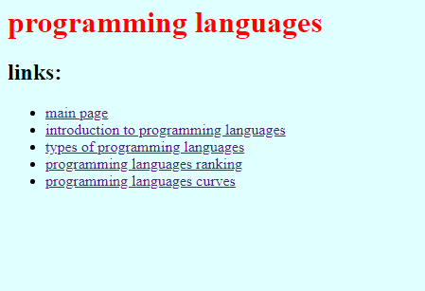

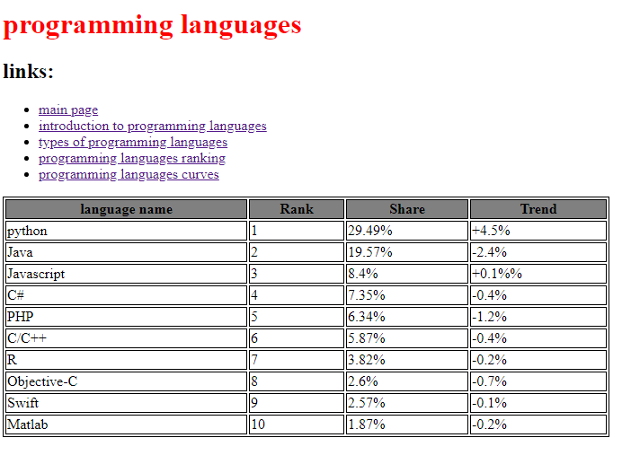

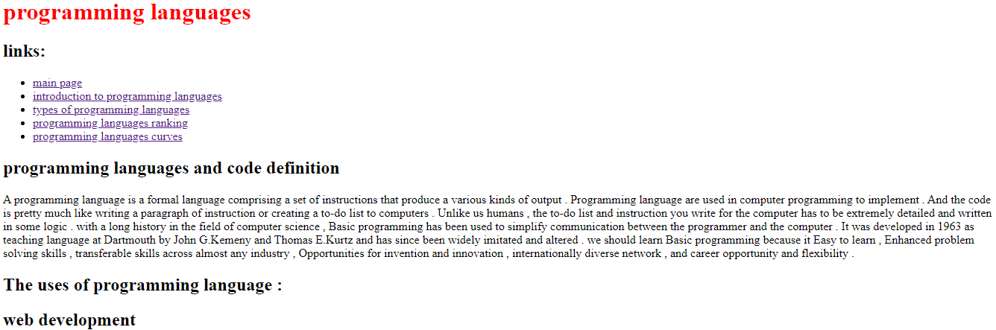

**Source code**

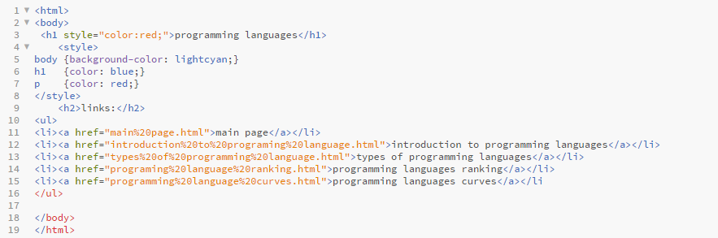

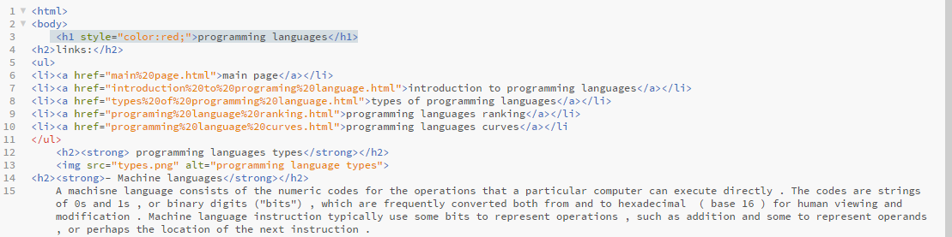

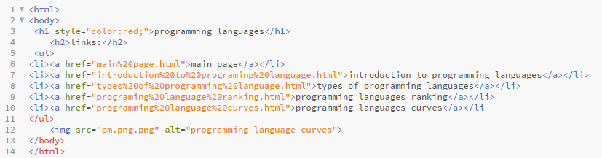

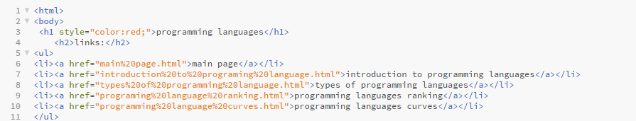

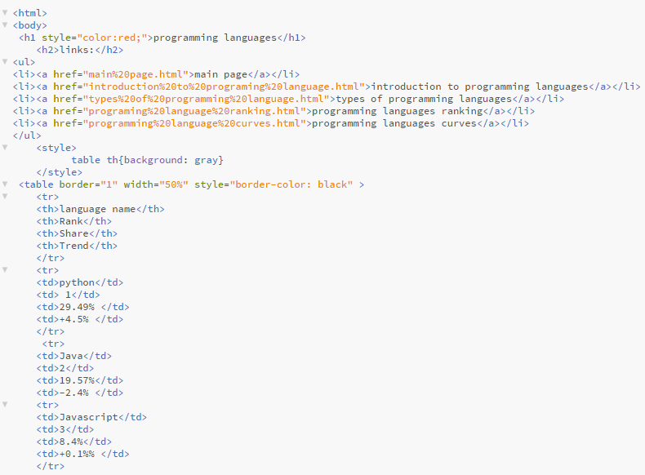

**References**

[**http://www.cs.bsu.edu/homepages/dmz/cs697/langtbl.htm**](http://www.cs.bsu.edu/homepages/dmz/cs697/langtbl.htm)

[**https://www.cis.upenn.edu/~bcpierce/tapl/**](https://www.cis.upenn.edu/~bcpierce/tapl/)

[**https://www.uopeople.edu/blog/6-reasons-why-you-should-learn-basic-programming/**](https://www.uopeople.edu/blog/6-reasons-why-you-should-learn-basic-programming/)

[**https://www.britannica.com/technology/computer-programming-language**](https://www.britannica.com/technology/computer-programming-language)

[**https://www.computerscience.org/resources/computer-programming-languages/**](https://www.computerscience.org/resources/computer-programming-languages/)