TCP Chat Application Report
AN NAJAH NATIONAL UNIVERSITY
Faculty of Engineering and Information Technology
Network and Information Security Department
Prepared by: Amr Sharif
Course: Transport Techniques Networks
Supervisor: Dr. Jehad Hamamreh

Abstract
This report presents a TCP-based chat application with GUI using Python, demonstrating real-time communication using sockets and multithreading.

Introduction
The project implements a chat system using TCP ensuring reliable communication between multiple clients.

Implementation Overview
The server uses socket and threading to manage multiple clients. The client uses Tkinter GUI for interaction and message exchange.

Testing and Results
The following figures show the system during execution:
Figure 1: Server code implementation
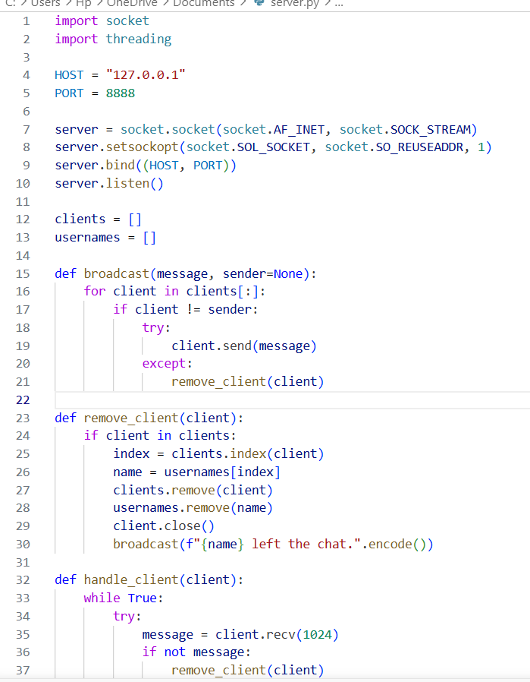
Figure 2: Server running in terminal
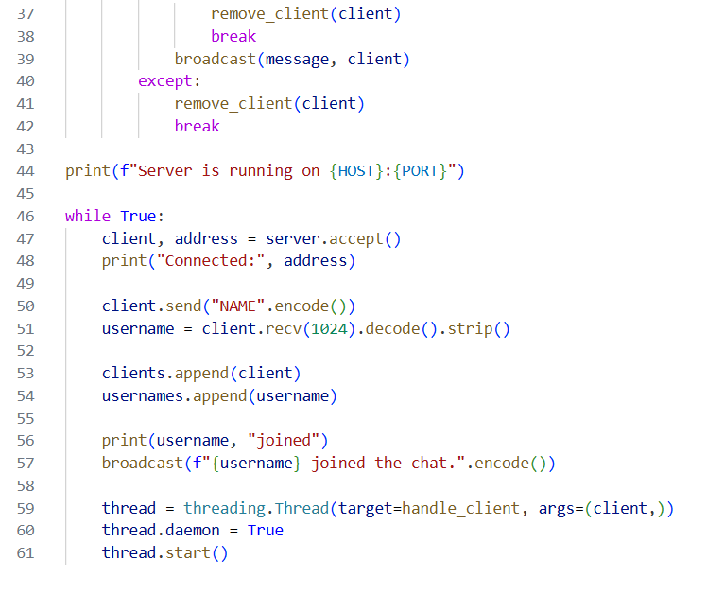
Figure 3: Client GUI initialization
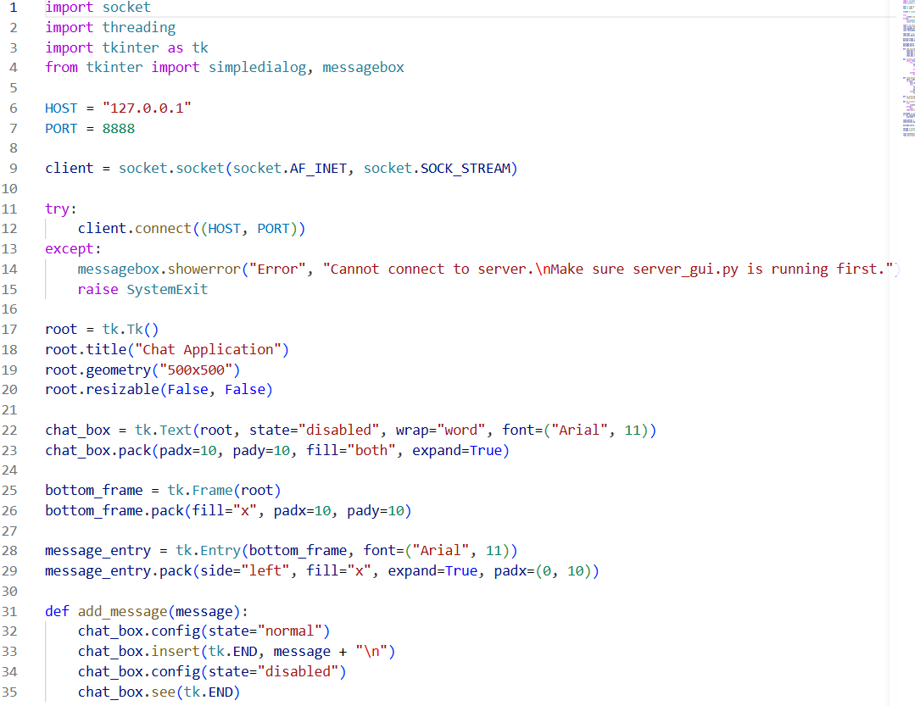
Figure 4: Client entering username
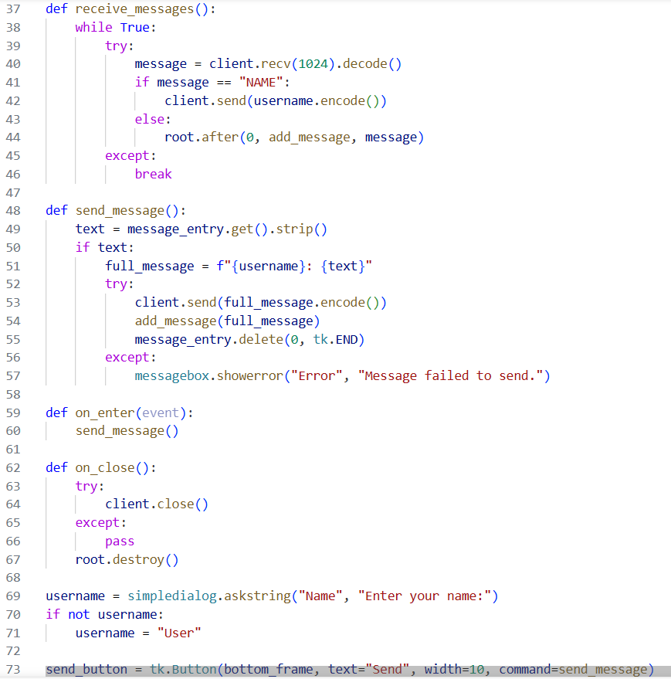
Figure 5: Two clients joined chat
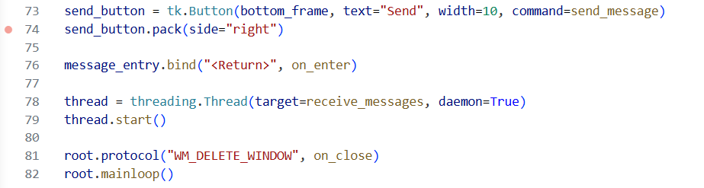
Figure 6: Message sending test
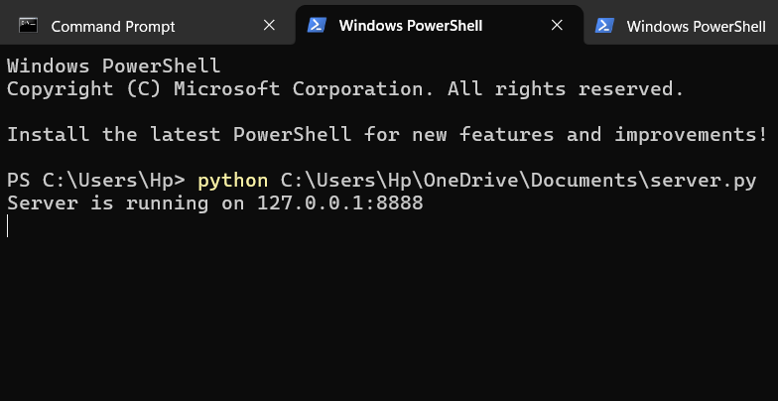
Figure 7: Chat communication working
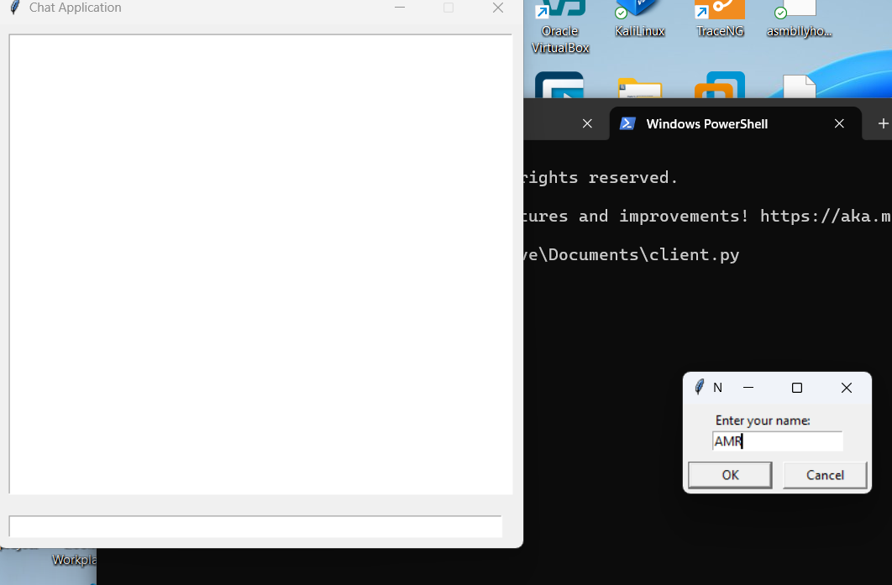
Figure 8: Multiple messages exchange
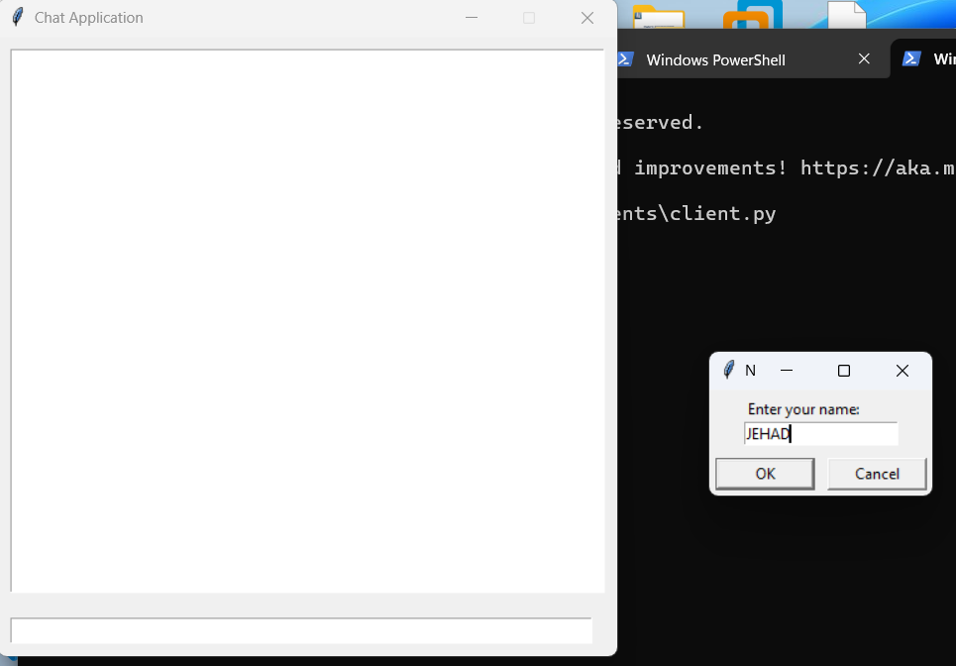

Conclusion
The system successfully demonstrates TCP communication, GUI-based interaction, and multi-client support using threads.

