**Case Study: Shopping Cart System**

**Stakeholders:**

1] Admin

2] Any user

**Modules**:

1] Cart module: We can manage all the operations related to Cart from this module

.2] Orders module: This module is normally developed for managing the Orders operations Products module. All the operations related to Products will be managed by Products.

3] Category module: This module manages Category functionalities

.4] Customer module: Customer modules performs all the create, read, update and delete operations of Customer

5]. Payment module: It manages all the functionalities of Payment

**Collections in Database:**

Database Name: **ShoppingCart**

• User-

▪ user id

▪ user name

▪ user password

▪ user email

▪ user address

• Admin-

▪ id

▪ name

▪ password

• Product Category-

▪ category id

▪ category name

▪ category type

• Product -

▪ product id

▪ product name

▪ product price

▪ product description

▪ product status

• Order-

▪ order id

▪ order amount

▪ order status

**Flow Charts:**

**User Flow:**

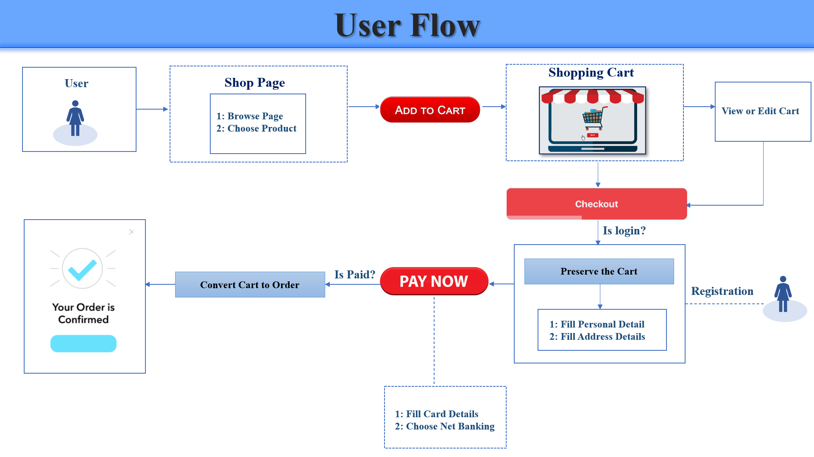

**Admin Flow:**

