When preparing for an interview focused on design patterns, you can expect questions that assess your understanding of various design patterns, their applications, and your ability to implement them in real-world scenarios. Here are some typical questions that might be asked:
- General Understanding:
  - What are design patterns and why are they important?
  - Can you explain the difference between creational, structural, and behavioral design patterns?
- Specific Patterns:
  - Describe the Singleton pattern. When would you use it?
  - What is the Factory Method pattern? Can you provide an example of where it might be useful?
  - Explain the Observer pattern. How does it differ from the Publish-Subscribe pattern?
  - What is the Decorator pattern and how does it improve code flexibility?
  - Can you explain the Strategy pattern with an example?
  - Describe the Adapter pattern. How does it help in integrating different interfaces?
  - What is the purpose of the Command pattern? Provide a use case.
  - How does the Builder pattern help in constructing complex objects?
  - Explain the Prototype pattern and its advantages.
- Comparison and Use Cases:
  - How would you choose between the Abstract Factory and Factory Method patterns?
  - Compare and contrast the Proxy pattern and the Decorator pattern.
  - When would you use the Composite pattern over the Flyweight pattern?
  - How does the Chain of Responsibility pattern help in designing flexible systems?
- Implementation:
  - Provide a code example of the Singleton pattern in your preferred programming language.
  - How would you implement the Observer pattern in a real-time application?
  - Can you walk through an implementation of the State pattern?
- Design Principles:
  - How do SOLID principles relate to design patterns?
  - Explain how the Open/Closed Principle can be achieved using design patterns.
- Scenario-Based Questions:
  - Given a scenario where you need to manage a collection of related objects, which design pattern would you use and why?
  - How would you refactor a monolithic application using design patterns to improve maintainability?
- Advanced Topics:
  - Discuss the trade-offs between using design patterns and other software design techniques.
  - How can design patterns be misused? Provide examples.
- Experience-Based:
  - Can you share an experience where you effectively used a design pattern to solve a problem?
  - Describe a situation where using a design pattern did not work as expected. What did you learn from it?
Preparing for these questions involves not only understanding the theory behind each design pattern but also being able to discuss real-world applications and implementations. Reviewing common patterns, practicing coding examples, and reflecting on past projects where you’ve applied these patterns can be very beneficial.

Design patterns are general, reusable solutions to common problems encountered in software design. They represent best practices used by experienced developers to solve recurring issues in software development. Design patterns help make code more flexible, reusable, and easier to manage and understand. They provide a shared vocabulary for developers to communicate solutions more effectively.
Importance of Design Patterns:
- Reusability: They promote code reuse by offering tested, proven development paradigms.
- Maintainability: They improve the readability and maintainability of the code by providing clear solutions to common problems.
- Efficiency: They speed up the development process by preventing developers from having to reinvent the wheel for common problems.
- Communication: They provide a standard terminology and are a great tool for discussing potential solutions with other developers.

Types of Design Patterns:
Design patterns are categorized into three main types: Creational, Structural, and Behavioral. Each category addresses a different aspect of software design.

1. Creational Design Patterns:
These patterns deal with object creation mechanisms, trying to create objects in a manner suitable to the situation. They help make a system independent of how its objects are created, composed, and represented.
- Examples:
  - Singleton: Ensures a class has only one instance and provides a global point of access to it.
  - Factory Method: Defines an interface for creating an object but lets subclasses alter the type of objects that will be created.
  - Abstract Factory: Provides an interface for creating families of related or dependent objects without specifying their concrete classes.
  - Builder: Separates the construction of a complex object from its representation, allowing the same construction process to create different representations.
  - Prototype: Creates new objects by copying an existing object, known as the prototype.

2. Structural Design Patterns:
These patterns deal with object composition or the relationships between objects. They help ensure that if one part of a system changes, the entire system doesn't need to change as a result.
- Examples:
  - Adapter: Allows incompatible interfaces to work together.
  - Bridge: Separates an object’s abstraction from its implementation so the two can vary independently.
  - Composite: Composes objects into tree structures to represent part-whole hierarchies, allowing clients to treat individual objects and compositions uniformly.
  - Decorator: Adds additional responsibilities to an object dynamically.
  - Facade: Provides a simplified interface to a complex subsystem.
  - Flyweight: Reduces the cost of creating and manipulating a large number of similar objects.
  - Proxy: Provides a surrogate or placeholder for another object to control access to it.
3. Behavioral Design Patterns:
These patterns are concerned with algorithms and the assignment of responsibilities between objects. They help in defining how objects interact and communicate with each other.
- Examples:
  - Chain of Responsibility: Passes a request along a chain of handlers, allowing multiple objects the chance to handle the request.
  - Command: Encapsulates a request as an object, thereby allowing for parameterizing clients with queues, requests, and operations.
  - Interpreter: Defines a way to evaluate language grammar or expressions.
  - Iterator: Provides a way to access elements of a collection sequentially without exposing its underlying representation.
  - Mediator: Defines an object that encapsulates how a set of objects interact.
  - Memento: Captures and externalizes an object’s internal state so that it can be restored later, without violating encapsulation.
  - Observer: Defines a one-to-many dependency between objects so that when one object changes state, all its dependents are notified and updated automatically.
  - State: Allows an object to alter its behavior when its internal state changes, appearing to change its class.
  - Strategy: Defines a family of algorithms, encapsulates each one, and makes them interchangeable.
  - Template Method: Defines the skeleton of an algorithm in an operation, deferring some steps to subclasses.
  - Visitor: Represents an operation to be performed on elements of an object structure, allowing you to define a new operation without changing the classes of the elements on which it operates.
Understanding and utilizing these patterns can significantly improve the design and architecture of your software projects, making them more robust, maintainable, and scalable.

Singleton Pattern
The Singleton pattern is a creational design pattern that ensures a class has only one instance and provides a global point of access to that instance.

This is useful when exactly one object is needed to coordinate actions across the system, such as managing a resource like a database connection or a configuration manager.
When to Use the Singleton Pattern
- Resource Management: When you need to control access to a shared resource, such as a file or a database.
- Configuration Settings: When you have global configuration settings that need to be accessed by multiple parts of the program.
- Logging: When you want a single point of control for logging information.
- Caching: When you need a global cache that can be accessed from anywhere in the application.

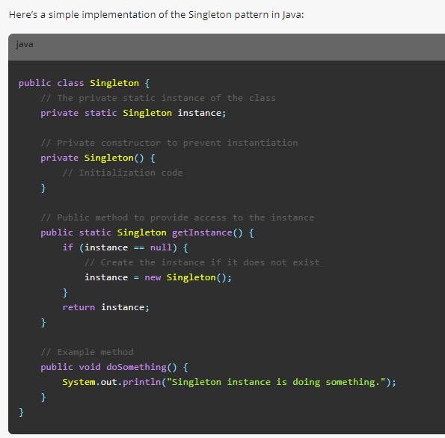

Thread-Safe Singleton Implementation
The above implementation is not thread-safe. In a multithreaded environment, multiple threads could potentially create multiple instances of the Singleton class. Here’s how you can make it thread-safe:
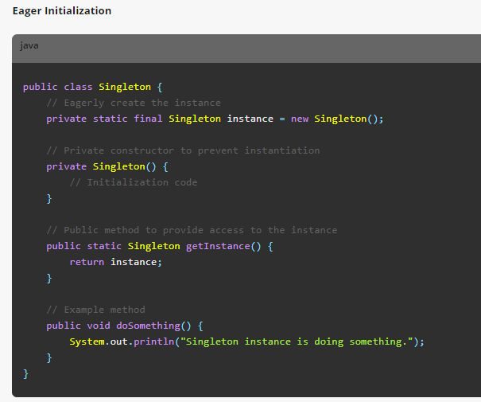

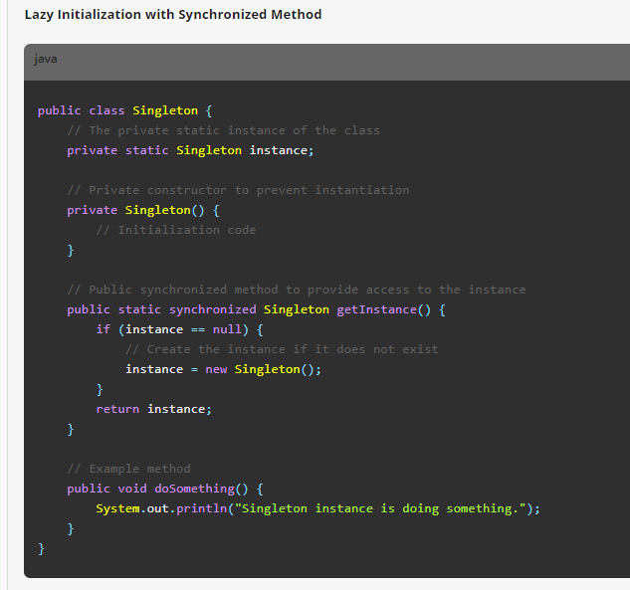
Factory Method Pattern
The Factory Method pattern is a creational design pattern that defines an interface for creating an object, but allows subclasses to alter the type of objects that will be created. This pattern delegates the responsibility of object instantiation to subclasses, promoting code reuse and flexibility by decoupling the client code from the specific classes it needs to instantiate.
When to Use the Factory Method Pattern
- When a class cannot anticipate the type of objects it needs to create: The Factory Method allows subclasses to specify the object types they need.
- To promote code reuse and flexibility: By using a common interface for object creation, the Factory Method enables code to operate on a variety of objects.
- To control the creation process: You can provide subclasses with the ability to alter the creation logic.
- When working with a class hierarchy: Often used when you have a class that defines a method for creating objects, but the subclasses implement the method to create objects of the appropriate type.

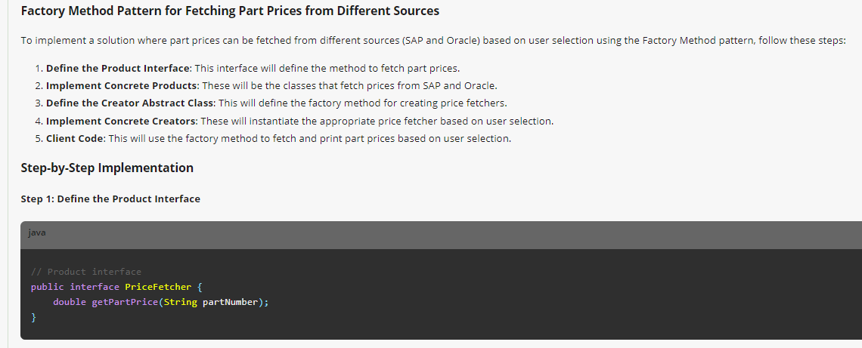
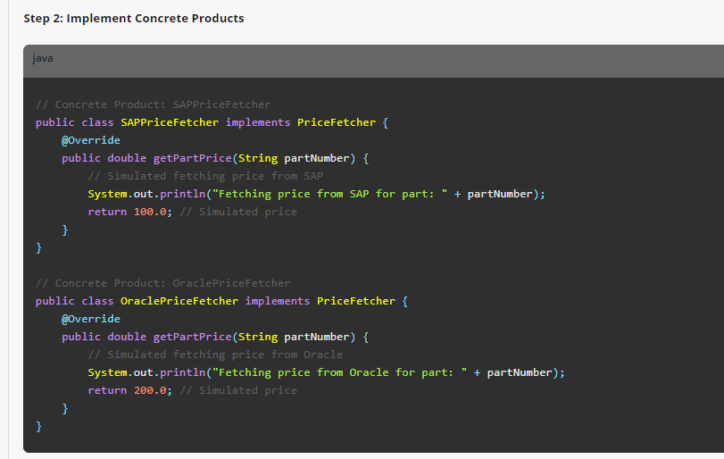
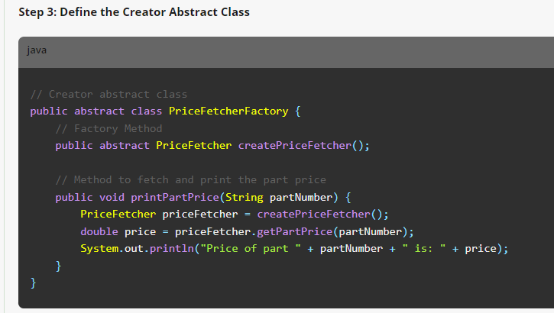
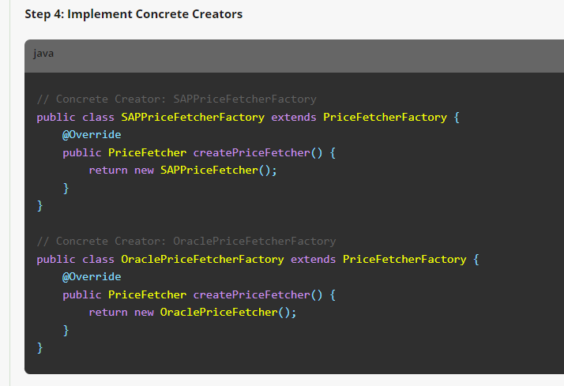
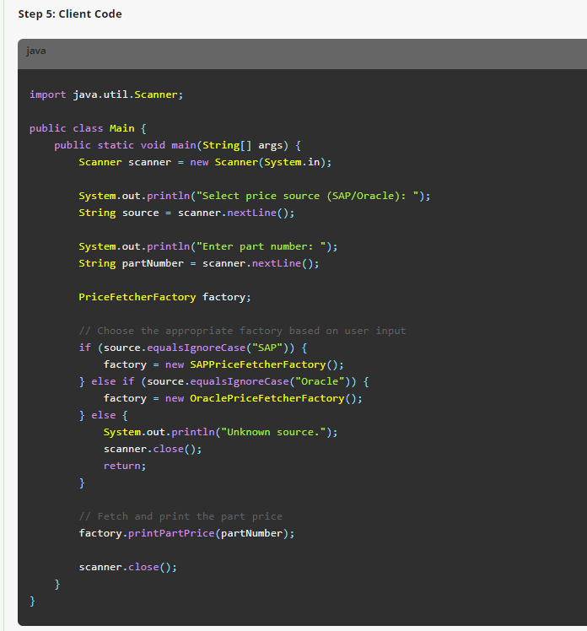

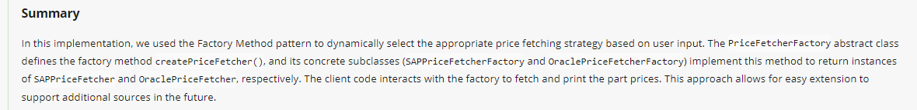

Prototype Pattern
The Prototype pattern is a creational design pattern that enables the creation of new objects by copying an existing object, known as the prototype. Instead of creating new instances from scratch, you clone the prototype object, which can be more efficient in terms of performance and resource usage. This pattern is particularly useful when the cost of creating a new object is high.
Key Concepts
- Prototype Interface: This defines a method for cloning itself, typically called clone.
- Concrete Prototype: These classes implement the prototype interface, and the clone method returns a copy of the object.
- Client: The client interacts with the prototype and uses the clone method to create new objects.
Advantages of the Prototype Pattern
- Performance: Cloning an existing object can be more efficient than creating a new instance from scratch, especially if the object creation process is resource-intensive.
- Simplifies Object Creation: It abstracts the complex object creation logic, making it easier to create objects with varying configurations.
- Reduces Subclassing: By using prototypes, you can avoid creating a hierarchy of builder classes or factories for different configurations of objects.
- Dynamic Object Creation: Prototypes allow for dynamic creation of objects at runtime, which can be particularly useful in scenarios where the types of objects are not known until runtime.
- Simplifies Code: It can simplify code by reducing the complexity involved in creating new objects and managing their configurations.
Example Scenario
Consider a scenario where you are developing a system that manages shapes (e.g., Circle, Rectangle). Creating shapes with various configurations (e.g., size, color) can be complex. Using the Prototype pattern, you can clone existing shapes to create new ones with similar configurations.

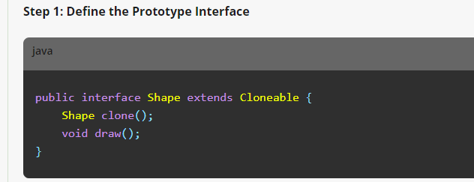
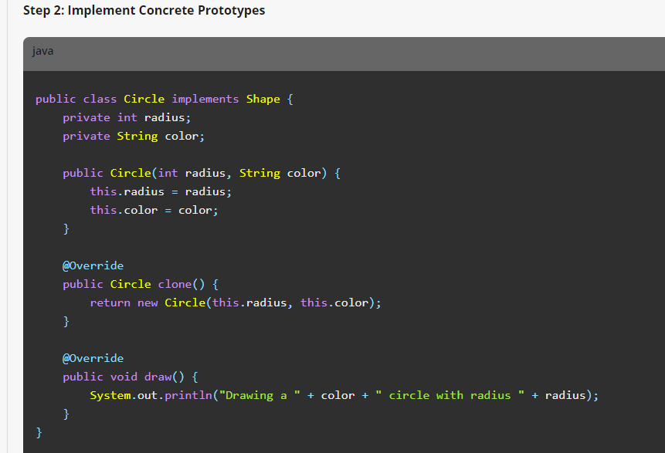
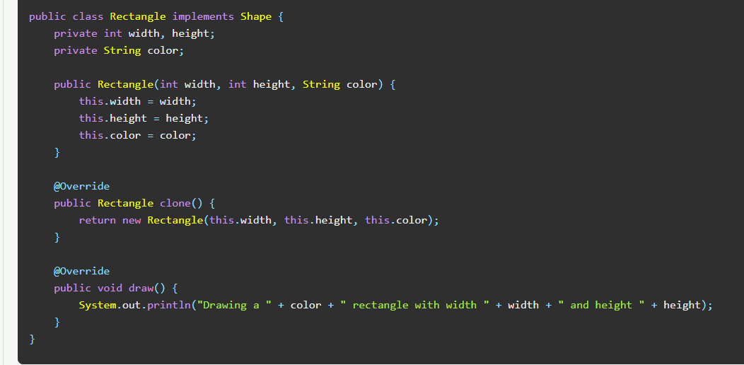
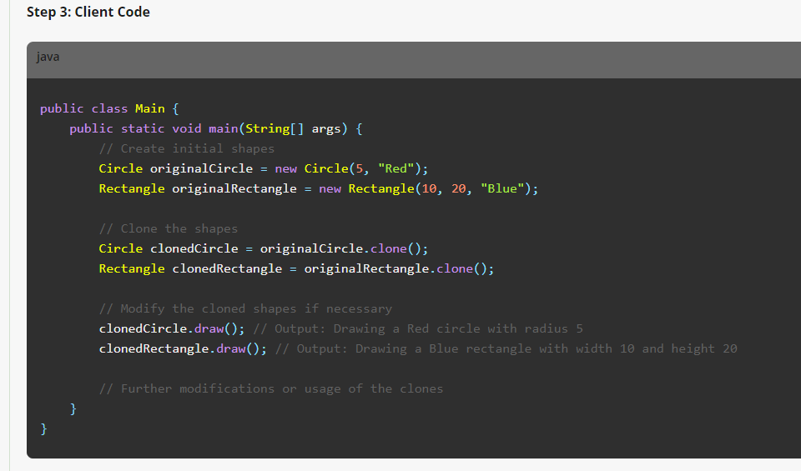

Summary
The Prototype pattern can perform either shallow or deep cloning depending on the implementation of the clone method.
The Prototype pattern is a powerful tool for creating new objects by copying existing ones, which can lead to performance improvements and simplified object creation logic. It is particularly useful in scenarios where the cost of creating new objects is high or when the types of objects are not known until runtime. By cloning prototypes, you can avoid complex hierarchies of builder classes or factories, making your codebase more maintainable and flexible.

**Can you share an experience where you effectively used a design pattern to solve a problem?

Requirement: Users want to compare prices from all three sources (SAP, Oracle, Mainframe IMS) for consistency.

Question: Can you share an experience where you effectively used a design pattern to solve a problem?
Answer:
In a recent project, we encountered a challenging problem related to fetching parts prices from multiple sources, namely SAP, Oracle, and Mainframe IMS. Each source had a different way of accessing data, and integrating these disparate systems into our application required a flexible and maintainable solution.
To address this, I decided to use the Strategy design pattern. This pattern was particularly suitable because it allows us to define a family of algorithms (in this case, price-fetching strategies) and make them interchangeable. Here’s how we implemented it:
- Defined the Strategy Interface: We started by creating a PriceStrategy interface that declared the method getPrice(String partId). This method would be implemented by concrete strategies for each data source.
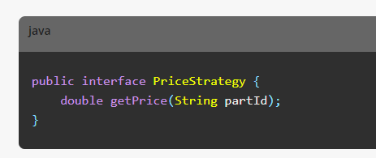
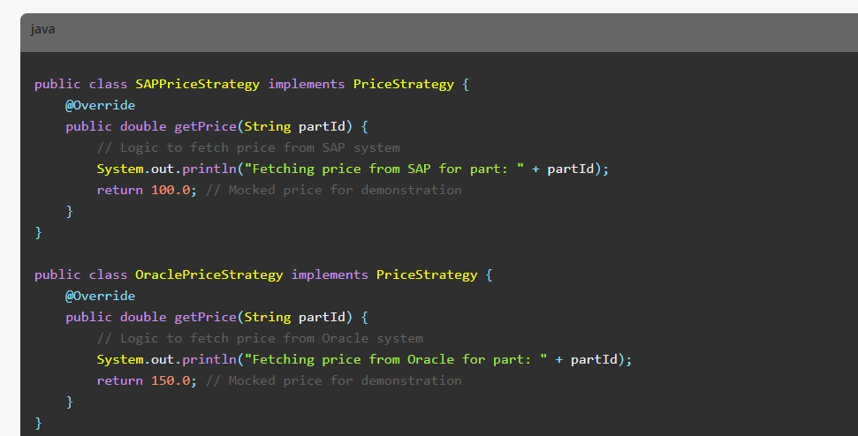
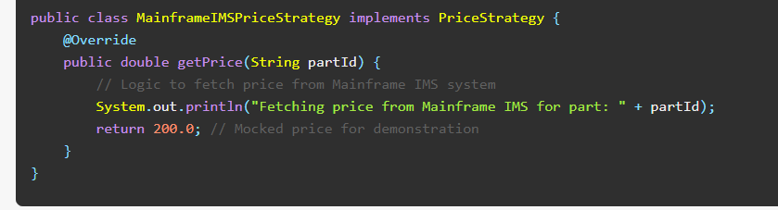

Created the Context Class: We then created a PriceContext class that used a PriceStrategy to fetch the price. The strategy could be set at runtime, allowing for dynamic selection of the data source.

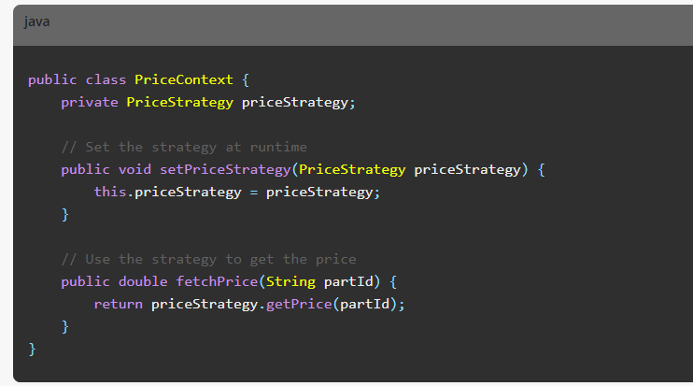

Demonstrated Usage: Finally, we demonstrated how to use the PriceContext class to fetch prices from different sources by setting the appropriate strategy.

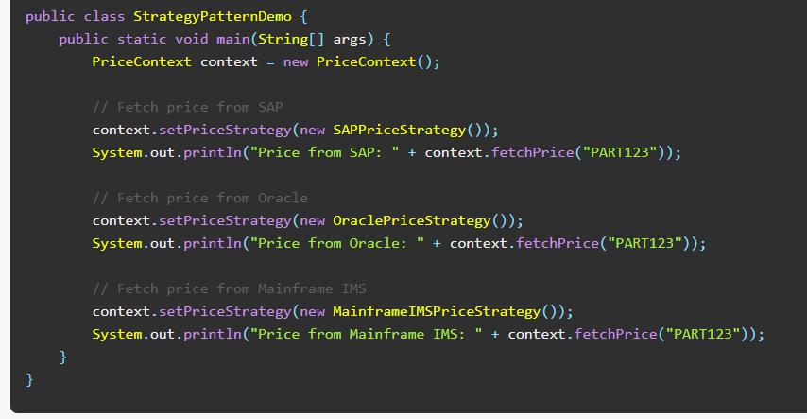

Outcome:
Using the Strategy pattern provided several benefits:
- Flexibility: We could easily switch between different price-fetching strategies without changing the client code.
- Scalability: Adding new data sources in the future would be straightforward; we would simply implement a new strategy and set it in the context.
- Maintainability: Each data-fetching logic was encapsulated in its own class, making the codebase cleaner and easier to manage.
This solution significantly improved our system's ability to integrate with multiple data sources in a flexible and maintainable way, demonstrating the effectiveness of the Strategy design pattern.
