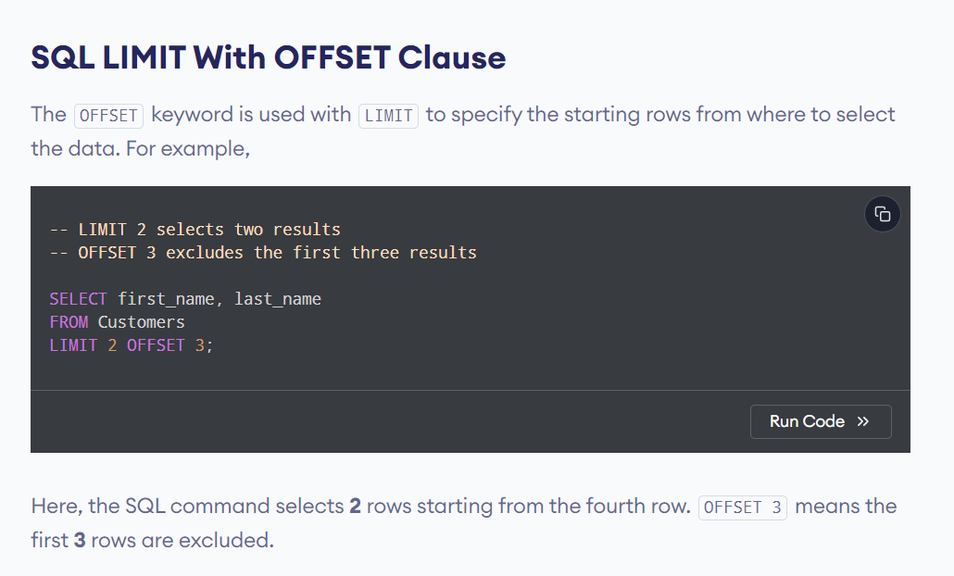

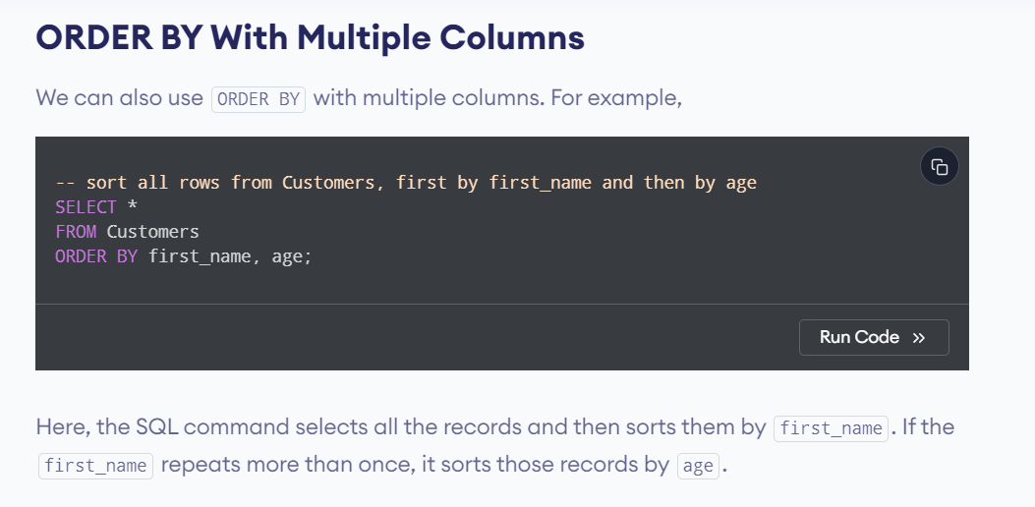

- Counting All Rows vs. Non-NULL Entries:
  - Use COUNT(*) when you need to count all rows in a table, regardless of NULL values.
  - Use COUNT(column_name) when you need to count only the non-NULL entries in a particular column.
- Performance Considerations:
  - In most database systems, COUNT(*) is optimized to be very fast because the database engine can use internal statistics to quickly determine the row count.
  - COUNT(column_name) may be slightly slower if the column contains NULL values because the database has to scan the column to check for NULL entries.

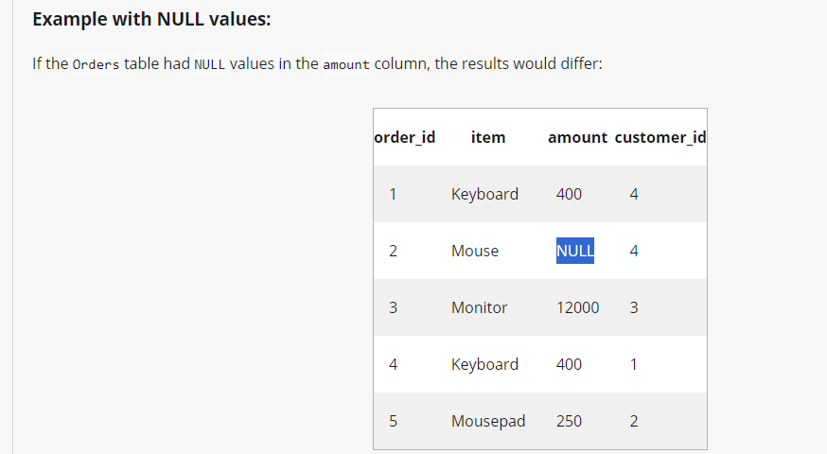
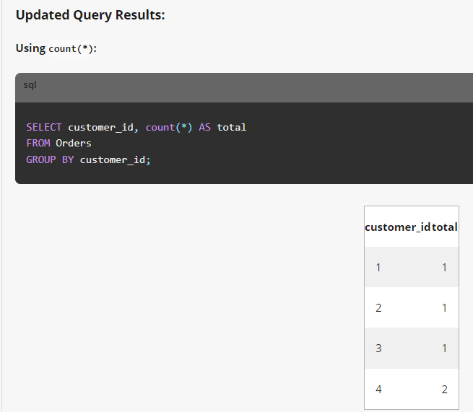
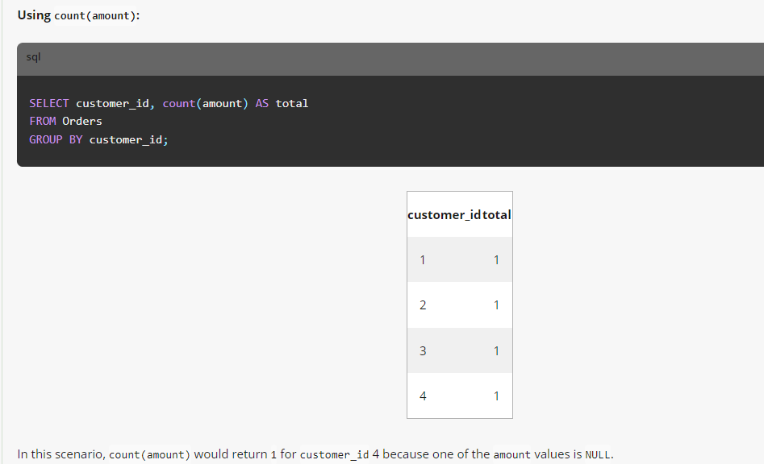

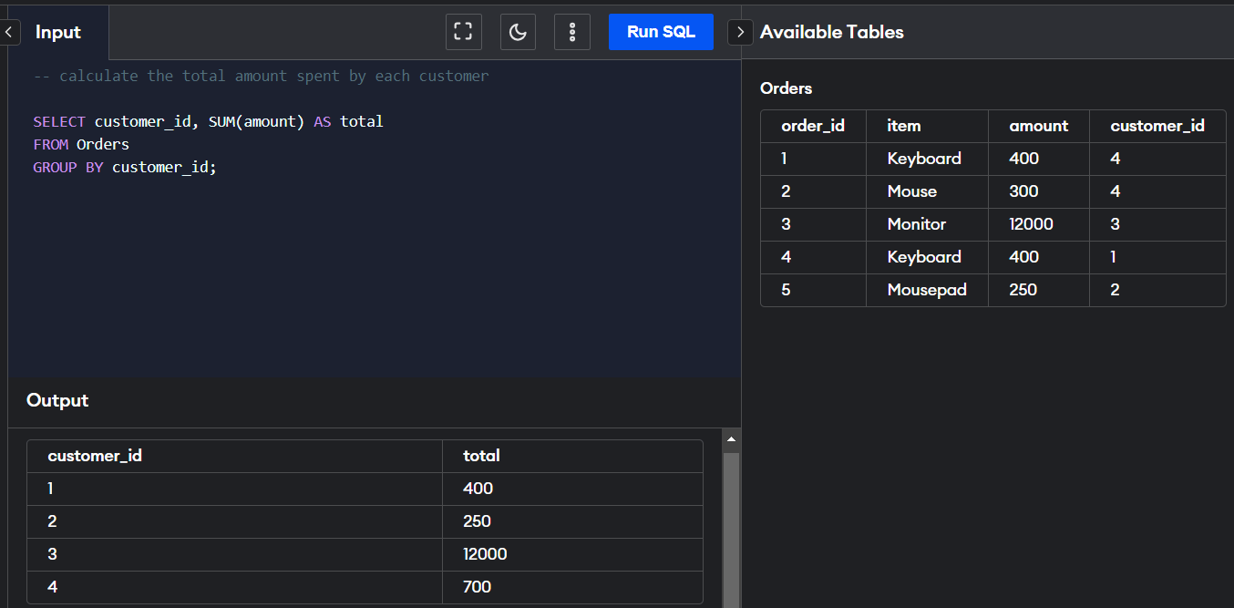

Give number of orders that are placed by each customer.
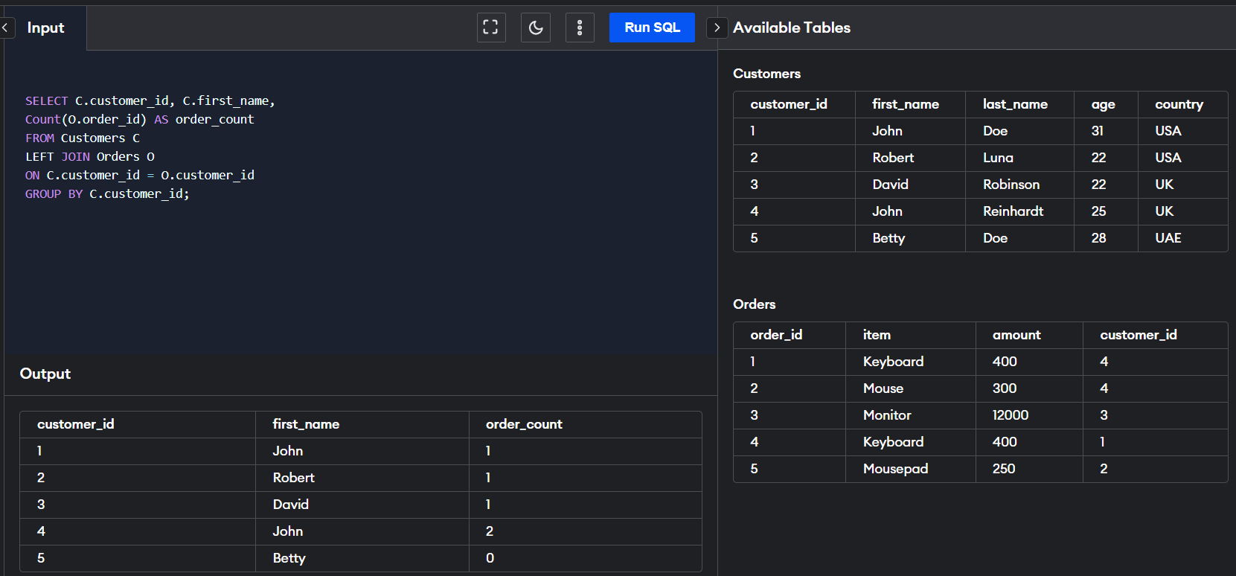
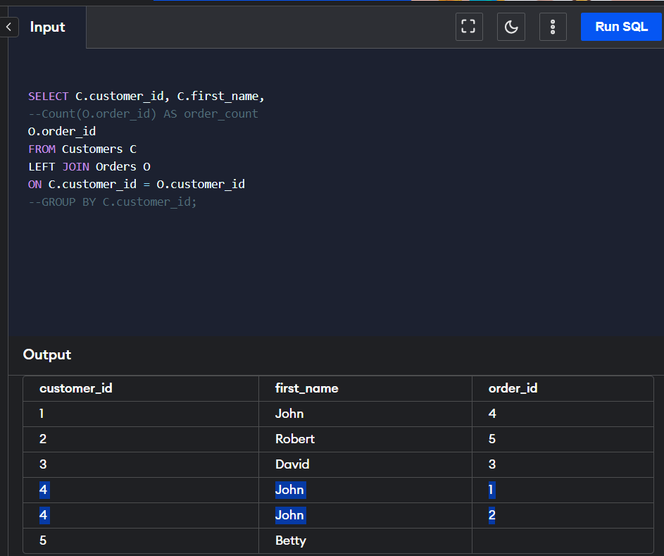
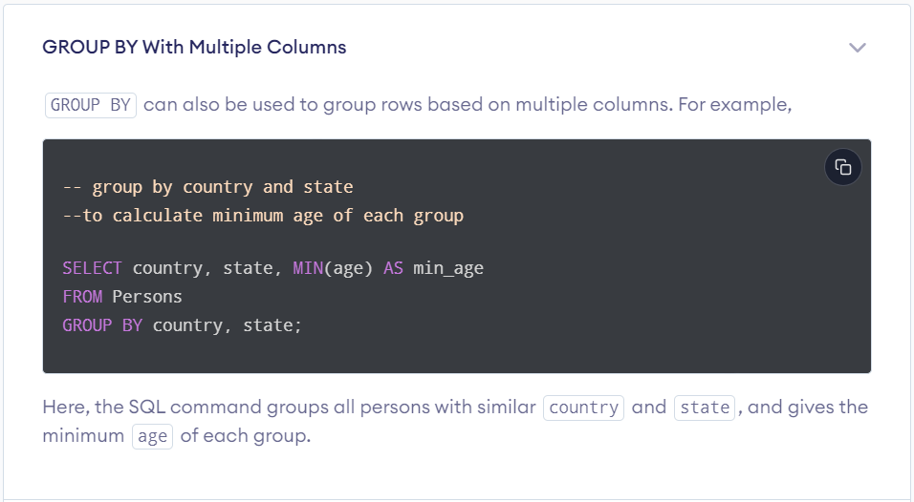
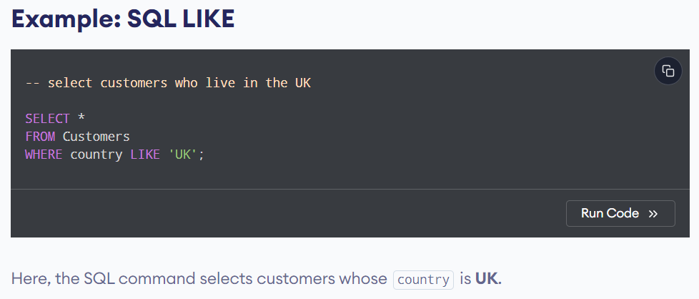
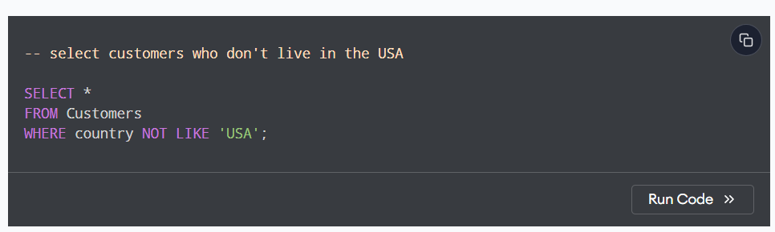
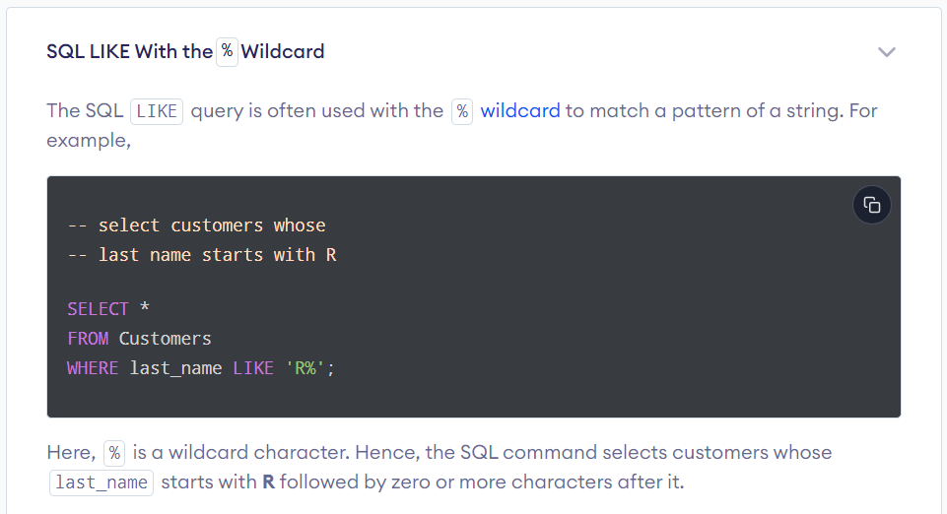
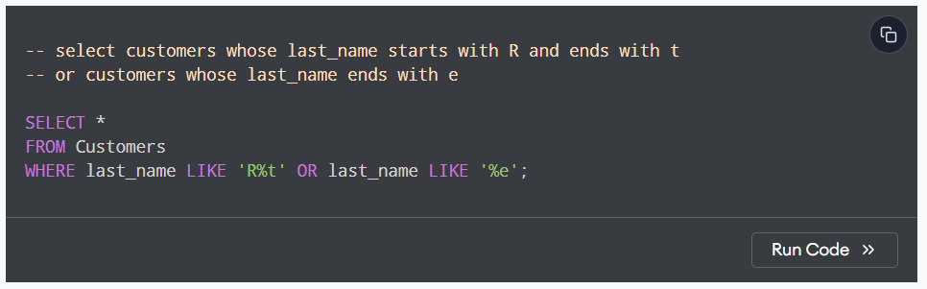
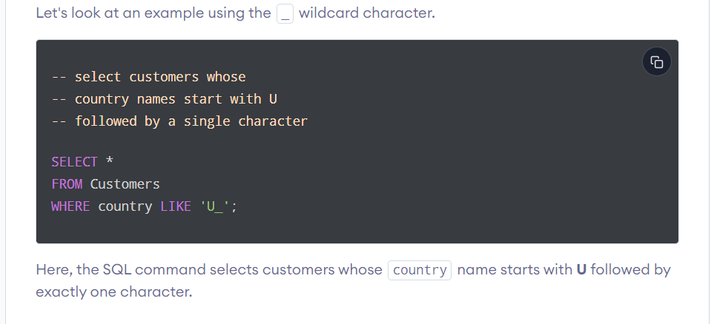
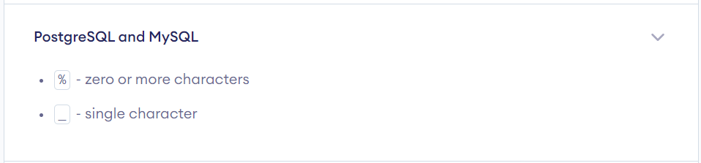
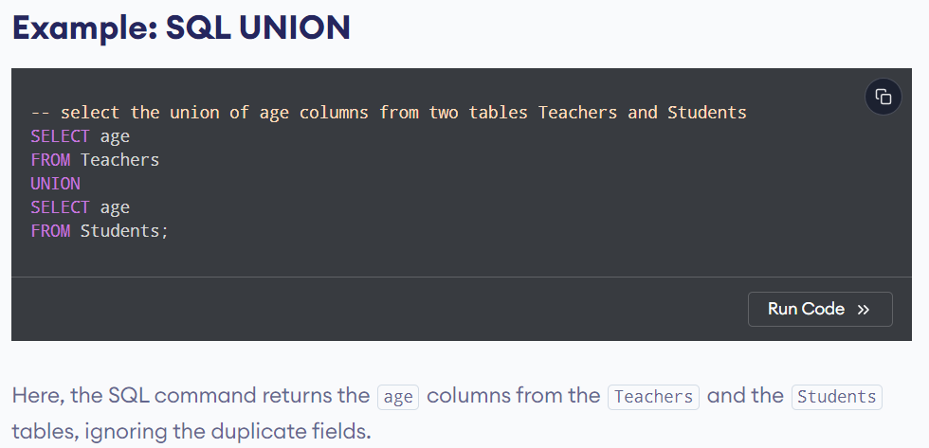

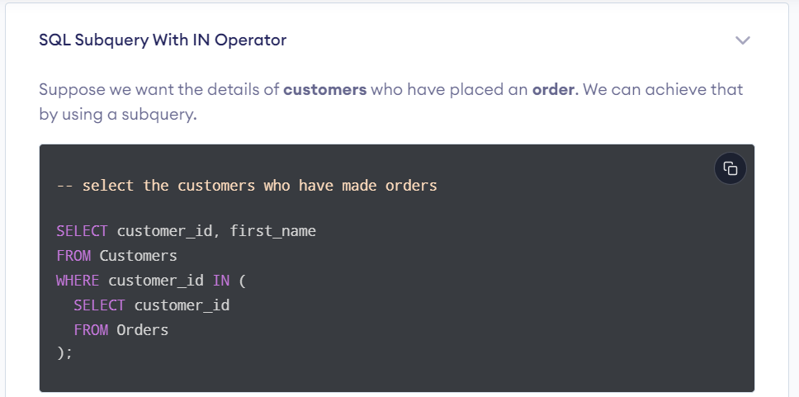

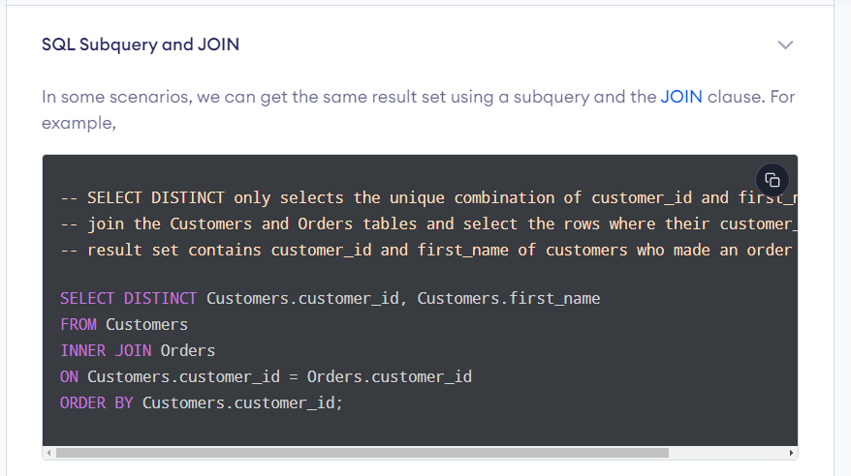
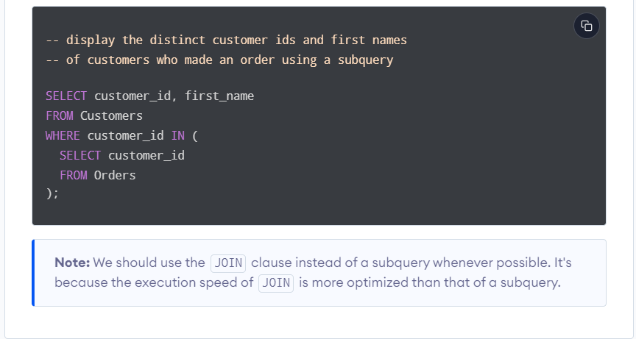
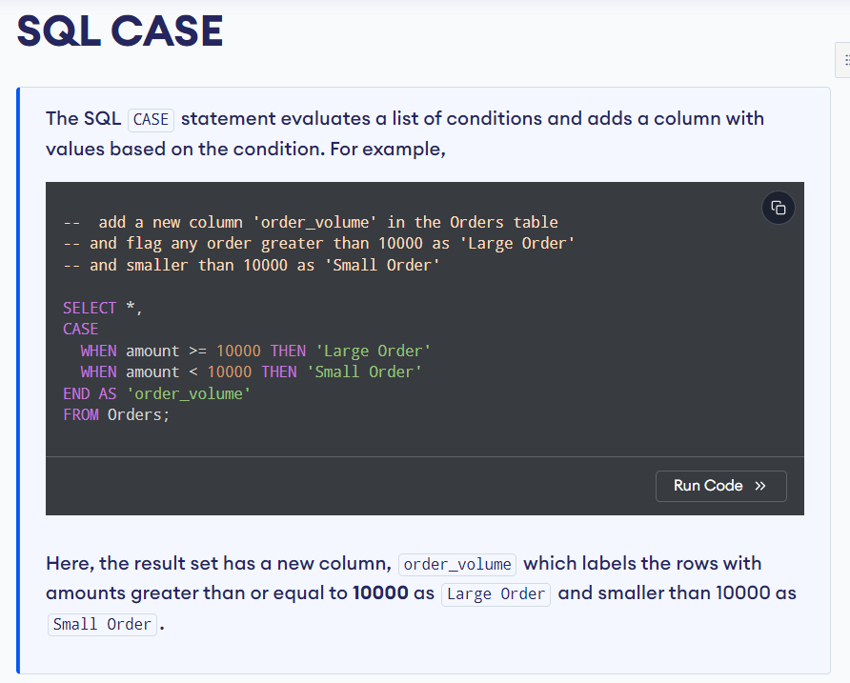
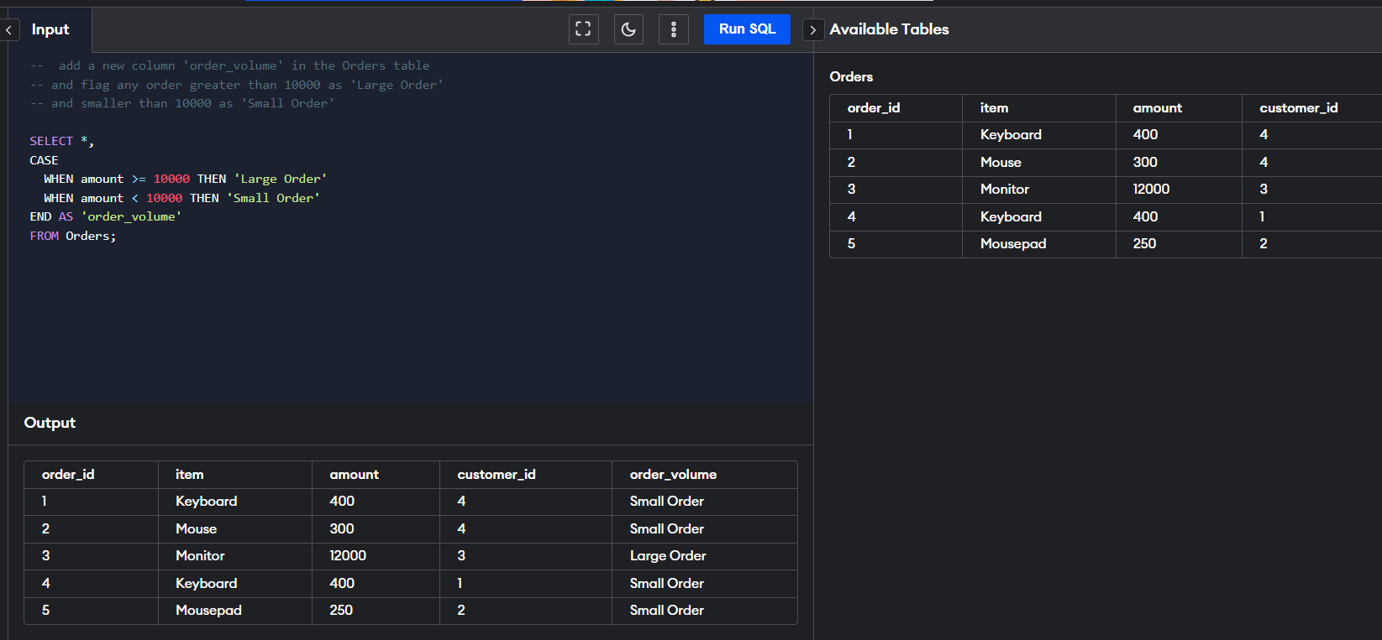
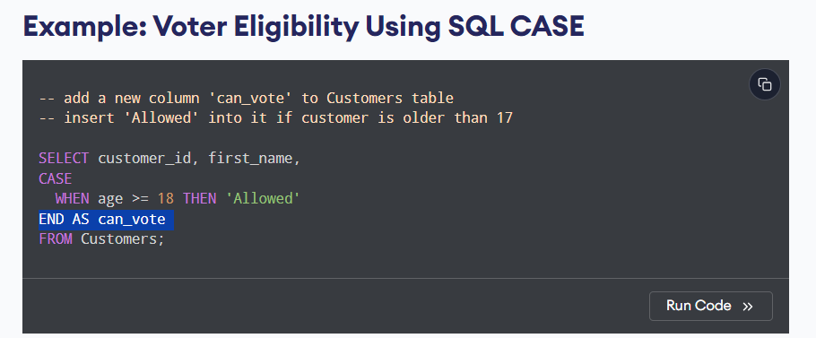

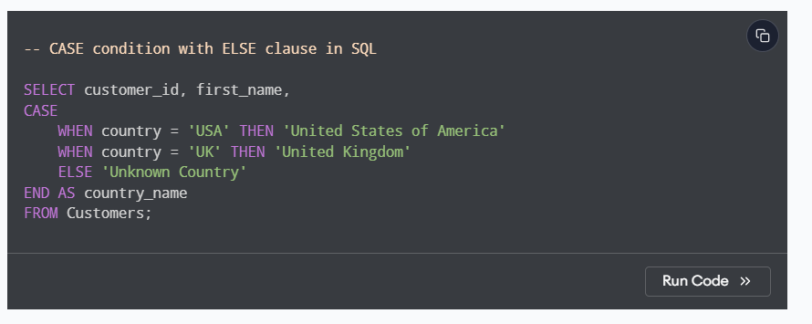
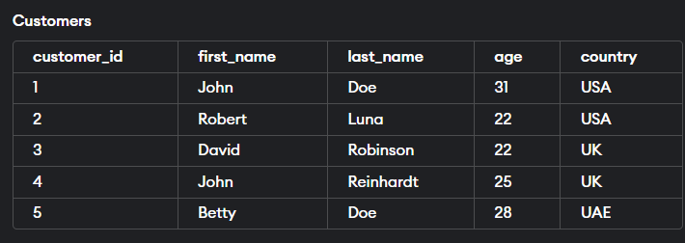
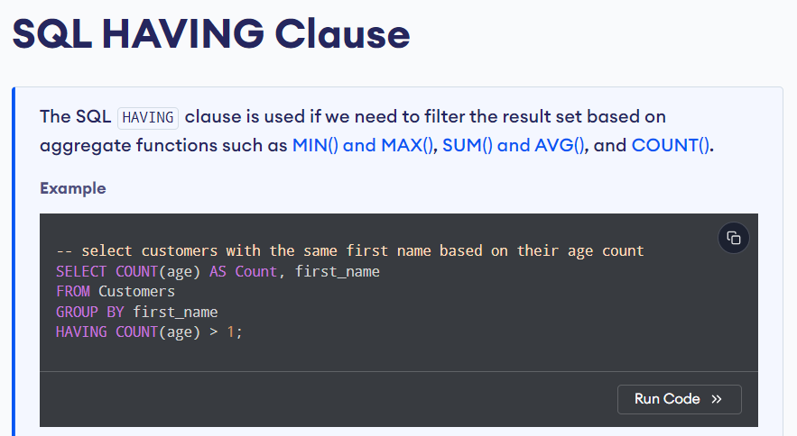



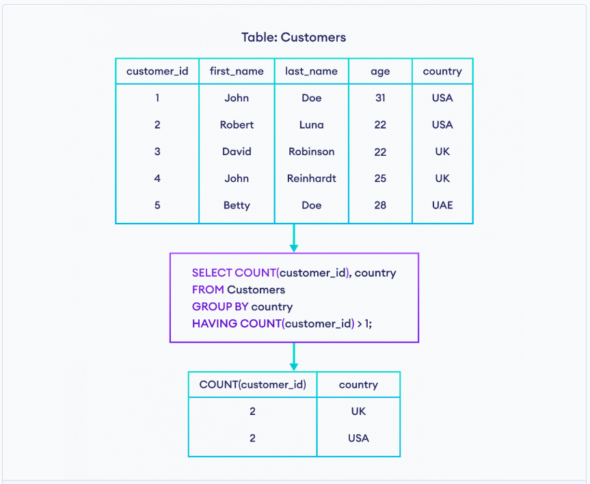
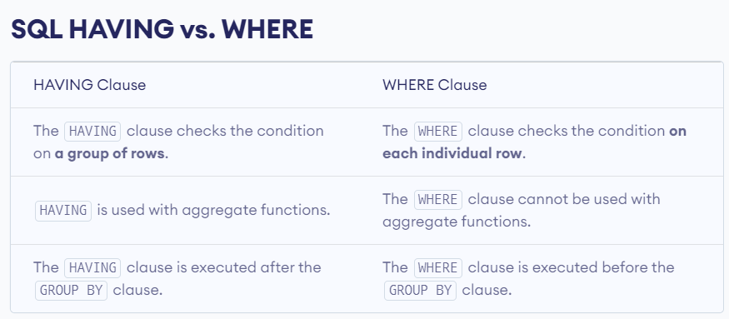

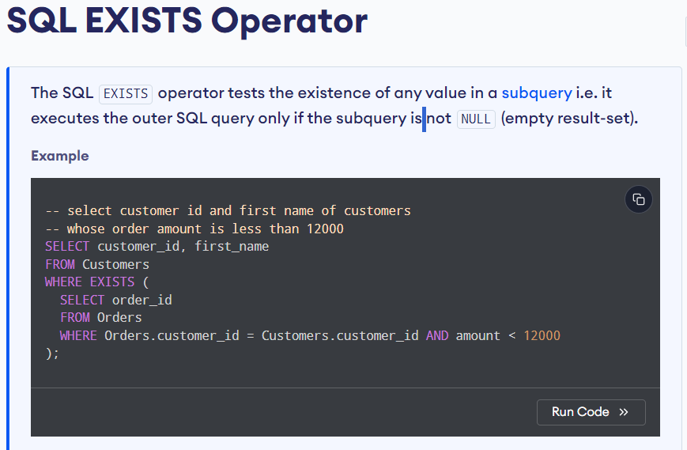
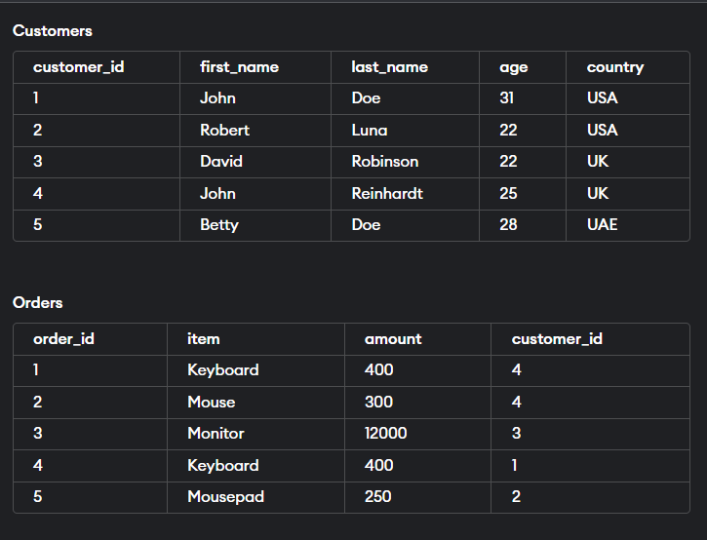
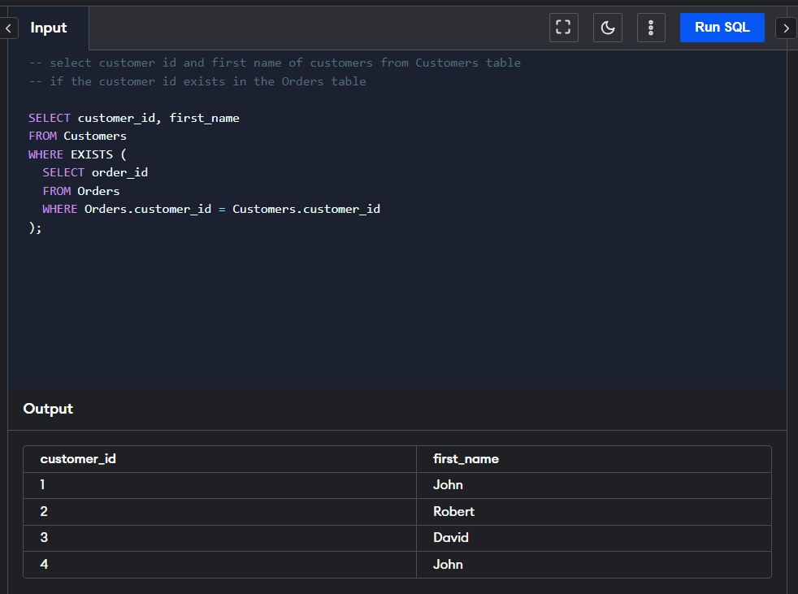
Same Results using joins
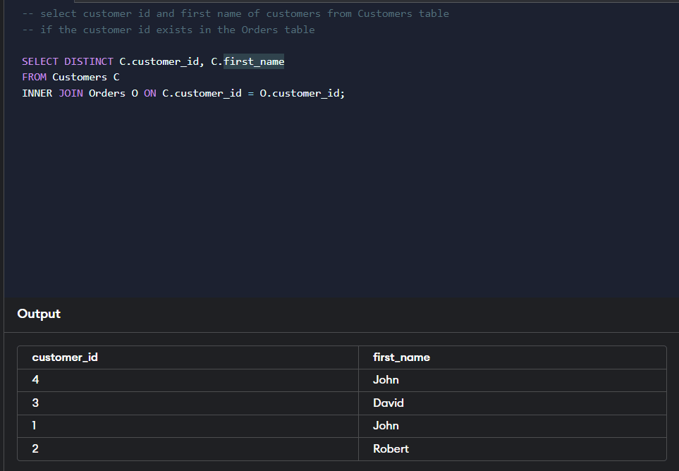
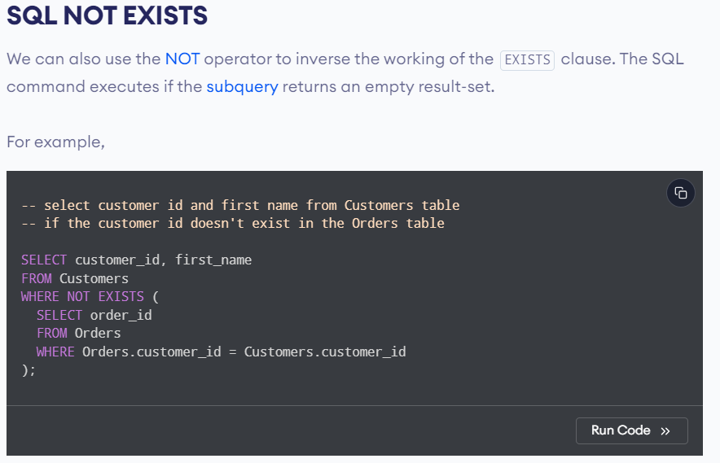
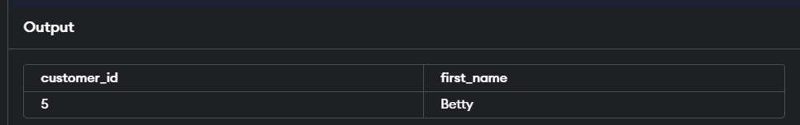

https://www.programiz.com/sql/join
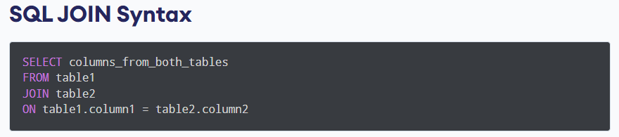
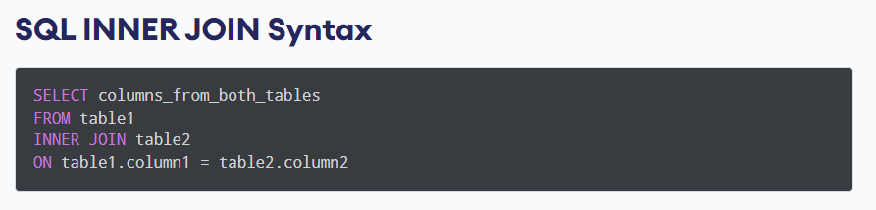
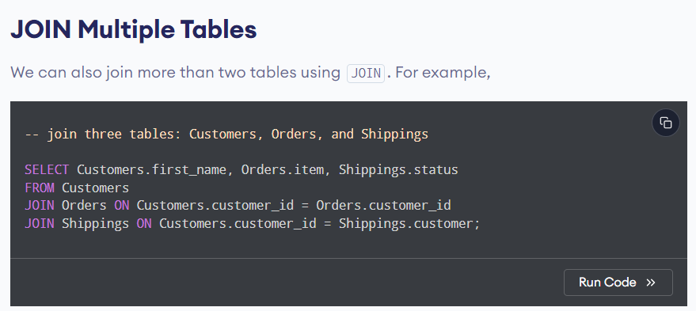

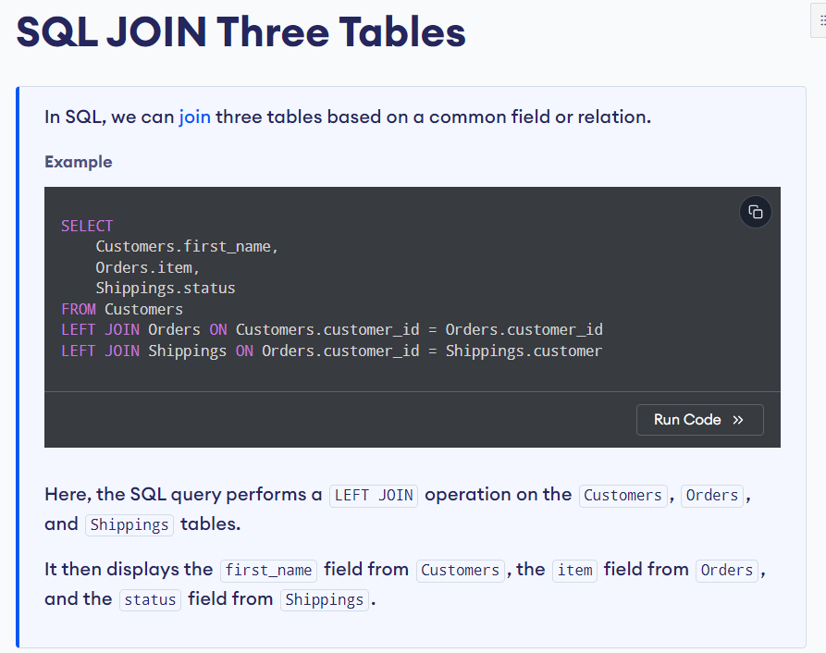

SQL joins are used to combine rows from two or more tables based on a related column between them. Here's a detailed explanation of the different types of SQL joins and their differences:
Types of SQL Joins
- INNER JOIN
- LEFT JOIN (or LEFT OUTER JOIN)
- RIGHT JOIN (or RIGHT OUTER JOIN)
- FULL JOIN (or FULL OUTER JOIN)
- CROSS JOIN
- SELF JOIN
1. INNER JOIN
Definition:
- An INNER JOIN returns only the rows that have matching values in both tables.
Syntax:
sql
SELECT columns
FROM table1
INNER JOIN table2
ON table1.common_column = table2.common_column;

Example:
sql
Copy Code
SELECT Customers.customer_id, Customers.first_name, Orders.order_id
FROM Customers
INNER JOIN Orders ON Customers.customer_id = Orders.customer_id;
Result:
- Only the rows where there is a match in both Customers and Orders tables will be returned.

2. LEFT JOIN (or LEFT OUTER JOIN)
Definition:
- A LEFT JOIN returns all rows from the left table, and the matched rows from the right table. If no match is found, NULL values are returned for columns from the right table.
Syntax:
sql
Copy Code
SELECT columns
FROM table1
LEFT JOIN table2
ON table1.common_column = table2.common_column;
Example:
sql
Copy Code
SELECT Customers.customer_id, Customers.first_name, Orders.order_id
FROM Customers
LEFT JOIN Orders ON Customers.customer_id = Orders.customer_id;
Result:
- All rows from the Customers table will be returned, along with matching rows from the Orders table. For customers with no orders, NULL values will be shown for columns from the Orders table.

3. RIGHT JOIN (or RIGHT OUTER JOIN)
Definition:
- A RIGHT JOIN returns all rows from the right table, and the matched rows from the left table. If no match is found, NULL values are returned for columns from the left table.
Syntax:
sql
Copy Code
SELECT columns
FROM table1
RIGHT JOIN table2
ON table1.common_column = table2.common_column;
Example:
sql
Copy Code
SELECT Customers.customer_id, Customers.first_name, Orders.order_id
FROM Customers
RIGHT JOIN Orders ON Customers.customer_id = Orders.customer_id;
Result:
- All rows from the Orders table will be returned, along with matching rows from the Customers table. For orders with no corresponding customer, NULL values will be shown for columns from the Customers table.
4. FULL JOIN (or FULL OUTER JOIN)
Definition:
- A FULL JOIN returns all rows when there is a match in either left or right table. Rows that do not have a match in one of the tables will have NULL values for that table's columns.
Syntax:
sql
Copy Code
SELECT columns
FROM table1
FULL JOIN table2
ON table1.common_column = table2.common_column;
Example:
sql
Copy Code
SELECT Customers.customer_id, Customers.first_name, Orders.order_id
FROM Customers
FULL JOIN Orders ON Customers.customer_id = Orders.customer_id;
Result:
- All rows from both Customers and Orders tables will be returned. Rows with no match in the other table will have NULL values for the corresponding columns.
5. CROSS JOIN
Definition:
- A CROSS JOIN returns the Cartesian product of the two tables. This means that it returns all possible combinations of rows from the two tables.
Syntax:
sql
Copy Code
SELECT columns
FROM table1
CROSS JOIN table2;
Example:
sql
Copy Code
SELECT Customers.customer_id, Customers.first_name, Orders.order_id
FROM Customers
CROSS JOIN Orders;
Result:
- Every row from the Customers table is combined with every row from the Orders table.
6. SELF JOIN
Definition:
- A SELF JOIN is a regular join but the table is joined with itself.
Syntax:
sql
Copy Code
SELECT a.column_name, b.column_name
FROM table1 a, table1 b
WHERE condition;
Example:
sql
Copy Code
SELECT a.customer_id, b.customer_id
FROM Customers a, Customers b
WHERE a.customer_id < b.customer_id;
Result:
- This will return pairs of customer IDs where the first ID is less than the second ID.
Differences in SQL Joins
- INNER JOIN vs. LEFT JOIN:
  - INNER JOIN: Returns only matching rows from both tables.
  - LEFT JOIN: Returns all rows from the left table and matched rows from the right table. If no match is found, NULL is returned for columns from the right table.
- INNER JOIN vs. RIGHT JOIN:
  - INNER JOIN: Returns only matching rows from both tables.
  - RIGHT JOIN: Returns all rows from the right table and matched rows from the left table. If no match is found, NULL is returned for columns from the left table.
- LEFT JOIN vs. RIGHT JOIN:
  - LEFT JOIN: Returns all rows from the left table and matched rows from the right table. If no match is found, NULL is returned for columns from the right table.
  - RIGHT JOIN: Returns all rows from the right table and matched rows from the left table. If no match is found, NULL is returned for columns from the left table.
- FULL JOIN vs. LEFT JOIN / RIGHT JOIN:
  - FULL JOIN: Returns all rows when there is a match in either left or right table. Rows with no match in the other table will have NULL values for the corresponding columns.
  - LEFT JOIN: Returns all rows from the left table and matched rows from the right table.
  - RIGHT JOIN: Returns all rows from the right table and matched rows from the left table.
- CROSS JOIN vs. INNER JOIN:
  - CROSS JOIN: Returns the Cartesian product of two tables, which means all possible combinations of rows.
  - INNER JOIN: Returns only matching rows from both tables based on a specified condition.
By understanding these different types of joins and their differences, you can effectively manipulate and query relational database tables to extract meaningful information based on various relationships between the data.

