https://www.baeldung.com/spring-interview-questions
https://gainjavaknowledge.medium.com/spring-interview-questions-aea3998db9ac
https://medium.com/javarevisited/21-spring-mvc-rest-interview-questions-answers-for-beginners-and-experienced-developers-21ad3d4c9b82

Dependency Injection & Inversion of Control
https://www.youtube.com/watch?v=EPv9-cHEmQw

What is Spring Bean? Object / instance
A Bean is an object that is instantiated, assembled, and managed by a Spring IoC container.

What is Dependency Injection?
Dependency Injection - injecting the dependency (like a Service) into the dependent object (like a Controller) rather than the object creating it itself with New keyword.

Crisp Interview Answer: "Dependency Injection is a design pattern where the Spring IoC container provides the required dependencies (e.g., Service) to a dependent class (e.g., Controller) instead of the class creating them itself. This promotes loose coupling and easier testing."

How Spring Injects?
- Spring scans components (@Component, @Service, @Repository) and creates beans.
- It resolves dependencies automatically using IoC Container.
- @Autowired can be used for setter or field injection.
✅ Interview Tip
If asked:
- What is DI? → "It’s a design pattern where dependencies are provided externally rather than created inside the class."
- How does Spring implement DI? → "Through IoC container using annotations like @Autowired, @Component, and configuration classes."
- Which type is preferred? → "Constructor Injection is recommended because it makes the class immutable and easier to test."

Crisp Interview Answer
@ComponentScan is used to tell Spring where to look for beans. It scans the specified packages for classes annotated with @Component and its specializations like @Service, @Controller, and @Repository, and registers them in the IoC container.

In Spring Boot, the SpringBootApplication annotation includes @ComponentScan by default and scans the package of the main application class along with all its sub-packages. If your components are in different packages or modules, you can customize the scanning using scanBasePackages or basePackageClasses.

For JPA entities and repositories, you need to configure @EntityScan and @EnableJpaRepositories separately.

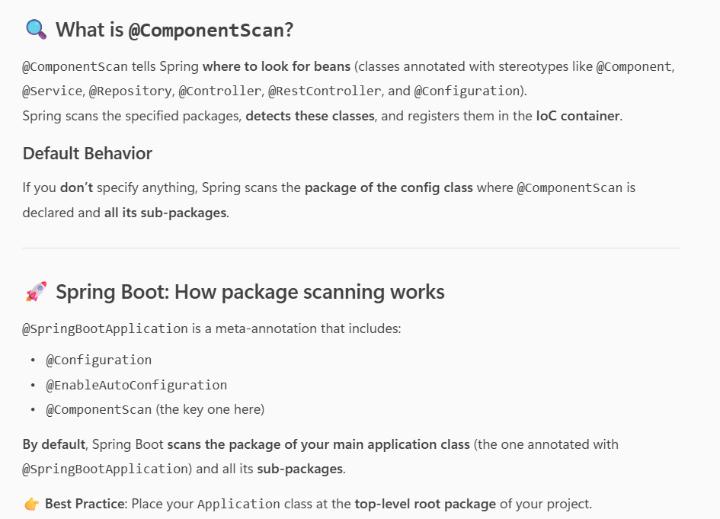

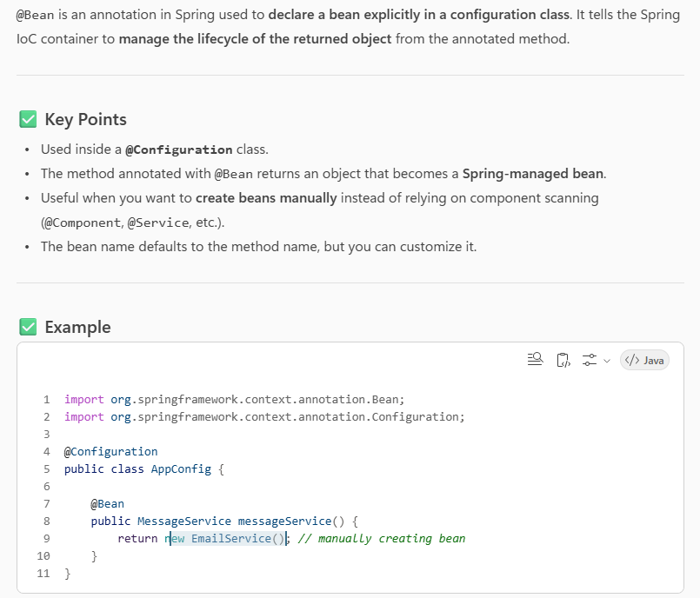
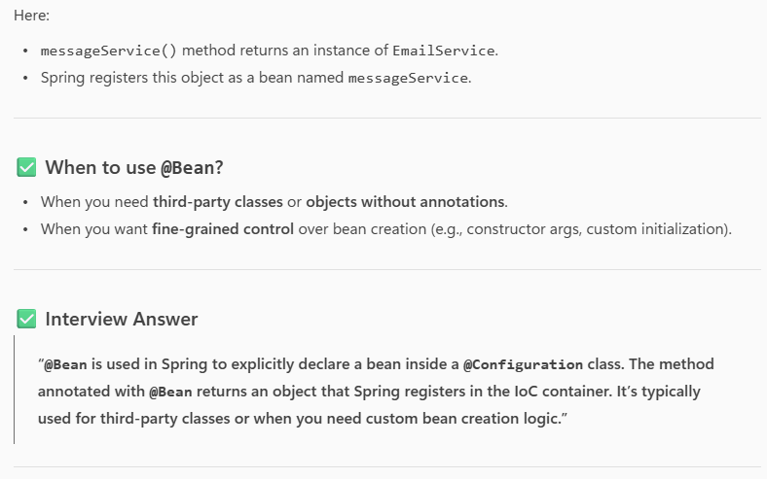

How to set 2 database or datasource?
Set dependacies in pom, database properties in property file.
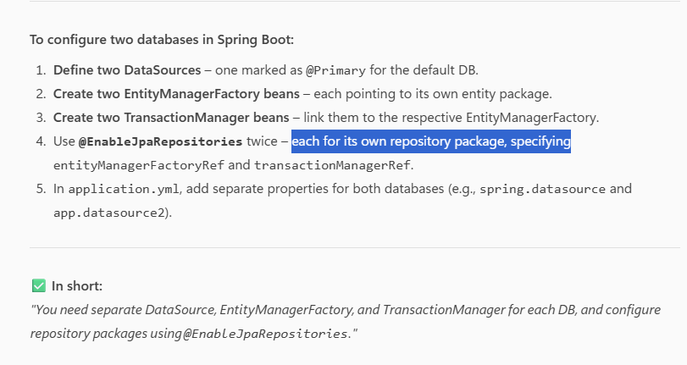
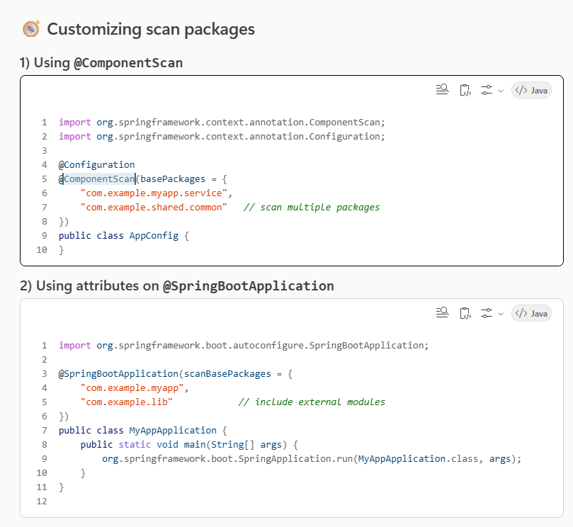

clear, step-by-step guide to configure and use two databases with two JdbcTemplate beans in Spring Boot—starting from pom.xml, using .properties (not YAML), defining beans, and calling them in a service.

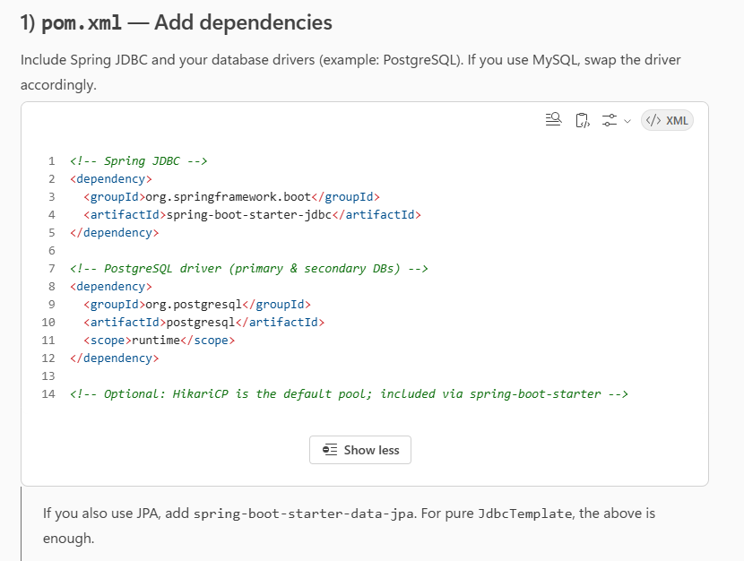
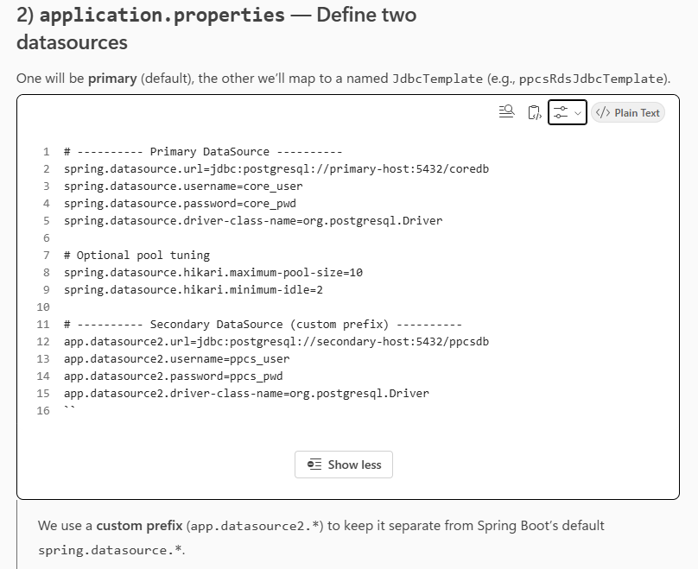
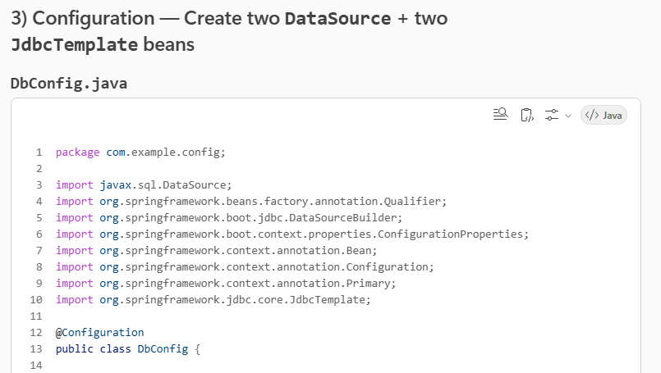
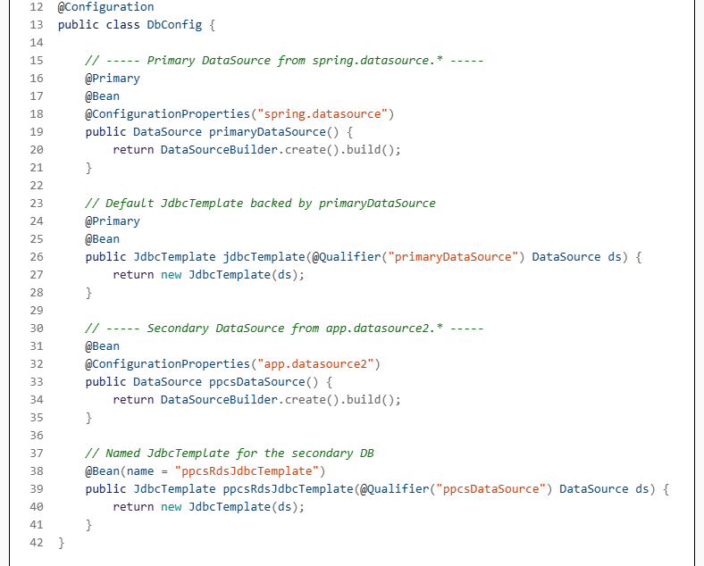
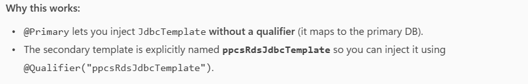

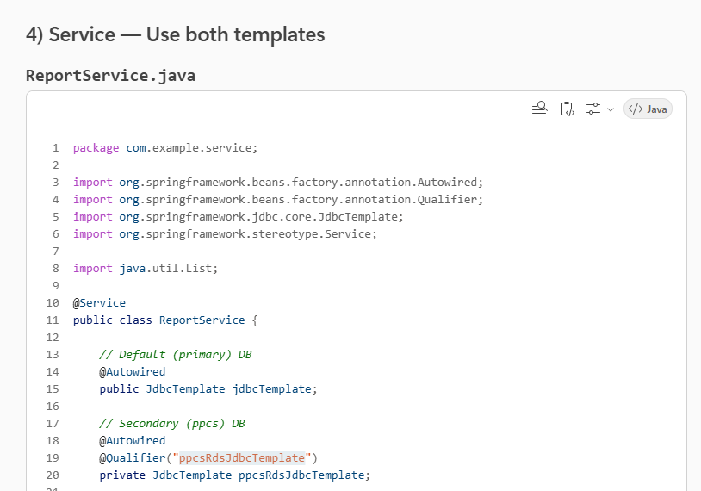
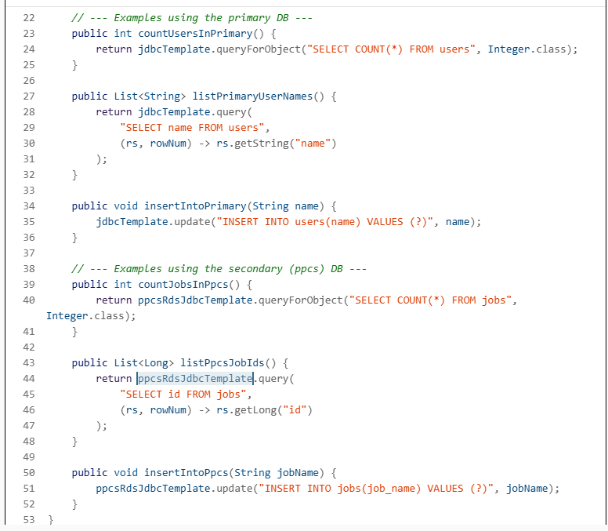

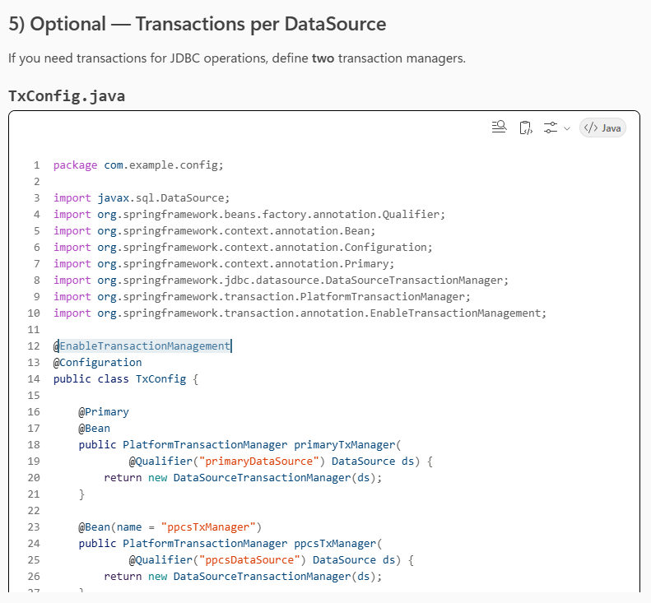
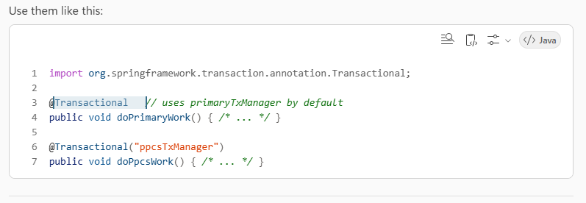
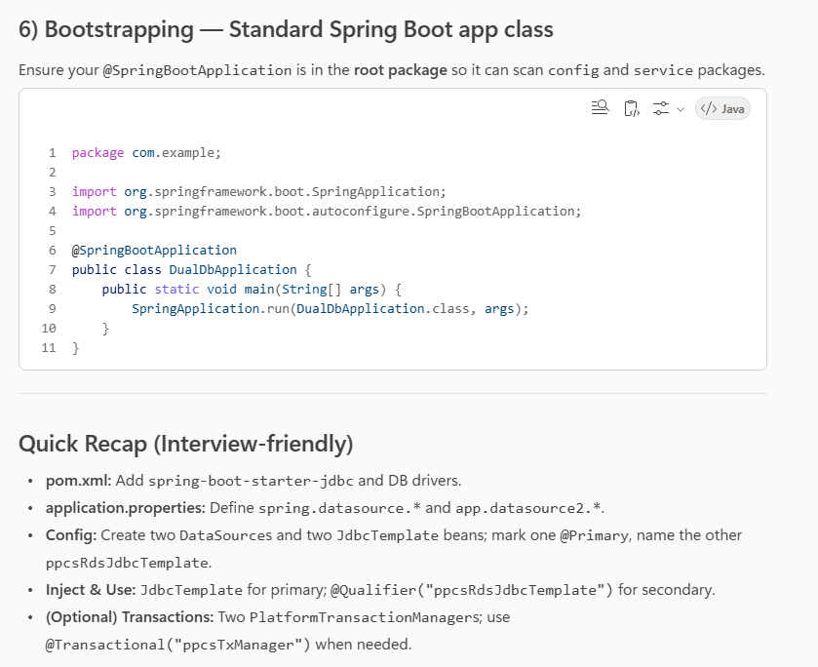

Absolutely, Nilesh! Here’s a crisp, interview-ready Q\&A set focused on configuring two databases with JdbcTemplate and using @Transactional—aligned with the example you’re working on.

1) How do you configure two databases in Spring Boot?
Answer:\ Define two DataSource beans (mark one as @Primary), create two JdbcTemplate beans (one default, one named), and wire them using @Autowired + @Qualifier for the secondary. Put DB credentials in application.properties.
Example (config excerpt):
@Primary
@Bean
@ConfigurationProperties("spring.datasource")
public DataSource primaryDataSource() { return DataSourceBuilder.create().build(); }

@Primary
@Bean
public JdbcTemplate jdbcTemplate(@Qualifier("primaryDataSource") DataSource ds) {
return new JdbcTemplate(ds);
}

@Bean
@ConfigurationProperties("app.datasource2")
public DataSource ppcsDataSource() { return DataSourceBuilder.create().build(); }

@Bean(name = "ppcsRdsJdbcTemplate")
public JdbcTemplate ppcsRdsJdbcTemplate(@Qualifier("ppcsDataSource") DataSource ds) {
return new JdbcTemplate(ds);
}

2) How do you inject and use each JdbcTemplate?
Answer:\ Inject the primary template directly; inject the secondary with @Qualifier("ppcsRdsJdbcTemplate").
@Service
public class ReportService {
@Autowired public JdbcTemplate jdbcTemplate; // primary
@Autowired @Qualifier("ppcsRdsJdbcTemplate")
private JdbcTemplate ppcsRdsJdbcTemplate; // secondary

public int countUsersInPrimary() {
return jdbcTemplate.queryForObject("SELECT COUNT() FROM users", Integer.class);
}
public int countJobsInPpcs() {
return ppcsRdsJdbcTemplate.queryForObject("SELECT COUNT() FROM jobs", Integer.class);
}
}

3) Why use @Primary for one DataSource/JdbcTemplate?
Answer:\ @Primary resolves ambiguity when multiple beans of the same type exist. It lets you inject JdbcTemplate without a qualifier and ensures default transaction manager selection if you define multiple managers.

4) What’s the role of application.properties here?
Answer:\ It separates credentials and connection settings for each DB. Use spring.datasource.* for the primary and a custom prefix (e.g., app.datasource2.*) for the secondary so Spring Boot doesn’t auto-bind it as the default.
# Primary
spring.datasource.url=jdbc:postgresql://primary-host:5432/coredb
spring.datasource.username=coreuser
spring.datasource.password=corepwd
spring.datasource.driver-class-name=org.postgresql.Driver

# Secondary
app.datasource2.url=jdbc:postgresql://secondary-host:5432/ppcsdb
app.datasource2.username=ppcsuser
app.datasource2.password=ppcspwd
app.datasource2.driver-class-name=org.postgresql.Driver

5) How do you enable transactions for each DataSource?
Answer:\ Create two PlatformTransactionManager beans (one @Primary), then annotate methods with @Transactional. The default uses the primary manager; specify the secondary with a qualifier name.
@EnableTransactionManagement
@Configuration
public class TxConfig {
@Primary
@Bean
public PlatformTransactionManager primaryTxManager(@Qualifier("primaryDataSource") DataSource ds) {
return new DataSourceTransactionManager(ds);
}
@Bean(name = "ppcsTxManager")
public PlatformTransactionManager ppcsTxManager(@Qualifier("ppcsDataSource") DataSource ds) {
return new DataSourceTransactionManager(ds);
}
}
Usage:
@Transactional // primaryTxManager
public void doPrimaryWork() { /* … / }

@Transactional("ppcsTxManager")
public void doPpcsWork() { / … */ }

6) How does @Transactional behave with JdbcTemplate?
Answer:\ With a DataSourceTransactionManager, @Transactional starts/joins a JDBC transaction on the associated DataSource. All JdbcTemplate calls in that method run within the same transaction—commit on success, rollback on runtime exceptions.
Key points:
- Default rollback: on unchecked (Runtime) exceptions; use rollbackFor=Exception.class for checked exceptions.
- You can tune propagation (e.g., REQUIRED, REQUIRES_NEW) and isolation levels (e.g., READ_COMMITTED) per method.
@Transactional(value = "ppcsTxManager", propagation = Propagation.REQUIRESNEW, isolation = Isolation.READCOMMITTED)
public void createJobInPpcs(/* … /) { / … */ }

7) How do you run a cross-DB workflow safely?
Answer:\ Avoid mixing two different DB operations in one transaction manager. If the workflow touches both DBs, either:
- Split into two transactional methods, one per DB, and handle compensations on failure.
- Use a saga/compensating transactions pattern for reliability.
Traditional two-phase commit isn’t built-in for simple JdbcTemplate setups; keep it eventual or compensating.

8) Common pitfalls and fixes
Answer:
- Ambiguous beans (no @Primary) → add @Primary or use @Qualifier.
- Wrong packages not scanned → ensure your @SpringBootApplication sits at the root package so config beans are scanned.
- Transactions not applied → missing @EnableTransactionManagement, or injecting the wrong JdbcTemplate.
- Silent failures on secondary props → typo in app.datasource2.* keys; verify @ConfigurationProperties prefixes.

9) Difference between configuring two DBs with JPA vs JdbcTemplate?
Answer:
- With JPA, you need two EntityManagerFactory and two TransactionManager, plus two @EnableJpaRepositories pointing to different packages.
- With JdbcTemplate, you only need two DataSources, two JdbcTemplate beans, and (optionally) two DataSourceTransactionManager.

10) Short elevator pitch (30 seconds)
Answer:\ “In Spring Boot, to use two databases with JdbcTemplate, define two DataSources—mark one @Primary—then create two JdbcTemplate beans, injecting the secondary via @Qualifier. Put each DB’s properties in application.properties. For transactions, declare two DataSourceTransactionManagers and annotate methods with @Transactional, using the manager name for the second DB. This cleanly separates operations per database and keeps your code testable and maintainable.”

If you want, I can package this Q\&A into a PDF like the previous guide, or tailor the examples to your exact schemas (users/jobs in core/ppcs).

How bean is created in Spring? And its lifecycle?
Spring Singleton vs GOF Singleton
- GOF Singleton – means 1 instance of bean per JVM,
By GOF definition, even if multiple application context are running in the same jvm, you should just have one instance of that specific class
- Spring Singleton - means one instance per application context

Whenever one of the dependency is Prototype, however, the bean using it is not a prototype
Solve it using Proxy

