Document: System Requirement Specification Document

Title: System Requirement Specification for Online Shopping Portal

Team: Direct Customer, Indirect Customer, Architect, Business Analyst, Quality Assurance Team, System Analyst

**HomeAway-Online PG/Hostel Booking System:**

An online PG/Hostel booking system is a full-stack web application that allows users to search for and book PG (paying guest) /Hostel accommodations over the internet. It is less time and effort consuming. The system typically includes a database of available PG/Hostel properties with information such as location, amenities, pricing, and availability. Users can search for properties based on various criteria such as location, price range, and required facilities. Once they have found a property they are interested in, they can book it online using a secure payment gateway. The system can also provide features such as email and SMS notifications, customer reviews, and the ability for property owners to manage their listings. The goal of the project is to provide a convenient and efficient way for users to find and book PG/Hostel accommodations, while also providing property owners with a powerful tool to manage their properties. There are many conclusive features of the project which suggest there can be further development and an outlook can be created for a business perspective using various hosting platforms.

**Objective (Purpose):**

**Scope:**

**Definitions:**

**Requirements:**

**Functional Requirements:**

1) User registration and login system: Users should be able to create an account, log in and edit their personal information.

2) Search and filter options for available PGs/hostels: Users should be able to search for PGs/hostels based on location, type, price range, amenities, etc.

3) Online booking and payment system: Users should be able to book a PG/hostel and make payments online.

4) Real-time availability status for PGs/hostels: Users should be able to see the real-time availability status of PGs/hostels.

5) Management of booking details and reservations: Users should be able to view, cancel and modify their bookings.

6) Integration with Google Maps for location of PGs/hostels: Users should be able to view the location of PGs/hostels on a map.

7) Option for users to leave reviews and ratings for PGs/hostels: Users should be able to leave reviews and ratings for PGs/hostels they have stayed in.

8) Email and SMS notifications for bookings and cancellations: Users should receive email and SMS notifications for bookings and cancellations.

9) Administrative panel for managing listings and user accounts: Site administrator should be able to manage listings, approve bookings, manage user accounts and handle any disputes or issues.

10) Option for landlords to update prices and availability of their listings: Landlords should be able to update prices and availability of their listings, and manage bookings.

**Non-Functional Requirement:**

**Security**

Registered PG Owner will be allowed to post property details.

Registered users will be allowed to book property.

Each stakeholder will be able to access system through authentication process. System will provide access to the content, operations using Role based security (Authorization) (Permissions based on Role)

The confidential information shared by stakeholders of the system will be protected by using SSL in all transactions.

System will automatically log of all stakeholder after some time due to inactiveness.

System will block operations for inactive stakeholder and would redirect for authentication.

System will internally maintain secure communication channel between Servers (Web Servers, App Servers, database Server)

Sensitive data will be always encrypted across communication.

Use of proper firewall to protect servers from outside fishing, vulnerable attacks.

**Reliability**

The system will backup business data on regular basis and recover in short time duration to keep system operational

Continuous updates are maintained, continuous Administration is done to keep system operational.

During peak hours system will maintain same user experience by managing load balancing .

Availability uptime: 24* 7 available 99.999%

**Maintainability:**

Commercial database software will be used to maintain System data Persistence.

A readymade Web Server will be installed to host online PG/hostel booking portal (Web Site) to management server capabilities.

IT operations team will easily monitor and configure System using Administrative tools provided by Servers.

Separate environment will be maintained for system for isolation in production, testing, and development.

**Portablility:**

PDA: Portable Device Application

System will provide portable User Interface (HTML, CSS, and JS) through users will be able to access online PG/Hostel booking portal.

System can be deployed to single server, multi-server, to any OS, Cloud (Azure or AWS or GCP)

**Accessibility:**

Only registered user will be able to book accommodation after authentication.

Admin can reject or approve booking requests, PG owner registration requests based on role provided.

Admin team will be able to view daily, weekly, monthly, annual bookings, registered users, registered PG owners, property details through customized dashboard.

PG owners will be able to see bookings made for their properties, feedbacks given by users, requests made by users for property booking.

**Durability:**

System will maintain wishlist for users .Users will be able to shortlist accomodations and can book any room from shortlisted accomodations whenever needed.

System will implement backup and recovery for retaining stake holders data, bussiness operation data and business data over time.

**Efficiency:**

System will be able to manage all transactions with isolation.

**Modularity:**

System will be designed and developed using reusable, independent or dependent business scenarios in the form of modules. These modules will be loosely coupled and highly cohesive. System will contain User module, Admin, PG Owner module, Wishlist, Room management, Room Bookings, Payment processing, Membership and Role management modules.

**Scalability:**

System will be able to provide consistent user experience to stake holder as well as visitors irrespective of load.

**Safety:**

Online PG booking portal will be secure from malicious attack, fishing.

Online PG booking portal functionalities are protected from outside attacks with proper firewall configuration.

Online PG booking portal will be always kept updated with latest antivirus software.

Business data will be backed up periodically to ensure safety of data using incremental back up strategy.

Role based security will be applied for Application data and operations accessibility.

**Use Case Diagram: (UML)**

Object Oriented Analysis and Design Notation: UML--------Unified Modeling language

**Design Phase:**

**Use case diagram**

**Activity diagram**

**State Transition diagram**

**Class diagram**

**Class Diagram Relationship:**

**_________________________**

USER has a many-to-many relationship with Booking (a user can make multiple bookings and a booking can be made by multiple users)

ROOM has a one-to-many relationship with Booking (a room can be booked multiple times but a booking is for a single room)

HOSTEL/PG has a one-to-many relationship with Room (a hostel can have multiple rooms but a room belongs to a single hostel)

ROOM has a one-to-many relationship with Room-Type (a room type can be associated with multiple rooms)

BOOKING has a one-to-many relationship with Payment (a booking can have multiple payments and a payment is associated with a single booking)

**Deployment diagram**

**Object diagram**

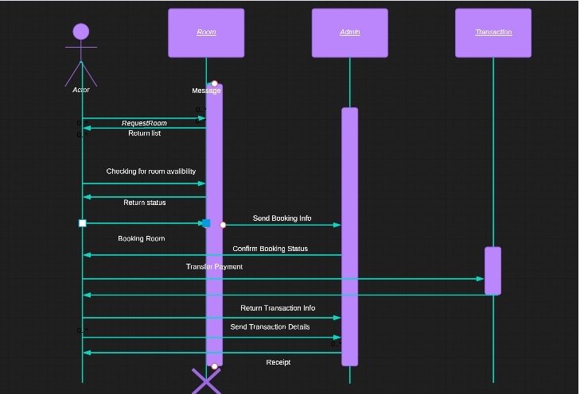

Sequence Diagram