Pr01
Title: Socket Programming
Aim: To develop any distributed application through implementing client-server communication
programs based on Java Sockets.
Objectives:
1. To study inter-process communication
2. To learn client server communication using socket
Tools / Environment:
Java Programming Environment, rmiregistry, jdk 1.8, Eclipse IDE.
implementation
The server run firsts and waits for client to connect.
When the client runs, it connects to the server and client sends a message to the server through socket connection.
The server receives the message and sends response back to the client.
This practical helps us understand inter-process communication in distributed systems
What is Socket Programming?
Socket Programming is used for communication between two systems over a network.
- Server → waits for client request
- Client → sends request to server
Both communicate using:
- IP Address
- Port Number

Important Terms
1. Socket
A socket is an endpoint for communication between client and server.
Simple meaning:
It acts like a communication channel.

2. Port Number
Port number identifies a specific application/service.
Example:
5000
Here server listens on port 5000.

3. ServerSocket
Used only by server side.
Purpose:
Waits for client connection.

4. Socket Class
Used for actual communication between client and server.
Inter Process Communication means:
Communication between two or more processes/programs.
Inter Process Communication means:

Title: Remote Method Invocation
Aim: To implement multi-threaded client/server Process communication using RMI.
What are you doing in this assignment?”
“Sir/Mam, in this practical we are implementing Remote Method Invocation using Java RMI.
used for communication between two Java programs running on different computers or processes.
Here client sends two numbers to server, and server performs addition and returns result to client.”
In Your RMI Program
- Server is one process
- Client is another process
Both communicate remotely using RMI.

What is RMI?
RMI = Remote Method Invocation
It is a Java technology that allows:
one Java program to call methods of another Java program running on different machine/system.

Simple Meaning
Client can call server methods remotely.
Like:
Client → calls add() method → Server executes → Result returned

Real Life Example
Think like online calculator:
- You enter numbers
- Server processes
- Result comes back

Main Components in RMI
File | Purpose
AddServerIntf.java | Remote Interface – declare methods
AddServerImpl.java | Remote Object Implementation – implements methods
AddServer.java | Server Program – registers remote objects with rmi reg
AddClient.java | Client Program – client searches r o

Complete Flow
Client requests addition
↓
RMI registry finds remote object
↓
Server executes add() method
↓
Result returned to client
What is RMI Registry?
RMI Registry is:
a naming service used to store and locate remote objects
Server registers object using:
Naming.rebind("AddServer", obj);
Client searches object using:
Naming.lookup("rmi://localhost/AddServer");

Assignment 3
Title: Common Object Request Broker Architecture (CORBA)
Aim: To develop any distributed application with CORBA program using JAVA IDL.

Imagine you have a calculator program written in Java that runs on Computer A. Now imagine someone sitting at Computer B, in another city, wants to use that calculator. They want to call methods like add(10, 5) and get the result 15 — even though the calculator code isn't on their machine.
How do you make that happen?
That's exactly the problem CORBA solves.
It is a technology used in:
Distributed Systems
to allow:
✔ client and server
✔ running on different machines
✔ written in different languages to communicate with each other.
CORBA acts like a: middleman / broker between client and server.
Features:
Platform independent
Language independent
ORB = Object Request Broker
It:
✔ receives client request
✔ finds server object
✔ sends response back
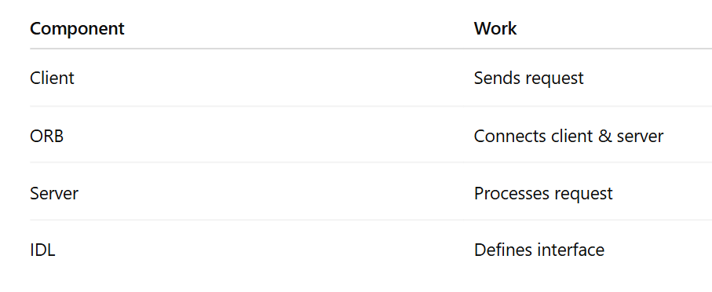

What is IDL?
Interface Definition Language
Used to define remote methods.
POA?"
"POA stands for Portable Object Adapter. It's the part of the ORB that manages servant objects on the server side. It receives incoming requests, finds the right servant, and invokes the method.

Assignment 4: MPI (Message Passing Interface)
To find the sum of N elements in an array by distributing elements among n processors, and computing partial (intermediate) sums at each processor.
MPI means Message Passing Interface
MPI (Message Passing Interface) is a standard programming model used for communication between multiple processes in a distributed system.
It is used in distributed systems where:
- Each processor works separately
- They communicate using messages
- Each processor computes part of the work
Idea of This Program
Assume:
- Array = [1, 2, 3, 4, 5, 6]
- Processors = 3
Then:
Processor | Data | Partial Sum
P0 | 1, 2 | 3
P1 | 3, 4 | 7
P2 | 5, 6 | 11
👉 Final Sum = 3 + 7 + 11 = 21
Input
- Number of elements (N)
- Array elements
- Number of processors (n)

📤 Output
- Data assigned to each processor
- Intermediate sum at each processor
- Final sum

MPI.COMM_WORLD?
👉 MPI.COMM_WORLD is the default communicator in MPI.
It represents:
✔ All processes running your program
So if you run:
mpjrun.sh -np 4 mpisum
Then:
COMM_WORLD = {P0, P1, P2, P3}
1. Rank()
👉 Used to get the ID of a process
2. Size()
👉 Used to get total number of processes
3. Send()
4. Recv()
👉 Used to receive data from another process
Bcast() (Broadcast)
👉 Used to send same data to all processes

Send() Syntax
MPI.COMM_WORLD.Send(buffer, 0, count, MPI.INT, destination, tag);

📌 Meaning:
Part | Meaning
buffer | data to send
0 | starting index
count | number of elements
MPI.INT | data type
destination | receiver process rank
tag | message id

/*open eclipse and create java project inside that create mpisum.java
downlaod mpjexpress - create home/amruta and paste all files from that downloaded zip...
right click on java project - properties- java build path- classpath - add external jar-
naviaget to Navigate to /home/amruta/lib/mpj.jar - apply and close
imp - Delete module-info.java if it exists

open terminal -
go to the path where mpirmi.java file exist(cd "")
Set MPJ_HOME - export MPJ_HOME=/home/amruta
Add MPJ bin to PATH - export PATH=$PATH:$MPJ_HOME/bin---- not required
compile - javac -cp .:$MPJ_HOME/lib/mpj.jar mpisum.java
run - mpjrun.sh -np 4 mpisum */

Assignment 5: Clock Synchronization
Berkeley Algorithm for Clock Synchronization
What is Clock Synchronization?
In distributed systems:
👉 Every computer has its own clock
👉 But clocks are NOT perfectly same
👉 So time may differ in each node
Node A → 10:00
Node B → 10:05
Node C → 09:58
👉 All show different time ❌
👉 This creates confusion in system

🟢 Solution → Berkeley Algorithm
👉 It is used to synchronize all clocks to a common time

🧠 Main Idea
✔ One node becomes Master (Coordinator)
✔ It collects time from all nodes
✔ It calculates average time
✔ It sends correction to all nodes
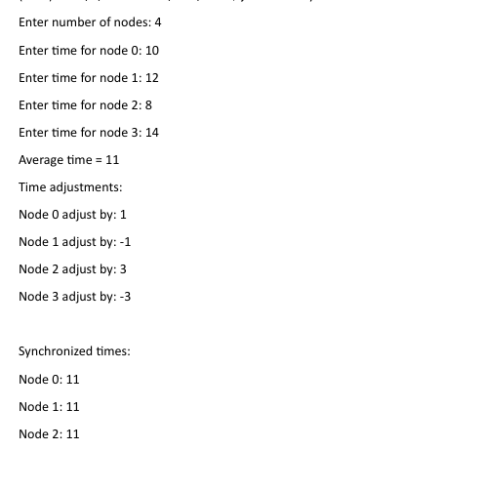
Pr06
Assignment: Mutual Exclusion (Token Ring Algorithm)
To implement the Token Ring Mutual Exclusion algorithm, where only one process at a time can enter the Critical Section using a circulating token.
What is Mutual Exclusion?
Mutual exclusion means:
Only one process can use a shared resource at a time (A shared resource is a resource that multiple processes want to access.)
Other processes must wait
Only one person can use ATM at a time
Token Ring Algorithm idea:
- All processes are arranged in a ring (circle)
- A special message called TOKEN circulates in the ring
- Only the process holding the TOKEN can enter the critical section
- After finishing, it passes the TOKEN to the next process
“Whoever has the token gets permission to use the resource.”

Real-life Analogy
Think of a microphone in a group discussion:
- Only the person holding mic can speak (Critical Section)
- After speaking, mic is passed to next person (Token passing)

Pr07
Assignment: Election Algorithms
Leader Election using Bully and Ring Algorithm
Leader Selection
In a distributed system:
👉 There are many nodes
👉 One node must act as leader (coordinator)
👉 If leader fails → new leader must be selected
Why election is needed?
✔ Coordination of tasks
✔ Avoid conflict
✔ Manage system properly
Bully algorithm
Bully Algorithm is a leader election algorithm in distributed systems
👉 Used when current coordinator (leader) fails
Each process has a unique ID
✔ Highest ID process becomes leader
✔ If a process detects failure, it “calls higher processes”
✔ Highest alive process “wins” the election (bully behavior)
P1, P2, P3, P4, P5
👉 P5 is initial leader
P5 (Leader) → FAIL ❌
Step 2: P2 detects failure
P2 starts election:
P2 → sends message to P3, P4, P5
Step 3: Responses
P3 → alive
P4 → alive
P5 → no response (dead)
Higher ID always wins → "Bully wins the fight"
Ring Algorithm
Ring Algorithm is a leader election algorithm in distributed systems
👉 All processes are arranged in a logical circle (ring)
👉 Election message moves around the ring
Highest ID process becomes leader
Pr08
A Web Service is a way for two different applications to communicate over the internet.

🧠 Simple Meaning
It allows:
- One system to provide service
- Another system to use (consume) that service
Types of Web Services
1. SOAP Web Service- SOAP = Simple Object Access Protocol
It is a web service communication protocol used to exchange data between applications over a network.
- Uses XML
- Heavy but secure
- Old style
2. REST Web Service ⭐ (most used)
- Uses HTTP (GET, POST)
- Lightweight
- Easy and fast
In real web services:
- Server runs on internet (API)
- Client sends HTTP request
- Server sends response (JSON/XML)

A web service is a system where a client sends a request and a server returns a response over a network.”
Your program roles:
Web Service Concept Your Program
Client Java program (taking input)
Server Logic performing addition
Request User inputs (a, b)
Response Sum result

