1. Problem Description:

In Tanzania villages, we have a number of water pumps provided. Unfortunately, not all are in working condition. Moreover, many require repair. Based on the given compiled dataset, we need to predict, based on various factors such as the kind of pump operating, when it was installed, and how it is managed, sub-village, region, funder etc, that if the test instance falls under which class label. The class labels are as follows: functional, non-functional, functional but needs repair.

2. Related Work:

According to the website: <http://dashboard.taarifa.org/#/dashboard> the national data for the current situation for water pumps in Tanzania is as follows: 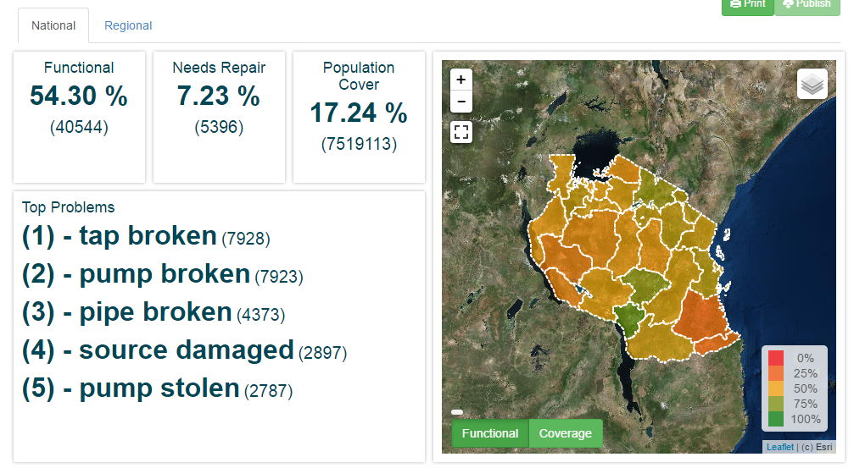

This data has been collected, along with a large number of other attributes, which have been described below.

3. Dataset Details:

* No of features - 39
* Instances - 59400
* Data Distribution - See the attached .pdf with R code to find correlation of different attributes with the class labels. Also the histograms depicting relation of class labels with the most important attributes are attached in the .pdf
* Feature summary is as follows:
  + amount_tsh - Total static head (amount water available to waterpoint)
  + date_recorded - The date the row was entered
  + funder - Who funded the well
  + gps_height - Altitude of the well
  + installer - Organization that installed the well
  + longitude - GPS coordinate
  + latitude - GPS coordinate
  + wpt_name - Name of the waterpoint if there is one
  + num_private -
  + basin - Geographic water basin
  + subvillage - Geographic location
  + region - Geographic location
  + region_code - Geographic location (coded)
  + district_code - Geographic location (coded)
  + lga - Geographic location
  + ward - Geographic location
  + population - Population around the well
  + public_meeting - True/False
  + recorded_by - Group entering this row of data
  + scheme_management - Who operates the waterpoint
  + scheme_name - Who operates the waterpoint
  + permit - If the waterpoint is permitted
  + construction_year - Year the waterpoint was constructed
  + extraction_type - The kind of extraction the waterpoint uses
  + extraction_type_group - The kind of extraction the waterpoint uses
  + extraction_type_class - The kind of extraction the waterpoint uses
  + management - How the waterpoint is managed
  + management_group - How the waterpoint is managed
  + payment - What the water costs
  + payment_type - What the water costs
  + water_quality - The quality of the water
  + quality_group - The quality of the water
  + quantity - The quantity of water
  + quantity_group - The quantity of water
  + source - The source of the water
  + source_type - The source of the water
  + source_class - The source of the water
  + waterpoint_type - The kind of waterpoint
  + waterpoint_type_group - The kind of waterpoint

4. Pre-processing Techniques:

Preprocessing is a very important part of this project. We have taken 2 steps for the same.

1. Remove all non-available data (missing values). This ensures all the data we have is complete and to the mark, resulting in more accurate results.

2. Check correlation of all attributes with the class labels so that we can reduce the attributes that are not required. This reduces the dimensionality of the dataset. The results are less complex and more efficient results. Basically correlation shows the relation of each attribute with the class label. A higher value of absolute magnitude means the attribute is highly related to the class label and should not be ignored. Whereas attributes with a correlation value tends to 0 means it can be removed and ignored. Using this, we removed certain attributes to reduce complexity of the dataset.

5. Proposed Solution and method: [MAIN SECTION. NEEDS THEORY AND PRACTICAL]

One major problem faced was runtime to create model… Solution???

6. Experimental Results and Analysis: [LOT OF DETAILS EXPECTED]

Here we can vary certain parameters of input to change the accuracy of our output. These include the kernel (sigmoid, radial, polynomial etc…), gamma value, cost. A small gamma means a Gaussian with a large variance so the influence is more. If gamma is large, then variance is small implying the support vector does not have wide-spread influence. Technically speaking, large gamma leads to high bias and low variance models, and vice-versa. We have attached a table showing our experiments with the parameters and hence our deduction of the the best parameters to use based on accuracy:

7. Coding Language and Technique:

We have decided to use SVM (Support Vector Machine) as our technique to combat this problem. We have been given the class labels here and can thus use this supervised learning model to overcome the issue of predicting the current status of the new pump given to be tested. We will be doing the project in R.

Simple explanation of SVM: Here we will plot data in a non linear dimension, and consider the plotted points closest to the hyperplanes separating the data as our support vectors. Here we choose a non-linear kernel, as our data is quite complex and there will be no clear separators for the same. Moreover, since our data is supervised (i.e. class labels are given) we can use this technique with ease.

Pros of this method: Accuracy, Works well on smaller cleaner datasets, It can be more efficient because it uses a subset of training points.

Cons of this method: Isn’t suited to larger datasets as the training time with SVMs can be high, Less effective on noisier datasets with overlapping classes.

8. Conclusion:

9. Contribution: All team members contributed equally in all parts of the project. It was a group effort at every stage.

10. References:

* <http://dashboard.taarifa.org/#/dashboard>
* <https://www.drivendata.org/competitions/7/page/25/>
* <http://machinelearningmastery.com/pre-process-your-dataset-in-r/>