Marathwada Shikshan Prasarak Mandal’s

**Deogiri Institute of Engineering and Management Studies,**

**Aurangabad**

Seminar Report

On

**STUDINDUS**

Submitted By

**Rushikesh Aware (36015)**

**Dr. Babasaheb Ambedkar Technological University**

**Lonere (M.S.)**

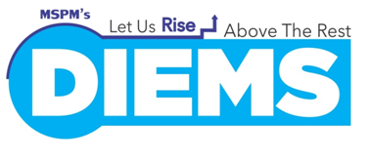

Department of Computer Science and Engineering

**Deogiri Institute of Engineering and Management Studies,**

**Aurangabad**

(2019- 2020)

**CONTENTS -**

1. Abstract
2. Literature survey
3. Module

**Abstract –**

This project is beneficial for college students, various companies visiting the campus for recruitment and even the college placement officer (H.R.). This website allows the students to create their profiles and upload all their details including their marks into this website. The admin can check each student details and can remove faulty accounts. The system also consists of a company login where various companies visiting the college can view a list of students in that college and also their respective resumes. The software system allows students to view a list of companies who have posted for vacancy. The admin has overall rights over the system and can moderate and delete any details not pertaining to college placement rules. The system handles student as well as company data and efficiently displays all this data to respective sides.

Campus Recruitment and Placement System aims at providing the compatibility to simplify the process of placement for students. This system that consists of a student login, company login and an admin login. This is beneficial for college students, various companies visiting the campus for recruitment and even the college placement officer. The software system allows the student’s to create their profiles and upload all their details including their marks onto the system. The admin can check each student details and can remove faulty accounts. The system also consists of a company login where various companies visiting the college can view a list of students in that college and also their respective resumes. The software system allows students to view a list of companies who have posted for vacancy. The admin has overall rights over the system and can moderate and delete any details not pertaining to college placement rules.

**Literature survey -**

As my project is not yet discovered fully so there was lack of information directly related to my research topic so I have gathered different research paper and different article related to my topic with different information in it they are as follow -

## [1] - Changing Approaches in Campus Placements: A New Futuristic Model

## Sreeramana Aithal and Varun Shenoy

[https://mpra.ub.uni-muenchen.de/72245/](C:\\Users\\Sai\\Desktop\\a.docx)

# [2] - Online College Management System

# By- Kartiki Datarkar Neha Hajare Nidhi Fulzele Sonali Kawle

# [www.ijcsmc.com](www.ijcsmc.com%20)

# [3] - Campus Placement Automation

# 1 Harpreet Kaur Bhamra, 2 Kawaleen Singh Malhotra, 3 Kanhaiya Chaudhary, 1Leader,Developer,Tester, 2Tester,Developer ,3Tester, *guide 1Dept of Information Technology.

# [www.ijedr.org](,)

**Literature survey abstract –**

[1] - The success of higher education is measured in olden days by determining the level of knowledge and skills the students gained during that period. But as time progress, the phenomena of globalization and large quantity of job creation in Information Technology industries changed the scenario in such a way that new model of higher education is seen which consists of providing campus placement as a final part of their higher education service. Recently, providing campus placement to successful students is considered as institutional obligation and institutions are ranked based on number of successful job placement provided in the campus for a given year along with the average salary offered. But as time progress, the model of campus placement is going to change and it is predicted that industries are thinking of adopting new model of placement through online. In this new model called “Onlineoriented industry placement model”, students have to study various companies of their choice in different countries, and study their business models along with suggesting solutions to their problems and business expansion opportunities with students/applicants promise of individual contribution to the company. If company executives realise that the candidate is suitable for their organization they may offer competitive job but sustainability is a function of candidate’s contribution to organizational challenge and his individual continuation to group productivity. The paper contains the details on this new proposed model and strategy to be followed by the student to get good challenging job offers from reputed international companies and hard and smart work he/she has to perform for his/her sustainability and growth in the organization. The paper also contains advantages, benefits, constraints, and disadvantages of such online student centric placement model.

[2] - Online College Management System (OCMS) provides a simple interface for maintenance of student information. It can be used by educational institutes or colleges to maintain the records of students easily. The creation and management of accurate, up-to-date information regarding a students’ academic career is critically important in the university as well as colleges. Student information system deals with all kind of student details, academic related reports, college details, course details, curriculum, batch details, placement details and other resource related details too. It will also have faculty details, batch execution details, students’ details in all aspects, the various academic notifications to the staff and students updated by the college administration. It also facilitate us explore all the activities happening in the college, Different reports and Queries can be generated based on vast options related to students, batch, course, faculty, exams, semesters, certification and even for the entire college The placement officer is responsible for updating the placement related information like eligible criteria for a particular company, arriving date for the company which is coming for recruitment, the list of students who are eligible for attending the recruitment process. E-Library (also referred to as digital library) is a special library with a focused collection of digital object.

[3] - Campus Placement Automation (CPA) aims at providing the Training & Placement Office (TPO) of an Institute to automate the process of the office. This automation out-turns collecting required student data necessary for registration in Campus Placement process and notifying eligible candidates about the important dates and other updates. This Automation is accomplished through the medium of a Website and smart phone application. The front end of this system is built with Bootstrap. Bootstrap is the most popular HTML, CSS and JS framework which scales the website and application with a single code base, from phones to tablets to desktops with CSS media queries. The back end of this system is built with PHP. Fast, flexible and pragmatic, PHP is a server scripting language that empowers some of the most popular websites. MySQL is the most popular database system used with PHP for storing information categorically.

**Module -**

* Admin Login
* Student Login
* Company Login
* Notification bar
* Check point menu
* Top project of the month(approved by technical faculty)
* Student’s can also post their project’s in (video’s or link format)
* Company can also sort all the respective student based upon their criteria of eligibility such as :- Marks, branch, year of student getting graduated in, also any other constrain provided by the company
* There will be also many internship option provided to students based upon there year of perceiving
* Respective of company’s placement criteria there will be notes, video’s ,lecture provided to the student who has applied for the job of that specific company
* Company can view student data
* Student can view company’s notice’s (eligibility criteria)
* Admin dashboard has overall functional rights
* Appropriate data processing and handling

**Key features:**

* **Admin:**

1. Attracts many companies
2. Increase in recruitment %
3. Quicker placements
4. Reduced burden on placement committee
5. Faculty and students satisfaction

* **Company:**

1. List of eligible candidate for the placement
2. Preparation hints for the students appearing in the process
3. Guide students to develop key skills mentioned in the job profile.
4. Enhance career planning knowledge.
5. Uploading list of the student who can be eligible for the process

* **Student:**

1. Quick Placement
2. Well prepared for the campus interview
3. Large job opportunities
4. Improving the key skills mention by the company
5. Guidance by the faculty members
6. Checkpoint for the courses done.

**Advantages:**

* There will be no need of putting up notice or emailing every student about the company coming in college. The students can keep updated themselves through this software.
* The company can view all students' detail and system can shortlist students according to their criteria instead of doing manually.
* There is admin login that can view and manage both students and company's account and also can put up notifications.
* Student can register online instead of going to placement department for registration.
* This system saves time and efforts

**Features:**

* Multiple Login
* Job Posting
* Email Notification to faculty for meeting
* Eligibility Criteria for campus recruitment
* Email and SMS Notification to students
* Serves the College Administration, Faculty and Students.
* 24*7 access
* Easy to access
* Reduced burden of placement committee
* Large choice of job opportunities
* Overcome barrier to the recruitment departments
* Improving hiring speed and efficiency

**Architecture:**

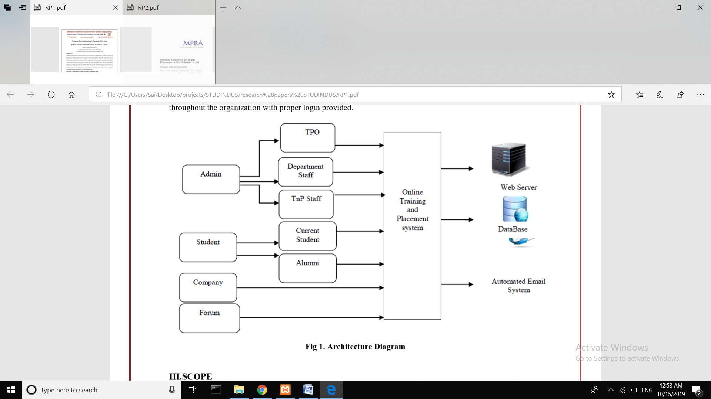

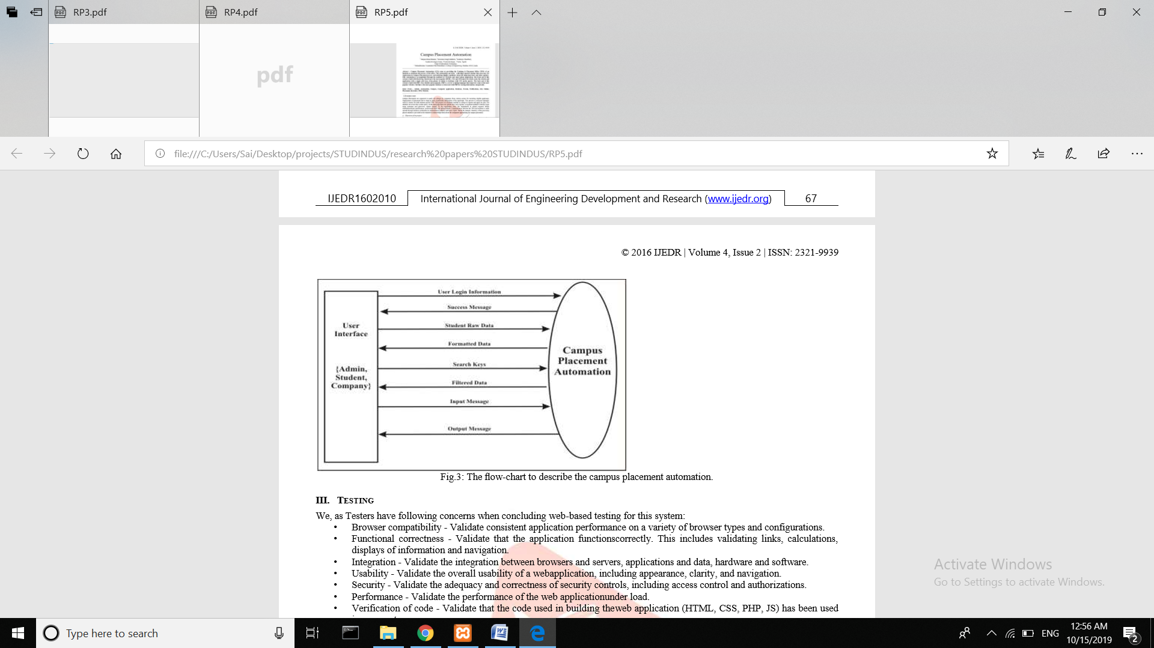

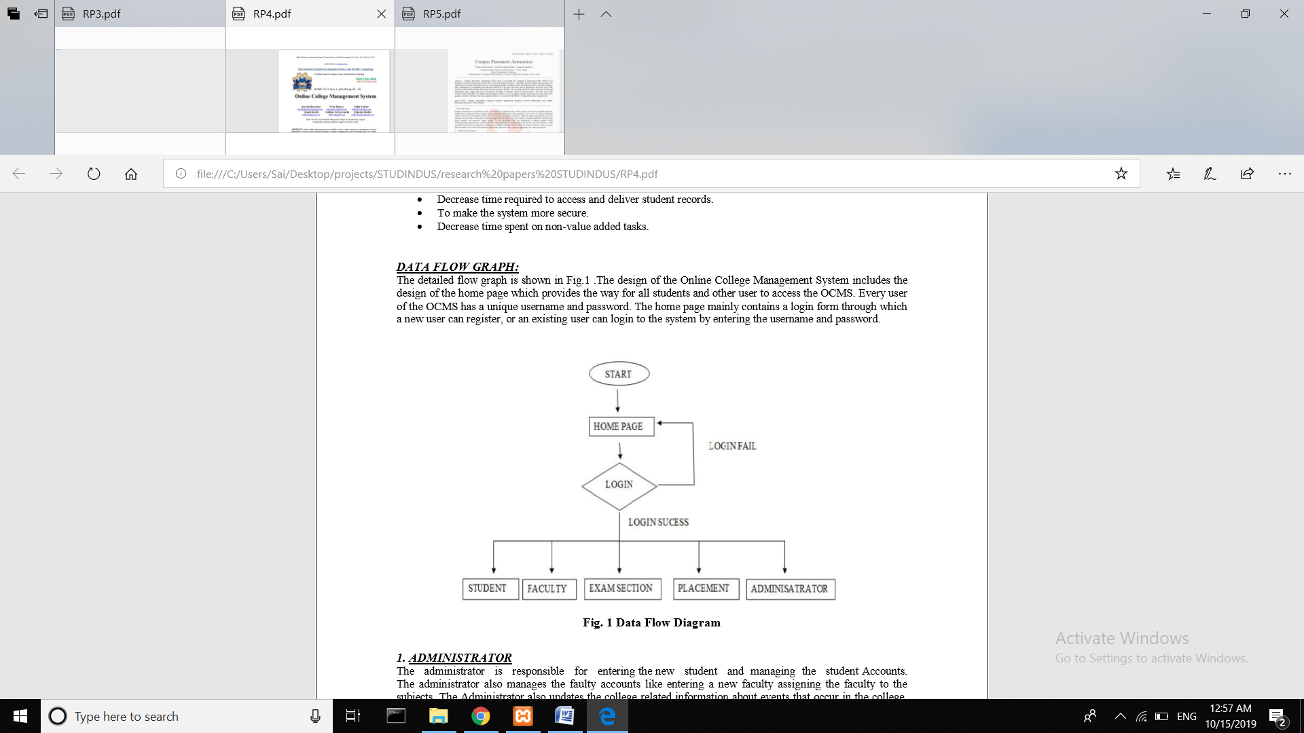

**Platform:**

1. Server :mysql
2. Front end : PHP, HTML5, J.S, A.J.S, VISUAL STUDIO
3. Back end : JAVA, PY 3.0

**Conclusion:**

This software hence improves the whole placement scenario of the college making it easier for the students not to miss any information of the company coming to the campus and the faculty can give the required orientation in their department.