# Daily Retail Couponz

1. Home Page (main page)
2. Login Page
3. Signup/register page
4. Stores Page – Ven*d*or page (<http://www.frugaa.com/stores/> )
5. Individual vendor pages (for individual pages - <http://www.frugaa.com/stores/101phones/> - example)
6. Submit a Coupon Page
7. Special Offers
8. Payment Page

Login Page

1. My Profile Page
2. Customer
3. Employee
4. Wish List
5. Payment History
6. Added Coupon (History)

Extra’s –

1. Mobile App (.apk application)
2. Mobile Specific Website (not an app)
3. Points Specific Section for registered customer
4. E-Commerce Feature

References –

1. <https://www.thenewboston.com/videos.php?cat=11>
2. [www.frugaa.com](http://www.frugaa.com)
3. [www.retailmenot.com](http://www.retailmenot.com)

Software Required –

1. FTP
2. Dreamweaver

Learn these things

1. Bootstrap Framework- <http://getbootstrap.com/> or <http://www.w3schools.com/bootstrap/default.asp>
2. PHP - <https://www.thenewboston.com/videos.php?cat=11>

Aniket Sarkar

1. Basic structure (in php)

## Login Page

1. Email address
2. Password
3. Sign up with facebook - option

## Register Page

1. Name (firstname lastname)
2. Email id
3. Password / Confirm password page
4. (confirm register link via email) – option

## Store page

1. List down all the vendor page – from database
2. Assign a category for each store

## Individual page for a particular store (**COUPON**)

1. Image of store – *from database or file-manager*
2. Coupon id
3. Deal title
4. Deal description
5. Coupon code
6. *Coupon Link*
7. Expiry date
8. Commenting on single coupon
9. Ratings
10. Category name

## Category page

1. Image of store – *from database or file-manager*
2. Coupon id – fetch coupon based on selected category
3. Deal title, deal description, coupon code, expiry date, commenting on single coupon, ratings
4. Category name

## Submit a Coupon – Email to all employees

1. Store name
2. Coupon Code
3. Deal title
4. Deal description
5. Members Username – (details)

## Logged in Users (**CUSTOMER**)

1. Name (lastname, firstname)
2. Email id
3. Gender
4. DOB
5. Address, zip code
6. Password

## 29th Sep

1. Sign In – Depending on who is signing in (Employee or Customer)

* Employee should have all roles.
* Customer should only have defined roles.

1. Vendor List – Look for available brands
2. Design

* Structure to display a coupon – (Coupon title, Coupon description, Coupon Code)
* Comment section on each coupon

1. Submit a coupon via Email/Database –

# **Login – <http://dev1couponz.dailyretailcouponz.com>**

This is a development website in which we will be working for now.

## Hosting credentials

Cpanel - dealvoucherz.com/cpanel

Username- grabxgvz

Password - 9r3?cS1oG-Ouw

## FTP Credentials – Input these on FILEZILLA (https://filezilla-project.org/)

Host: 37.61.237.93

UserName: [Dailyretail1@grabvoucher.co.uk](mailto:Dailyretail1@grabvoucher.co.uk)

Password: iad620independent

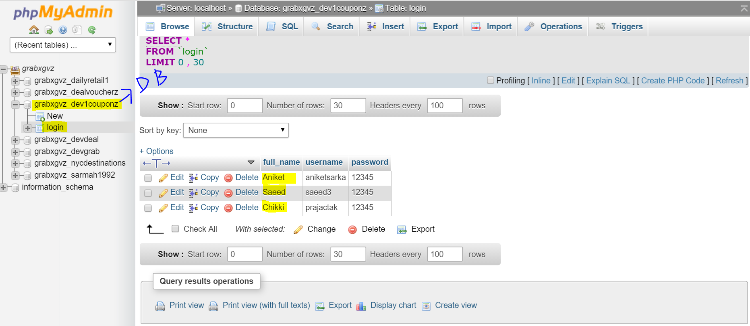

## Database Details we will be working – (database is highlighted above)

Domain name – dev1couponz.dailyretailcouponz.com

Database name - **grabxgvz_dev1couponz**

Database username - **grabxgvz_dev1c**

Database password – **dev1couponz**

*===== this is the database details of main domain server ===========*

*Database Details – Not to be changed – Original Database Details*

*Not to be changed*

*Domain name – dailyretailcouponz.com*

*Database name - grabxgvz_dailyretail1*

*Database username - grabxgvz_daily1*

*Database password – dailyretail1*

==========================================================

Resources –

Login Module

1. <http://www.sourcecodester.com/tutorials/php/4340/how-create-registration-page-phpmysql.html>
2. <http://www.sourcecodester.com/tutorials/php/4341/how-create-login-page-phpmysql.html>
3. <https://frozenade.wordpress.com/2007/11/24/how-to-create-login-page-in-php-and-mysql-with-session/>

1. <http://websistent.com/php-login-page-script/> - we are using

Login Based on roles

1. <http://www.techyari.in/2014/10/multi-user-role-based-login-in-php-with-mysql.html>
2. <http://www.thesoftwareguy.in/creating-multi-user-role-based-admin-using-php-mysql-bootstrap/>