**Chapter 1**

**INTRODUCTION**

**1.1 INTRODUCTION TO COMPUTER GRAPHICS**

Computer Graphics is concerned with all aspects of producing pictures or images using a computer.

**Applications of Computer Graphics**

1. Display of information
2. Design
3. Simulation and animation
4. User interfaces

**The Graphics Architecture**

Graphics Architecture can be made up of seven components:

1. Display processors
2. Pipeline architectures
3. The graphics pipeline
4. Vertex processing
5. Clipping and primitive assembly
6. Rasterization
7. Fragment processing

Input

Devices

Processor

Frame

Buffer

Memory

Output

Device

**Figure 1.1: Components of Graphics Architecture and their working**

**1.2 INTRODUCTION TO OPENGL**

OpenGL is software used to implement computer graphics. The structure of OpenGL is similar to that of most modern APIs including Java 3D and DirectX. OpenGL is easy to learn, compared with other.

APIs are nevertheless powerful. It supports the simple 2D and 3D programs. It also supports the advanced rendering techniques. OpenGL API explains following 3 components

1. Graphics functions
2. Graphics pipeline and state machines
3. The OpenGL interfaces

There are so many polygon types in OpenGL like triangles, quadrilaterals, strips and fans.

There are 2 control functions, which will explain OpenGL through,

1. Interaction with window system

2. Aspect ratio and view ports

**OpenGL**

**Application**

**Program**

**Frame**

**Buffer**

**GLU**

**Xlib, Xtk**

**GL**

**GLUT**

**GLX**

**Figure 1.2: OpenGL Library organization**

Most implementations of OpenGL have a similar order of operations, a series of processing stages called the OpenGL rendering pipeline. This ordering, as shown in Figure 1.2, is not a strict rule of how OpenGL is implemented but provides a reliable guide for predicting what OpenGL will do. The following diagram shows the assembly line approach, which OpenGL takes to process data. Geometric data (vertices, lines, and polygons) follow the path through the row of boxes that includes evaluators and per-vertex operations, while pixel data (pixels, images, and bitmaps) are treated differently for part of the process. Both types of data undergo the same final steps (rasterization and per-fragment operations) before the final pixel data is written into the frame buffer.

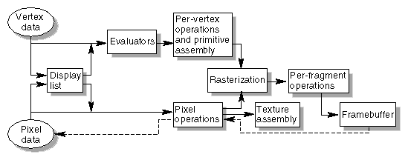

**Figure 1.3: OpenGL Order of Operations**

**Chapter 2**

**REQUIREMENTS SPECIFICATION**

**2.1 SOFTWARE REQUIREMENTS**

* This project runs using Visual Studio 2013
* OPENGL software
* Language used is C/C++

**2.2 HARDWARE REQUIREMENTS**

* There are no rigorous restrictions on the machine configurations. Since OPENGL software is portable, that is, it is platform independent or architecturally neutral it can run on any machine with any configurations.

**2.3 MISCELLANEOUS REQUIREMENTS**

* All the required library files and the header files should be available in the include directory.
* The library files are GL, GLU, and GLUT.

**Chapter 3**

**SYSTEM DEFINITION**

**3.1 Project Description**

The scope is to use the basic primitives defined in openGL library creating complex objects. Users make use of different concepts such as pushmatrix(), translate(), popmatrix(), timer function. When we press ‘S’ the flight takes off and when we press ‘Q’ the program quits. The final goal of the project is that aeroplane crashes , when the aeroplane hits there is a ‘BOOM!’ effect at the end. If the aeroplane crosses the small building it can easily sail, but when it hits a long building there is a ‘BOOM’ effect. The project was a pictorial representation of WTC attack stands for world trade centre attack, which was attacked by terrorists on the date of 9/11.

**3.2 User Defined Functions**

* **myinit() :** This function initializes light source for ambient, diffuse and specular types.
* **display() :** This function creates and translates all the objects in a specified location in a particular order and also rotates the objects in different axes.

**glClear(GL_COLOR_BUFFER_BIT);**

**glFlush();**

* **timerfunc() :** This function starts a timer in the event loop that delays the event loop for delay miliseconds.
* **MainLoop() :** This function whose execution will cause the program to begin an event processing loop.
* **PushMatrix() :** Save the present values of attributes and matrices placing , or pushing on the top of the stack.
* **PopMatrix() :** We can recover them by removing them from stack
* **Translated() :** In translate func the variables are components of the displacement vector.
* **main() :** The execution of the program starts from this function. It initializes the graphics system and includes many callback functions.
* **PostRedisplay() :** It ensures that the display will be drawn only once each time the program goes through the event loop.

**3.3 Flow diagram**

Press Q

Keyboard

Press S

Window/Display 1

Plane Take-off

Window/Display 2

Plane Flying

Window/Display 2

Plane Crash on WTC

STOP

**Fig 3.3.1 : System Architecture**

**Chapter 4**

**IMPLEMENTATION**

**4.1 Source Code**

#include <stdio.h>

#include <glut.h>

GLfloat a = 0, b = 0, c = 0, d = 0, e = 0;

void building();

void building1();

void outline();

void blast();

void road();

void display2();

void display3();

void build_outline();

void update(int value){

a += 20.0; //Plane position takeoff on x axis

b -= 10.0; //Road Strip backward movement

c += 15; //take off at certain angle on y axis

if (b <= -78.0) // moving of run way

b = 0.0;

glutPostRedisplay();

glutTimerFunc(150, update, 0); //delay

}

void display(void){

glClear(GL_COLOR_BUFFER_BIT);

road();

glPushMatrix();

glTranslated(a, c, 0.0);

glColor3f(1.0, 1.0, 1.0);

glBegin(GL_POLYGON); //rectangular body

glVertex2f(0.0, 30.0);

glVertex2f(0.0, 55.0);

glVertex2f(135.0, 55.0);

glVertex2f(135.0, 30.0);

glEnd();

glPopMatrix();

glPushMatrix();

glTranslated(a, c, 0.0);

glColor3f(1.0, 1.0, 1.0);

glBegin(GL_POLYGON); //upper triangle construction plane

glVertex2f(135.0, 55.0);

glVertex2f(150.0, 50.0);

glVertex2f(155.0, 45.0);

glVertex2f(160.0, 40.0);

glVertex2f(135.0, 40.0);

glEnd();

glPopMatrix();

glPushMatrix();

glTranslated(a, c, 0.0);

glColor3f(0.0, 0.0, 0.0);

glBegin(GL_LINE_LOOP); //outline of upper triangle plane

glVertex2f(135.0, 55.0);

glVertex2f(150.0, 50.0);

glVertex2f(155.0, 45.0);

glVertex2f(160.0, 40.0);

glVertex2f(135.0, 40.0);

glEnd();

glPopMatrix();

glPushMatrix();

glTranslated(a, c, 0.0);

glColor3f(1.0, 0.0, 0.0);

glBegin(GL_POLYGON); //lower triangle

glVertex2f(135.0, 40.0);

glVertex2f(160.0, 40.0);

glVertex2f(160.0, 37.0);

glVertex2f(145.0, 30.0);

glVertex2f(135.0, 30.0);

glEnd();

glPopMatrix();

glPushMatrix();

glTranslated(a, c, 0.0);

glColor3f(1.0, 0.0, 0.0);

glBegin(GL_POLYGON); //back wing

glVertex2f(0.0, 55.0);

glVertex2f(0.0, 80.0);

glVertex2f(10.0, 80.0);

glVertex2f(40.0, 55.0);

glEnd();

glPopMatrix();

glPushMatrix();

glTranslated(a, c, 0.0);

glColor3f(1.0, 0.0, 0.0);

glBegin(GL_POLYGON); //left side wing

glVertex2f(65.0, 55.0);

glVertex2f(50.0, 70.0);

glVertex2f(75.0, 70.0);

glVertex2f(90.0, 55.0);

glEnd();

glPopMatrix();

glPushMatrix();

glTranslated(a, c, 0.0);

glColor3f(1.0, 0.0, 0.0);

glBegin(GL_POLYGON); //rightside wing

glVertex2f(70.0, 40.0);

glVertex2f(100.0, 40.0);

glVertex2f(80.0, 15.0);

glVertex2f(50.0, 15.0);

glEnd();

glPopMatrix();

if (c > 360) //timer to jump to next display

{

display2();

d += 20; //plane takeoff on x in 2nd display

}

if (a > 500.0) //window position during take off

{

a = 0.0;

b = 0.0;

}

if (c > 750) //timer to jump to 3rd display

{

display3();

e += 20; //plane takeoff on x in 3rd display

if (e > 250) //timer to call blast function

{

blast();

e = 250;

}

}

glFlush();

}

void building(){

glColor3f(0.60, 0.40, 0.70);

glBegin(GL_POLYGON);

glVertex2f(350.0, 80.0);

glVertex2f(350.0, 480.0);

glVertex2f(400.0, 400.0);

glVertex2f(400.0, 0.0);

glEnd();

glColor3f(0.75, 0.75, 0.75);

glBegin(GL_POLYGON);

glVertex2f(400.0, 0.0);

glVertex2f(400.0, 400.0);

glVertex2f(450.0, 400.0);

glVertex2f(450.0, 0.0);

glEnd();

glColor3f(1.0, 1.0, 1.0);

glBegin(GL_POLYGON);

glVertex2f(400.0, 400.0);

glVertex2f(350.0, 480.0);

glVertex2f(400.0, 480.0);

glVertex2f(450.0, 400.0);

glEnd();

glColor3f(0.60, 0.40, 0.70);

glBegin(GL_POLYGON); //upper triangle of building

glVertex2f(400.0, 400.0);

glVertex2f(350.0, 480.0);

glVertex2f(400.0, 480.0);

glEnd();

glColor3f(0.0, 0.0, 0.0);

glBegin(GL_LINES); //seperation line of floors

glVertex2f(350.0, 180);

glVertex2f(400.0, 100);

glEnd();

glColor3f(0.0, 0.0, 0.0);

glBegin(GL_LINES);

glVertex2f(350.0, 280);

glVertex2f(400.0, 200);

glEnd();

glColor3f(0.0, 0.0, 0.0);

glBegin(GL_LINES);

glVertex2f(350.0, 380);

glVertex2f(400.0, 300);

glEnd();

glColor3f(0.0, 0.0, 0.0);

glBegin(GL_LINES);

glVertex2f(450.0, 100);

glVertex2f(400.0, 100);

glEnd();

glColor3f(0.0, 0.0, 0.0);

glBegin(GL_LINES);

glVertex2f(450.0, 200);

glVertex2f(400.0, 200);

glEnd();

glColor3f(0.0, 0.0, 0.0);

glBegin(GL_LINES);

glVertex2f(450.0, 300);

glVertex2f(400.0, 300);

glColor3f(0.0, 0.0, 0.0);

glBegin(GL_LINES);

glVertex2f(350.0, 180);

glEnd();

//2nd

glColor3f(0.60, 0.40, 0.70);

glBegin(GL_POLYGON);

glVertex2f(250.0, 80.0);

glVertex2f(250.0, 380.0);

glVertex2f(300.0, 300.0);

glVertex2f(300.0, 0.0);

glEnd();

glColor3f(0.75, 0.75, 0.75);

glBegin(GL_POLYGON);

glVertex2f(300.0, 0.0);

glVertex2f(300.0, 300.0);

glVertex2f(350.0, 300.0);

glVertex2f(350.0, 0.0);

glEnd();

glColor3f(1.0, 1.0, 1.0);

glBegin(GL_POLYGON);

glVertex2f(300.0, 300.0);

glVertex2f(250.0, 380.0);

glVertex2f(300.0, 380.0);

glVertex2f(350.0, 300.0);

glEnd();

glColor3f(0.60, 0.40, 0.70);

glBegin(GL_POLYGON); //upper triangle of building

glVertex2f(300.0, 300.0);

glVertex2f(250.0, 380.0);

glVertex2f(300.0, 380.0);

glEnd();

glColor3f(0.0, 0.0, 0.0);

glBegin(GL_LINES); //seperation line of floors

glVertex2f(250.0, 80);

glVertex2f(300.0, 0.0);

glEnd();

glColor3f(0.0, 0.0, 0.0);

glBegin(GL_LINES);

glVertex2f(250.0, 180);

glVertex2f(300.0, 100);

glEnd();

glColor3f(0.0, 0.0, 0.0);

glBegin(GL_LINES);

glVertex2f(250.0, 280);

glVertex2f(300.0, 200);

glEnd();

glColor3f(0.0, 0.0, 0.0);

glBegin(GL_LINES);

glVertex2f(350.0, 0.0);

glVertex2f(300.0, 0.0);

glEnd();

glColor3f(0.0, 0.0, 0.0);

glBegin(GL_LINES);

glVertex2f(250.0, 100);

glVertex2f(300.0, 100);

glEnd();

glColor3f(0.0, 0.0, 0.0);

glBegin(GL_LINES);

glVertex2f(350.0, 200);

glVertex2f(300.0, 200);

glColor3f(0.0, 0.0, 0.0);

glBegin(GL_LINES);

glVertex2f(250.0, 80);

glEnd();

build_outline();

}

void build_outline() //building out lines

{

glColor3f(0.0, 0.0, 0.0);

glBegin(GL_LINE_LOOP);

glVertex2f(350.0, 80.0);

glVertex2f(350.0, 480.0);

glVertex2f(400.0, 400.0);

glVertex2f(400.0, 0.0);

glEnd();

glColor3f(0.0, 0.0, 0.0);

glBegin(GL_LINE_LOOP);

glVertex2f(400.0, 0.0);

glVertex2f(400.0, 400.0);

glVertex2f(450.0, 400.0);

glVertex2f(450.0, 0.0);

glEnd();

glColor3f(0.0, 0.0, 0.0);

glBegin(GL_LINE_LOOP);

glVertex2f(400.0, 400.0);

glVertex2f(350.0, 480.0);

glVertex2f(400.0, 480.0);

glVertex2f(450.0, 400.0);

glEnd();

glColor3f(0.0, 0.0, 0.0);

glBegin(GL_LINE_LOOP);

glVertex2f(250.0, 80.0);

glVertex2f(250.0, 380.0);

glVertex2f(300.0, 300.0);

glVertex2f(300.0, 0.0);

glEnd();

glColor3f(0.0, 0.0, 0.0);

glBegin(GL_LINE_LOOP);

glVertex2f(300.0, 0.0);

glVertex2f(300.0, 300.0);

glVertex2f(350.0, 300.0);

glVertex2f(350.0, 0.0);

glEnd();

glColor3f(0.0, 0.0, 0.0);

glBegin(GL_LINE_LOOP);

glVertex2f(300.0, 300.0);

glVertex2f(250.0, 380.0);

glVertex2f(300.0, 380.0);

glVertex2f(350.0, 300.0);

glEnd();

}

void blast(void) //blast polygon construction

{

glPushMatrix();

glTranslated(-10.0, -60.0, 0.0);

glColor3f(1.0, 0.0, 0.0);

glBegin(GL_POLYGON);

glVertex2f(404.4, 320.0);

glVertex2f(384.0, 285.0);

glColor3f(0.0, 0.0, 1.0);

glVertex2f(368.0, 344.5);

glVertex2f(344.0, 355.0);

glVertex2f(347.2, 414.5);

glColor3f(0.0, 1.0, 0.0);

glVertex2f(332.8, 442.5);

glVertex2f(347.2, 477.5);

glVertex2f(352.0, 530.0);

glVertex2f(379.2, 519.5);

glColor3f(0.0, 0.0, 1.0);

glVertex2f(396.8, 565.0);

glVertex2f(416.0, 530.0);

glVertex2f(440.0, 547.5);

glColor3f(1.0, 1.0, 0.0);

glVertex2f(452.8, 512.5);

glVertex2f(472.0, 512.5);

glVertex2f(475.2, 470.5);

glColor3f(0.0, 1.0, 1.0);

glVertex2f(488.0, 442.5);

glVertex2f(488.0, 404.0);

glVertex2f(470.0, 372.5);

glColor3f(0.3, 1.0, 0.6);

glVertex2f(475.2, 337.5);

glVertex2f(464.0, 306.0);

glVertex2f(444.8, 320.0);

glVertex2f(425.6, 285.0);

glVertex2f(404.8, 320.0);

glEnd();

glPopMatrix();

}

void road(){

glColor3f(0.0, 0.0, 0.0);

glBegin(GL_POLYGON); //black road

glVertex2f(0.0, 0.0);

glVertex2f(0.0, 100.0);

glVertex2f(500.0, 100.0);

glVertex2f(500.0, 0.0);

glEnd();

glPopMatrix();

glPushMatrix();

glTranslated(b, 0.0, 0.0);

glColor3f(1.0, 1.0, 1.0);

glBegin(GL_POLYGON); //white strips on roadglVertex2f(0.0,40.0);

glVertex2f(8.0, 60.0);

glVertex2f(58.0, 60.0);

glVertex2f(50.0, 40.0);

glEnd();

glPopMatrix();

glPushMatrix();

glTranslated(b, 0.0, 0.0);

glColor3f(1.0, 1.0, 1.0);

glBegin(GL_POLYGON);

glVertex2f(100.0, 40.0);

glVertex2f(108.0, 60.0);

glVertex2f(158.0, 60.0);

glVertex2f(150.0, 40.0);

glEnd();

glPopMatrix();

glPushMatrix();

glTranslated(b, 0.0, 0.0);

glColor3f(1.0, 1.0, 1.0);

glBegin(GL_POLYGON);

glVertex2f(200.0, 40.0);

glVertex2f(208.0, 60.0);

glVertex2f(258.0, 60.0);

glVertex2f(250.0, 40.0);

glEnd();

glPopMatrix();

glPushMatrix();

glTranslated(b, 0.0, 0.0);

glColor3f(1.0, 1.0, 1.0);

glBegin(GL_POLYGON);

glVertex2f(300.0, 40.0);

glVertex2f(308.0, 60.0);

glVertex2f(358.0, 60.0);

glVertex2f(350.0, 40.0);

glEnd();

glPopMatrix();

glPushMatrix();

glTranslated(b, 0.0, 0.0);

glColor3f(1.0, 1.0, 1.0);

glBegin(GL_POLYGON);

glVertex2f(400.0, 40.0);

glVertex2f(408.0, 60.0);

glVertex2f(458.0, 60.0);

glVertex2f(450.0, 40.0);

glEnd();

glPopMatrix();

}

void display2(){

glClear(GL_COLOR_BUFFER_BIT);

glPushMatrix();

glTranslated(d, 300.0, 0.0);

glColor3f(1.0, 1.0, 1.0);

glBegin(GL_POLYGON);

glVertex2f(0.0, 30.0); //rectangulr body

glVertex2f(0.0, 55.0);

glVertex2f(135.0, 55.0);

glVertex2f(135.0, 30.0);

glEnd();

glPopMatrix();

glPushMatrix();

glTranslated(d, 300.0, 0.0);

glColor3f(1.0, 1.0, 1.0);

glBegin(GL_POLYGON);

glVertex2f(135.0, 55.0); //upper triangle construction plane

glVertex2f(150.0, 50.0);

glVertex2f(155.0, 45.0);

glVertex2f(160.0, 40.0);

glVertex2f(135.0, 40.0);

glEnd();

glPopMatrix();

glPushMatrix();

glTranslated(d, 300.0, 0.0);

glColor3f(0.0, 0.0, 0.0);

glBegin(GL_LINE_LOOP);

glVertex2f(135.0, 55.0); //upper triangle construction plane

glVertex2f(150.0, 50.0);

glVertex2f(155.0, 45.0);

glVertex2f(160.0, 40.0);

glVertex2f(135.0, 40.0);

glEnd();

glPopMatrix();

glPushMatrix();

glTranslated(d, 300.0, 0.0);

glColor3f(1.0, 0.0, 0.0);

glBegin(GL_POLYGON); //lower triangle

glVertex2f(135.0, 40.0);

glVertex2f(160.0, 40.0);

glVertex2f(160.0, 37.0);

glVertex2f(145.0, 30.0);

glVertex2f(135.0, 30.0);

glEnd();

glPopMatrix();

glPushMatrix();

glTranslated(d, 300.0, 0.0);

glColor3f(1.0, 0.0, 0.0);

glBegin(GL_POLYGON); //back wing

glVertex2f(0.0, 55.0);

glVertex2f(0.0, 80.0);

glVertex2f(10.0, 80.0);

glVertex2f(40.0, 55.0);

//glVertex2f(165.0,40.0);

glEnd();

glPopMatrix();

glPushMatrix();

glTranslated(d, 300.0, 0.0);

glColor3f(1.0, 0.0, 0.0);

glBegin(GL_POLYGON); //left side wing

glVertex2f(65.0, 55.0);

glVertex2f(50.0, 70.0);

glVertex2f(75.0, 70.0);

glVertex2f(90.0, 55.0);

glEnd();

glPopMatrix();

glPushMatrix();

glTranslated(d, 300.0, 0.0);

glColor3f(1.0, 0.0, 0.0);

glBegin(GL_POLYGON);

glVertex2f(70.0, 40.0);

glVertex2f(100.0, 40.0);

glVertex2f(80.0, 15.0);

glVertex2f(50.0, 15.0);

glEnd();

glPopMatrix();

//3

glColor3f(0.60, 0.40, 0.70);

glBegin(GL_POLYGON);

glVertex2f(150.0, 80.0);

glVertex2f(150.0, 280.0);

glVertex2f(200.0, 200.0);

glVertex2f(200.0, 0.0);

glEnd();

glColor3f(0.75, 0.75, 0.75);

glBegin(GL_POLYGON);

glVertex2f(200.0, 0.0);

glVertex2f(200.0, 200.0);

glVertex2f(250.0, 200.0);

glVertex2f(250.0, 0.0);

glEnd();

glColor3f(1.0, 1.0, 1.0);

glBegin(GL_POLYGON);

glVertex2f(200.0, 200.0);

glVertex2f(150.0, 280.0);

glVertex2f(200.0, 280.0);

glVertex2f(250.0, 200.0);

glEnd();

glColor3f(0.60, 0.40, 0.70);

glBegin(GL_POLYGON); //upper triangle of building

glVertex2f(200.0, 200.0);

glVertex2f(150.0, 280.0);

glVertex2f(200.0, 280.0);

glEnd();

glColor3f(0.0, 0.0, 0.0);

glBegin(GL_LINES); //seperation line of floors

glVertex2f(150.0, 80);

glVertex2f(200.0, 0.0);

glEnd();

glColor3f(0.0, 0.0, 0.0);

glBegin(GL_LINES);

glVertex2f(150.0, 180);

glVertex2f(200.0, 100);

glEnd();

glColor3f(0.0, 0.0, 0.0);

glBegin(GL_LINES);

glVertex2f(150.0, 280);

glVertex2f(200.0, 200);

glEnd();

glColor3f(0.0, 0.0, 0.0);

glBegin(GL_LINES);

glVertex2f(250.0, 0.0);

glVertex2f(200.0, 0.0);

glEnd();

glColor3f(0.0, 0.0, 0.0);

glBegin(GL_LINES);

glVertex2f(150.0, 100);

glVertex2f(200.0, 100);

glEnd();

glColor3f(0.0, 0.0, 0.0);

glBegin(GL_LINES);

glVertex2f(250.0, 200);

glVertex2f(200.0, 200);

glColor3f(0.0, 0.0, 0.0);

glBegin(GL_LINES);

glVertex2f(150.0, 80);

glEnd();

}

void display3(){

glClear(GL_COLOR_BUFFER_BIT);

building();

building();

glPushMatrix();

glTranslated(e, 300.0, 0.0);

glColor3f(1.0, 1.0, 1.0);

glBegin(GL_POLYGON);

glVertex2f(0.0, 30.0); //rectangular body

glVertex2f(0.0, 55.0);

glVertex2f(135.0, 55.0);

glVertex2f(135.0, 30.0);

glEnd();

glPopMatrix();

glPushMatrix();

glTranslated(e, 300.0, 0.0);

glColor3f(1.0, 1.0, 1.0);

glBegin(GL_POLYGON);

glVertex2f(135.0, 55.0);

glVertex2f(150.0, 50.0);

glVertex2f(155.0, 45.0);

glVertex2f(160.0, 40.0);

glVertex2f(135.0, 40.0);

glEnd();

glPopMatrix();

glPushMatrix();

glTranslated(e, 300.0, 0.0);

glColor3f(0.0, 0.0, 0.0);

glBegin(GL_LINE_LOOP);

glVertex2f(135.0, 55.0);

glVertex2f(150.0, 50.0);

glVertex2f(155.0, 45.0);

glVertex2f(160.0, 40.0);

glVertex2f(135.0, 40.0);

glEnd();

glPopMatrix();

glPushMatrix();

glTranslated(e, 300.0, 0.0);

glColor3f(1.0, 0.0, 0.0);

glBegin(GL_POLYGON); //lower triangle

glVertex2f(135.0, 40.0);

glVertex2f(160.0, 40.0);

glVertex2f(160.0, 37.0);

glVertex2f(145.0, 30.0);

glVertex2f(135.0, 30.0);

glEnd();

glPopMatrix();

glPushMatrix();

glTranslated(e, 300.0, 0.0);

glColor3f(1.0, 0.0, 0.0);

glBegin(GL_POLYGON); //back wing

glVertex2f(0.0, 55.0);

glVertex2f(0.0, 80.0);

glVertex2f(10.0, 80.0);

glVertex2f(40.0, 55.0);

//glVertex2f(165.0,40.0);

glEnd();

glPopMatrix();

glPushMatrix();

glTranslated(e, 300.0, 0.0);

glColor3f(1.0, 0.0, 0.0);

glBegin(GL_POLYGON);

glVertex2f(65.0, 55.0);

glVertex2f(50.0, 70.0);

glVertex2f(75.0, 70.0);

glVertex2f(90.0, 55.0);

//glVertex2f(165.0,40.0);

glEnd();

glPopMatrix();

glPushMatrix();

glTranslated(e, 300.0, 0.0);

glColor3f(1.0, 0.0, 0.0);

glBegin(GL_POLYGON);

glVertex2f(70.0, 40.0);

glVertex2f(100.0, 40.0);

glVertex2f(80.0, 15.0);

glVertex2f(50.0, 15.0);

glEnd();

glPopMatrix();

}

void myinit(){

glClearColor(0.196078, 0.6, 0.8, 1);

glColor3f(1.0, 0.0, 0.0);

glPointSize(1.0);

glMatrixMode(GL_PROJECTION);

glLoadIdentity();

gluOrtho2D(0.0, 499.0, 0.0, 499.0);

}

void keys(unsigned char key, int x, int y){

if (key == 's'){

glutTimerFunc(100, update, 0);

}

if (key == 'q') exit(0);

}

void main(int argc, char* argv[]){

glutInit(&argc, argv);

glutInitDisplayMode(GLUT_SINGLE | GLUT_RGB);

glutInitWindowSize(500.0, 500.0);

glutInitWindowPosition(0, 0);

glutCreateWindow("AERO");

glutDisplayFunc(display);

myinit();

glutKeyboardFunc(keys);

//glutTimerFunc(100, update, 0);

glutMainLoop();

}

**Chapter 5**

**TESTING AND RESULTS**

**5.1 Different types of testing**

**1. Unit Testing**

Individual components are tested to ensure that they operate correctly. Each component is tested independently, without other system components.

**2. Module Testing**

A module is a collection of dependent components such as a object class, an abstract data type or some looser collection of procedures and functions. A module related components, so can be tested without other system modules.

**3. System Testing**

This is concerned with finding errors that result from unanticipated interaction between sub-system interface problems.

**4. Acceptance Testing**

The system is tested with data supplied by the system customer rather than simulated test data.

**5.2 TEST CASES FOR THE PROJECT**

|  |  |  |  |  |
| --- | --- | --- | --- | --- |
| **SLNO** | **TEST INPUT** | **EXPECTED RESULTS** | **OBSERVED RESULTS** | **REMARKS** |
| 1. | Press S | Plane take off. | Plane takes off. | PASS |
| 2. | Press Q | Quit Program | Quits program | PASS |

Table 5.2: Test cases

**Chapter 6**

**Screenshots**

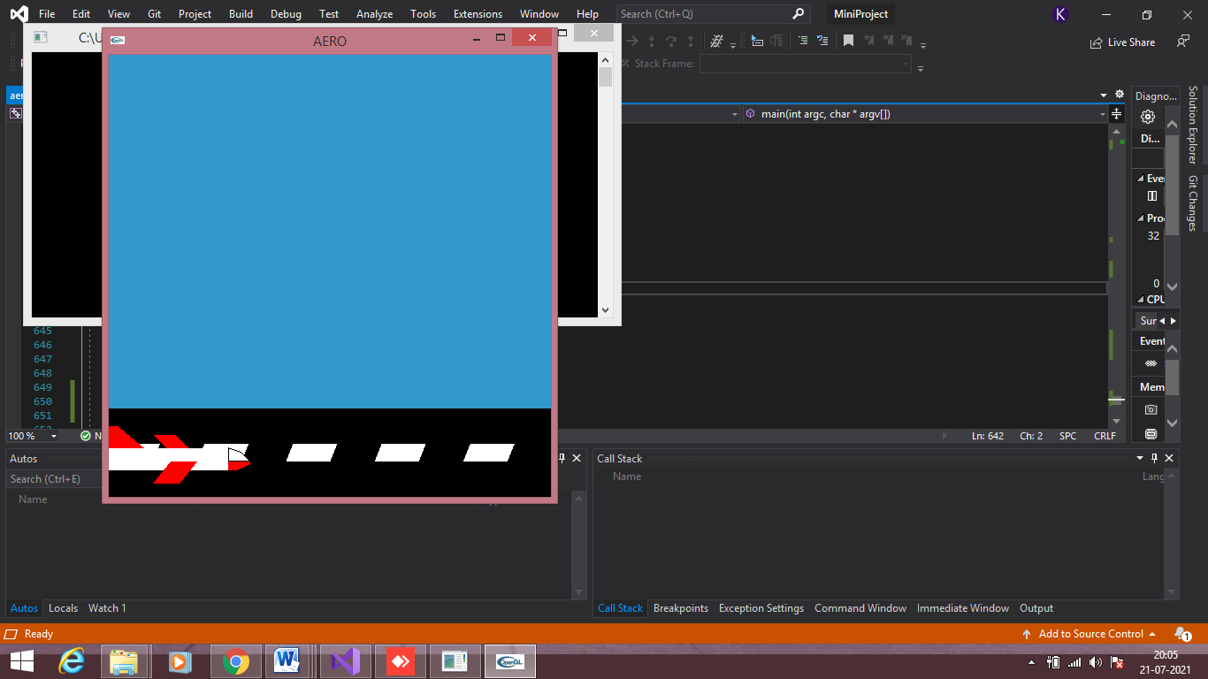

**Screenshot 6.1. Flight on run-way**

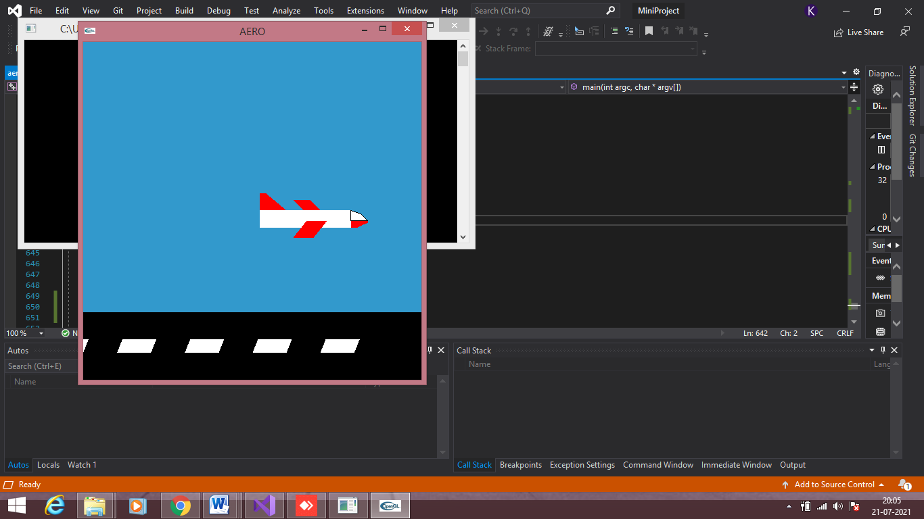

**Screenshot 6.2. Flight when take off**

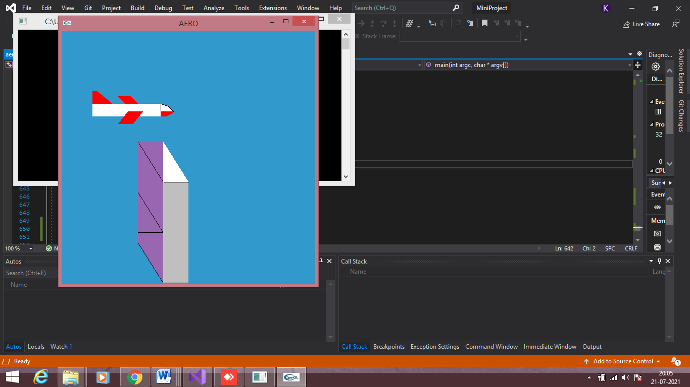

**Screenshot 6.3: Display 2**

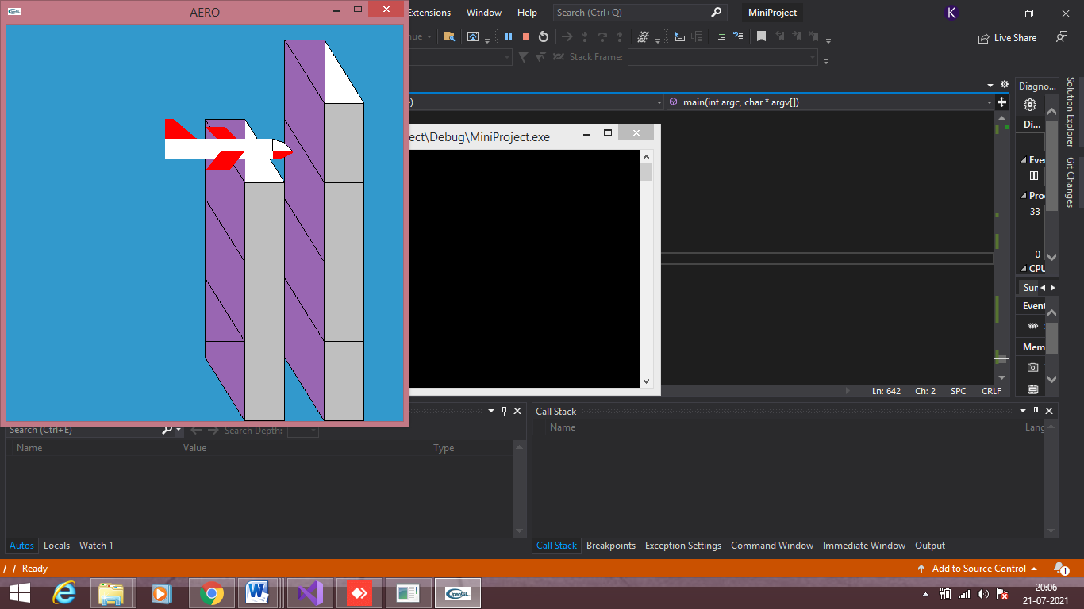

**Screenshot 6.4: Display 3**

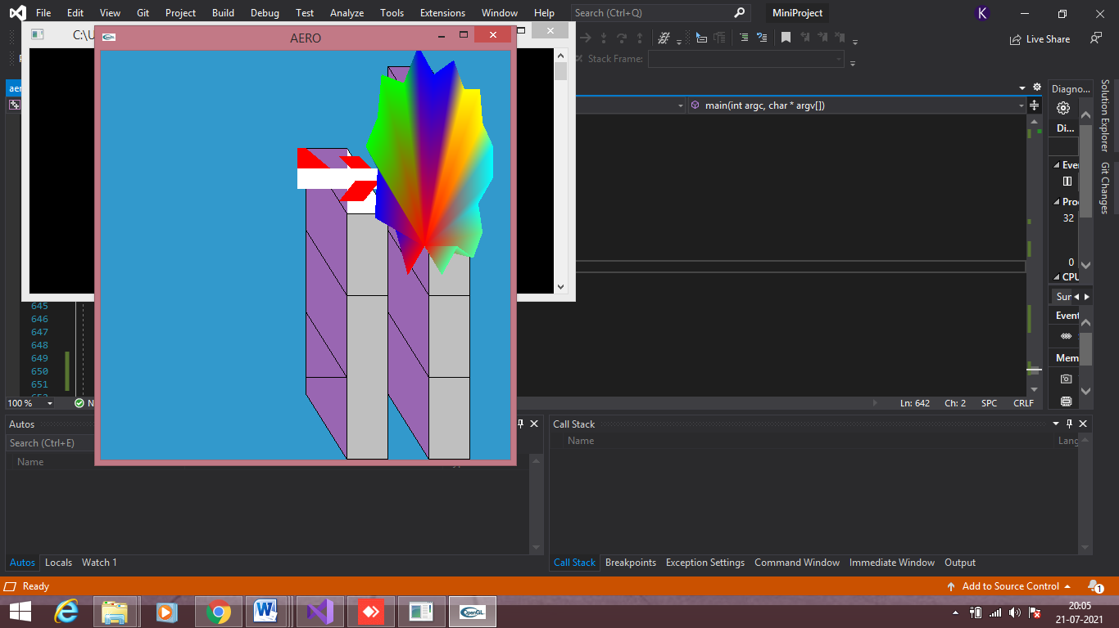

**Screenshot 6.5: Crashing simulation (Display 3)**

Chapter 7

CONCLUSION

The project has been successful in demonstrating Aeroplane crashing simulation/game using a variety of features and options present in OpenGL. The project combines the richness of the graphics library and programming skills. The development of this project was very helpful to demonstrate the crashing simulation of aeroplane. Designing this Project, gave a good learning experience. It helped a lot to learn about computer graphics and design of graphical interfaces. The project thought how the inbuilt and user defined functions can be integrated to produce an efficient working code. The development of the mini project has given a good exposure to OpenGL by which some of the techniques which help in development of animated pictures and gaming were learnt.

**Chapter 8**

**BIBLIOGRAPHY**

#### Books

[1] Computer Graphics with OpenGL(4th ed.) [Hearn, Baker & Carithers 2013]

[2] Edward Angel: Interactive Computer Graphics- A Top Down approach with OpenGL,5th edition. Pearson Education, 2008

**Websites**

[3] https://www.opengl.org/

[4] https://www.glprogramming.com/red/

[5] https://www.codeproject.com/