Experiment-09
Execute and display the results for the following Nmap Timing and performance commands in Kali Linux operating Systems:

Aim: To execute and study the Polite and normal IDS evasion commands in the Kali Linux operating system and observe their outputs.
- polite IDS evasion: The -T2 option performs the Nmap scan at a slow and polite speed, reducing network traffic and minimizing the load on the target system.
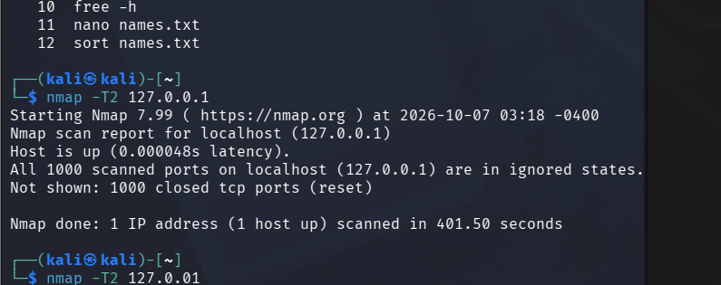(ii) normal IDS evasion: The -T3 option performs the Nmap scan at a normal speed, providing a balance between scanning speed and networkperformance.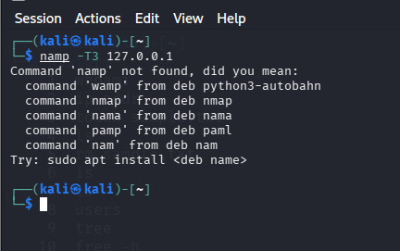

RESULT : we successfully executed and their outputs were observed in the Kali Linux operating system.

