Experiment-10
10. To execute the following commands in Kali Linux Operating Systems:
Free command
Sort command
History command
AIM : To execute and study the free , sort and history commands in the Kali Linux operating system and observe their outputs.
Description:
Free Command: Used to display the available, used, and total memory (RAM) and swap memory in the system.
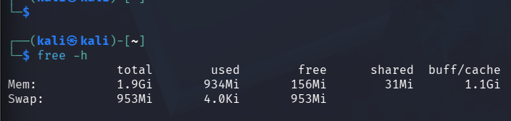
Sort Command : Used to arrange the contents of a file or input in a specific order, usually alphabetically or numerically.
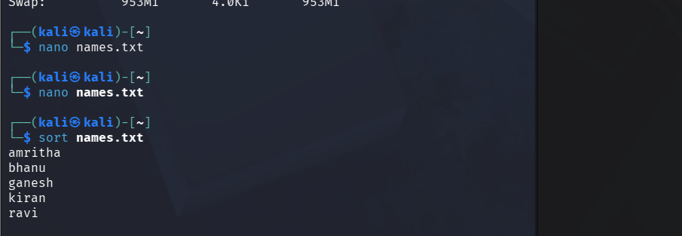

History command: Used to display the list of previously executed commands in the terminal.
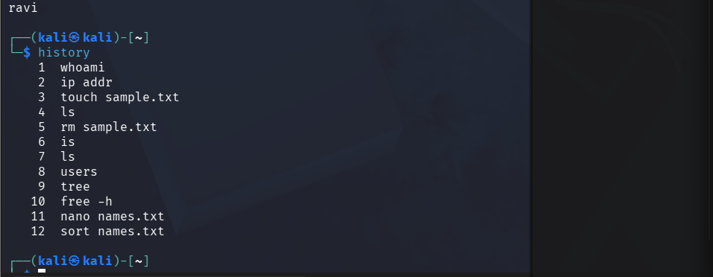

RESULT : we successfully executed and their outputs were observed in the Kali Linux operating system.

