Experiment-11

11. Execute and display the results for the following Nmap Timing and performance
commands in Kali Linux operating Systems:
(i) aggressive speed scan
(ii) insane speed scan
Aim: To execute and display the results of aggressive speed scan and insane speed scan using Nmap in Kali Linux.
Description: Nmap is a network scanning tool used to identify open ports and services on a target system. It provides timing options to control scanning speed. Aggressive speed scan uses -T4, while insane speed scan uses -T5.

(i) aggressive speed scan
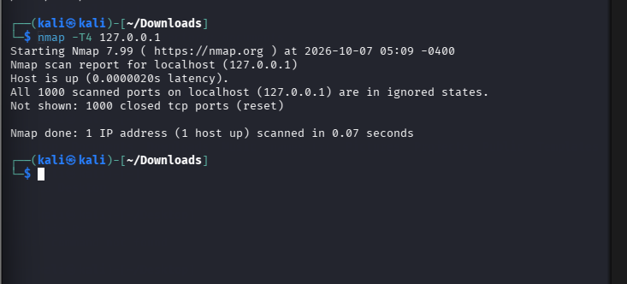

(ii) insane speed scan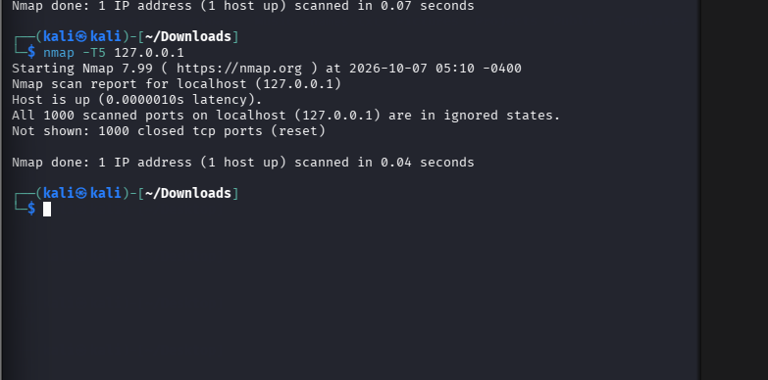
RESULT : we successfully executed and their outputs were observed in the Kali Linux operating system.

