Assignment-CO1

Name: PALLE AMRUTHA
Roll No.: 192372359
Course Code & CO: CSA0902, CO1
Assignment Set: Direct-Descriptive
Question No.: 23
Assigned Question
23. Iterating a HashMap with entrySet()
Write a Java program that creates a HashMap containing several key-value pairs, and then iterates over all of its entries using the entrySet() method combined with a loop over Map.Entry objects. For each entry, display the key and its corresponding value in a clearly formatted line.
Concepts: HashMap, entrySet(), Map.Entry.
GitHub Repository Link:
https://github.com/amrutha3542/Java
Submission Date:
31-07-2026

2. PROBLEM UNDERSTANDING :
The program demonstrates how to store data in a HashMap and access all key-value pairs efficiently. It uses the entrySet() method with Map.Entry to iterate through every element and display the key along with its corresponding value in a readable format.

3. APPROACH / DESIGN NOTES
- Used HashMap to store student ID and student name.
- Used put() method to insert key-value pairs.
- Used entrySet() to obtain all map entries.
- Used Map.Entry<Integer, String> inside a for-each loop for iteration.
- Displayed each key and value in a formatted output.
4.Source Code :
import java.util.HashMap;
import java.util.Map;
public class HashMapEntrySetExample {
public static void main(String[] args) {
HashMap<Integer, String> students = new HashMap<>();
students.put(101, "Amrutha");
students.put(102, "Ganesh");
students.put(103, "Rahul");
students.put(104, "Priya");
System.out.println("Student Records:");
for (Map.Entry<Integer, String> entry : students.entrySet()) {
System.out.println(entry.getKey() + " - " + entry.getValue());
}
}
}

Output:
Key: 101 Value: Amrutha
Key: 102 Value: Ganesh
Key: 103 Value: Rahul
Key: 104 Value: Priya
5.Test Cases:
Sl.No | Input | Expected Output | Actual Output
1 | 101-Amrutha,  (Typical case) | Displays all key-value pairs | Displays all key-value pairs
2 | Empty HashMap  (edge case) | No records displayed | No records displayed
3 | Duplicate Key (101,"Amrutha"), then (101,"Anjali") | Latest value replaces previous value | Latest value replaces previous value

6.Screenshots:
Test Case-1:
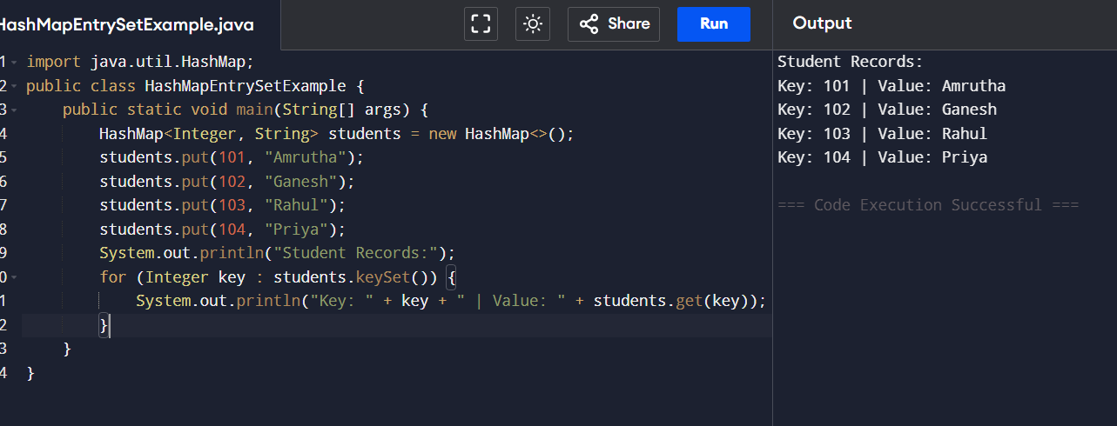

Test Case-2:
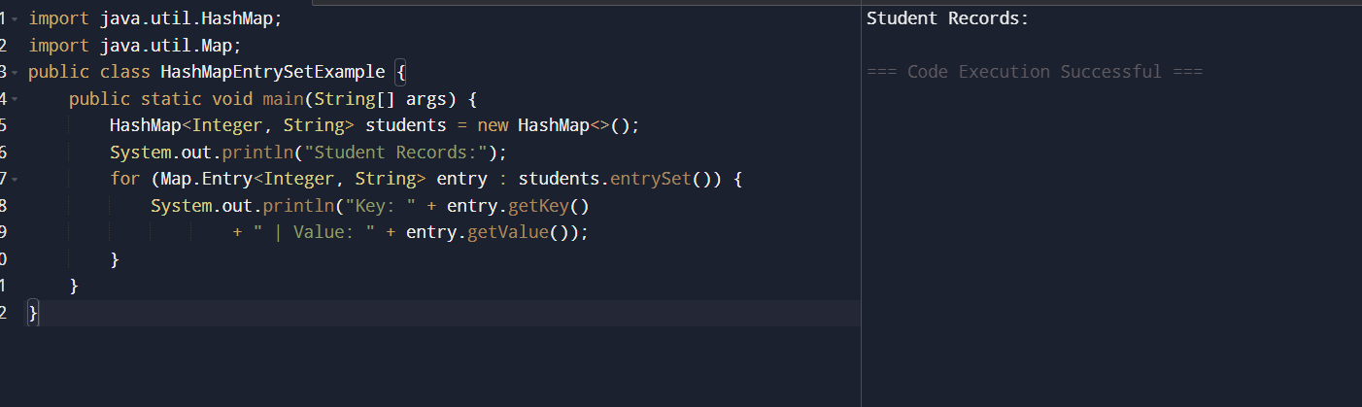

TestCase-3:
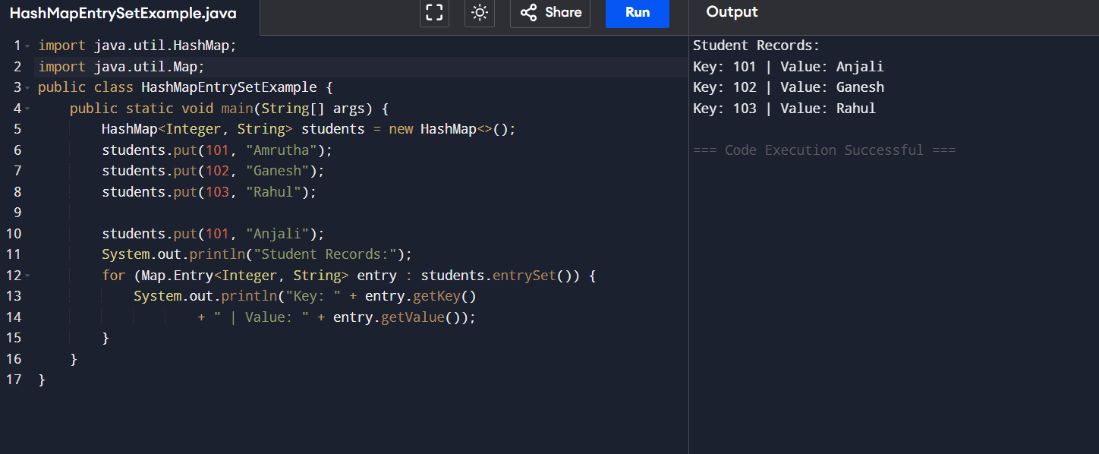

7. REFLECTION
This assignment helped me understand how the HashMap collection stores data using unique keys and corresponding values. I also learned that the entrySet() method provides an efficient way to iterate through all entries, while duplicate keys automatically replace the existing value with the new one.
8.Declaration:
This is my own work. Any AI/external tool assistance used is disclosed above. No external assistance was used in writing the core code logic.

