Assignment-2
1. HEADER
Name: PALLE AMRUTHA
Roll No.:192372359
Course Code & CO: CSA0902, CO2
Assignment Set: Direct-Descriptive
Question No.: 23
Assigned Question
Q23. Creating and Running Multiple Threads
Write a Java program that creates three separate threads, each printing its own identifying message (such as its thread name) a fixed number of times in a loop. Start all three threads at roughly the same time and observe that their output is interleaved unpredictably on the console, demonstrating concurrent execution.
Concepts: Multiple Threads, Concurrent Execution, Interleaving.
GitHub Repository Link:
https://github.com/amrutha3542/Java
Submission Date:
31-07-2026
2. PROBLEM UNDERSTANDING (4–5 lines)
The objective of this program is to understand the concept of multithreading in Java. Three separate threads are created, and each thread performs the same task of printing its own name multiple times. All threads are started almost simultaneously using the start() method. Since the threads execute concurrently, the output appears in a different order each time the program is run.
3. APPROACH / DESIGN NOTES
- Created a custom thread class by extending the Thread class.
- Overrode the run() method to define the task performed by each thread.
- Created three thread objects with different names.
- Started all the threads using the start() method.
- Allowed the operating system to schedule thread execution concurrently.
- Displayed the thread names in a loop to observe interleaved execution.
4. SOURCE CODE:
public class MultipleThreadsExample extends Thread {
String name;
MultipleThreadsExample(String name) {
this.name = name;
}
public void run() {
for(int i = 1; i <= 5; i++) {
System.out.println(name + " Count: " + i);
}
}
public static void main(String[] args) {
MultipleThreadsExample t1 = newMultipleThreadsExample("Thread-1");
MultipleThreadsExample t2 = new MultipleThreadsExample("Thread-2");
MultipleThreadsExample t3 = new MultipleThreadsExample("Thread-3");
t1.start();
t2.start();
t3.start();
}
}

Output:
Thread-2 Count: 1
Thread-2 Count: 2
Thread-2 Count: 3
Thread-2 Count: 4
Thread-2 Count: 5
Thread-1 Count: 1
Thread-1 Count: 2
Thread-1 Count: 3
Thread-1 Count: 4
Thread-1 Count: 5
Thread-3 Count: 1
Thread-3 Count: 2
Thread-3 Count: 3
Thread-3 Count: 4
Thread-3 Count: 5

5.Test Cases
SL.NO | Input | Expected Output | Actual Output
1 | students.put(101,"Amrutha");  students.put(102,"Ganesh");  students.put(103,"Rahul");  students.put(104,"Priya"); | Displays all student IDs with their corresponding names. | Displays all student IDs with their corresponding names.
2 | No entries added (HashMap is empty). | Only the heading is displayed; no key-value pairs are printed. | Only the heading is displayed; no key-value pairs are printed.
3 | students.put(101,"Amrutha");  students.put(101,"Anjali"); | Key 101 displays the updated value Anjali. | Key 101 displays the updated value Anjali.

6.Screenshots:
Test Case-1:
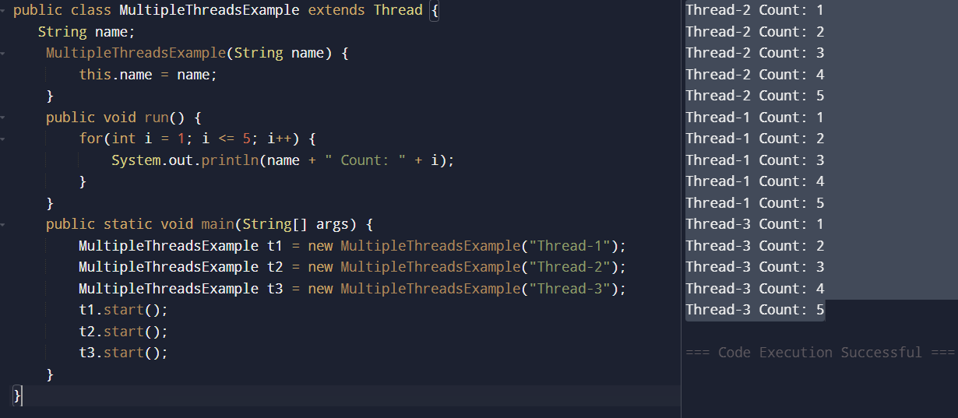

Test Case-2:
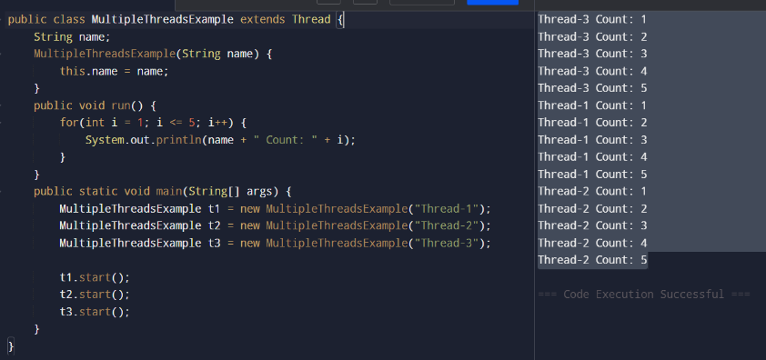

Test case-3:
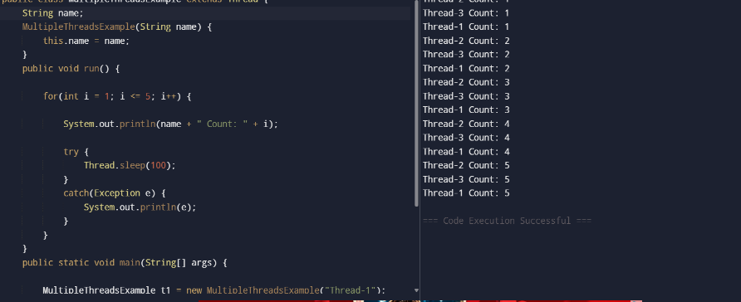

7. REFLECTION :
This program helped me understand how multiple threads can run concurrently in Java. I learned the difference between the start() and run() methods and observed that thread execution order is not fixed. The output changes each time because thread scheduling is managed by the JVM and the operating system. This experiment improved my understanding of concurrent programming concepts.
8.Declaration:
This is my own work. Any AI/external tool assistance used is disclosed above. No external assistance was used in writing the core code logic.

