|  |  |
| --- | --- |
| **Ex No: 3.1**  **Date: 20-08-2024** | **Gradient descent implementation** |

**Objective:**

The objective is to build a deep neural network with multiple hidden layers, using non-linear activation functions like ReLU to improve performance.

**Descriptions:**

The deep neural network was built with functions for initializing, running forward passes, and performing backward passes. Parameters for both simple and complex networks were set up, and activations and cost functions were calculated. Model parameters were updated using ReLU to boost performance. The framework for both basic and advanced forward and backward processes was put in place, making the system robust and efficient. This work prepares for tackling image classification tasks and improving neural network designs in future projects. Experience was also gained in optimizing models and managing complex network structures.

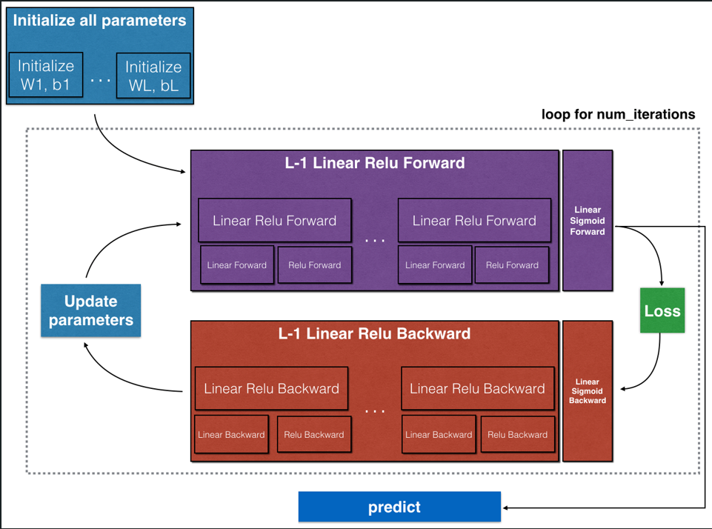

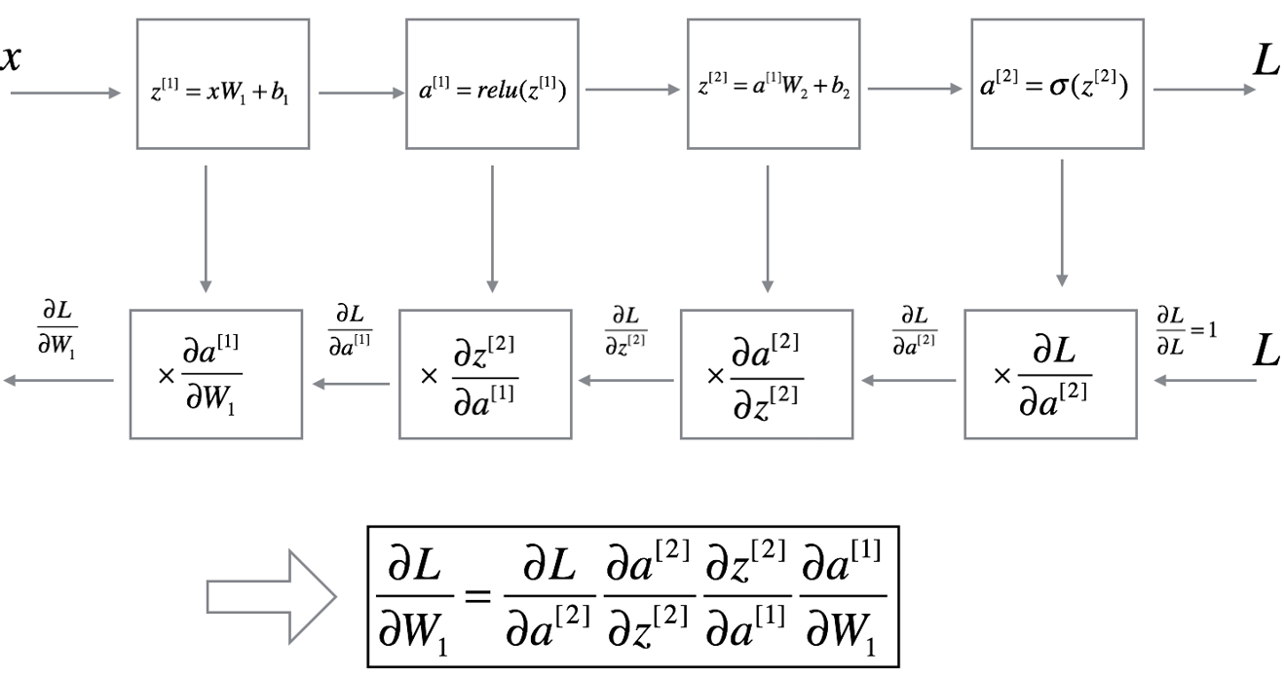

**Model:**

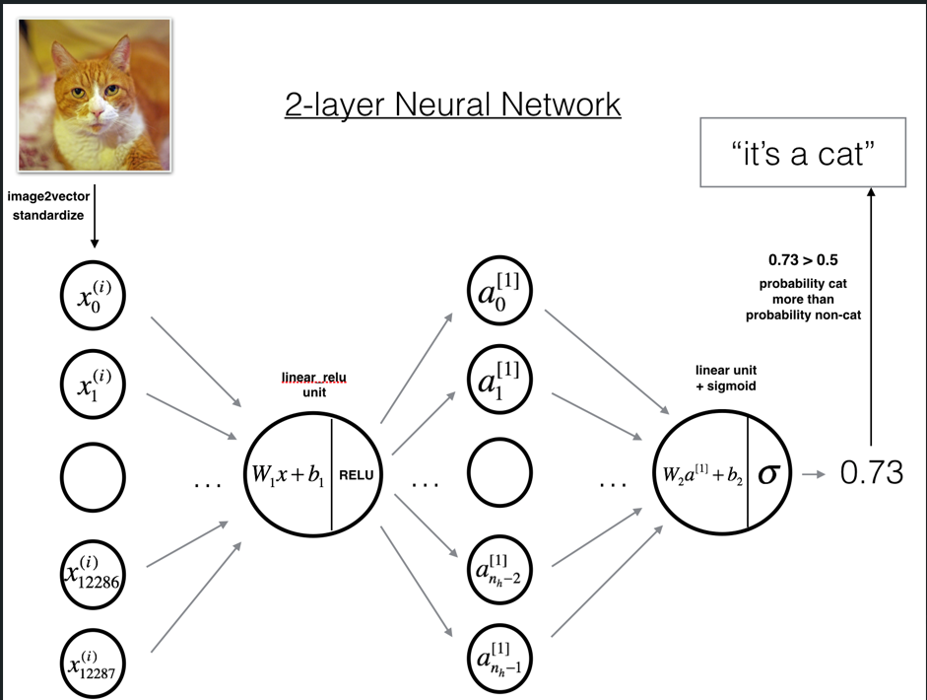

**Building the parts of algorithm**

* Initialize Parameters: Set up weights and biases for each layer of the network.
* Forward Propagation: Calculate activations through each layer of the network.
* Cost Calculation: Measure how well the network’s predictions match the actual values.
* Backward Propagation: Adjust weights and biases to improve the network’s performance based on the calculated errors.

**GitHub Link:**

https://github.com/amruthaa-m/DL-Lab1/tree/main/Unit-1/Lab3.1