|  |  |
| --- | --- |
| **Ex No: 6.4**  **Date: 11-9-2024** | **Lab Encoder 4 - Denoising DISTRI** |

**Objective:**

The objective of this is to build a convolutional autoencoder that can denoise images from the Fashion MNIST dataset. The autoencoder takes noisy images as input, encodes them into a compressed latent space, and reconstructs the original clean images. It aims to train the model to minimize the difference between noisy inputs and their clean images.

**Descriptions:**

This lab is about creating a convolutional autoencoder to clean up noisy images from the Fashion MNIST dataset. The autoencoder has two main parts: an encoder that shrinks the noisy images into a smaller, simpler form, and a decoder that rebuilds the clean images from that compact form. We train the model to minimize the difference between the noisy input and the clean output, using a loss function that measures this difference. The project uses TensorFlow and TensorFlow Datasets to handle data and build the model efficiently. By adding random noise to the images during training, the autoencoder gets better at removing noise, making it useful for other image cleanup tasks in the real world.

**Model:**

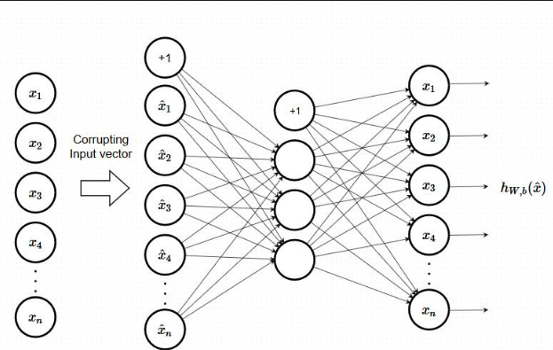

**Building the parts of algorithm**

1) **Data Preparation:**

* Load and preprocess the Fashion MNIST dataset.
* Add random noise to images and normalize them.

2) **Model Architecture:**

* **Encoder:** Apply convolutional layers with max pooling.
* **Bottleneck:** Add a convolutional layer for compressed representation.
* **Decoder:** Use convolutional layers and upsampling to reconstruct images.

3) **Training:**

* Compile and train the autoencoder using noisy images.

4) **Evaluation:**

* Predict and visualize noisy inputs, encoded representations, and cleaned outputs.

**GitHub Link:**

**https://github.com/amruthaa-m/DL-Lab1/tree/main/Unit-2/lab6.4**