BEHAVIOURAL FINGERPRINTING FOR INSIDER THREAT DETECTION

A REPORT SUBMITTED IN
PARTIAL FULFILMENT OF THE REQUIREMENTS FOR
INTERNSHIP
By
Amrutha Ajish Achuthan
Saintgits College of Engineering

DURING
23rd May 2025 – 23rd June 2025

UNDER THE GUIDANCE OF
Dr. Fasila K A

INDIAN INSTITUTE OF INFORMATION TECHNOLOGY KOTTAYAM

1. Introduction to Insider Threats
Insider threats are considered among the most complex and damaging cybersecurity risks faced by modern organizations. Unlike external attackers, insiders possess legitimate access to internal systems and data, making traditional security controls inadequate for preventing or detecting such threats. Insider threats can arise from employees, contractors, partners, or anyone with authorized system access who misuses that access for malicious or negligent purposes.
This project specifically focuses on detecting insider threats using behavioural fingerprinting. The rationale behind this focus is that insider threat actors, even when malicious, often exhibit subtle behavioral deviations that differ from their usual network activity. Identifying these deviations can help flag potential threats early, even when they occur under authorized access conditions.
2. Related Work
Extensive research has been conducted in the area of insider threat detection. Studies have explored both supervised and unsupervised machine learning approaches to identifying anomalous user or network behavior. Notable examples include:
The CERT Insider Threat Dataset developed by Carnegie Mellon University, which provides synthetic insider threat scenarios for research purposes.
Research by Alshamrani et al. (2020) demonstrates the use of Isolation Forest and clustering techniques to detect insider threats based on network traffic patterns.
Projects that utilize behavioural analytics, such as analyzing login patterns, file transfers, and communication trends, to build profiles of normal user behavior.
This project draws inspiration from these approaches but emphasizes lightweight, flow-level network analysis and unsupervised models that require minimal labelled data, making the solution applicable to real-world enterprise environments.
3. Setup and Methodology
The system for insider threat detection was developed using simulated enterprise network traffic and standard packet analysis tools. The simulation aimed to realistically mimic both normal and suspicious user behavior within a controlled network environment.
Wireshark was used to capture network traffic in. pcapng format. CICFlowMeter was then utilized to convert raw packet data into structured, flow-level features suitable for machine learning analysis. Additionally, a custom Python script based on PyShark was tested for lightweight feature extraction.
For the machine learning component, Python libraries such as scikit-learn, seaborn, and matplotlib were employed for building and visualizing models.
The dataset used to train and test the machine learning models was entirely generated from simulated network traffic. This included both benign and suspicious activity to ensure comprehensive model evaluation.
Normal behavior simulated routine web browsing, file transfers via approved protocols, DNS queries, and system updates. Suspicious behavior included large, unauthorized file downloads, port scanning activity, and data exfiltration attempts.
By incorporating both legitimate and anomalous network activities, the dataset provided a reliable foundation for training and evaluating the anomaly detection models.

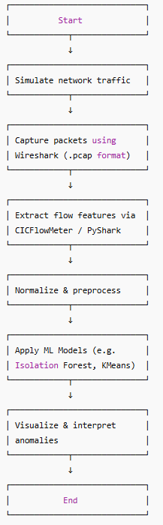

4. Data Collected and Feature Extraction
The dataset was created from the simulated packet captures obtained using Wireshark. These packet captures were processed through a python code to extract a wide range of network flow features. These features provided essential insights into the behavior of individual network sessions.
Key features extracted included total forward and backward packet counts, the size of data transferred in both directions, protocol types such as TCP, UDP, or ICMP, and precise timestamps of session initiation. These structured features were stored in a .csv file and used as the primary input for the machine learning models.
5. Detection Model and Results
Unsupervised machine learning models were applied to the extracted network flow features to identify potential insider threats based on behavioral anomalies. The models were selected for their suitability in situations with limited labeled data, such as detecting unknown or emerging insider threat patterns.
The Isolation Forest model was employed for anomaly detection. It operates by constructing an ensemble of isolation trees that effectively isolate anomalous data points. The model labeled outliers with a value of -1 and normal sessions with a value of 1. Approximately 5% of network sessions were identified as anomalies.
It is important to note that the detection of a relatively high percentage of anomalies is expected in simulated environments, where suspicious activities are deliberately injected to test the system's effectiveness. In real-world scenarios, the anomaly rate may vary based on the prevalence of insider threat activity and the complexity of user behavior.
The Isolation Forest model achieved an accuracy of 97%, precision of 100%, and recall of 80% based on manual evaluation of detection thresholds.
Additionally, K-Means clustering was applied to group network flows based on similarity in behavior. The model identified natural clusters corresponding to normal and suspicious activities, further validating the system's ability to differentiate insider threat patterns.
To enhance analysis, DBSCAN (Density-Based Spatial Clustering of Applications with Noise) was also utilized. This clustering technique effectively distinguished dense regions of normal activity from sparse regions containing anomalies, providing an alternative perspective on the dataset.
6. Visual Outputs
The following figures illustrate key results generated during the project:
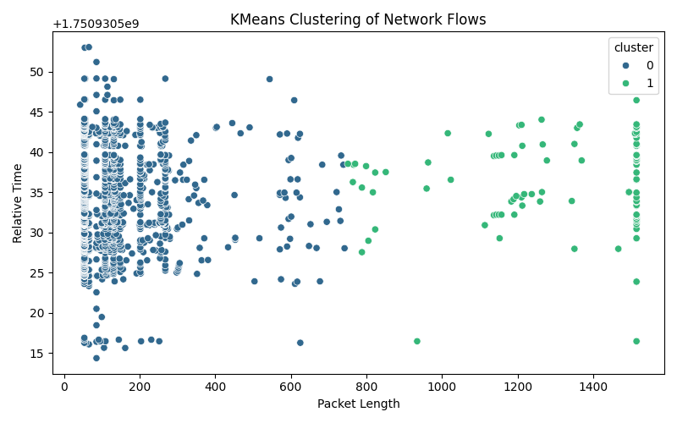
Figure 1: KMeans Clustering of Network Flows
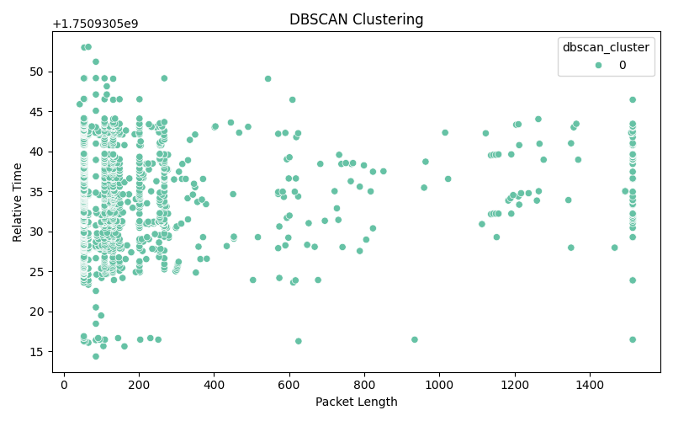
Figure 2: DBSCAN Clustering of Network Flows
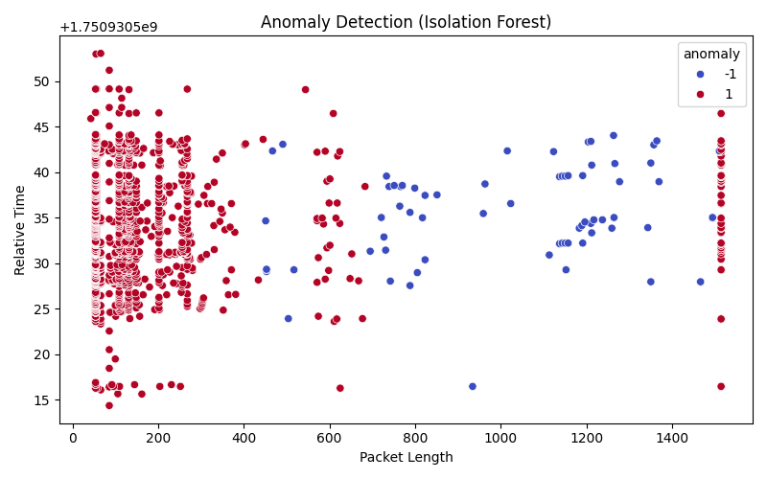
Figure 3: Anomaly Detection using Isolation Forest
7. Limitations and Future Scope
While the system demonstrated promising results in detecting insider threats within simulated network environments, several limitations exist. The primary constraint is the reliance on synthetic datasets, which may not fully capture the complexities of real-world enterprise networks.
Additionally, the current models operate on static datasets and are not optimized for real-time detection in live network environments. The exclusion of user and device authentication logs also limits the system's ability to perform comprehensive behavioral fingerprinting.
Future work will focus on enhancing the system's capabilities by integrating real-time data streams, incorporating user and device context, and exploring advanced machine learning techniques such as deep learning models, including Long Short-Term Memory (LSTM) networks and Autoencoders. Applying the system to real enterprise datasets will also be critical in validating its effectiveness in operational environments.

8. Proposed Extension: Autoencoder-Based Anomaly Detection
To augment the existing anomaly detection pipeline, a deep-learning approach using Autoencoders is proposed. As explained by Wei Gang in Demystifying Neural Networks: Anomaly Detection with AutoEncoder (Jan 2024), autoencoders are neural networks trained to reconstruct their input—they compress the data into a bottleneck and then decompress it to approximate the original data.
When trained exclusively on “normal” network flows, autoencoders learn to reproduce these patterns with low error. However, when presented with deviant or malicious flows, the reconstruction error increases significantly, serving as an anomaly indicator. This reconstruction error can be measured, for instance, using mean squared error (MSE), and a threshold is then applied: flows with error above the threshold are flagged as anomalies .
An autoencoder has two primary components:
- An encoder, which compresses the input into a latent vector.
- A decoder, which reconstructs the input from this vector.
During training, the network minimizes reconstruction error.
Because the latent space is limited, the network learns to represent only frequent “normal” behaviors. Thus, when faced with unusual patterns, it fails to reconstruct them well leading to a higher error used to detect anomalies.
Supporting Literature:
- Wei Gang, “Demystifying neural networks: anomaly detection with autoencoder,” Medium, Jan 2024 — provides a clear overview and example using Keras
- “Autoencoders and anomaly detection” (Fraud Detection Handbook) — outlines how anomaly scores from reconstruction error can distinguish normal versus outlier data
- A SpringerOpen study on cloud network security proposes using per-feature error vectors for improved thresholding, rather than a single aggregate error
Advantages and Limitations:
- Pros:
  - Can model non-linear, complex patterns in high-dimensional network flow data
  - Learns unsupervised from unlabeled normal data — no need for attack labels
- Cons:
  - Requires careful hyperparameter tuning (e.g. network size, learning rate)
  - Needs a sizable and representative dataset of normal traffic
  - Selection of an optimal reconstruction-error threshold can be non-trivial
Future Work Integration:
An autoencoder can be implemented using frameworks like TensorFlow/Keras:
- Train on simulated normal network flows.
- Compute reconstruction error on new flows.
- Flag anomalies using a statistically determined threshold (e.g., 95th percentile of reconstruction errors).
Once implemented, compare its performance with existing methods (Isolation Forest, One-Class SVM) using metrics like precision, recall, and F1-score.

