Table of Contents

Bottom-Up Reconstruction of the Chicago Speed-Camera Study
Supplementary technical report · 27 October 2026
Co-authors: Saketh Donepudi and Amrutha Kakumani
This supplement does not replace the existing 21-page working paper. It records what changed when the project was rebuilt from the raw public data, and what did not change. It is not peer reviewed.

1. Motivation
The original study treated 2015-09 as the start of usable crash data and trained V1/V2 forecasts from 2017-01. Both choices were reasonable before the portal metadata was checked. The current official description is explicit: E-Crash data exist for some Chicago police districts in 2015, but citywide coverage is not available until September 2017.
That changes the meaning of the early panel. It does not merely remove a few sparse months. It changes the composition of reported crashes, the injury share, the pre-treatment history available to later cameras, and the population on which a model is trained. The reconstruction therefore starts with the reporting process, not with a new LightGBM configuration.
The guiding rule is simple: do not make the analysis look stronger by treating unobserved crashes as zeros, backfilling 2026 traffic exposure into 2017, or comparing models trained on different populations as if their raw MAE ranked them.

2. Reporting completeness

2.1 Official evidence
The Chicago Data Portal description for 85ca-t3if states that citywide data are not available until September 2017 and that records are added when a report is finalized or amended. The portal does not expose a per-record finalization timestamp. The current extract contains 1,107,461 rows; the preserved modeling snapshot contains 1,106,882 rows. The current extract has 581 records added after the snapshot and 2 records absent from it.

2.2 Empirical diagnostics
The raw monthly count rises from 7,685 in August 2017 to 9,038 in September 2017 (+17.6%). The injury share rises from 13.8% to 15.7%. Across the adjacent twelve-month windows, mean monthly crashes rise from 5,382 to 9,817 and mean injury share from 7.7% to 14.1%.
These are not interpreted as a real one-month safety shock. They are consistent with the official reporting-regime change. All 22 CPD districts have at least one record in every month from 2015-09 onward, including the pre-citywide period, so district presence alone cannot measure completeness. That is why the reconstruction uses the official metadata as the boundary and the monthly patterns only as corroborating diagnostics.
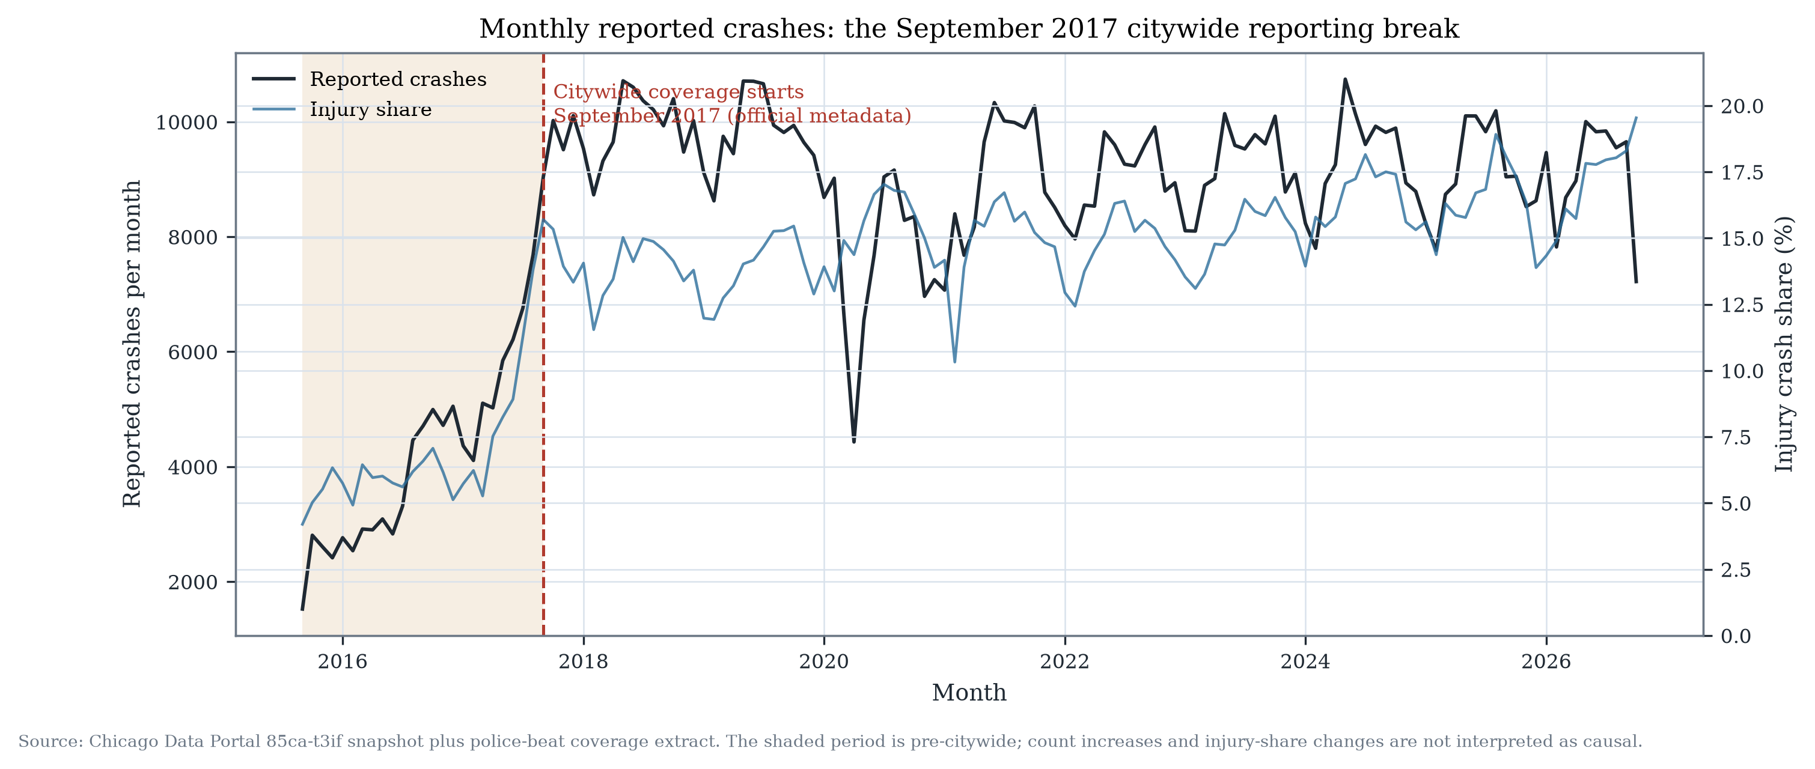
Monthly coverage

2.3 Other record-level limits
- 8,673 snapshot rows have missing coordinates; 75 have zero coordinates; 8,748 raw points fall outside the analysis bounding box.
- 240 records are marked AMENDED; no before/after versions are available.
- Notification delay (date_police_notified − crash_date) is short for most records: median 0.02 days, p95 2.53 days, p99 9.17 days; 0.17% exceed 30 days. This is not the same as portal finalization delay, which is unobservable.
- The last two source months (2026-09 and 2026-10) are marked incomplete; the model window ends 2026-08.
The two-month operating lag is retained as a conservative rule. It is not presented as a measured publication lag.

3. Revised data construction

3.1 Coverage-consistent camera-zone dataset
The camera-zone design was rebuilt from StudyData.subset_start("2017-09-01"). Controls were selected on the citywide period, not on the 2015–2017 partial period. The target window starts in 2018-01, allowing at least four months of history before the first target month and avoiding a target month with no lag structure.
Statistic | Value
Locations | 1,326
Camera catchments | 129
Comparison sites | 1,197
Target months | 104 (2018-01…2026-08)
Rows | 137,904
Zero-crash share | 10.7%
Mean crashes per location-month | 3.88
Test rows | 15,912 (2025-09…2026-08)
This is not the same task as V1/V2. V1/V2 start in 2017-01 and contain eight months of partial reporting. The coverage-consistent model is compared on the common test location-months, not by assuming identical training populations.

3.2 Road-segment dataset
The road design uses TIGER/Line 2024 EDGES clipped to the union of Chicago community areas:
- 73,088 road segments; 3,126 major and 69,962 local.
- 6,659 km of road; median segment length 54.9 m.
- 98.9% of 2024 Cook segments existed as 2017 TLIDs; 6,633 older segments are absent and 795 are new.
Crashes are assigned once to the nearest segment within 30 m. Of 982,255 in-city crashes, 975,033 (99.26%) are assigned; 7,222 are unassigned; 331,234 (34.0%) have a second segment within 5 m and are flagged ambiguous; 2,214 (0.23%) are more than 20 m from the chosen segment.
The modelling sample is all major segments plus 12,000 seeded random local segments: 15,126 segments, 1,633,608 segment-months, 2,440 zero-crash segments, and 23.6% of assigned crashes. This is a transparent sample, not a citywide road census.

4. Geographic representation
The historical 250 m catchment is retained for comparability with the original study. The road design is an additional prediction-oriented geography, not a replacement for the causal design.
The two geographies answer different questions:
Camera-zone | Road-segment
250 m around a camera or comparison site | TIGER road segment
Crash-dense, non-random location set | All major segments + seeded local sample
1,326 locations; 10.7% zeros | 15,126 sampled segments; 89.4% zeros
Connected to the causal analysis | Predictive only
No exposure denominator | No exposure denominator
The 2024 road geometry is not treated as a perfect 2017 map. The TIGER 2017 comparison documents both continuity and missing older segments. Historical road-network changes remain a limitation at block-face level.

5. Traffic exposure
The AADT dataset (gc7y-n4xa) does not support the 2017–2026 forecast:
- The portal description says data begin in October 2020 and quality improves from May 2026.
- The current extract actually begins in July 2022.
- It contains 2,525 segment IDs and 83,232 segment-months.
- 1,454 distinct 2024 road segments match within 50 m (2.0% of the 73,088 city segments).
- 199/209 camera locations have an AADT segment within 250 m, but the segment identity and time coverage are not sufficient for a historical merge.
- Counts are camera-derived; using them as an exogenous exposure denominator risks treatment-related measurement bias.
No 2017–2021 traffic denominator was manufactured. The final forecast remains count-based, and the missing exposure is an explicit limitation. A normalized crash rate is not reported for 2017–2021.
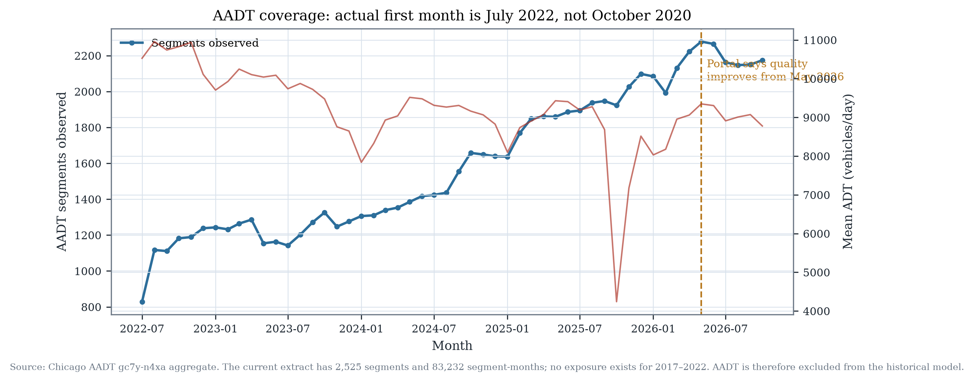
AADT availability

6. Model experiments

6.1 Declared protocol
Before the final test evaluation, the following selection rule was fixed:
- a new model may replace the deployed V1 only if validation Poisson deviance improves by at least 1%;
- test MAE must not regress by more than 2%;
- high-crash subgroup MAE must not regress by more than 2%;
- geographic holdout and calibration must remain acceptable.
This is the existing V2 rule, retained. The coverage-consistent experiments do not change the threshold after seeing results.

6.2 Feature ablation
All ablation models use the same fixed V1 hyperparameters, so differences are attributable to feature groups.
Model | Features | Validation deviance | Validation MAE
M0 minimal | 34 | 1.2249 | 1.6104
+ camera operation | 37 | 1.2253 | 1.6103
+ weather | 43 | 1.2211 | 1.6068
+ road network | 56 | 1.2198 | 1.6054
+ neighbourhood | 62 | 1.2189 | 1.6045
+ citywide | 69 | 1.2187 | 1.6081
+ long history (full) | 78 | 1.2167 | 1.6059
Coverage-aware V1 reference | 44 | 1.2224 | 1.6081
The full feature set lowers validation deviance by about 0.67% versus the minimal model. Road features add about 0.11% over the weather model; neighbourhood and citywide features add smaller increments. Camera operation is predictively redundant.
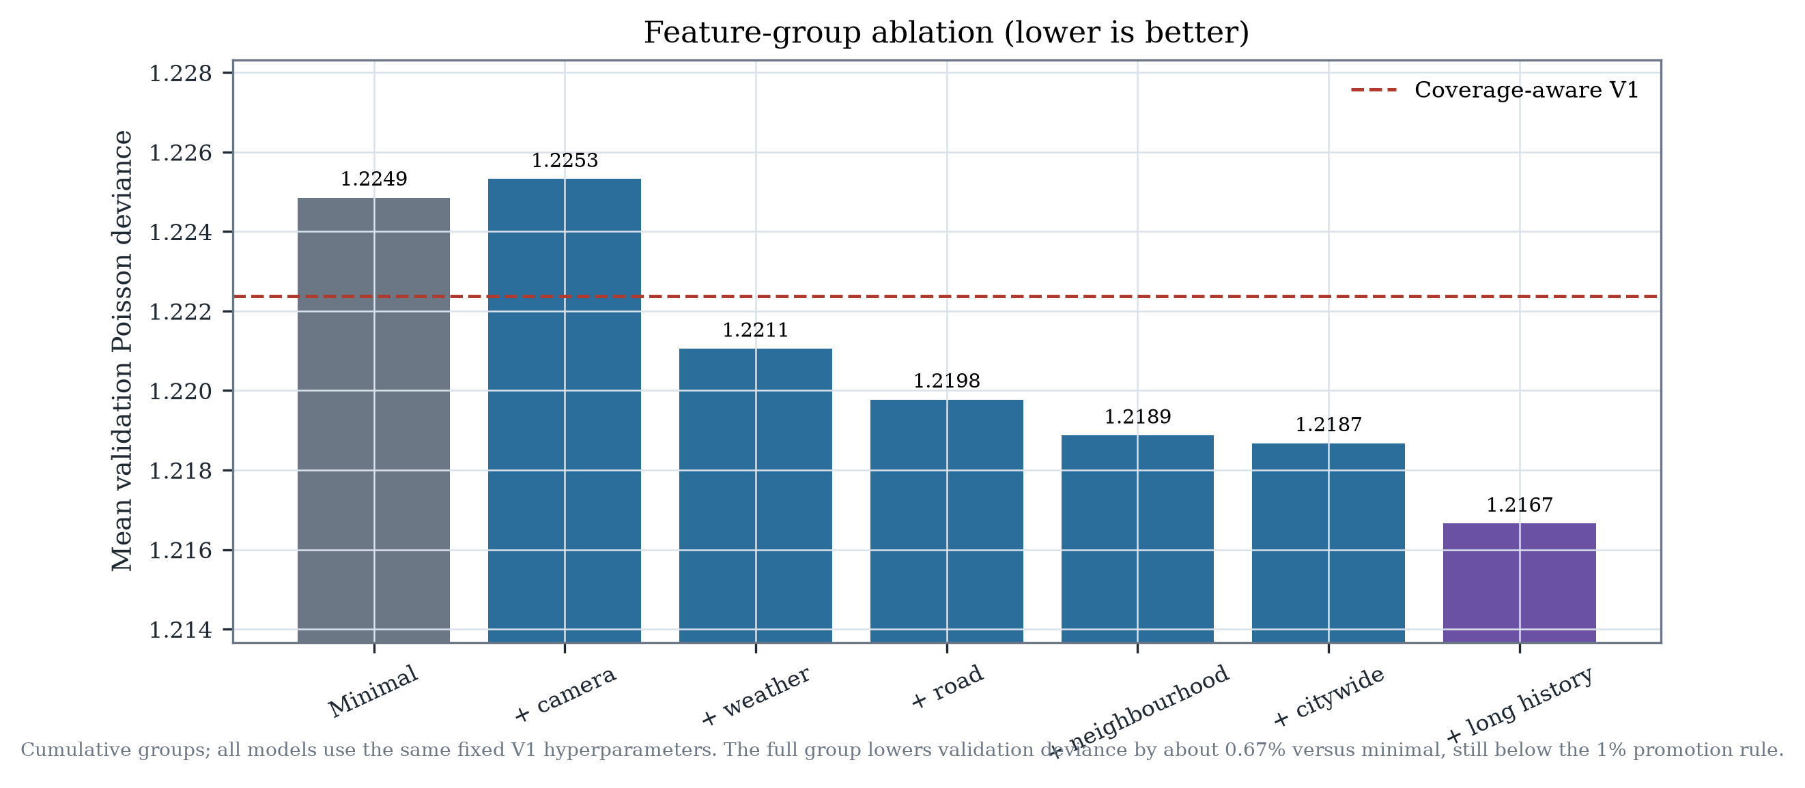
Feature ablation

6.3 Optuna budget
The coverage-consistent full model was tuned with 8 Optuna trials and a 600-second cap. The best validation deviance was 1.21647, a 0.48% improvement over coverage-aware V1 (1.22238), still below 1%. The tuned test deviance was 1.2162; test MAE 1.5775.

6.4 Road-segment experiment
The road model uses history, calendar and static road attributes; it omits AADT. It achieves test MAE 0.182, Poisson deviance 0.395 and R² 0.351. Overall 90% interval coverage is 90.3%, but the highest-risk decile is only 60.2%. Hotspot precision at the top 10% is 0.48 and recall 0.46.
These numbers are not comparable with camera-zone MAE. The road task has a different unit, a different population, a 90% zero share, and 34% ambiguous assignments.

7. Statistical evaluation

7.1 Common test rows
The deployed V1, V2 candidate and coverage-consistent models were evaluated on the same 15,912 camera-zone test rows (12 months, 169 2 km blocks).
Model | MAE | Poisson deviance | Bias | R²
Deployed V1 | 1.5860 | 1.2242 | +0.164 | 0.657
V2 candidate | 1.5820 | 1.2193 | +0.145 | 0.659
Coverage V1 | 1.5799 | 1.2201 | +0.119 | 0.659
Coverage full | 1.5786 | 1.2175 | +0.130 | 0.659
Coverage tuned | 1.5775 | 1.2162 | +0.127 | 0.660
Paired spatial-block bootstrap (1,000 draws over 169 blocks) gives a coverage- tuned minus V1 deviance difference of −0.0080 [−0.0114, −0.0043]. The improvement is small and below the 1% promotion rule. V2 minus V1 deviance is −0.0050 [−0.0080, −0.0018], also below 1%.

7.2 Temporal validation
Coverage V1 has fold mean deviance 1.2224 and MAE 1.6081. Coverage full has 1.2167 and 1.6059. The tuned model reaches 1.2165. The temporal folds are 2024-01…2024-06, 2024-07…2024-12 and 2025-01…2025-06.

7.3 Geographic holdout
A 2 km block holdout with a 1 km buffer was evaluated before the test period: 34 held-out blocks, 290 locations and 3,480 rows. Coverage V1 deviance is 1.2257; coverage full is 1.2267. The richer model does not generalize better on this geographic holdout.

7.4 Calibration and intervals
Coverage V1: 90% interval coverage 90.6% overall, 85.6% in the highest-risk decile. Coverage full: 90.5% overall, 84.7% in the highest decile. Coverage tuned: 90.4% overall, 84.9% in the highest decile.
The high-risk interval undercoverage persists. It is not fixed by adding features or tuning.

7.5 Hotspots and tails
Coverage tuned hotspot precision at the top 10% predicted is 0.72 and recall 0.55 using a training-derived high-crash threshold; lift is about 5.5. Zero-crash months are over-predicted and high-crash months under-predicted. The model remains a count forecaster, not a high-risk decision system.

8. Causal sensitivity
Causal inference remains independent of the forecasting model. The reporting regime changes the pre-treatment history available to later cameras.
A strict coverage-consistent design requires 24 citywide pre-months and 36 post-months. This leaves 15 cameras (go-live 2021-07…2023-07) and 5,400 panel rows.
Design | Cameras | Conditional Poisson | 95% CI | p | Cohort ATT | Pre-trend p
Original notebook | 33 | −7.3% | [−13.6, −0.6] | 0.034 | — | —
Revised local 2015-start | 20 | −2.6% | [−11.5, +7.2] | 0.591 | −0.095 | 0.635
Coverage 24/36 | 15 | −8.6% | [−16.9, +0.4] | 0.061 | −0.075 | 0.855
Coverage 12/36 | 16 | −6.9% | [−15.2, +2.2] | 0.131 | −0.008 | 0.507
Coverage 24/24 | 18 | −6.6% | [−14.3, +1.7] | 0.115 | +0.372 | 0.791
The strict coverage estimate is more negative than the revised 2015-start estimate, but it is a different sample and remains compatible with zero. The geographic placebo one-sided p-value is 0.25; the estimate sits inside the placebo distribution. The 24/36 cohort estimate is −0.075 [−0.773, +0.605] crashes/site-month.
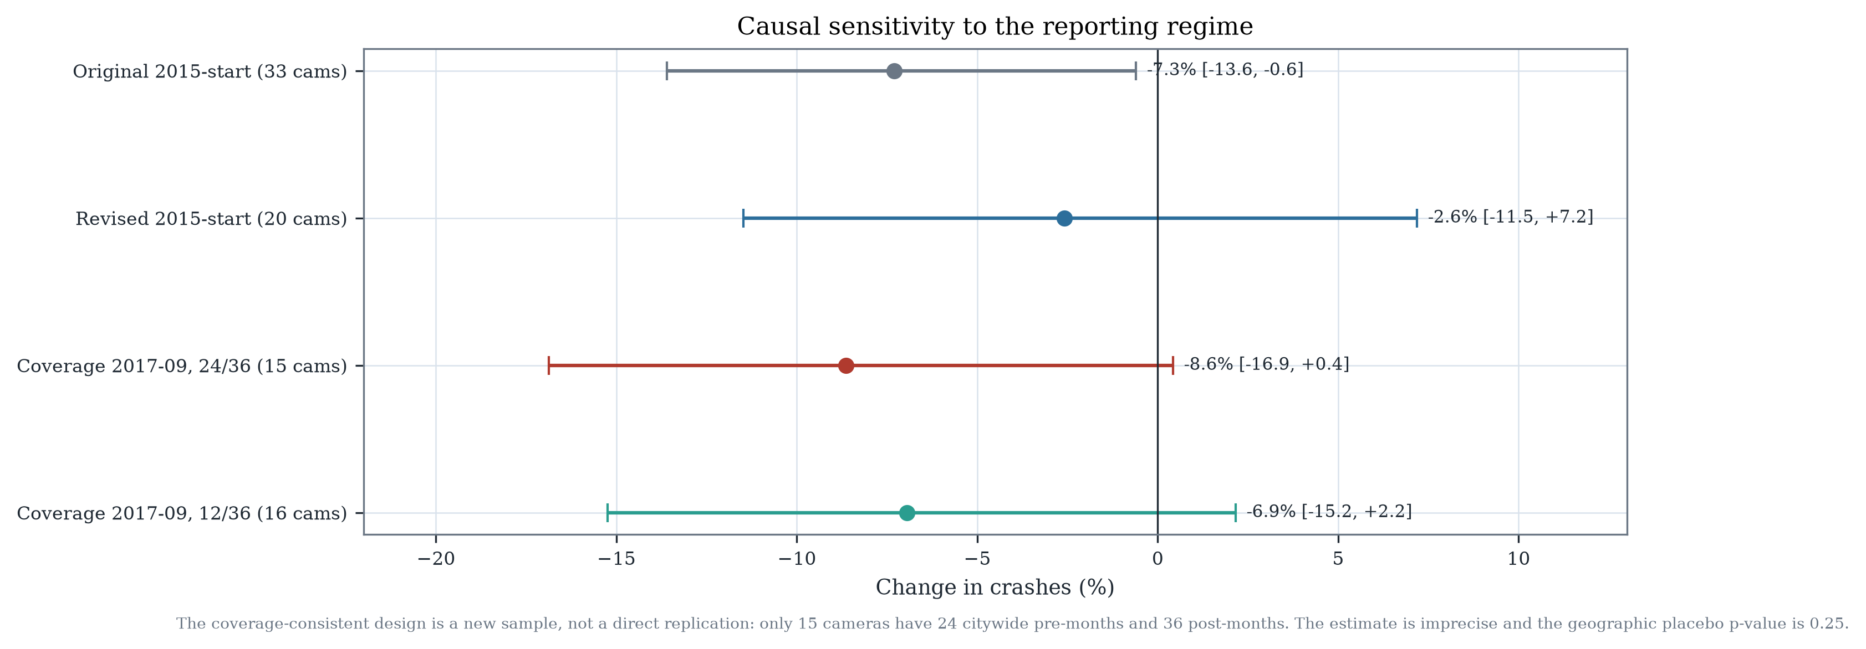
Causal coverage
This does not establish a stronger camera effect. It demonstrates that the reporting regime is material to the estimand and that the public data cannot resolve the effect at policy precision.

9. Final model decision
Candidate | Validation deviance | Test deviance | High-risk interval coverage | Geographic holdout | Decision
Deployed V1 | 1.2227 | 1.2233* | 84.8% | — | Keep deployed
V2 candidate | 1.2197 | 1.2181* | 84.8% | 1.2189 | Research candidate
Coverage V1 | 1.2224 | 1.2201† | 85.6% | 1.2257 | Research reference
Coverage full | 1.2167 | 1.2175† | 84.7% | 1.2267 | Not selected
Coverage tuned | 1.2165 | 1.2162† | 84.9% | — | Not selected
Road segment | 0.4043 | 0.3949† | 60.2% | — | Separate task
* V1/V2 test values are their original retrospective test evaluation (16,260 rows). † Common 15,912-row evaluation. The table mixes populations only where explicitly marked; raw MAE across camera-zone and road tasks is not comparable.
The deployment decision does not change:
- V1 remains deployed.
- V2 remains a research candidate under the pre-declared 0.243% validation gain.
- The coverage-tuned model is retained as a research artifact; it does not meet the 1% rule and does not improve geographic holdout.
- The road-segment model is not selected for the camera-zone task.

10. Implications
- The publication’s forecasting test is not independent of the reporting regime. V1/V2 start eight months before citywide coverage. This should be disclosed and, where feasible, a coverage-consistent sensitivity should be added.
- The revised causal estimate is not the only defensible estimate. A citywide pre-period design yields a more negative but imprecise estimate on a much smaller cohort. Neither estimate should be described as definitive.
- Exposure remains the largest missing measurement. AADT cannot supply a historical denominator, and camera-derived counts are not exogenous.
- Road segments are a useful separate task, not a replacement task. The road model has a 90% zero share and 34% assignment ambiguity; its raw MAE is not a better camera-zone score.
- More features are not the main lever. The full feature set improves validation deviance by 0.67% over minimal; the 1% rule is not met.
- Test-period reuse. The 2025-09…2026-08 period was already inspected in V1. Every coverage-consistent and V2 test result reported here is retrospective, not a new untouched confirmation.

Appendix A — Artifacts
Coverage:
- results/bottom_up/coverage/summary.json
- results/bottom_up/coverage/monthly_coverage.csv
- results/bottom_up/coverage/district_month_coverage.csv
- results/bottom_up/coverage/beat_month_coverage.csv
Exposure:
- results/bottom_up/exposure/summary.json
- results/bottom_up/exposure/aadt_monthly_coverage.csv
- results/bottom_up/exposure/aadt_availability_matrix.parquet
- results/bottom_up/exposure/aadt_road_match.json
Road design:
- data/processed/road_segments.parquet
- data/processed/crash_road_assignments.parquet
- data/processed/road_segment_month_counts.parquet
- data/processed/road_model_panel_features.parquet
- results/bottom_up/roads/
Models:
- results/bottom_up/coverage_model/
- results/bottom_up/road_model/
- models/bottom_up/
Causal:
- results/bottom_up/coverage_causal/
Figures:
- results/bottom_up/figures/

Appendix B — Reproduction
python -m chicago_cameras.coverage
python -m chicago_cameras.exposure
python -m chicago_cameras.road_network
python -m chicago_cameras.ml.coverage_dataset
python -m chicago_cameras.ml.reconstruction
python -m chicago_cameras.ml.tune_coverage
python -m chicago_cameras.ml.road_model
python scripts/make_bottom_up_figures.py
The original publication branch, 21-page paper, V1/V2 artifacts and LinkedIn drafts remain intact. No DOI, release, deployment or peer-review claim is added.

