SIMATS ENGINEERING
SAVEETHA INSTITUTE OF MEDICAL AND TECHNICAL SCIENCES
CHENNAI-602105
Department of Computer Science and Engineering
ASSESSMENT TOOL 1 – SAVEETHA COMPILER ASSESSMENT (LEVEL 1 & VIVA VOCE)
Course Code: | CSA09 | Course Title: | Programming in Java
CO Assessed: | CO1 – Manipulation (BL4) | Assessment: | AT1 – Saveetha Compiler (Level 1 & Viva)
Weightage: | 20% of CIA | Total Marks: | 100 (5 Questions × 20 Marks)
CO1 Statement: | CO1: Apply object-oriented programming principles such as classes, objects, encapsulation, data hiding, inheritance, and polymorphism to design and implement entity manipulations (BL3,BL4)
Student Name: | K. Amrutha Sandhya | Reg. No.: | 192524270
Section / Batch: | AIDS | Date: | 27-07-2026

Instructions to Students
Answer ALL 5 questions. Total: 100 Marks.
Questions 1–5: Write complete, syntactically correct Java programs on the Saveetha Compiler with proper indentation. Each question carries 20 Marks.
For program questions: test with at least two sample inputs; ensure output is displayed clearly. Each question carries 5 Marks.
No calculators or electronic devices permitted during the viva session.

Question Type | Description | Questions | Marks
Level 1 – Program Writing | Control Flow, classes and Object programs, Collection Framework on compiler | Q1 – Q4 | 50
GRAND TOTAL: |  |  | 100 Marks

SECTION A – LEVEL 1: PROGRAM WRITING QUESTIONS (Q1–Q5)
Q1. (Level 1 – Program Writing) [20 Marks]
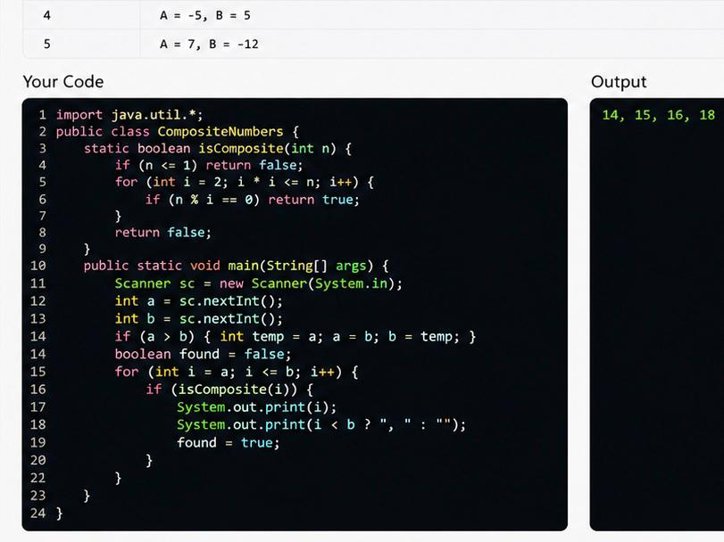
Answer / Program with output:
START
INPUT A, B
IF A > B THEN
PRINT "No composite numbers"
STOP
END IF
SET found = false
FOR i = A TO B
IF i > 1 THEN
SET count = 0
FOR j = 1 TO i
IF i MOD j = 0 THEN
count = count + 1
END IF
END FOR
IF count > 2 THEN
PRINT i
found = true
END IF
END IF
END FOR

IF found = false THEN
PRINT "No composite numbers"
END IF

STOP

Q2. (Level 1 – Program Writing) [20 Marks]
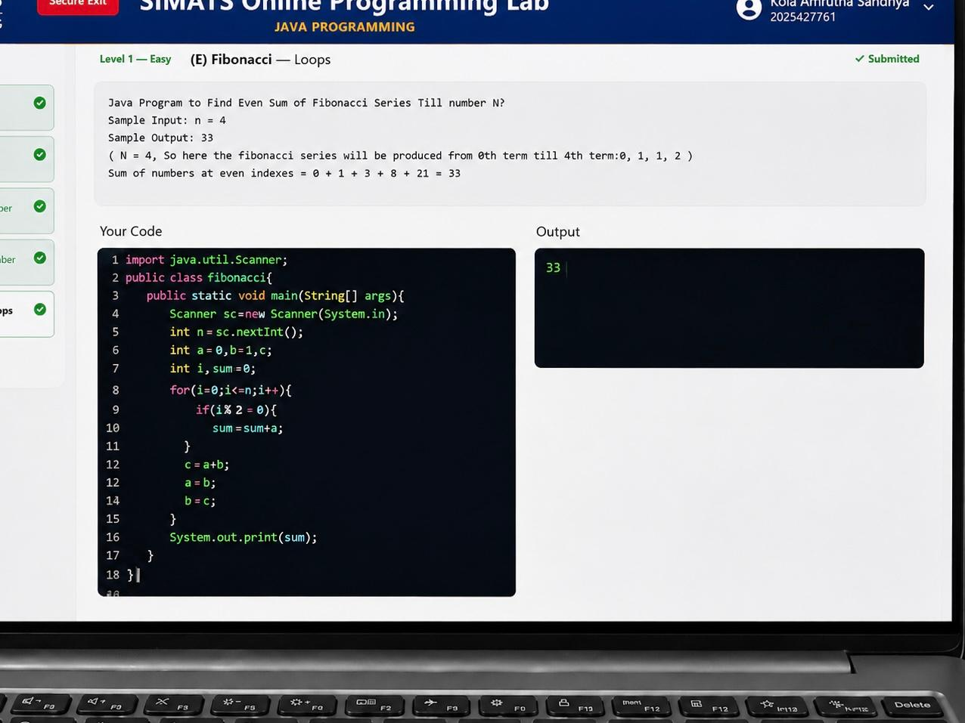
Answer / Program with output:
START
INPUT n
a = 0
b = 1
sum = 0
FOR i = 0 TO n-1
IF i % 2 == 0
sum = sum + a
END IF
c = a + b
a = b
b = c
END FOR
PRINT sum
STOP

Q3. (Level 1 – Program Writing) [20 Marks]
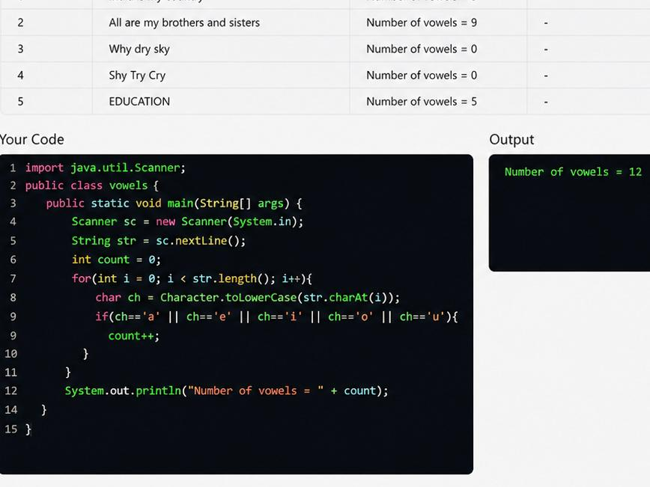

Answer / Program with output:
START

INPUT str

count = 0

FOR each character ch in str
IF ch = 'a' OR 'e' OR 'i' OR 'o' OR 'u'
OR ch = 'A' OR 'E' OR 'I' OR 'O' OR 'U'
count = count + 1
END IF
END FOR

PRINT count

STOP

Q4. (Level 1 – Program Writing) [20 Marks]
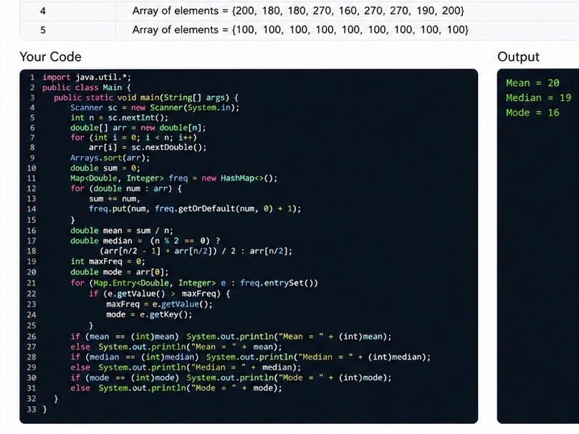
Answer / Program with output:
START
INPUT n
INPUT array
sum = 0
FOR i = 0 TO n-1
sum = sum + array[i]
END FOR
mean = sum / n
SORT array
IF n % 2 == 0
median = (array[n/2 - 1] + array[n/2]) / 2
ELSE
median = array[n/2]
END IF
mode = array[0]
max = 0
FOR i = 0 TO n-1
count = 0
FOR j = 0 TO n-1
IF array[i] == array[j]
count = count + 1
END IF
END FOR

IF count > max
max = count
mode = array[i]
END IF
END FOR

PRINT "Mean =", mean
PRINT "Median =", median
PRINT "Mode =", mode

STOP

Q5. (Level 1 – Program Writing) [20 Marks]
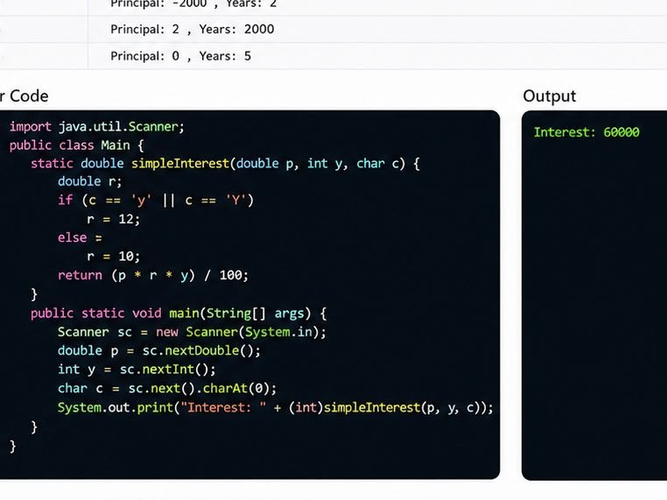
Answer / Program with output:
START

INPUT principal, rate, time
INPUT senior

IF senior == 'Y'
rate = rate + 2
END IF

SI = (principal * rate * time) / 100

PRINT SI

STOP

RUBRICS FOR EVALUATION
Criteria | Level 4 – Exemplary (5 Marks) | Level 3 – Proficient (3–4 Marks) | Level 2 – Developing (2 Marks) | Level 1 – Beginning (0–1 Mark)
Problem Analysis & Understanding
Logic / Algorithm Design
Python Syntax & String Operations
Output Correctness & Testing
Communication & Explanation (Viva)

Code of Conduct
I ____________________________ (Name / Reg No) certify that this submission is my original work and that I have adhered to the guidelines specified for this assessment. I understand that any violation of academic integrity rules will result in disciplinary action.
Signature of the Student: _________________________

