SIMATS ENGINEERING (SAVEETHA SCHOOL OF ENGINEERING)
Department of Computer Science and Engineering
CO1_AT3 — VISUALIZATION DESIGN EXERCISE

Course Code: | DSA06 | Course Title: | Data Handling and Visualization
CO Assessed: | CO1 – Precision (BL2) | Assessment: | Assessment Tool 3 – Visualization Design
Weightage: | 40% of CIA | Total Marks: | 20 (2 Questions × 10 Marks)
CO1 Statement: | Understand the fundamental concepts, principles, and techniques of data visualization.(BL2)
Student Name: | K. Amrutha Sandhya | Reg. No.: | 192524270
Section / Batch: | AIDS | Date: | 28-07-2026

Code of Conduct
I K. Amrutha Sandhya(192524270) (Name / Reg No) certify that this submission is my original work and that I have adhered to the guidelines specified for this assessment. I understand that any violation of academic integrity rules will result in disciplinary action.

Signature of the Student: Amrutha

Instructions
- This assessment contains 2 questions, each carrying 10 marks. Total: 20 Marks.
- No negative marking. Unanswered questions carry zero marks.
- No calculators or electronic devices permitted.
- Duration: 60 minutes.

Annexure A – VISUALIZATION DESIGN

ASSESSMENT RUBRIC
AT3 — Visualization Design Exercise
CO1 · BT3: Apply ·
This rubric is used to assess student responses to the AT3 Visualization Design Exercise problems, in which students design and justify a complete visualization (chart type, aesthetic mappings, scales, coordinate systems, and/or color scheme) for a given dataset or design brief.

Criteria | Weightage | Level 4 – Exemplary | Level 3 – Proficient | Level 2 – Developing | Level 1 – Beginning
Understanding of Concepts | 25% | Demonstrates thorough, accurate understanding of chart types, aesthetic mappings, scales, coordinate systems, and color scales, and correctly identifies which apply to the given design scenario. | Good understanding of the relevant design concepts, with only minor gaps in selecting appropriate chart types, aesthetic mappings, or scales. | Basic understanding of design concepts, but with some misconceptions about appropriate chart types, aesthetics, or scales for the scenario. | Poor understanding of core design concepts; proposes chart types or mappings that are fundamentally unsuited to the data.
Explanation | 25% | Provides detailed, well-reasoned justification for every design decision, explicitly connecting each choice to the properties of the data and the scenario. | Provides clear justification for design decisions, with adequate reasoning for most sub-questions. | Justification is limited or superficial; design choices are stated without sufficient reasoning. | Little or no justification provided; design choices appear arbitrary or unexplained.
Application | 20% | Effectively applies visualization design principles to produce a complete, appropriate, and well-reasoned design solution for the specific scenario. | Applies design principles to produce an appropriate solution, with only minor errors or missed refinements. | Limited application of design principles; the proposed design partially addresses the scenario but has notable weaknesses. | Fails to apply appropriate design principles; the proposed design does not suit the scenario or data.
Organization | 15% | The design proposal is clearly structured, addressing each sub-question (a, b, c) in a logical sequence with coherent flow throughout. | The proposal is organized and addresses each sub-question, with only minor issues in flow or clarity. | Basic structure; sub-questions are addressed but the proposal lacks clarity or a logical sequence. | Poorly organized; the proposal is incoherent, and sub-questions are left unaddressed or answered out of order.
Accuracy | 10% | All design choices — chart type, aesthetic mapping, scale, coordinate system, and/or color scheme — are completely accurate and well-suited to the data. | Mostly accurate design choices, with only minor omissions or a small error in one part of the proposal. | Partially correct; some design elements are missing, mismatched to the data, or incorrect. | Design choices are largely incorrect or inappropriate, with major gaps in matching the visualization to the data.

Scoring Guide
For each criterion, award a performance level (1–4) based on the descriptors above. Multiply the level achieved (as a percentage of 4, i.e., Level 4 = 100%, Level 3 = 75%, Level 2 = 50%, Level 1 = 25%) by the criterion's weightage, then sum across all five criteria to obtain the total score out of 100%.

Faculty In-charge | Course Coordinator | Head of Department
Signature: _______________ | Signature: _______________ | Signature: _______________
Date: ___________________ | Date: ___________________ | Date: ___________________

Problem 4
Scenario: A dataset tracks a company's employees by City (Nominal), Tenure in Years (Numeric), and Performance Rating (Ordinal: Low, Medium, High).
a) Design a single visualization that encodes all three variables simultaneously. Specify each aesthetic mapping.
Recommended Chart: Scatter Plot
Aesthetic Mapping:
• X-axis → City (Nominal)
• Y-axis → Tenure in Years (Numeric)
• Colour → Performance Rating (Low = Red, Medium = Yellow, High = Green)
Justification:
A scatter plot effectively combines three different data types within a single visualization. The categorical City variable is displayed along the horizontal axis, the numerical Tenure is represented on the vertical axis, and the ordered Performance Rating is encoded using colour. This allows viewers to compare employee tenure across cities while simultaneously identifying high-, medium-, and low performing employees.
b) Which chart type did you choose, and why is it suited to combining a nominal, a numeric, and an ordinal variable?
The Scatter Plot is chosen because it supports multiple visual encodings simultaneously. The X-axis naturally represents the nominal variable (City), the Y-axis accurately displays the numeric variable (Tenure), and colour communicates the ordinal Performance Rating. This design minimizes clutter while making relationships and patterns easy to identify, satisfying effective visualization principles.

c) What is one limitation of your design that could cause confusion for a viewer, and how would you mitigate it?
A possible limitation is overplotting, where several employees from the same city have similar tenure values, causing markers to overlap. This can hide information and reduce readability. The issue can be
reduced by applying transparency, jitter, or smaller marker sizes, and by including a clearly labelled legend explaining the colour scale.
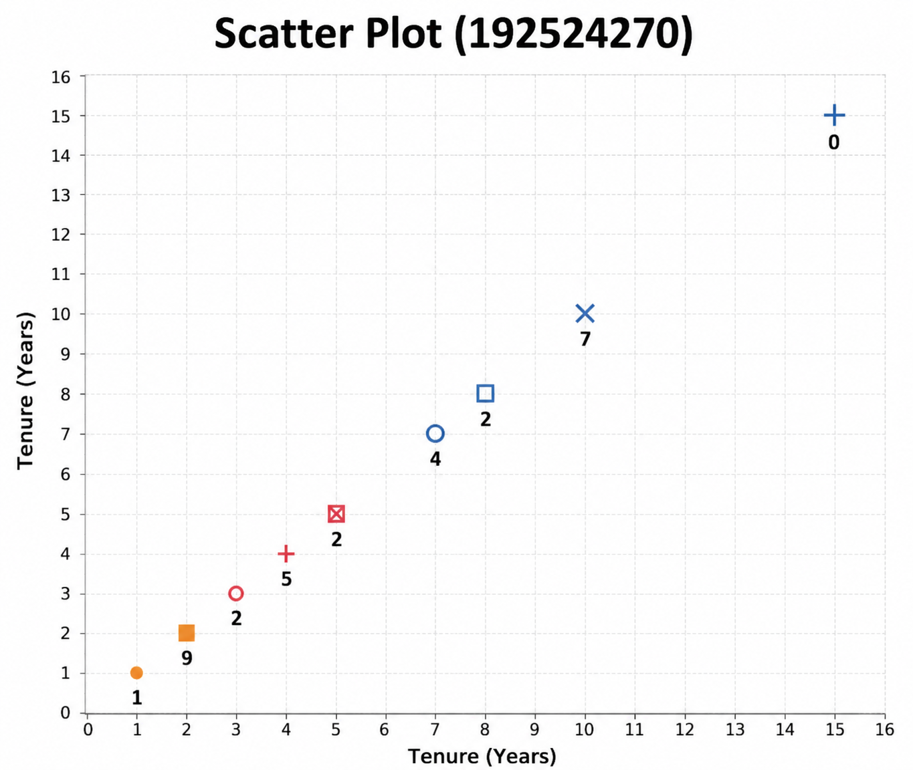Problem 14
Scenario: A quality control team measures a manufacturing defect rate (1–100,000 PPM) across 12 production lines.
a) Design a chart to compare defect rates across the 12 lines, specifying your choice of axis scale.
Recommended Chart: Vertical Bar Chart
X-axis → Production Lines
Y-axis → Defect Rate (PPM)
Axis Scale → Logarithmic Scale
A logarithmic scale enables comparison across all 12 production lines despite the extremely wide range of defect rates.
b) Justify why a logarithmic axis may be necessary here, referencing the wide range of values.
A logarithmic axis is necessary because the defect rates range from 1 to 100,000 PPM, covering several orders of magnitude. If a linear scale were used, the smaller values would appear compressed near the bottom of the chart, making them difficult to compare. A logarithmic scale compresses larger values while expanding smaller ones, allowing viewers to observe patterns and compare all production lines more effectively. This provides a more balanced and informative visualization.
c) What potential misinterpretation risk exists if the audience is unfamiliar with reading logarithmic axes, and how would you mitigate it (e.g., through annotation)? A common risk is that viewers may assume equal spacing on the logarithmic axis represents equal numerical differences. In reality, each interval represents a 10× increase, not a fixed numerical increase. This misunderstanding may lead to incorrect conclusions about the defect rates. To avoid confusion, the chart should include a clear Y-axis label such as "Logarithmic Scale (PPM)", display tick marks (1, 10, 100, 1,000, 10,000, 100,000), and add a short annotation explaining that each step on the axis represents a tenfold increase. This helps viewers interpret the chart correctly.
