Set 5: Website Analytics
Dataset: Website Traffic
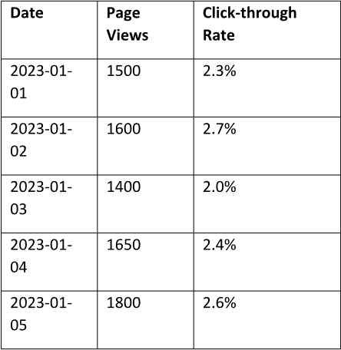
1. Create a line chart to visualize the trend in daily page views over time. Label the axes and
title the chart.
- Drag Date → Columns.
- Drag Page Views → Rows.
- In the Marks card, select Line.
- Rename the worksheet to Daily Page Views.
- Edit the title to Daily Page Views Over Time.

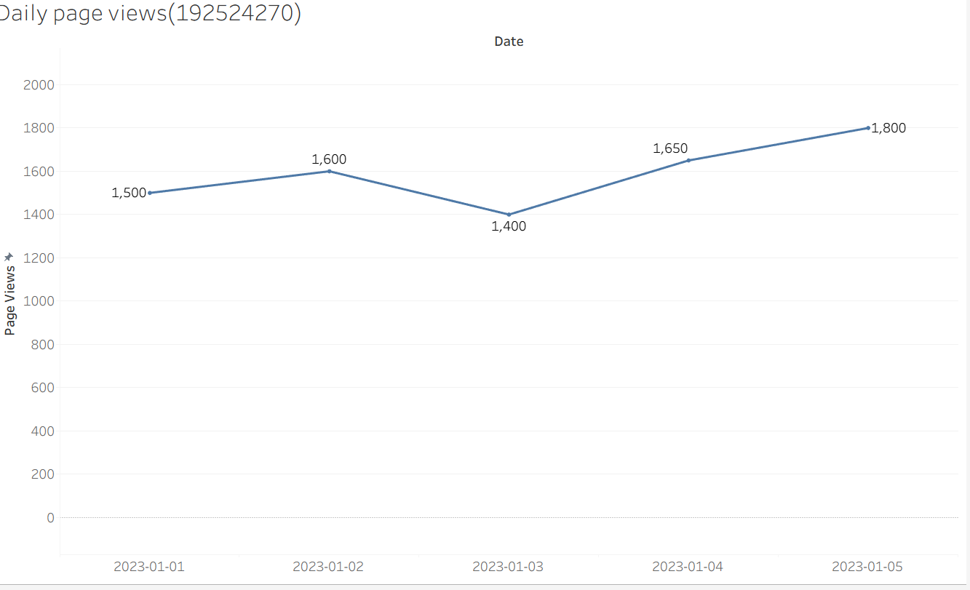
2. Generate a bar chart showing the top N days with the highest click-through rates. Label the
chart elements.
- Click New Worksheet.
- Drag Date → Columns.
- Drag Click-through Rate → Rows.
- Change Marks to Bar.
- Click the Sort Descending button.
- Click Label → Show Mark Labels.
- Rename the worksheet to Top Click-through Rates.

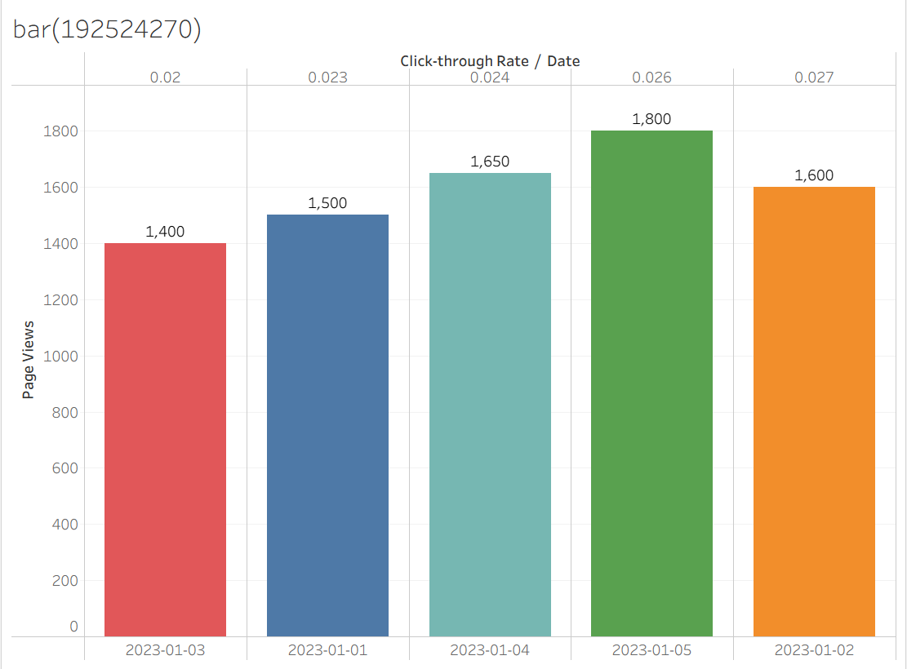

3. Develop a stacked area chart to display the distribution of user interactions (likes, shares,
comments) on a website.
- Click New Worksheet.
- Drag Date → Columns.
- Drag Measure Values → Rows.
- Drag Measure Names → Color.
- Drag Measure Names → Filters.
- Select Likes, Shares, and Comments only.
- Change Marks to Area.
- Go to Analysis → Stack Marks → On.
- Rename the worksheet to User Interactions.
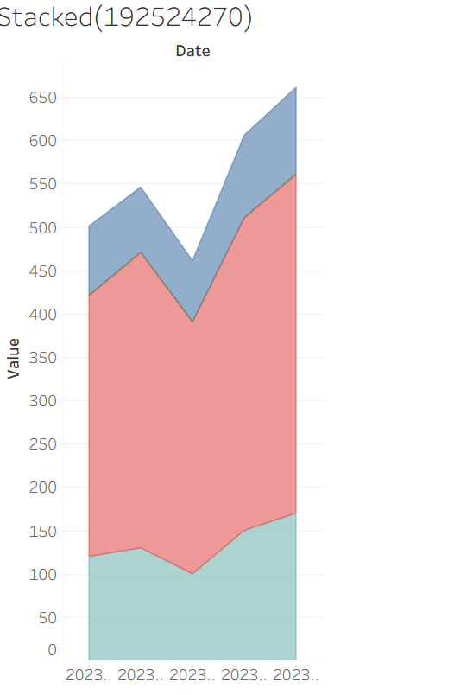

4. Build a Tableau dashboard with the line chart and bar chart for interactive exploration of
website traffic data.
- Click New Dashboard.
- Drag the following sheets to the dashboard:
  - Daily Page Views
  - Top Click-through Rates
  - (Optional) User Interactions
- Arrange the charts neatly.
- Set Size to Automatic.
- Save the workbook.

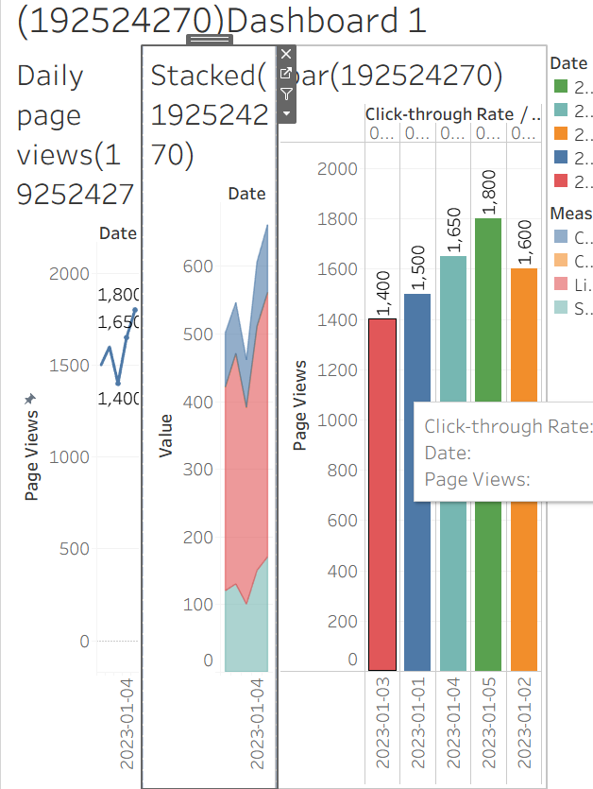

Set 6: Product Sales Analysis
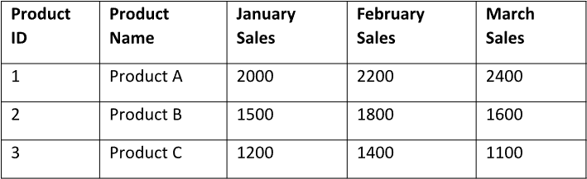
1. Create a grouped bar chart to visualize the sales of each product for the first quarter. Label
the chart elements.
- Drag Product Name → Columns.
- Drag Measure Values → Rows.
- Drag Measure Names → Columns (next to Product Name).
- Drag Measure Names → Filters.
- Select only:
- ✔ January Sales
- ✔ February Sales
- ✔ March Sales
- Click OK.
- Drag Measure Names → Color.
- In the Marks card, select Bar.
- Click Label → Show Mark Labels.
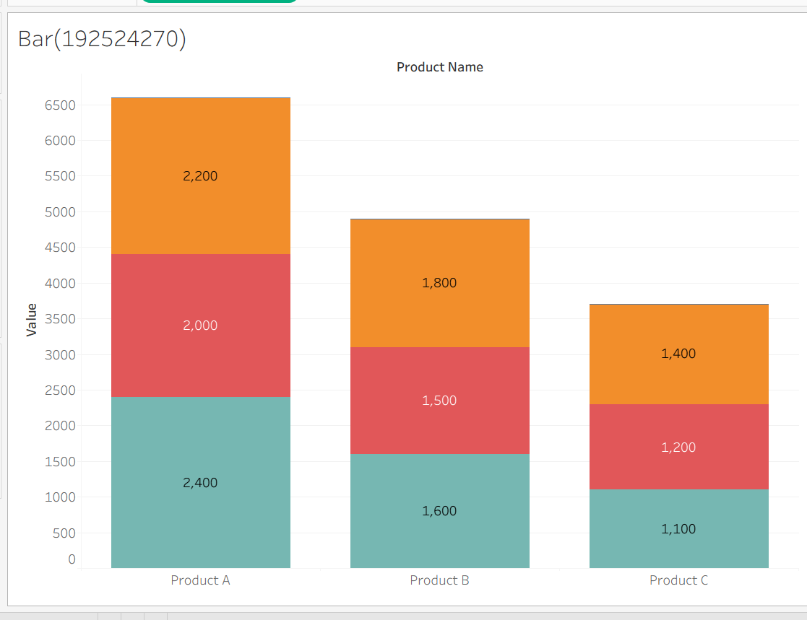
2. Generate a stacked area chart to represent the overall sales trend for all products over the
three months.
- Click New Worksheet.
- Drag Measure Names → Columns.
- Drag Measure Values → Rows.
- Drag Product Name → Color.
- Drag Measure Names → Filters.
- Select:
- ✔ January Sales
- ✔ February Sales
- ✔ March Sales
- Click OK.
- In the Marks card, select Area.
- Go to Analysis → Stack Marks → On.
- Rename the worksheet to Stacked Area Chart.
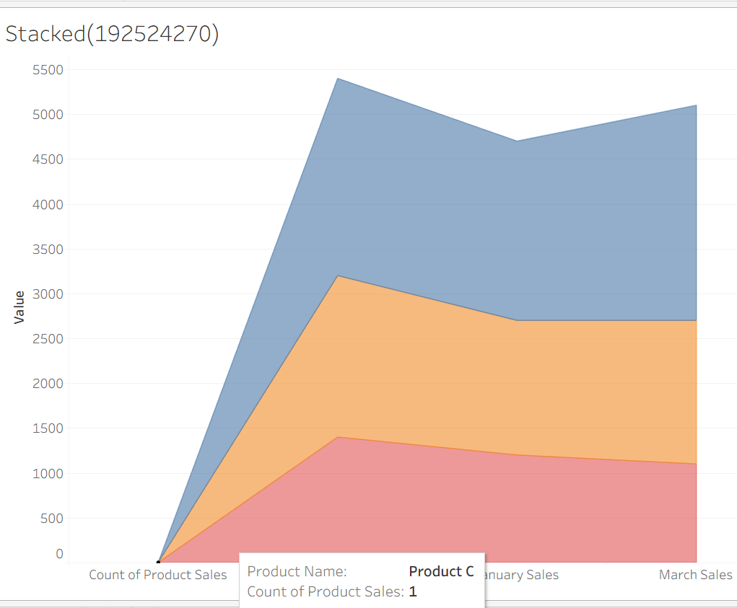

3. Build a table to show the monthly sales data for each product. Label the table elements.
- Click New Worksheet.
- Drag Product Name → Rows.
- Drag Measure Names → Columns.
- Drag Measure Values → Text (on the Marks card).
- Drag Measure Names → Filters.
- Select:
- ✔ January Sales
- ✔ February Sales
- ✔ March Sales
- Click OK.
- Rename the worksheet to Monthly Sales Table.

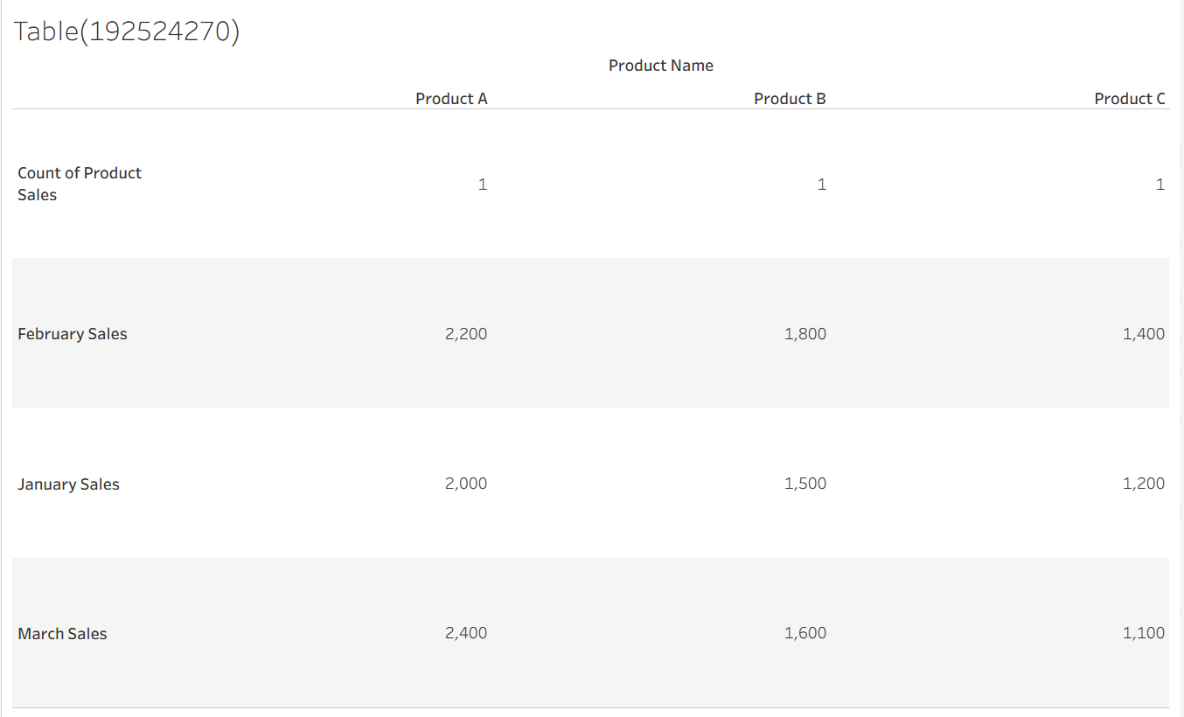
4. Develop a Tableau dashboard combining the grouped bar chart, stacked area chart, and the
table for interactive exploration of sales data.
- Click New Dashboard.
- Drag the following worksheets onto the dashboard:
  - Grouped Bar Chart
  - Stacked Area Chart
  - Monthly Sales Table
- Arrange them neatly.
- Set Size to Automatic.
- Save the workbook.

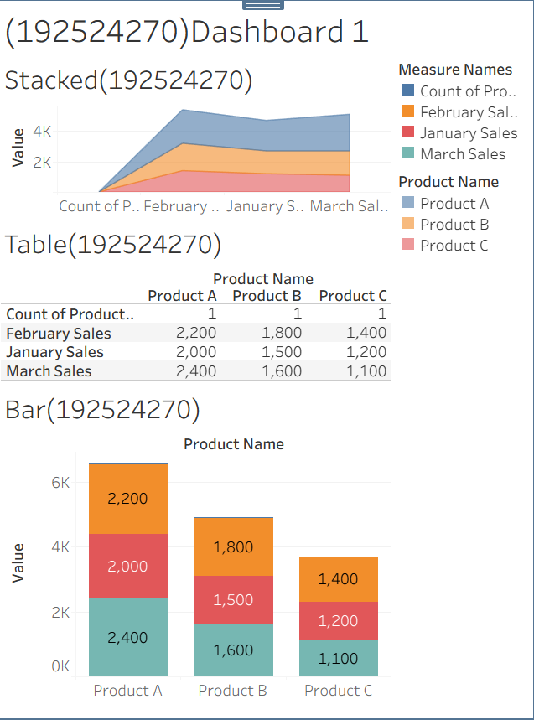
Set 7: Customer Demographics Analysis

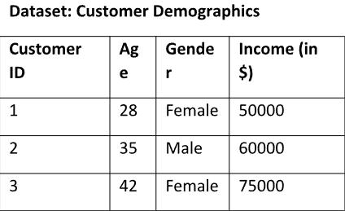
1. Create a bar chart to visualize the distribution of customer ages. Label the axes and title the
chart.
- Open Tableau.
- Connect to Customer_Demographics.xlsx.
- Click Sheet 1.
- Drag Customer ID to Columns.
- Drag Age to Rows.
- In the Marks card, select Bar.
- Click Label → Show Mark Labels.
- Rename the title to Customer Age Distribution.
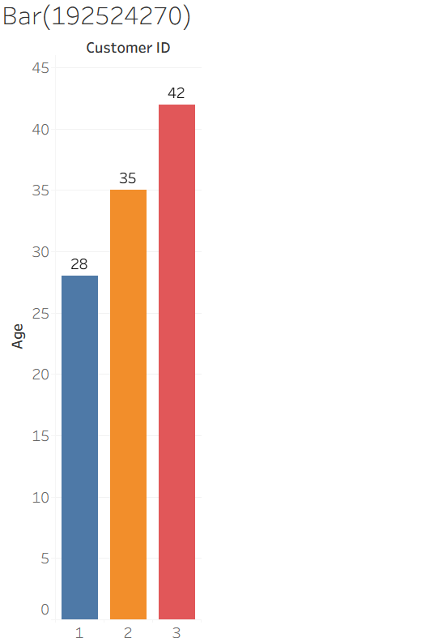
2. Generate a pie chart to represent the distribution of customers by gender.
- Click New Worksheet.
- Change Marks to Pie.
- Drag Gender to Color.
- Drag Gender to Label.
- Drag Customer ID to Angle.
- Increase the pie size using Size.
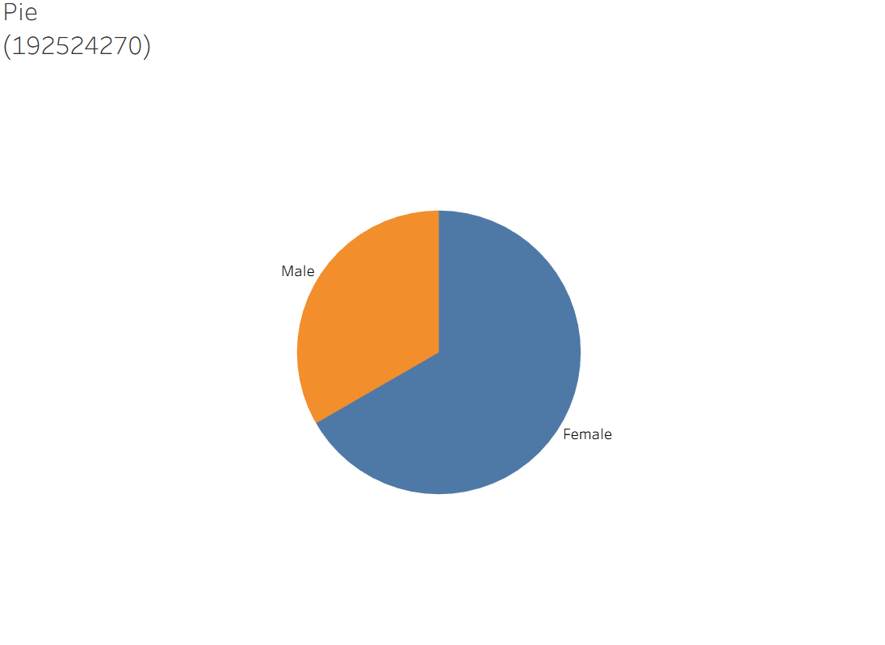
- Rename the title to Gender Distribution.
3. Build a table to show the demographic information for each customer. Label the table
elements.
- Click New Worksheet.
- Drag Customer ID to Rows.
- Drag Age to Text.
- Drag Gender to Text.
- Drag Income ($) to Text.
- Rename the title to Customer Demographics Table.

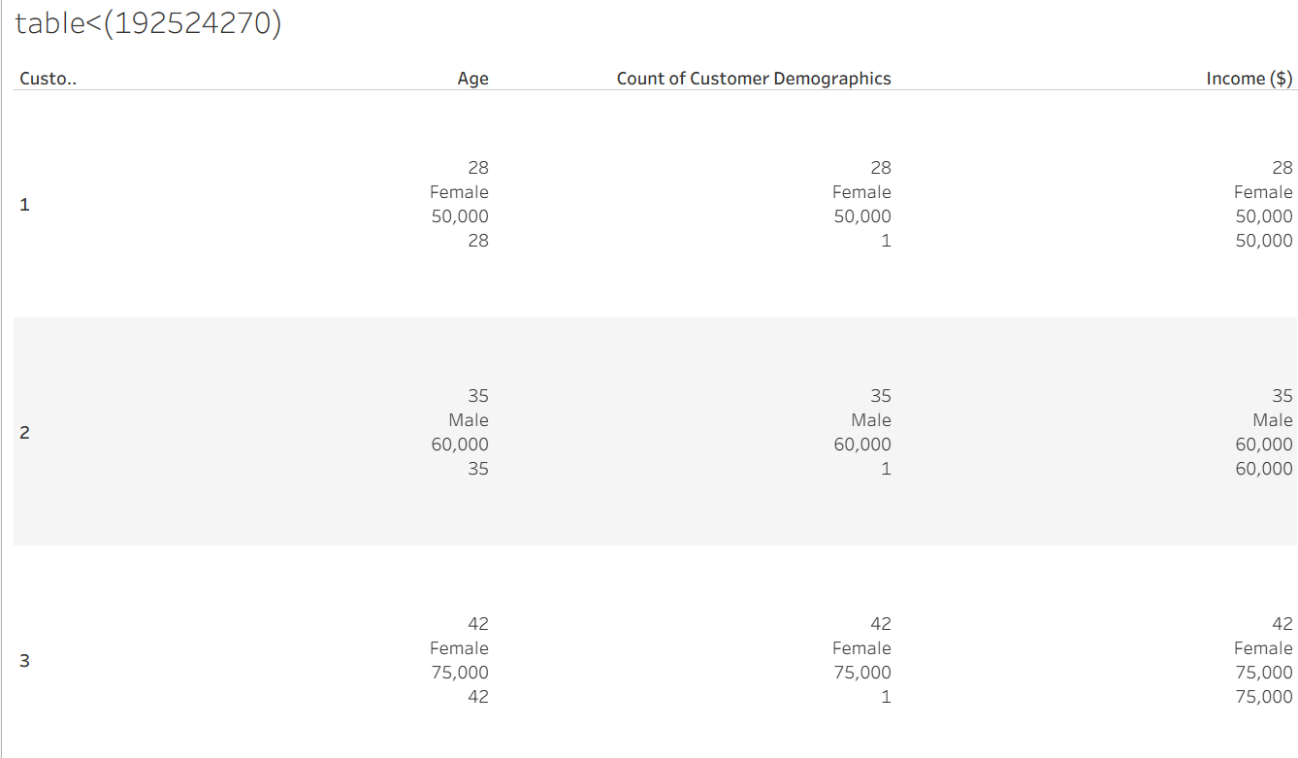
4. Develop a Tableau dashboard combining the bar chart, pie chart, and the table for
interactive exploration of customer demographics.
- Click New Dashboard.
- Drag Customer Age Distribution to the dashboard.
- Drag Gender Distribution to the dashboard.
- Drag Customer Demographics Table to the dashboard.
- Arrange the charts neatly.
- Save the workbook.
