Task Scheduler & Manager
Name: Amruth Badi
Course: Bachelor of Computer Applications (B.C.A)
College: K.L.E Society's P. C. Jabin Science College, Hubballi
Academic Year: 2025–2026

Table of Contents
1. Introduction
2. Objectives
3. Technologies Used
4. Folder Structure
5. Flask Application Overview
6. HTML Pages Overview
7. Static Resources
8. How to Run the Project
9. Screenshot
10. Conclusion
11. Future Scope

1. Introduction
This Task Scheduler & Manager is a personal productivity web app built using Flask, HTML, CSS, and SQLite. It enables users to add, manage, and track tasks, offering a clean dashboard with visual insights via animated pie charts and notifications.

2. Objectives
• Build a responsive task dashboard with light/dark mode.
• Integrate SQLite backend for task persistence.
• Allow full CRUD operations (Create, Read, Update, Delete).
• Display dynamic task statistics and overdue alerts.

3. Technologies Used
• HTML5 – for structured content.
• CSS3 – for styling and responsive layout.
• JavaScript – for toggles, filter, and animations.
• Flask – Python backend framework to serve and route pages.
• SQLite – Lightweight database for task storage.
• Chart.js – For animated pie chart statistics.

4. Folder Structure
/TaskScheduler
├── app.py
├── static/ (CSS, JS)
├── templates/ (HTML files)
├── database.db
├── README.md

5. Flask Application Overview
• `app.py`: Core backend handling routing, DB operations, task stats.
• Routes:
- `/`: Dashboard view
- `/add`, `/edit/<id>`, `/delete/<id>`, `/complete/<id>`: CRUD
- `/task_stats`: Returns JSON stats

6. HTML Pages Overview
index.html – Task dashboard (summary + table view)
add_task.html – Add task form (title, desc, due date)
edit_task.html – Edit and update task info

7. Static Resources
All styling and JS logic stored in `/static/`:
• style.css – Light/Dark Mode, animations, layout
• script.js – Chart.js rendering, dark toggle, filter logic

8. How to Run the Project
1. Install Flask: `pip install flask`
2. Run app: `python app.py`
3. Open browser: http://127.0.0.1:5000/

9. Screenshot
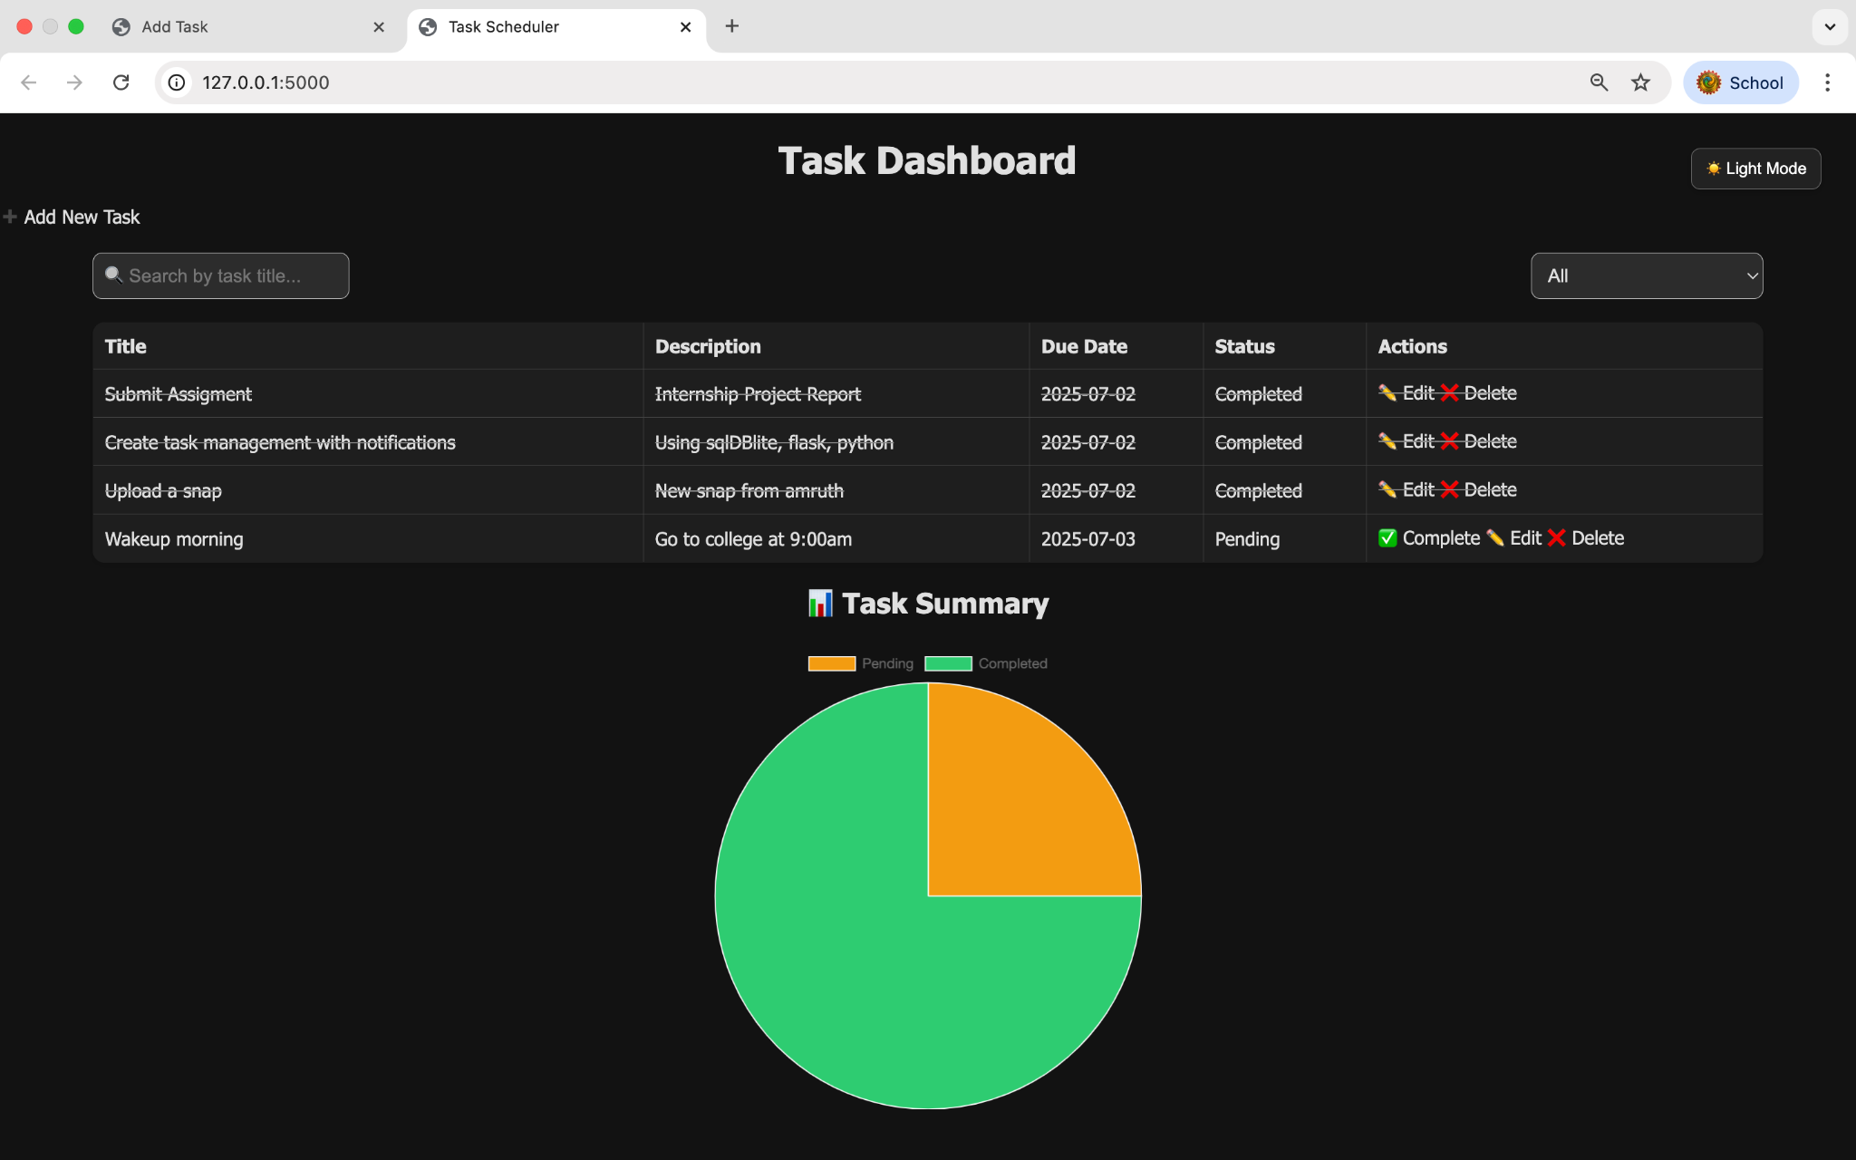

10. Conclusion
The Task Scheduler project demonstrates full-stack capability combining frontend interactivity with backend data management. It offers real-time task stats, smooth UI, and user-friendly features.

11. Future Scope
• Add user authentication and session management.
• Email notifications or reminders.
• Task category filters and CSV export.
• Deploy online via Render or Railway.

