FITNESS TRACKER

Mrs. ANDAVARAPU SRAVANI,

Assistant professor,

Department of Computer Science and Engineering,

Gandhi Institute of Technology and Management,

Visakhapatnam, India

L. CHAITANYA SRINIVAS

Department of Computer Science and Engineering,

Gandhi Institute of Technology and Management,

Visakhapatnam, India

L. SRINIDHI

Department of Computer Science and Engineering,

Gandhi Institute of Technology and Management,

Visakhapatnam, India

**Abstract - Fitness Tracker with AI Nutritionist is an intelligent system that integrates caloric expenditure estimation with personalized dietary recommendations to enhance health and fitness management. It employs a Random Forest Regressor to predict calories burned based on gender, age, height, weight, exercise duration, heart rate, and body temperature. The estimated calories serve as a threshold for a linear programming-based optimization model, which recommends high-protein diets while maintaining calorie constraints. A user-friendly interface, developed with Gradio and Streamlit, allows users to input personal**

WITH AI NUTRITIONIST

D. AMRUTH

Department of Computer Science and Engineering,

Gandhi Institute of Technology and Management,

Visakhapatnam, India

P. DHEERAJ

Department of Computer Science and Engineering,

Gandhi Institute of Technology and Management,

Visakhapatnam, India

**details and receive tailored advice. Additionally, data visualization tools enable progress tracking, ensuring informed decision-making. By combining machine learning, mathematical optimization, and interactive design, this system provides a holistic AI-driven approach to fitness and nutrition management.**

1. INTRODUCTION

In recent years, the growing emphasis on health and wellness has led to an increased demand for intelligent systems that assist individuals in effectively managing them fitness and dietary needs. Traditional methods of tracking caloric expenditure and planning nutritional intake often require manual effort and lack personalized optimization. To address this challenge, we present an integrated system that combines fitness monitoring with AI-driven dietary recommendations, leveraging advanced data-driven techniques to enhance accuracy and user convenience.

The proposed system employs a Random Forest Regressor to estimate calorie burn based on user-specific parameters such as age, gender, height, weight, exercise duration, heart rate, and body temperature. This model is chosen for its robustness in handling nonlinear relationships and its ability to provide reliable predictions based on diverse input features. Once the estimated caloric burn is determined, a linear programming approach is utilized to generate personalized dietary recommendations that maximize protein intake while ensuring that the total calorie consumption does not exceed the predicted energy expenditure. This optimization strategy aims to help users maintain a balanced diet while aligning with their fitness goals.

To enhance accessibility and usability, the system integrates Gradio and Streamlit, enabling users to interact with the model through intuitive web-based interfaces. Furthermore, interactive data visualizations allow users to track their fitness progress over time, making the system a comprehensive solution for health-conscious individuals.

By integrating machine learning models with optimization techniques and user-friendly interfaces, this system provides a holistic approach to fitness and nutrition management. It empowers users with data-driven insights, personalized recommendations, and continuous tracking, ultimately contributing to improved health outcomes and informed decision-making regarding exercise and diet.

2 . LITERATURE REVIEW

The literature review provides valuable insights into the existing research and advancements in the field of personalized nutrition and fitness tracking systems. Here are the key inferences drawn from the survey:

1.AI-Powered Nutrition Assistant and Step Tracker  
Machine learning and IoT integration enhance personalized meal recommendations and fitness tracking. Wearable devices enable real-time activity monitoring, promoting an active lifestyle.  
*Challenges:* Data Privacy, Algorithm Bias, Connectivity Issues, Integration Challenges, User Compliance.

2.Personalized Fitness Recommendation Using Sequential Data  
A system using k-means clustering on the FitRec dataset helps users choose suitable sports activities based on physiological factors. Big data analytics play a key role in optimizing recommendations.  
*Challenges:* Data Dependency, Model Complexity, Scalability, Bias, Equipment Requirements.

3.Future of AI in Fitness Apps  
AI-powered apps like Freeletics and MyFitnessPal provide adaptive workout plans, real-time feedback, and gamification to boost engagement. AI in wearables aids health monitoring.  
*Challenges:* Limited to Android Users.

4.AI-Driven Health Platform for Self-Management  
AI and behavioral science (nudge theory) improve diabetes management through real-time monitoring, predictive analytics, and personalized care. Research focuses on long-term engagement and adherence.  
*Challenges:* User Engagement, Data Privacy, Algorithm Bias, Personalization, Long-term Effectiveness.

In conclusion, Existing AI-driven health platforms face several drawbacks, including data privacy concerns, as they require extensive personal data, raising security risks. Algorithm bias is another challenge, where imbalanced datasets can lead to inaccurate or non-inclusive fitness and dietary recommendations. Additionally, connectivity dependence limits the effectiveness of IoT-based solutions in areas with poor network access. Scalability challenges arise when handling large datasets, affecting performance and accuracy. Furthermore, user adoption and compliance issues make long-term engagement difficult, as many users struggle to adhere to AI-recommended fitness and nutrition plans. Lastly, hardware dependency restricts accessibility, as some fitness applications require specific wearable devices for accurate tracking, limiting usability for those without such devices.

3. SYSTEM ANALYSIS

3.1 PROPOSED SYSTEM

To overcome the limitations of existing fitness and nutrition tracking solutions, we propose Fitness Tracker with AI Nutritionist, an integrated system that combines machine learning-based caloric burn prediction with AI-driven dietary recommendations. The system leverages Random Forest Regressor to accurately estimate caloric expenditure based on user-specific parameters such as gender, age, height, weight, exercise duration, heart rate, and body temperature. Once the estimated caloric burn is determined, linear programming optimization is employed to generate personalized high-protein dietary recommendations, ensuring that the user’s total calorie intake aligns with their energy expenditure.

3.2 IMPROVEMENTS OVER EXISTING SYSTEMS:

1. Enhanced Accuracy with Machine Learning: Unlike conventional calorie tracking apps that rely on predefined calculations or manual input, our system utilizes a Random Forest Regressor, a robust machine learning model that captures complex, nonlinear relationships in user data. This significantly improves the accuracy of calorie burn estimation, offering personalized insights based on real-time input.
2. Optimized Dietary Planning:  
   Many existing fitness applications provide generic meal recommendations that do not factor in individual caloric needs or nutrient optimization. Our system, however, employs linear programming to suggest an optimal diet plan that prioritizes protein intake while staying within the predicted energy expenditure limit. This ensures balanced nutrition while maximizing fitness goals.
3. Improved Accessibility with a Web-Based Interface: Most fitness and nutrition apps require dedicated mobile applications or specific wearables for data collection and analysis. In contrast, our system offers a fully accessible web-based interface built using Gradio and Streamlit, allowing users to input their details and receive instant predictions without the need for additional hardware. This makes the platform more inclusive and user-friendly.
4. Better User Engagement & Compliance: Real-time calorie tracking, personalized diet recommendations, and data visualization tools encourage users to stay engaged with their fitness goals. The system offers interactive progress tracking, helping users monitor weight trends and calorie intake patterns over time, leading to higher compliance and sustained engagement.
5. Reduced Data Bias for Fairer Predictions: Existing AI-powered health solutions often suffer from demographic bias, leading to inaccurate predictions for underrepresented groups. Our system is trained on a diverse dataset that includes multiple demographic and physiological factors, ensuring more inclusive and fair predictions for users across different age groups, body types, and activity levels.
6. Privacy-Focused Design for Secure Data Handling: While most fitness and health apps store user data on cloud-based servers, raising concerns about data privacy and security, our system is designed with local deployment options. Users can choose to run the system entirely on their device, ensuring that sensitive health information remains private and secure.

In conclusion, by integrating machine learning, mathematical optimization, and an intuitive user interface, the Fitness Tracker with AI Nutritionist provides a holistic, AI-driven approach to fitness and nutrition management. The system not only improves accuracy, accessibility, and user engagement but also addresses key limitations in existing solutions such as data bias, privacy concerns, and generic recommendations. This innovative platform empowers users to make data-driven fitness decisions, ultimately contributing to better health outcomes.

4. SYSTEM DESIGN

4.1 MODULE DESCRIPTION

The Fitness Tracker with AI Nutritionist consists of several key modules that work together to provide accurate calorie expenditure estimations and personalized dietary recommendations. Each module is designed to ensure efficiency, accuracy, and user engagement, making the system both intuitive and effective. Below is a detailed breakdown of the core components:

a) User Input Module

The User Input Module is the entry point of the system, where users provide relevant personal details via a user-friendly Gradio/Streamlit interface. The collected data includes:

* Age, Gender, Height, Weight → Used to determine the user’s Basal Metabolic Rate (BMR) and overall fitness profile.
* Exercise Duration → Helps measure activity level and contribution to calorie burn.
* Heart Rate & Body Temperature → Indicators of physical exertion and metabolic rate during activity.

This module is crucial as it sets the foundation for accurate calorie estimation and dietary planning.

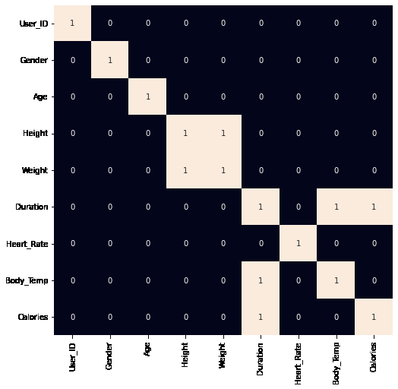

Fig 1: Correlation between metrics

Source: <https://request.geeksforgeeks.org>

b) Calorie Expenditure Estimation Module

The Caloric Expenditure Estimation Module uses machine learning to predict the number of calories burned based on user inputs. The model used is a Random Forest Regressor, chosen for its ability to:

* Handle non-linear relationships between variables.
* Reduce overfitting through ensemble learning.
* Provide highly accurate predictions based on historical fitness data.

This module is essential for generating  real-time fitness insights and enabling personalized nutrition planning.

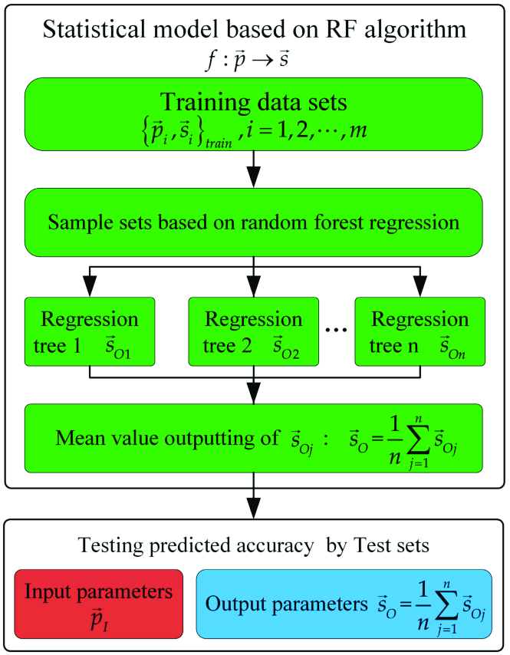

Fig 2: Random Forest Regression algorithm

Source: <https://www.researchgate.net/figure/The-parameters-prediction-flow-chart-of-random-forest-regression-By-comparison>

c) Diet Optimization Module

The Diet Optimization Module utilizes Linear Programming to generate a nutritionally optimized diet plan based on the predicted caloric expenditure. The goal is to:

* Maximize protein intake to support muscle recovery and fitness goals.
* Ensure the total calorie intake does not exceed estimated expenditure, maintaining a healthy balance.

This module ensures nutritional efficiency, aligning diet recommendations with scientific dietary principles.

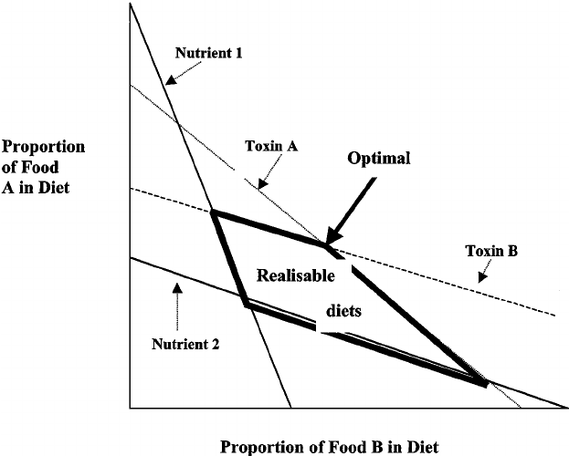

Fig 3: Linear programming model for dietary choice

Source: <https://www.researchgate.net/figure/Linear-programming-model-for-dietary-choice-The-range-of-realizable-or-possible>

d) User Interface & Visualization Module

The User Interface Module provides an interactive and intuitive platform for users to access their fitness and nutrition insights. It enables users to:

* View calorie expenditure results in real-time.
* Receive detailed dietary recommendations tailored to their needs.
* Track progress over time through dynamic visualizations.

This module enhances user engagement by providing clear, actionable insights, making it easier for users to stay committed to their fitness goals.

In conclusion, by integrating machine learning, optimization techniques, and interactive UI elements, the Fitness Tracker with AI Nutritionist offers a comprehensive, AI-driven solution for health and fitness management. Each module plays a critical role in ensuring accurate predictions, efficient diet planning, and an engaging user experience, ultimately empowering individuals to make informed health decisions and maintain a balanced lifestyle.

5. SYSTEM IMPLEMENTATION

5.1 FUNCTIONAL REQUIRMENTS

1. Data Handling: Import and merge exercise and nutritional data from CSV files. Process data by cleaning, filling missing values, and converting types.
2. Calorie Prediction and Exercise Analysis: Predict calories burned using a pre-trained Random Forest Regressor based on user inputs like gender, age, height, etc. (Implied) Analyse exercise form and track repetitions, leveraging pose estimation if applicable.
3. Dietary Optimization: Generate dietary plans optimized for calorie intake and nutritional balance using linear programming. Adjust dietary recommendations based on user's real-time data and goals.
4. User Interface: Provide interactive input and output handling through Gradio and Streamlit, allowing users to receive personalized fitness and dietary feedback.
5. Visualization and Monitoring: Visualize exercise and diet data to monitor progress and adjustments in dietary plans.

5.2 NON-FUNCTIONAL REQUIREMENTS

1. Performance: Ensure quick response times for data processing and user interactions.
2. Usability: Offer intuitive interfaces that non-technical users can easily navigate.
3. Scalability: Handle increasing volumes of data and user interactions efficiently.
4. Reliability: Provide a stable system with high availability, especially for web-based access.

5.3 MODULE IMPLEMENTATION

a) Data Collection & Preprocessing

* User Inputs: The user provides key information such as height, weight, age, duration of workout, gender, and temperature to estimate calorie burn accurately.
* Dataset Integration: The project uses a fitness activity dataset containing historical workout records and corresponding calorie expenditures.
* Data Cleaning & Transformation: Handling Missing Values: Missing or inconsistent entries are either removed or imputed using statistical techniques. Feature Encoding: Categorical variables (e.g., exercise type) are converted into numerical values.

b) Calorie Prediction Using Random Forest Regression

* Training the Model: The dataset is split into training (80%) and testing (20%) subsets. The model is trained on features such as age, weight, height, gender, exercise duration, and temperature to predict calorie burn.
* Performance Evaluation: The model's accuracy is assessed using R² score (coefficient of determination) and RMSE (Root Mean Square Error).

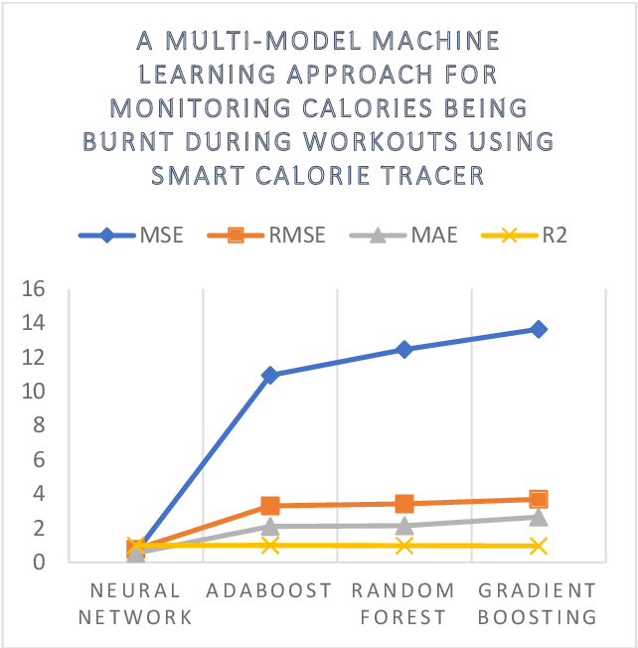

Fig 4: Visualizing the Performance: A line graph depicting the outcomes after running diverse machine learning algorithms, revealing insights into their effectiveness.

Source: <https://www.semanticscholar.org/paper/A-Multi-Model-Machine-Learning-Approach>

c) Meal Plan Optimization Using Linear Programming

* Objective: Generate a personalized meal plan based on predicted calorie expenditure while ensuring optimal nutrient intake.
* Constraints Considered: Total calorie limit (as predicted by the ML model) and protein requirements (e.g., high-protein diet for muscle gain).
* Optimization Technique: PuLP (Linear Programming Solver) is used to find the best meal combination that meets calorie constraints while maximizing protein intake. The system iteratively generates multiple meal plans, allowing users to select their preferred option.

d) Data Visualization & Weight Forecasting

* Weight Forecasting: Uses linear regression to predict future weight based on historical calorie intake and exercise levels. Users can adjust workout and diet parameters to see the projected impact on their weight over time.
* Visualization Tools Used: Matplotlib & Seaborn generate interactive charts and graphs for fitness progress tracking.

e) Web Application Development & Deployment

* User Interface (UI): The front end is built using Streamlit, allowing users to input fitness data, view calorie predictions, and receive meal plans in real time.
* Backend API & Server: A Flask API processes user inputs and sends requests to the machine learning model.
* Deployment: The project is hosted on a cloud platform, making it accessible from any device with internet access.

6. RESULTS

a) User Interaction: Interfaces built with Streamlit facilitated real-time feedback and interactive tracking, enhancing user engagement and goal adherence.

Fig 5: Streamlit interface

b)Diet Optimization: Linear programming optimized meal plans focused on maximizing protein within calorie limits, offering diverse and balanced diet options.

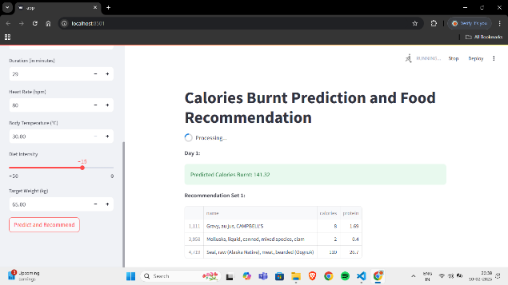

Fig 6: Recommended diet plans

c) Weight Forecasting: Uses linear regression to predict future weight based on historical calorie intake and exercise levels.

Fig 7: Interactive charts using Matplotlib

7. CONCLUSION AND FUTURE SCOPE

7.1 CONCLUSION

The implemented fitness and diet recommendation system effectively combines machine learning with linear programming to predict calorie expenditure and optimize dietary intake, tailored to individual health and fitness goals. Utilizing a Random Forest model integrated with user-friendly interfaces such as Streamlit, the system provides accurate predictions of calories burned based on various physical attributes and activity levels. It also offers optimized dietary suggestions that maximize nutritional intake without surpassing caloric needs, crucial for balanced diet maintenance. This interactive platform simplifies tracking fitness and dietary intake, enhancing user engagement through an accessible web interface. The system's design allows for scalability and future enhancements, such as integration with wearable technology and more detailed nutritional tracking, showing potential for personalized health management and improved public health outcomes.

7.2 FUTURE SCOPE

1. Integration with Wearable Devices: Enhancing data accuracy by syncing with wearable devices to monitor real-time activity and health stats.
2. Expanded Nutritional Database: Broadening the food database to include diverse dietary options, catering to various cultural and dietary preferences.
3. User Engagement and Interaction: Introducing features like goal setting, progress tracking, and social sharing to boost user motivation and engagement.
4. Comprehensive Meal Planning: Developing tools for automated meal planning, including shopping lists and recipe suggestions tailored to user preferences.
5. Predictive Health Analytics: Using data analytics to predict health risks and provide preventative recommendations.
6. Mobile App Development: Creating a mobile application for easier access and integration into users' daily routines.

8. REFERENCES

1. Dr. N K Sakthivel, Dr. S. Subasree, Mr. Surya Kannan Kumbhar, Mr. C. Jeffrey Hasan, Mr. G. Muruguraj, Mr. Shabin Sj, 2024, AI-Powered Nutrition Assistant and Step Tracker, INTERNATIONAL JOURNAL OF ENGINEERING RESEARCH & TECHNOLOGY (IJERT) Volume 13, Issue 04 (April 2024)
2. "AI-Powered Fitness App for Dynamic Workout Tracking and Personalized Exercise and Nutritional Plan Recommendations", International Journal of Emerging Technologies and Innovative Research (www.jetir.org), ISSN:2349-5162, Vol.11, Issue 5, page no.n464-n468, May-2024, Available :[http://www.jetir.org/papers/JETIR2405D66.pdf](https://www.jetir.org/papers/JETIR2405D66.pdf)
3. Machine Learning for Personalized Nutrition and Diet Recommendations, Sarda, A., Almeida, M., & Chen, J. (2019). *Machine Learning Techniques for Personalized Nutrition Recommendation Systems*. Journal of Nutritional Health. This paper discusses the role of machine learning in creating personalized dietary recommendations based on individual user data.
4. KH, Asha. (2024). Al Fitness Model using Deep Learning. International Journal of Advanced Research in Science Communication and Technology. 4. 459- 464. 10.48175/IJARSCT-15361. Tsolakidis, D.; Gymnopoulos, L.P.; Dimitropoulos, K. Artificial Intelligence and Machine Learning Technologies for Personalized Nutrition: A Review. *Informatics* 2024, *11*, 62. <https://doi.org/10.3390/informatics11030062>