**AUMS**

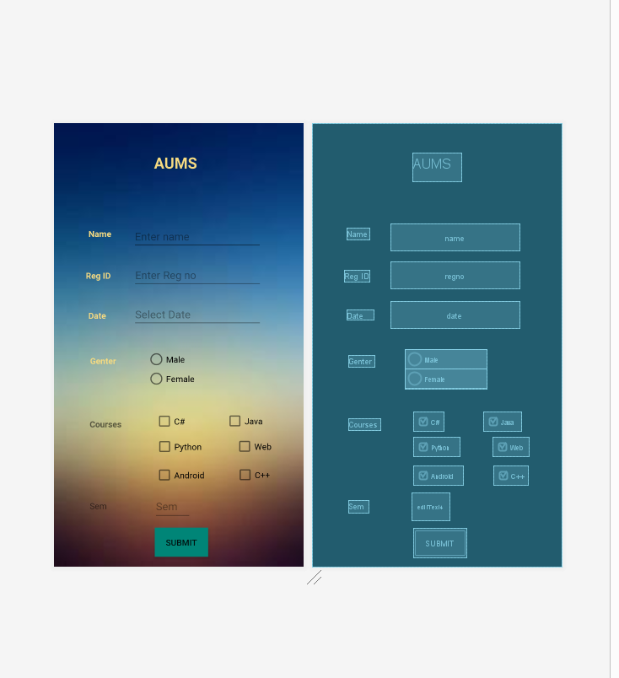

XML

*<?***xml version="1.0" encoding="utf-8"***?>*

<**androidx.constraintlayout.widget.ConstraintLayout xmlns:android="http://schemas.android.com/apk/res/android"**

**xmlns:app="http://schemas.android.com/apk/res-auto"**

**xmlns:tools="http://schemas.android.com/tools"**

**android:layout_width="match_parent"**

**android:layout_height="match_parent"**

**tools:context=".MainActivity"**

**android:background="@drawable/school"**>

<**TextView**

**android:id="@+id/textView"**

**android:layout_width="80dp"**

**android:layout_height="47dp"**

**android:text="AUMS"**

**android:textColor="#F5DA81"**

**android:textSize="25dp"**

**android:textStyle="bold"**

**app:layout_constraintBottom_toBottomOf="parent"**

**app:layout_constraintEnd_toEndOf="parent"**

**app:layout_constraintHorizontal_bias="0.498"**

**app:layout_constraintStart_toStartOf="parent"**

**app:layout_constraintTop_toTopOf="parent"**

**app:layout_constraintVertical_bias="0.07"** />

<**TextView**

**android:id="@+id/textView2"**

**android:layout_width="wrap_content"**

**android:layout_height="wrap_content"**

**android:text="Name"**

**android:textStyle="bold"**

**android:textColor="#F5DA81"**

**app:layout_constraintBottom_toBottomOf="parent"**

**app:layout_constraintEnd_toEndOf="parent"**

**app:layout_constraintHorizontal_bias="0.153"**

**app:layout_constraintStart_toStartOf="parent"**

**app:layout_constraintTop_toTopOf="parent"**

**app:layout_constraintVertical_bias="0.242"** />

<**EditText**

**android:id="@+id/name"**

**android:layout_width="wrap_content"**

**android:layout_height="wrap_content"**

**android:ems="10"**

**android:hint="Enter name"**

**android:inputType="textPersonName"**

**app:layout_constraintBottom_toBottomOf="parent"**

**app:layout_constraintEnd_toEndOf="parent"**

**app:layout_constraintHorizontal_bias="0.339"**

**app:layout_constraintStart_toEndOf="@+id/textView2"**

**app:layout_constraintTop_toTopOf="parent"**

**app:layout_constraintVertical_bias="0.24"** />

<**TextView**

**android:id="@+id/textView3"**

**android:layout_width="wrap_content"**

**android:layout_height="wrap_content"**

**android:text="Reg ID"**

**android:textStyle="bold"**

**android:textColor="#F5DA81"**

**app:layout_constraintBottom_toBottomOf="parent"**

**app:layout_constraintEnd_toEndOf="parent"**

**app:layout_constraintHorizontal_bias="0.142"**

**app:layout_constraintStart_toStartOf="parent"**

**app:layout_constraintTop_toBottomOf="@+id/textView2"**

**app:layout_constraintVertical_bias="0.096"** />

<**EditText**

**android:id="@+id/regno"**

**android:layout_width="wrap_content"**

**android:layout_height="wrap_content"**

**android:ems="10"**

**android:hint="Enter Reg no"**

**android:inputType="textPersonName"**

**app:layout_constraintBottom_toBottomOf="parent"**

**app:layout_constraintEnd_toEndOf="parent"**

**app:layout_constraintHorizontal_bias="0.656"**

**app:layout_constraintStart_toStartOf="parent"**

**app:layout_constraintTop_toBottomOf="@+id/name"**

**app:layout_constraintVertical_bias="0.039"** />

<**EditText**

**android:id="@+id/date"**

**android:layout_width="wrap_content"**

**android:layout_height="wrap_content"**

**android:ems="10"**

**android:hint="Select Date"**

**android:inputType="date"**

**app:layout_constraintBottom_toBottomOf="parent"**

**app:layout_constraintEnd_toEndOf="parent"**

**app:layout_constraintHorizontal_bias="0.656"**

**app:layout_constraintStart_toStartOf="parent"**

**app:layout_constraintTop_toBottomOf="@+id/regno"**

**app:layout_constraintVertical_bias="0.048"**

**tools:ignore="UnknownId"** />

<**TextView**

**android:id="@+id/textView4"**

**android:layout_width="44dp"**

**android:layout_height="17dp"**

**android:text="Date"**

**android:textColor="#F5DA81"**

**android:textStyle="bold"**

**app:layout_constraintBottom_toBottomOf="parent"**

**app:layout_constraintEnd_toEndOf="parent"**

**app:layout_constraintHorizontal_bias="0.155"**

**app:layout_constraintStart_toStartOf="parent"**

**app:layout_constraintTop_toBottomOf="@+id/textView3"**

**app:layout_constraintVertical_bias="0.103"** />

<**TextView**

**android:id="@+id/textView5"**

**android:layout_width="wrap_content"**

**android:layout_height="wrap_content"**

**android:text="Genter"**

**android:textStyle="bold"**

**android:textColor="#F5DA81"**

**app:layout_constraintBottom_toBottomOf="parent"**

**app:layout_constraintEnd_toEndOf="parent"**

**app:layout_constraintHorizontal_bias="0.161"**

**app:layout_constraintStart_toStartOf="parent"**

**app:layout_constraintTop_toBottomOf="@+id/textView4"**

**app:layout_constraintVertical_bias="0.149"** />

<**RadioGroup**

**android:id="@+id/radioGroup"**

**android:layout_width="135dp"**

**android:layout_height="66dp"**

**android:layout_marginStart="16dp"**

**android:layout_marginLeft="16dp"**

**app:layout_constraintBottom_toBottomOf="parent"**

**app:layout_constraintEnd_toEndOf="parent"**

**app:layout_constraintHorizontal_bias="0.525"**

**app:layout_constraintStart_toStartOf="parent"**

**app:layout_constraintTop_toTopOf="parent"**

**app:layout_constraintVertical_bias="0.561"**>

<**RadioButton**

**android:id="@+id/radioButton3"**

**android:layout_width="match_parent"**

**android:layout_height="wrap_content"**

**android:text="Male"**

**app:layout_constraintBottom_toBottomOf="parent"**

**app:layout_constraintEnd_toEndOf="parent"**

**app:layout_constraintStart_toStartOf="parent"**

**app:layout_constraintTop_toTopOf="parent"** />

<**RadioButton**

**android:id="@+id/radioButton4"**

**android:layout_width="match_parent"**

**android:layout_height="wrap_content"**

**android:text="Female"**

**app:layout_constraintEnd_toEndOf="parent"**

**app:layout_constraintStart_toStartOf="parent"** />

</**RadioGroup**>

<**TextView**

**android:id="@+id/textView6"**

**android:layout_width="wrap_content"**

**android:layout_height="wrap_content"**

**android:text="Courses"**

**android:textStyle="bold"**

**app:layout_constraintBottom_toBottomOf="parent"**

**app:layout_constraintEnd_toEndOf="parent"**

**app:layout_constraintHorizontal_bias="0.164"**

**app:layout_constraintStart_toStartOf="parent"**

**app:layout_constraintTop_toBottomOf="@+id/textView5"**

**app:layout_constraintVertical_bias="0.274"** />

<**CheckBox**

**android:id="@+id/checkBox"**

**android:layout_width="wrap_content"**

**android:layout_height="wrap_content"**

**android:layout_marginTop="36dp"**

**android:text="C#"**

**app:layout_constraintBottom_toBottomOf="parent"**

**app:layout_constraintEnd_toEndOf="parent"**

**app:layout_constraintHorizontal_bias="0.459"**

**app:layout_constraintStart_toStartOf="parent"**

**app:layout_constraintTop_toBottomOf="@+id/radioGroup"**

**app:layout_constraintVertical_bias="0.0"** />

<**CheckBox**

**android:id="@+id/checkBox2"**

**android:layout_width="wrap_content"**

**android:layout_height="wrap_content"**

**android:layout_marginStart="116dp"**

**android:layout_marginLeft="116dp"**

**android:text="Java"**

**app:layout_constraintBottom_toBottomOf="parent"**

**app:layout_constraintEnd_toEndOf="parent"**

**app:layout_constraintHorizontal_bias="0.0"**

**app:layout_constraintStart_toStartOf="@+id/checkBox"**

**app:layout_constraintTop_toTopOf="parent"**

**app:layout_constraintVertical_bias="0.679"** />

<**CheckBox**

**android:id="@+id/checkBox3"**

**android:layout_width="wrap_content"**

**android:layout_height="wrap_content"**

**android:layout_marginTop="39dp"**

**android:text="Python"**

**app:layout_constraintBottom_toBottomOf="parent"**

**app:layout_constraintEnd_toEndOf="parent"**

**app:layout_constraintHorizontal_bias="0.498"**

**app:layout_constraintStart_toStartOf="parent"**

**app:layout_constraintTop_toTopOf="@+id/checkBox"**

**app:layout_constraintVertical_bias="0.016"** />

<**CheckBox**

**android:id="@+id/checkBox4"**

**android:layout_width="wrap_content"**

**android:layout_height="wrap_content"**

**android:text="Web"**

**app:layout_constraintBottom_toBottomOf="parent"**

**app:layout_constraintEnd_toEndOf="parent"**

**app:layout_constraintHorizontal_bias="0.509"**

**app:layout_constraintStart_toEndOf="@+id/checkBox3"**

**app:layout_constraintTop_toBottomOf="@+id/checkBox2"**

**app:layout_constraintVertical_bias="0.052"** />

<**CheckBox**

**android:id="@+id/checkBox5"**

**android:layout_width="wrap_content"**

**android:layout_height="wrap_content"**

**android:layout_marginTop="47dp"**

**android:text="Android"**

**app:layout_constraintBottom_toBottomOf="parent"**

**app:layout_constraintEnd_toEndOf="parent"**

**app:layout_constraintHorizontal_bias="0.504"**

**app:layout_constraintStart_toStartOf="parent"**

**app:layout_constraintTop_toTopOf="@+id/checkBox3"**

**app:layout_constraintVertical_bias="0.0"** />

<**CheckBox**

**android:id="@+id/checkBox6"**

**android:layout_width="wrap_content"**

**android:layout_height="wrap_content"**

**android:layout_marginTop="47dp"**

**android:text="C++"**

**app:layout_constraintBottom_toBottomOf="parent"**

**app:layout_constraintEnd_toEndOf="parent"**

**app:layout_constraintHorizontal_bias="0.481"**

**app:layout_constraintStart_toEndOf="@+id/checkBox5"**

**app:layout_constraintTop_toTopOf="@+id/checkBox4"**

**app:layout_constraintVertical_bias="0.0"** />

<**Button**

**android:id="@+id/submit"**

**android:layout_width="wrap_content"**

**android:layout_height="wrap_content"**

**android:background="@color/colorPrimary"**

**android:text="Submit"**

**app:layout_constraintBottom_toBottomOf="parent"**

**app:layout_constraintEnd_toEndOf="parent"**

**app:layout_constraintHorizontal_bias="0.513"**

**app:layout_constraintStart_toStartOf="parent"**

**app:layout_constraintTop_toTopOf="parent"**

**app:layout_constraintVertical_bias="0.976"** />

<**TextView**

**android:id="@+id/textView7"**

**android:layout_width="33dp"**

**android:layout_height="20dp"**

**android:text="Sem"**

**app:layout_constraintBottom_toBottomOf="parent"**

**app:layout_constraintEnd_toEndOf="parent"**

**app:layout_constraintHorizontal_bias="0.156"**

**app:layout_constraintStart_toStartOf="parent"**

**app:layout_constraintTop_toBottomOf="@+id/textView6"**

**app:layout_constraintVertical_bias="0.563"** />

<**EditText**

**android:id="@+id/editText4"**

**android:layout_width="63dp"**

**android:layout_height="46dp"**

**android:ems="10"**

**android:hint="Sem"**

**android:inputType="textPersonName"**

**app:layout_constraintBottom_toBottomOf="parent"**

**app:layout_constraintEnd_toEndOf="parent"**

**app:layout_constraintHorizontal_bias="0.281"**

**app:layout_constraintStart_toEndOf="@+id/textView7"**

**app:layout_constraintTop_toTopOf="parent"**

**app:layout_constraintVertical_bias="0.889"** />

</**androidx.constraintlayout.widget.ConstraintLayout**>

JAVA

**package** com.example.labexam1;

**import** androidx.appcompat.app.AppCompatActivity;

**import** android.annotation.SuppressLint;

**import** android.app.DatePickerDialog;

**import** android.os.Bundle;

**import** android.view.View;

**import** android.widget.Button;

**import** android.widget.CheckBox;

**import** android.widget.DatePicker;

**import** android.widget.EditText;

**import** android.widget.RadioButton;

**import** android.widget.RadioGroup;

**import** android.widget.TextView;

**import** android.widget.Toast;

**import** java.text.SimpleDateFormat;

**import** java.util.Calendar;

**import** java.util.Date;

**public class** MainActivity **extends** AppCompatActivity {

TextView **textView**;

Button **btn**;

**int credits** = 0;

CheckBox **c**, **python**, **Java**, **web**, **android**, **cpp**;

RadioGroup **rd**;

RadioButton **r**;

@SuppressLint(**"ResourceType"**)

String **name** = getString(R.id.***name***);

@Override

**protected void** onCreate(Bundle savedInstanceState) {

**super**.onCreate(savedInstanceState);

setContentView(R.layout.***activity_main***);

**c** = (CheckBox) findViewById(R.id.***checkBox***);

**final** EditText date = (EditText) findViewById(R.id.***date***);

**Java** = (CheckBox) findViewById(R.id.***checkBox2***);

**python** = (CheckBox) findViewById(R.id.***checkBox3***);

**web** = (CheckBox) findViewById(R.id.***checkBox4***);

**android** = (CheckBox) findViewById(R.id.***checkBox5***);

**cpp** = (CheckBox) findViewById(R.id.***checkBox6***);

**btn** = (Button) findViewById(R.id.***submit***);

**rd** = (RadioGroup) findViewById(R.id.***radio***);

date.setOnClickListener(**new** View.OnClickListener() {

@Override

**public void** onClick(View v) {

**final** Calendar c = Calendar.*getInstance*();

**int** mYear = c.get(Calendar.***YEAR***);

**int** mMonth = c.get(Calendar.***MONTH***);

**int** mDay = c.get(Calendar.***DAY_OF_MONTH***);

DatePickerDialog datePickerDialog = **new** DatePickerDialog(MainActivity.**this**,

**new** DatePickerDialog.OnDateSetListener() {

@Override

**public void** onDateSet(DatePicker view, **int** year,

**int** monthOfYear, **int** dayOfMonth) {

date.setText(dayOfMonth + **"/"** + (monthOfYear + 1) + **"/"** + year);

}

}, mYear, mMonth, mDay);

datePickerDialog.show();

}

});

**btn**.setOnClickListener(**new** View.OnClickListener() {

@Override

**public void** onClick(View view) {

StringBuilder result=**new** StringBuilder();

result.append(**"Profile of Your courses :"**);

**if**(**c**.isChecked()){

result.append(**"\n C#"**);

**credits**+=4;

}

**if**(**Java**.isChecked()){

result.append(**"\n java"**);

**credits**+=4;

}

**if**(**python**.isChecked()){

result.append(**"\n python"**);

**credits**+=4;

}

**if**(**web**.isChecked()){

result.append(**"\n Web"**);

**credits**+=4;

}

**if**(**android**.isChecked()){

result.append(**"\n android"**);

**credits**+=4;

}

**if**(**cpp**.isChecked()){

result.append(**"\n Cpp"**);

**credits**+=4;

}

**if**(**credits**>20) {

result.append(**"\nTotal Credits exced limit "** + **credits** + **" Enter Max 20 Credits"**);

Toast.*makeText*(getApplicationContext(), result.toString(), Toast.***LENGTH_LONG***).show();

}

**else if** (**credits** < 20) {

result.append(**"\nTotal Credits has not met the limit "** + **credits** + **" Enter Min 20 Credits"**);

Toast.*makeText*(getApplicationContext(), result.toString(), Toast.***LENGTH_LONG***).show();

} **else** {

result.append(**"\n Your have been Registered with credits "** + **credits** + **" \n Thanku"**);

Toast.*makeText*(getApplicationContext(), result.toString(), Toast.***LENGTH_LONG***).show();

}

}

});

}

}