**LAB 2**

1. Counter application

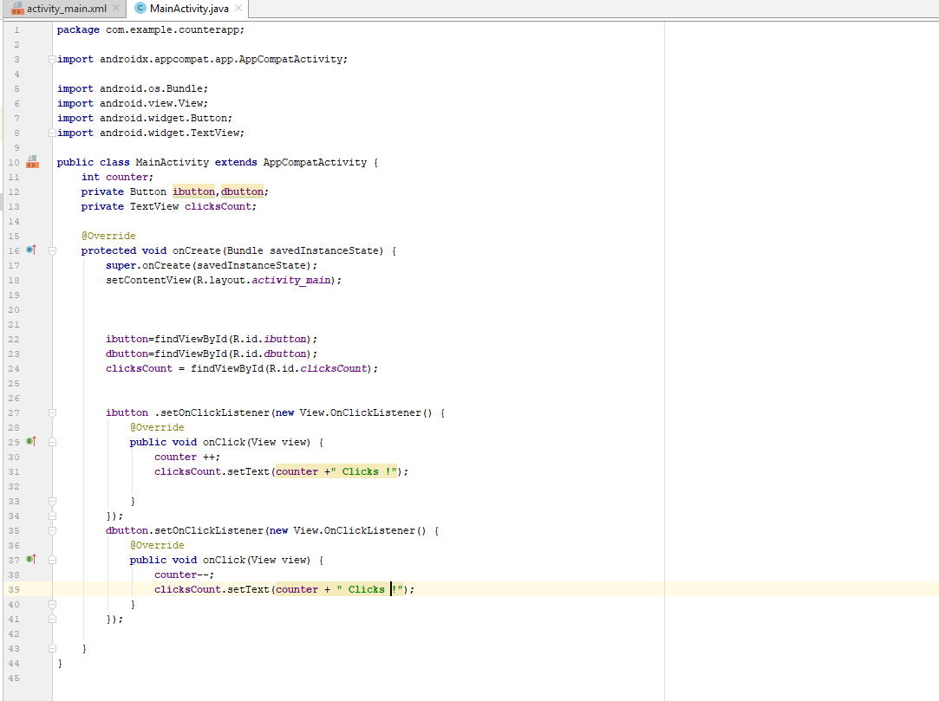

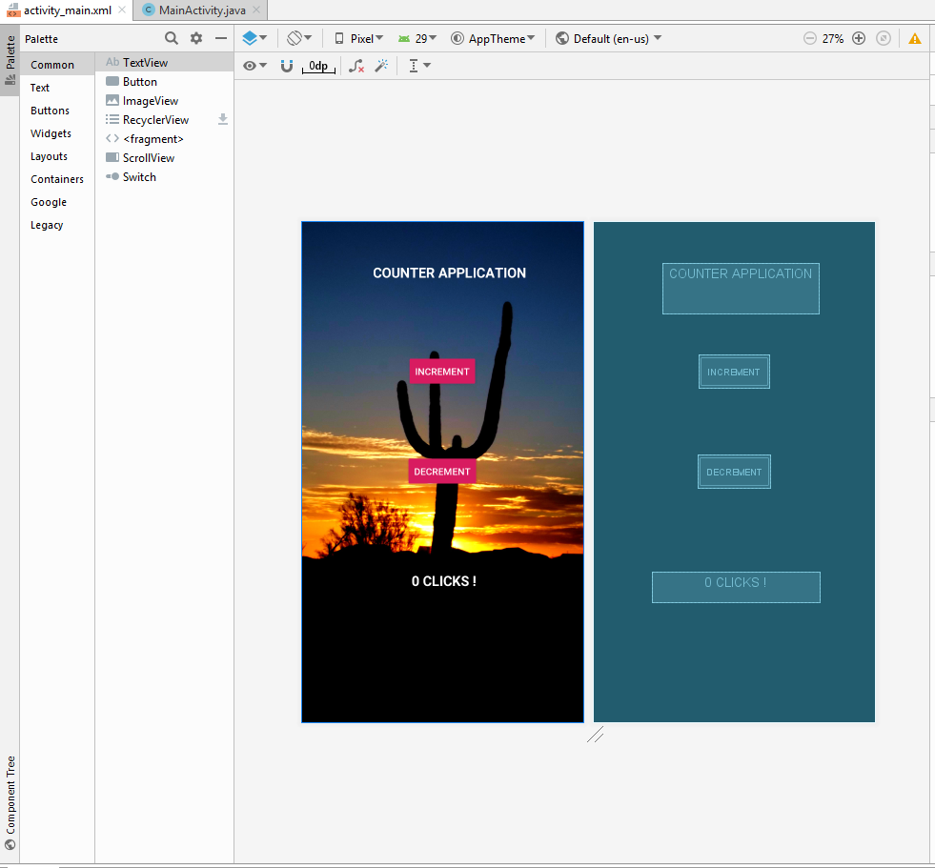

*<?***xml version="1.0" encoding="utf-8"***?>*

<**androidx.constraintlayout.widget.ConstraintLayout xmlns:android="http://schemas.android.com/apk/res/android"**

**xmlns:app="http://schemas.android.com/apk/res-auto"**

**xmlns:tools="http://schemas.android.com/tools"**

**android:layout_width="match_parent"**

**android:layout_height="match_parent"**

**tools:context=".MainActivity"**

**android:background="@drawable/counter"**>

<**Button**

**android:id="@+id/ibutton"**

**android:layout_width="wrap_content"**

**android:layout_height="wrap_content"**

**android:layout_marginTop="140dp"**

**android:text="INCREMENT"**

**android:textColor="#ffffff"**

**android:backgroundTint="@color/colorAccent"**

**app:layout_constraintBottom_toBottomOf="parent"**

**app:layout_constraintEnd_toEndOf="parent"**

**app:layout_constraintHorizontal_bias="0.501"**

**app:layout_constraintStart_toStartOf="parent"**

**app:layout_constraintTop_toTopOf="parent"**

**app:layout_constraintVertical_bias="0.101"** />

<**Button**

**android:id="@+id/dbutton"**

**android:layout_width="wrap_content"**

**android:layout_height="wrap_content"**

**android:text="DECREMENT"**

**android:backgroundTint="@color/colorAccent"**

**android:textColor="#ffffff"**

**app:layout_constraintBottom_toBottomOf="parent"**

**app:layout_constraintEnd_toEndOf="parent"**

**app:layout_constraintHorizontal_bias="0.501"**

**app:layout_constraintStart_toStartOf="parent"**

**app:layout_constraintTop_toBottomOf="@+id/ibutton"**

**app:layout_constraintVertical_bias="0.222"** />

<**TextView**

**android:id="@+id/clicksCount"**

**android:layout_width="244dp"**

**android:layout_height="44dp"**

**android:text="0 CLICKS !"**

**android:textAlignment="center"**

**android:textColor="#ffffff"**

**android:textSize="20dp"**

**android:textStyle="bold"**

**app:layout_constraintBottom_toBottomOf="parent"**

**app:layout_constraintEnd_toEndOf="parent"**

**app:layout_constraintHorizontal_bias="0.514"**

**app:layout_constraintStart_toStartOf="parent"**

**app:layout_constraintTop_toBottomOf="@+id/dbutton"**

**app:layout_constraintVertical_bias="0.409"** />

<**TextView**

**android:id="@+id/textView2"**

**android:layout_width="228dp"**

**android:layout_height="73dp"**

**android:text="COUNTER APPLICATION"**

**android:textAlignment="center"**

**android:textColor="#ffffff"**

**android:textStyle="bold"**

**android:textSize="20dp"**

**app:layout_constraintBottom_toTopOf="@+id/ibutton"**

**app:layout_constraintEnd_toEndOf="parent"**

**app:layout_constraintHorizontal_bias="0.56"**

**app:layout_constraintStart_toStartOf="parent"**

**app:layout_constraintTop_toTopOf="parent"** />

</**androidx.constraintlayout.widget.ConstraintLayout**>