**Timer app**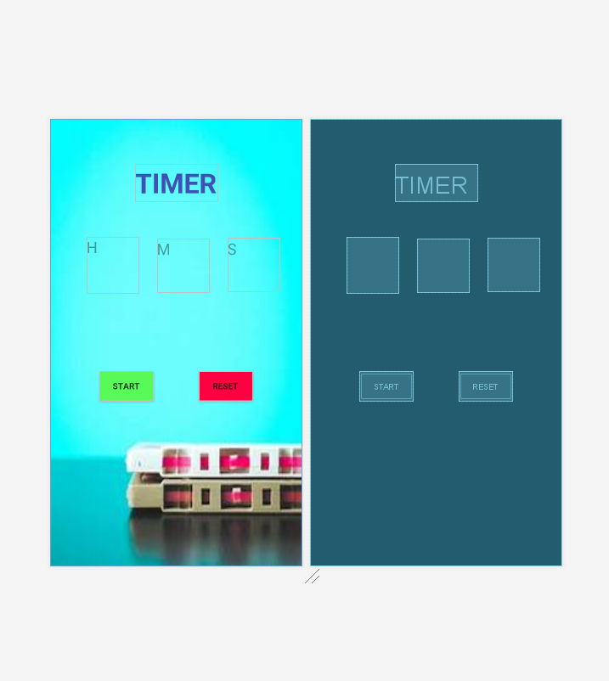

**XML**

*<?***xml version="1.0" encoding="utf-8"***?>*

<**androidx.constraintlayout.widget.ConstraintLayout xmlns:android="http://schemas.android.com/apk/res/android"**

**xmlns:app="http://schemas.android.com/apk/res-auto"**

**xmlns:tools="http://schemas.android.com/tools"**

**android:layout_width="match_parent"**

**android:layout_height="match_parent"**

**tools:context=".MainActivity"**

**android:background="@drawable/time"**>

<**TextView**

**android:id="@+id/Hour"**

**android:layout_width="84dp"**

**android:layout_height="91dp"**

**android:ems="10"**

**android:hint="H"**

**android:textSize="25dp"**

**android:inputType="textPersonName"**

**app:layout_constraintBottom_toBottomOf="parent"**

**app:layout_constraintEnd_toEndOf="parent"**

**app:layout_constraintHorizontal_bias="0.183"**

**app:layout_constraintStart_toStartOf="parent"**

**app:layout_constraintTop_toTopOf="parent"**

**app:layout_constraintVertical_bias="0.301"** />

<**TextView**

**android:id="@+id/Min"**

**android:layout_width="85dp"**

**android:layout_height="87dp"**

**android:ems="10"**

**android:hint="M"**

**android:textSize="25dp"**

**android:inputType="textPersonName"**

**app:layout_constraintBottom_toBottomOf="parent"**

**app:layout_constraintEnd_toEndOf="parent"**

**app:layout_constraintHorizontal_bias="0.536"**

**app:layout_constraintStart_toStartOf="parent"**

**app:layout_constraintTop_toTopOf="parent"**

**app:layout_constraintVertical_bias="0.304"** />

<**TextView**

**android:id="@+id/Sec"**

**android:layout_width="84dp"**

**android:layout_height="88dp"**

**android:ems="10"**

**android:hint="S"**

**android:textSize="25dp"**

**android:inputType="textPersonName"**

**app:layout_constraintBottom_toBottomOf="parent"**

**app:layout_constraintEnd_toEndOf="parent"**

**app:layout_constraintHorizontal_bias="0.886"**

**app:layout_constraintStart_toStartOf="parent"**

**app:layout_constraintTop_toTopOf="parent"**

**app:layout_constraintVertical_bias="0.304"** />

<**TextView**

**android:id="@+id/textView"**

**android:layout_width="wrap_content"**

**android:layout_height="wrap_content"**

**android:text="TIMER"**

**android:textStyle="bold"**

**android:textColor="#3F51B5"**

**android:textSize="45dp"**

**app:layout_constraintBottom_toBottomOf="parent"**

**app:layout_constraintEnd_toEndOf="parent"**

**app:layout_constraintStart_toStartOf="parent"**

**app:layout_constraintTop_toTopOf="parent"**

**app:layout_constraintVertical_bias="0.11"** />

<**Button**

**android:id="@+id/button"**

**android:layout_width="wrap_content"**

**android:layout_height="wrap_content"**

**android:text="Start"**

**android:background="#58FA58"**

**app:layout_constraintBottom_toBottomOf="parent"**

**app:layout_constraintEnd_toEndOf="parent"**

**app:layout_constraintHorizontal_bias="0.25"**

**app:layout_constraintStart_toStartOf="parent"**

**app:layout_constraintTop_toTopOf="parent"**

**app:layout_constraintVertical_bias="0.604"** />

<**Button**

**android:id="@+id/button2"**

**android:layout_width="wrap_content"**

**android:layout_height="wrap_content"**

**android:background="#FF0040"**

**android:text="Reset"**

**app:layout_constraintBottom_toBottomOf="parent"**

**app:layout_constraintEnd_toEndOf="parent"**

**app:layout_constraintHorizontal_bias="0.48"**

**app:layout_constraintStart_toEndOf="@+id/button"**

**app:layout_constraintTop_toTopOf="parent"**

**app:layout_constraintVertical_bias="0.604"** />

</**androidx.constraintlayout.widget.ConstraintLayout**>

**JAVA**

package com.example.timerapp;

import androidx.appcompat.app.AppCompatActivity;

import android.os.Bundle;

import android.os.CountDownTimer;

import android.view.View;

import android.widget.Button;

import android.widget.TextView;

public class MainActivity extends AppCompatActivity {

public int counter=0;

public int minutes=0;

public int hours=0;

Button button;

Button button2;

public int num=300;

TextView textView,textView1,textView2;

@Override

protected void onCreate(Bundle savedInstanceState) {

super.onCreate(savedInstanceState);

setContentView(R.layout.*activity_main*);

button= (Button) findViewById(R.id.*button*);

button2= (Button) findViewById(R.id.*button2*);

textView= (TextView) findViewById(R.id.*Sec*);

textView1 =(TextView) findViewById(R.id.*Min*);

textView2 =(TextView) findViewById(R.id.*Hour*);

button.setOnClickListener(new View.OnClickListener(){

@Override

public void onClick(View view) {

new CountDownTimer(1200000, 1000){

public void onTick(long millisUntilFinished){

textView.setText(String.*valueOf*(counter));

++counter;

if(counter==61){

++minutes;

textView1.setText(String.*valueOf*(minutes));

counter=0;

}

if(minutes==60){

hours++;

textView1.setText(String.*valueOf*(hours));

counter=0;

}

}

public void onFinish(){

textView.setText("FINISH!!");

}

}.start();

}

});

button2.setOnClickListener(new View.OnClickListener() {

@Override

public void onClick(View view) {

counter=0;

textView.setText(String.*valueOf*(counter));

minutes=0;

textView1.setText(String.*valueOf*(minutes));

hours=0;

textView2.setText(String.*valueOf*(hours));

}

});

}