Name : Piyush Deshmukh

PRN : 22311415  
Class : SY-C AIDS C-2, Roll no : 273041

Assignment – 2: Design at least 10 SQL queries for suitable database application using SQL DML statements: Insert, Select, Update, delete with operators, functions, Set operators, Clauses

Queries :

1. Insert 10 employee into EMP table

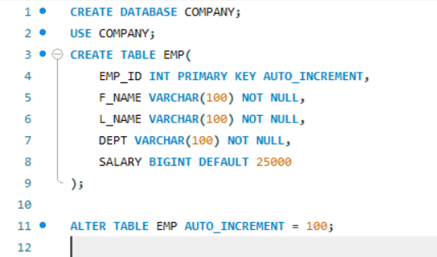

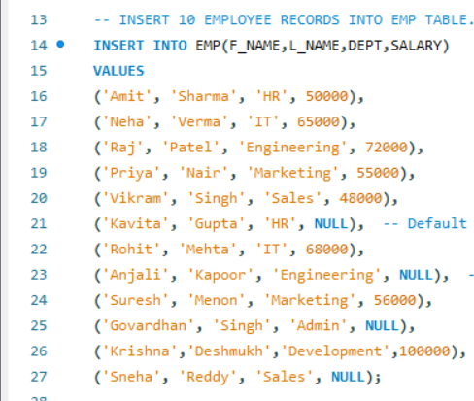

1. RETRIEVE DETAILS OF EMPLOYEES WHO WORK IN SALES DEPARTMENT

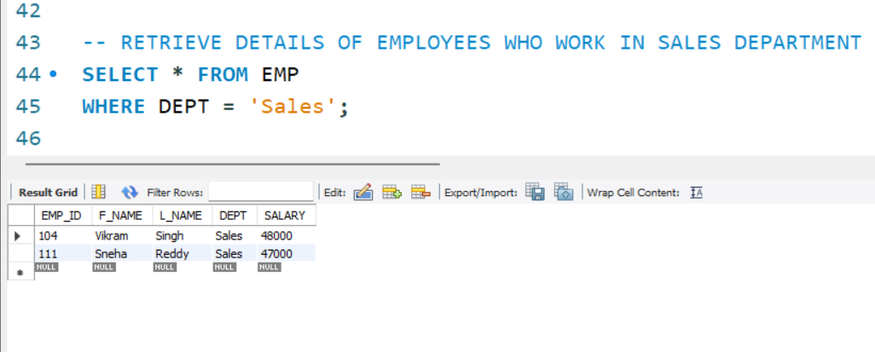

1. -- UPDATE SALARY OF EMPLOYEE TO 55000 HAVING EMP_ID AS 101

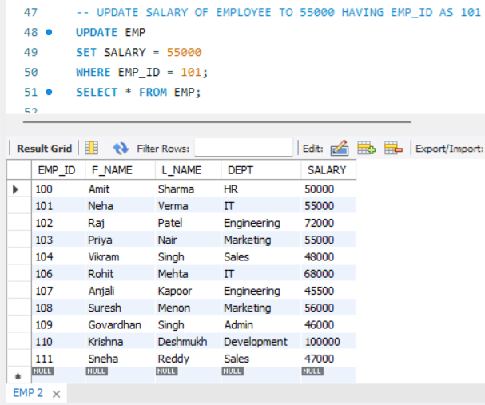

1. -- DELETE EMPLOYEE HAVING ID 105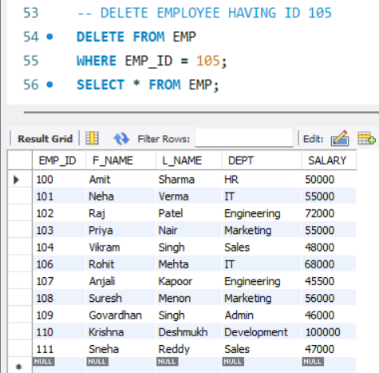
2. -- FIND AVERAGE SALARY OF EMPLOYEE IN EACH DEPARTMENT

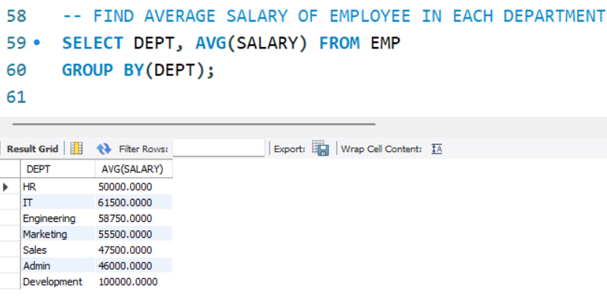

1. -- LIST NAMES OF EMP WHO EARN MORE THAN AVERAGE SALARY

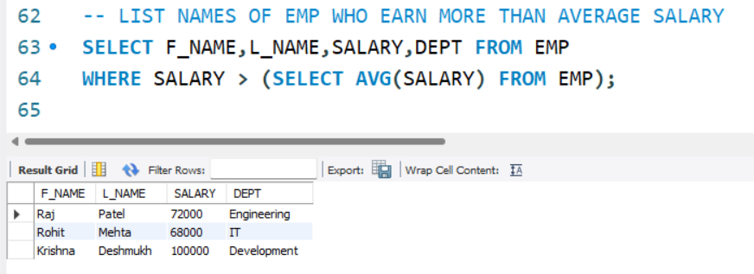

1. -- RETRIEVE THE NAMES OF EMPLOYEES WHO WORK IN EITHER ENGINEERING OR HR DEPARTMENT

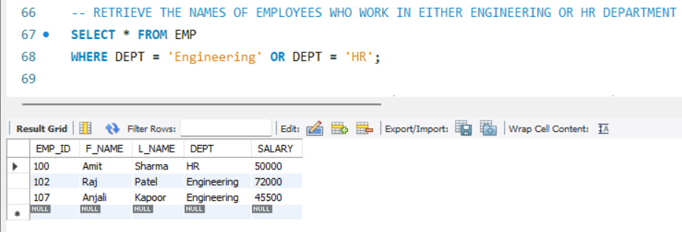

1. -- RETRIEVE THE FULL NAME OF ALL EMPLOYEES (CONCATANATE F_NAME AND L_NAME) AND THEIR NAME

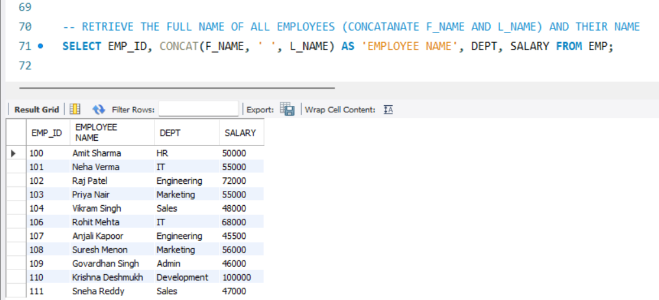

1. -- RETRIEVE DETAILS OF EMPLOYEES WHO WORK IN FINANCE AND IT DEPARTMENT USING IN OPERATOR

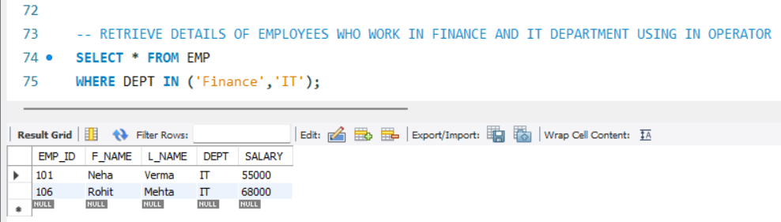

1. -- RETRIEVE THE DETAILS OF ALL EMPLOYEE WHOSE LAST NAME START WITH 'S'

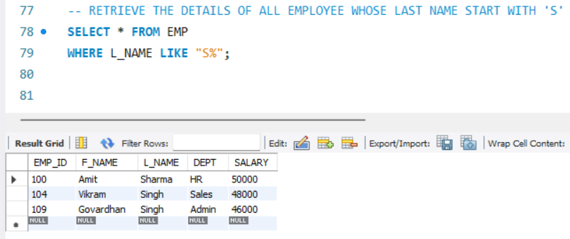

1. -- COUNT THE NO.OF EMPLOYEES IN EACH DEPARTMENT

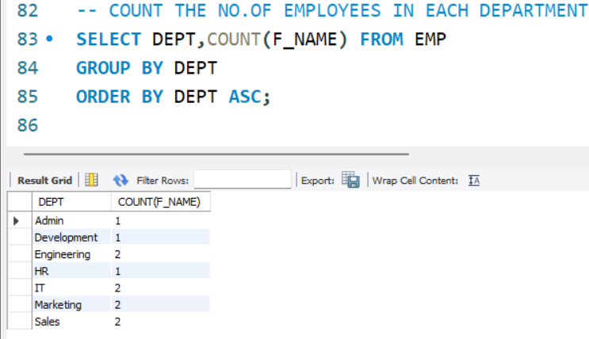

1. -- RETRIEVE THE NAMES OF EMPLOYEE IN BOTH ENGINEERING AND DEVELOPMENT

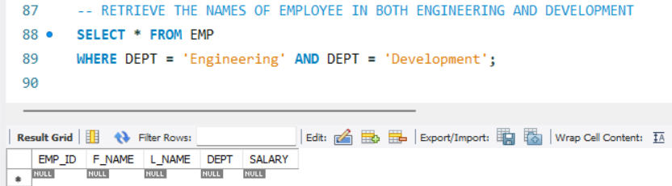

1. -- RETRIEVE DETAILS OF THE EMPLOYEE WHO DO NOT WORK IN ADMIN DEPARTMENT

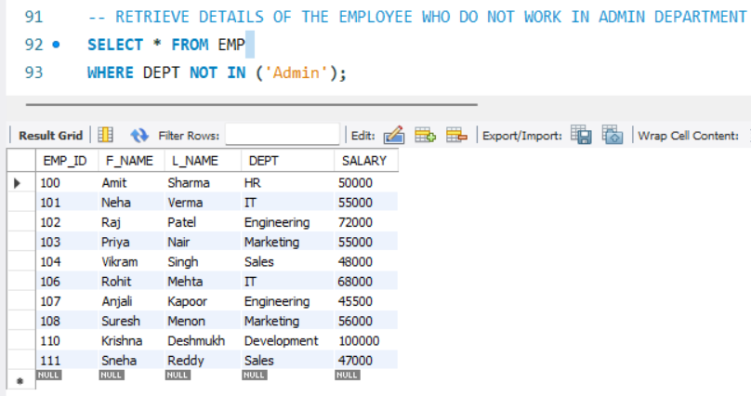

1. -- FIND HIGHEST SALARY IN EACH DEPT

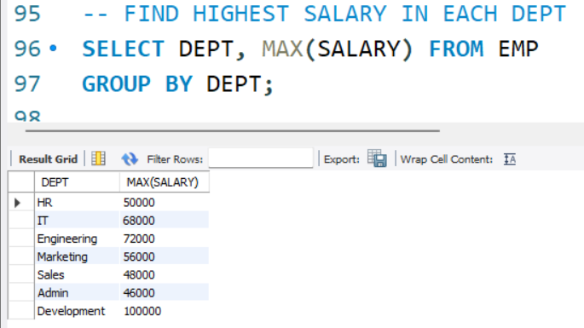

1. -- FIND EMPLOYEES HAVING SALARY BETWEEN 45000 AND 47000

