Current-sense front end and Goertzel phase measurement
Sonicator DPLL on the STM32F407 · design note · November 5, 2026

1. Purpose
The sonicator currently finds its phase with a zero-crossing detector on the T2 current-transformer signal. That method only looks at two instants per cycle, so comparator offset, noise, cavitation hash and changes in signal amplitude all turn directly into phase error. Bench data showed roughly ±100 ns of jitter while locked and large errors away from resonance.
This note describes a small analog front end that lets the STM32F407 sample the whole current waveform with its ADC, plus a Goertzel calculation that extracts the amplitude and phase of the drive-frequency component from every millisecond of data. The result is a far cleaner phase measurement, a current-amplitude measurement that tracks horn amplitude, and the data needed for Bode sweeps and automatic frequency tracking.

2. What is added
- A single op-amp stage that takes the existing T2 burden voltage, centres it on 1.65 V and amplifies it into ADC1 (PA1).
- A passive 1.65 V reference (VREF) made from two resistors and two capacitors.
- Optional: a two-resistor divider that brings the TIM1 drive signal into ADC2 (PA2) as the phase reference. This can be replaced by a firmware timestamp method (section 5.5).
- STM32 peripherals only, no new chips: TIM2 as the ADC trigger, ADC1 + ADC2 in dual simultaneous mode, and DMA.
Nothing in the existing drive path changes. TIM1 and its DMA dither keep generating the square wave; the gate driver, T1, LCCLC network, T2 and the existing burden, current limiter and zero-crossing detector all stay in place. The new circuit only listens.

3. The circuit
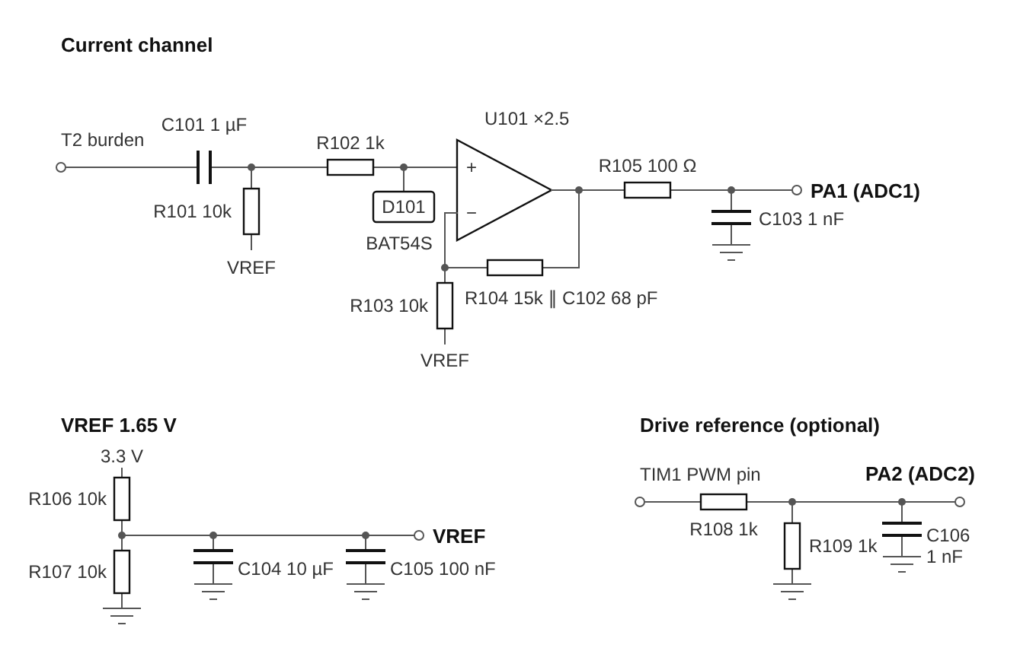
Figure 1. Current channel, passive VREF and optional drive reference. D101 is a BAT54S with its ends tied to 3.3 V and GND.

3.1 How the current channel works
- C101 (1 µF) passes the AC burden signal and blocks its DC level. With R101 it forms a high-pass corner near 16 Hz, far below 33 kHz.
- R101 (10 kΩ) ties the op-amp input to VREF, so the signal now swings around 1.65 V instead of 0 V. This is the level shift; no negative supply is needed. R101 loads the 120 Ω burden by under 2%, so the current limiter and zero-crossing detector are unaffected.
- R102 (1 kΩ) and D101 protect the op-amp. If a fault puts a large voltage on the burden, D101 clamps the node to the 3.3 V and GND rails and R102 limits the current.
- U101 is a non-inverting amplifier with gain 1 + R104/R103 = 2.5. Because R103 returns to VREF instead of ground, only the AC signal is amplified and the output stays centred on 1.65 V.
- C102 (68 pF) across R104 rolls the gain off above about 156 kHz. This is the anti-alias filter: it suppresses switching spikes and high harmonics that would otherwise fold back into the sampled band.
- R105 (100 Ω) and C103 (1 nF) sit at the ADC pin. C103 supplies the charge the ADC's sampling capacitor needs at the start of each sample, and R105 keeps the op-amp stable while driving that capacitance.

3.2 VREF
R106 and R107 divide the 3.3 V analog supply to 1.65 V. C104 (10 µF) and C105 (100 nF) hold it steady: at 33 kHz the capacitors' impedance is under 1 Ω, so the small AC currents from R101 and R103 cannot move it, and supply ripple is filtered with a corner near 3 Hz. Almost no DC current is drawn, because every node connected to VREF sits at 1.65 V. The exact value is unimportant; the Goertzel calculation ignores DC. Allow about 0.25 s after power-up for VREF to settle.

3.3 Drive reference (optional)
R108 and R109 halve the 3.3 V TIM1 PWM output to a 0–1.65 V square wave on PA2. The GPIO is a stiff source, so no op-amp is needed. C106 (1 nF) rounds the edges (corner about 320 kHz with the 500 Ω divider). This matters: a sharp square wave sampled at 750 kSPS has harmonics above the Nyquist frequency that fold back, and in simulation C106 reduced the reference phase error from about 0.13° to 0.02° per block. The filter adds a fixed lag of about 6° at 33 kHz, changing by only 0.18° per kHz, which the frequency loop absorbs. The Goertzel calculation extracts the fundamental of this square wave, which is the phase reference the current is compared against.

3.4 Parts list
New parts are numbered from 101 so they do not clash with designators already on the matching-network schematic (for example the existing C3–C5 on the burden).
Ref | Value | Type / rating | Function
U101 | MCP6021 or TLV9061 | Single rail-to-rail op-amp, 3.3 V supply, 100 nF decoupling at its supply pin | Amplifies and buffers the CT signal
C101 | 1 µF | Film or C0G, ≥16 V | AC coupling from the burden
R101 | 10 kΩ | 1% | Biases input to VREF
R102 | 1 kΩ | 1% | Fault current limit
D101 | BAT54S | Dual Schottky, ends to 3.3 V and GND | Input clamp
R103 | 10 kΩ | 1% | Gain setting, to VREF
R104 | 15 kΩ (see 3.5) | 1% | Gain setting, feedback
C102 | 68 pF | C0G | Anti-alias, ~156 kHz with R104
R105 | 100 Ω | 1% | Isolates op-amp from ADC load
C103 | 1 nF | C0G | ADC charge reservoir
R106, R107 | 10 kΩ | 1% | Divide 3.3 V to 1.65 V
C104 | 10 µF | Ceramic X5R/X7R | VREF filter
C105 | 100 nF | Ceramic | VREF high-frequency bypass
R108, R109 | 1 kΩ | 1% (optional) | Drive reference divider
C106 | 1 nF | C0G (optional) | Drive reference edge / anti-alias filter

Use C0G or film for C101, C102, C103 and C106. Their phase shift is part of the measurement, and X7R ceramics change value with temperature and voltage. For the same reason, change C3–C5 on the existing burden (the 3 × 33 nF across the burden resistors) to C0G.

3.5 Choosing the gain
Measure the burden's peak voltage at full power with a scope, then choose R104 so the signal at PA1 is about 1.2 V peak. That leaves headroom before the ADC clips at 0 and 3.3 V. Gain = 1 + R104/R103. If R104 changes, change C102 so that R104 × C102 stays near 1 µs (corner around 150 kHz).
Burden peak at full power | Gain needed | R104 | C102
0.25 V | ≈ 4.8 | 39 kΩ | 27 pF
0.5 V | ≈ 2.4 | 15 kΩ | 68 pF
0.8 V | ≈ 1.5 | 5.1 kΩ | 200 pF
1.2 V or more | 1 | 0 Ω (R103 not fitted) | Not fitted; divide the input down if above ~1.5 V

3.6 Practical notes
- Power U101 and VREF from the F407's analog 3.3 V (VDDA), the same supply as the ADC reference.
- Make sure the T2 secondary's ground is the same ground as the STM32. The existing schematic shows it tied to GND; confirm on the board.
- Keep the wires from the burden short and twisted with their ground return, and route them away from the T1/LCCLC high-voltage side.
- The whole circuit is low voltage and can be prototyped on perfboard next to the F407 board: two wires from the burden, one jumper from the TIM1 pin.

4. ADC set-up
Setting | Value
ADC clock | 21 MHz (APB2 84 MHz ÷ 4)
Mode | Dual regular simultaneous: ADC1 (PA1, current) and ADC2 (PA2, drive reference) sample at the same instant
Trigger | TIM2 TRGO at 750 kHz (84 MHz ÷ 112). Independent of TIM1, so the drive code is untouched
Sample time | 15 cycles (15 + 12 = 27 cycles = 1.29 µs per conversion, inside the 1.33 µs trigger period)
DMA | DMA2 Stream 0 Channel 0 from the ADC common data register, DMA mode 2 (each 32-bit word holds ADC2 in the top 16 bits and ADC1 in the bottom 16), circular, 2 × 1024 words
Block | 1024 sample pairs ≈ 1.37 ms, about 45 drive cycles. The DMA half-complete and complete interrupts hand each finished half to the main loop while the other half fills
CPU load | About 0.3 ms of processing per 1.37 ms block (roughly 20%)

If more speed is wanted later, the op-amp output can support 3-cycle sampling at up to about 1 MSPS. 750 kSPS (about 22 samples per cycle) is already far more than the Goertzel method needs.

5. How the Goertzel method works

5.1 The idea
Instead of timing when the waveform crosses zero, the processor looks at the whole waveform and asks one question: how much of this signal is a sine wave at exactly the drive frequency, and where is that sine wave in time? The answer is two numbers, an amplitude and a phase. The Goertzel algorithm is an efficient way to compute exactly that for one chosen frequency. Mathematically it is one bin of a Fourier transform, or equivalently a least-squares fit of a sine and cosine at the drive frequency to the samples.
Because every sample contributes, random noise averages out. With about 1000 samples per block, noise is reduced by a factor of roughly 20 compared with a single reading. Comparator offset and hysteresis do not exist in this method, harmonics and switching spikes fall into other frequency bins and are ignored, and the result does not depend on the signal being large or perfectly sinusoidal.

5.2 Step by step, for each block
- Capture. TIM2 triggers both ADCs together 750,000 times a second. DMA fills one half of the buffer with 1024 current/reference sample pairs while the processor works on the other half.
- Remove the offset. Subtract mid-scale (2048 counts, which is VREF) from each sample so the signal is centred on zero.
- Window. Multiply each sample by a Hann window, a smooth bump that is zero at both ends of the block. The block does not contain a whole number of cycles, and the window stops the cut-off ends from leaking energy into the result.
- Run the recursion. For each sample x[n], update two running values: s[n] = x[n] + 2·cos(ω)·s[n−1] − s[n−2], where ω = 2π · f_drive / f_sample. This is one multiply and two additions per sample per channel.
- Finish. After the last sample, combine the two stored values into a complex number: real part = s[N−1] − cos(ω)·s[N−2], imaginary part = sin(ω)·s[N−2].
- Amplitude. Peak amplitude = 2 × |complex result| / (sum of the window values). Multiply by 3.3 V / 4095 for volts at the pin, then by the front-end scale for amps in the transducer.
- Phase. Phase = atan2(imaginary, real). On its own this is the phase relative to the start of the block, which is arbitrary.
- Phase difference. Do the same calculation on the reference channel from the same block and subtract: phase of current − phase of drive. The arbitrary block-start time is common to both and cancels. Converting to time: Δt = Δphase / (2π · f_drive).

5.3 Why the timing details cancel
The two channels are sampled at the same instants and processed with the same frequency, window and block. Anything that affects both equally disappears in the subtraction: where the block happened to start, the TIM1 period dither, and small errors in the frequency value passed to the calculation. That is why the ADC does not need to be synchronised to the drive, and why the TIM2 trigger can run independently.

5.4 From measurement to frequency control
- Fast loop, every block: compare the measured phase with a target phase and nudge the TIM1 frequency with a proportional-integral controller. Skip blocks where the current amplitude is too small or the ADC clipped, and keep the frequency inside a window around the main resonance so the loop cannot jump to the 32.9 kHz feature.
- Slow trim, over a few seconds of on-time: move the target phase by a small amount up and down and keep whichever direction gives a larger current amplitude. This makes the loop settle at maximum amplitude even though the gate driver, transformer and matching network add an unknown, load-dependent phase offset.
- Bode sweeps: step the frequency, discard the first few milliseconds of each step while the horn rings up, average the remaining blocks, and log frequency, current amplitude, phase and the block-to-block phase spread. Sweeping both up and down shows any hysteresis like the vial jumps seen earlier.

5.5 Without the drive-reference channel
The processor generates the drive itself, so the reference can also come from firmware: configure TIM2 to capture its own counter on every TIM1 period through the internal timer link and log those values with DMA. That gives the exact time of every drive edge on the ADC's sample clock, from which the drive phase for each block can be calculated even with dither. It frees PA2 (for example, for a future transducer-voltage channel) at the cost of more firmware. The ADC reference channel is the simpler place to start.

5.6 Example code
A minimal sketch of the capture and calculation. It assumes the ADC, DMA and TIM2 are configured as in section 4 and that the drive code can report its current frequency. The Hann window is computed inline for clarity; in practice it is precomputed into a table once at start-up.
#include <math.h>
#include <stdint.h>

#define N 1024 /* sample pairs per block */
#define FS 750000.0f /* ADC sample rate (TIM2 trigger), Hz */
#define ADC_MID 2048.0f /* VREF = 1.65 V = mid-scale */
#define PI_F 3.14159265f

/* DMA mode 2: each word = (ADC2 << 16) | ADC1. Circular, two halves. */
static uint32_t adc_buf[2 * N];
static volatile const uint32_t *ready = 0; /* finished half-block */

void HAL_ADC_ConvHalfCpltCallback(ADC_HandleTypeDef *h) { ready = &adc_buf[0]; }
void HAL_ADC_ConvCpltCallback(ADC_HandleTypeDef *h) { ready = &adc_buf[N]; }

typedef struct { float amp; float phase; } tone_t; /* counts, radians */

/* Amplitude and phase of the f_hz component of one channel.
shift = 0 for ADC1 (current), 16 for ADC2 (drive reference). */
static tone_t goertzel(const uint32_t *buf, int shift, float f_hz)
{
float w = 2.0f * PI_F * f_hz / FS;
float coef = 2.0f * cosf(w);
float s1 = 0.0f, s2 = 0.0f, wsum = 0.0f;

for (int n = 0; n < N; n++) {
float win = 0.5f - 0.5f * cosf(2.0f * PI_F * n / N); /* Hann */
float x = ((float)((buf[n] >> shift) & 0xFFF) - ADC_MID) * win;
float s0 = x + coef * s1 - s2; /* the Goertzel recursion */
s2 = s1;
s1 = s0;
wsum += win;
}
float re = s1 - cosf(w) * s2;
float im = sinf(w) * s2;

tone_t t;
t.amp = 2.0f * sqrtf(re * re + im * im) / wsum; /* peak, ADC counts */
t.phase = atan2f(im, re); /* block-relative */
return t;
}

/* Call from the main loop. f_drive = actual TIM1 frequency in Hz. */
void measure_poll(float f_drive)
{
if (!ready) return;
const uint32_t *blk = (const uint32_t *)ready;
ready = 0;

tone_t cur = goertzel(blk, 0, f_drive); /* current (PA1) */
tone_t ref = goertzel(blk, 16, f_drive); /* drive (PA2) */

float dphi = cur.phase - ref.phase; /* block start cancels */
if (dphi > PI_F) dphi -= 2.0f * PI_F;
if (dphi < -PI_F) dphi += 2.0f * PI_F;

float phase_deg = dphi * (180.0f / PI_F);
float phase_ns = dphi / (2.0f * PI_F * f_drive) * 1e9f;
float i_pk_pin = cur.amp * (3.3f / 4095.0f); /* volts at PA1 */

/* -> feed phase_deg to the PI loop, log phase_ns and i_pk_pin */
(void)phase_deg; (void)phase_ns; (void)i_pk_pin;
}

6. Bring-up plan
- Build the front end on perfboard and power it from the F407 board's 3.3 V analog supply. Check VREF reads about 1.65 V.
- Bench test with a function generator: feed a 33 kHz sine into the burden input and the same signal, delayed by a simple RC, into the reference input. Confirm the amplitude and phase readings match a scope.
- Measure the burden's peak voltage at full power and set R104 and C102 from the table in section 3.5.
- Connect to the sonicator and compare the new phase readings with the existing zero-crossing detector during a sweep.
- Run up and down sweeps with the vial to map the response and find the frequency window for the tracking loop.
- Close the loop: fast phase loop first, then enable the slow amplitude-maximising trim.

7. Possible later addition
Measuring the transducer voltage as well (a high-voltage capacitive divider at the transducer terminals into a second op-amp stage) would add true impedance, real power, power factor, software cancellation of the transducer's C0 capacitance and a direct load indicator. Leaving a footprint and a free ADC channel for it costs little.

