SplitSync: Developer Setup & Feature Guide
Supplementary documentation for Assessment 4 - covers the sections not in Project_Documentation.docx
Group 01: Amsh Shrestha (S394695), Devi Maya (S388017), Shanti Moktan (S395240)

A. URLs
Written by: Amsh Shrestha (S394695)

A.1 Project Resources
Resource | URL
GitHub Repository | https://github.com/ams-sth/group01_software_project
Trello Board | https://trello.com/b/11CVnhSH/prt585-software-engineering-practice

A.2 Individual Timesheets
All timesheets are committed to the repository under each member's folder. Links below go to those files on GitHub.
Member | Timesheet Location (in repo)
Amsh Shrestha (S394695) | AmshShrestha_S394695/Individual Timesheets - Amsh Shrestha(S394695).xlsx
Devi Maya (S388017) | DeviMaya_S388017/Timesheet Devi Maya.xlsx
Shanti Moktan (S395240) | ShantiMoktan_S395240/ - weekly update files per week folder

A.3 Learning Materials
Written by: Amsh Shrestha (S394695)
The unit page on CDU LearnLine is where weekly content, assessment submissions and announcements are posted.
Resource | URL
CDU LearnLine - PRT585/681 unit page | https://learnline.cdu.edu.au/units/PRT585
Unit Study Guide (PRT585) | Available on the LearnLine unit page under Resources
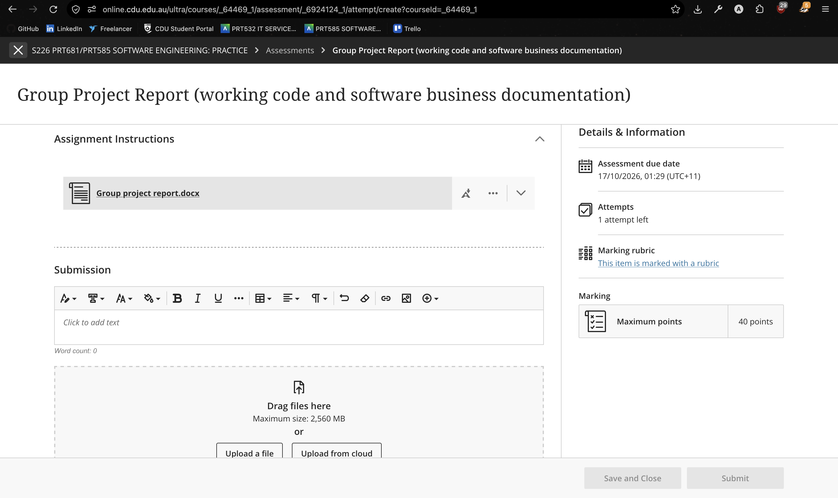

B. Git Download & Initial Setup
Written by: Amsh Shrestha (S394695)

This walks a brand-new developer through cloning the repo and getting both the server and client running for the first time.

B.1 Prerequisites
Install these before you start:
Tool | Version
.NET SDK | 10 (download from https://dot.net)
Node.js | 22 or newer (https://nodejs.org)
pnpm | install via: npm install -g pnpm
Git | any recent version (https://git-scm.com)

B.2 Clone the Repository
git clone https://github.com/ams-sth/group01_software_project.git
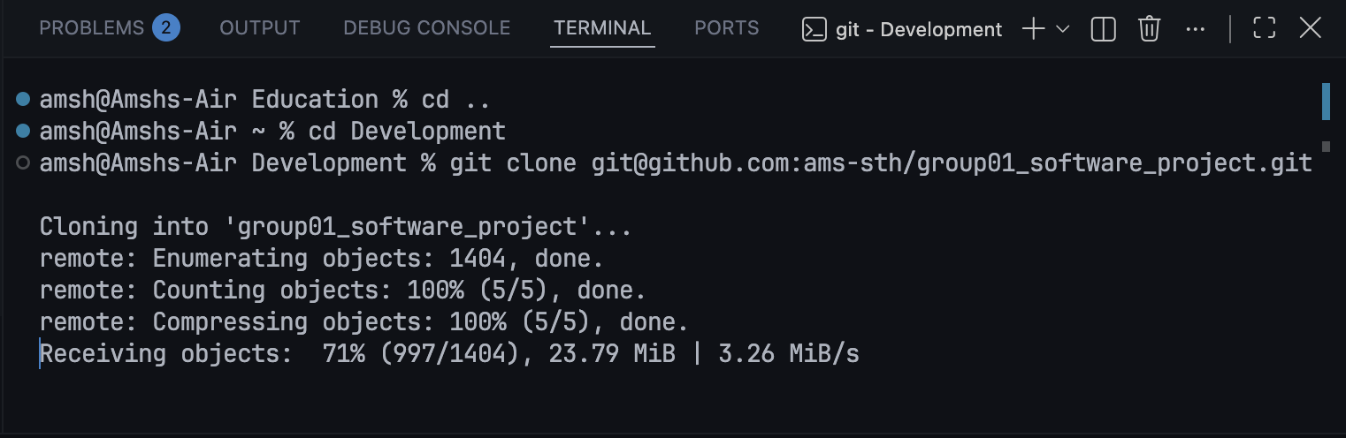
cd group01_software_project/splitsync

B.3 Set Up the Connection String
The project uses a shared Supabase Postgres database. The connection string is not committed to the repo - ask a team member for it, then store it in .NET user-secrets (never in appsettings.json):
cd server
dotnet user-secrets set "ConnectionStrings:Default" "<connection string from team>"
This writes the secret to your OS's user-secrets store, not to the project files, so it will never be accidentally committed.

B.4 Apply Database Migrations
Migrations do not run automatically locally. Run this from the server/ folder after setting the connection string:
dnx dotnet-ef@10.0.11 database update
You do not need to install dotnet-ef globally - dnx downloads and runs the pinned version for you. Tell the team when you apply a migration so everyone stays in sync.

B.5 Run the Application
From the splitsync/ folder, one command starts both the API and the client:
pnpm install # first time only
pnpm dev
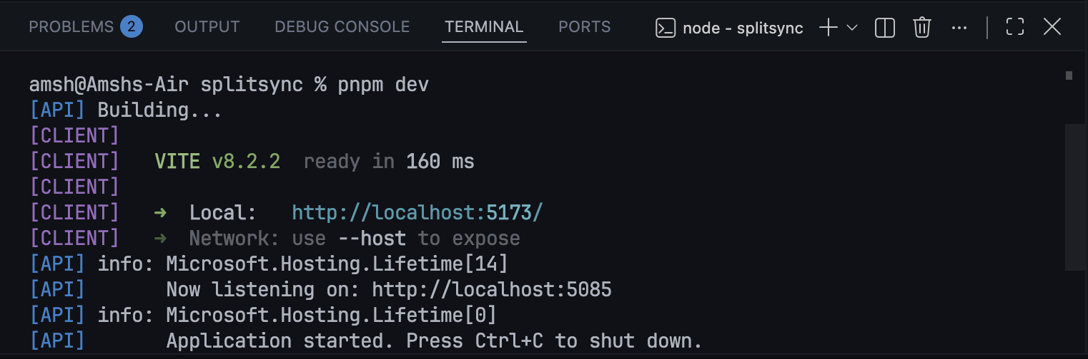
This starts the API on http://localhost:5085 and the client on http://localhost:5173. The client proxies /api/* to the API so there is no CORS setup needed locally.
To confirm everything is connected, open http://localhost:5173 or hit http://localhost:5085/api/health - it should return { "status": "ok" }.

B.6 Running Tests
Backend (xUnit):
cd server.Tests
dotnet test
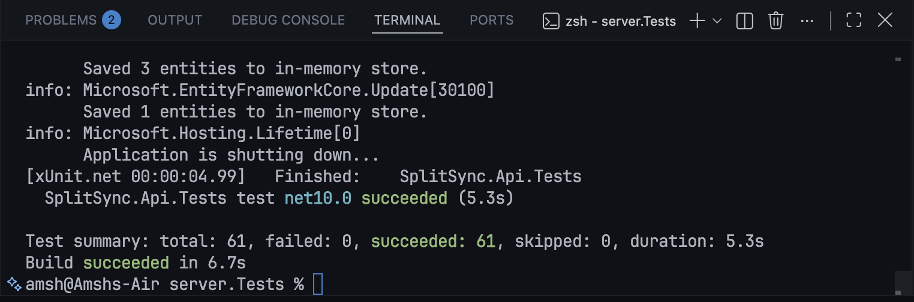

Frontend (Cypress):
cd client
pnpm test

B.7 Libraries and Versions
Written by: Amsh Shrestha (S394695)
The tables below list every third-party package the project depends on. Versions are pinned so a fresh clone always builds identically.

Backend (NuGet - server/SplitSync.Api.csproj)
Package | Version | Purpose
Microsoft.AspNetCore.Authentication.JwtBearer | 10.0.11 | Validates JWT tokens on every authenticated request
Microsoft.AspNetCore.Identity.EntityFrameworkCore | 10.0.11 | User accounts, password hashing, roles via ASP.NET Identity
Microsoft.AspNetCore.OpenApi | 10.0.11 | Auto-generates an OpenAPI spec for the API
Microsoft.EntityFrameworkCore.Design | 10.0.11 | EF Core CLI tools (migrations) - build-time only
Npgsql.EntityFrameworkCore.PostgreSQL | 10.0.3 | EF Core provider for PostgreSQL / Supabase

Test project (NuGet - server.Tests/SplitSync.Tests.csproj)
Package | Version | Purpose
xunit | 2.9.3 | Core xUnit test framework
xunit.runner.visualstudio | 3.1.4 | Runs xUnit tests in Visual Studio / Rider
Microsoft.NET.Test.Sdk | 17.14.1 | MSBuild integration for dotnet test
Microsoft.AspNetCore.Mvc.Testing | 10.0.11 | WebApplicationFactory for in-process integration tests
Microsoft.EntityFrameworkCore.InMemory | 10.0.11 | In-memory EF provider used by integration tests
coverlet.collector | 6.0.4 | Code-coverage collection during dotnet test

Frontend (npm - client/package.json)
Package | Version | Purpose
react | 19.2.8 | UI component library
react-dom | 19.2.8 | DOM renderer for React
react-router-dom | 7.18.2 | Client-side routing
tailwindcss | 4.3.3 | Utility-first CSS framework
@tailwindcss/vite | 4.3.3 | Vite plugin that compiles Tailwind
vite | 8.2.0 | Dev server and production bundler
typescript | 6.0.2 | Static type checking for the frontend
cypress | 15.20.1 | End-to-end browser test runner
@biomejs/biome | 2.5.14 | Formatter and linter (replaces ESLint + Prettier)
oxlint | 1.75.0 | Fast Rust-based linter
@vitejs/plugin-react | 6.0.4 | Babel/SWC transform for React in Vite

To update a package: edit the version in the relevant .csproj or package.json, then run dotnet restore (backend) or pnpm install (frontend). Always run the test suite after upgrading.

C. Exception Handling
Written by: Amsh Shrestha (S394695)

This section describes how errors flow from the server to the user - how the API signals problems, and how the client catches and displays them.

C.1 Server-Side - HTTP Status Codes
Controllers never throw unhandled exceptions for expected error cases. Every error path explicitly returns a typed HTTP result. The table below shows which status code is used and when:
Status | Meaning | Example trigger
200 OK | Success with a response body | GET /api/groups returns the list
204 No Content | Success with no body | DELETE /api/auth/me after account deletion
400 Bad Request | Validation failure | Expense amount <= 0; unequal splits don't add up; password too short
401 Unauthorized | Bad credentials | Wrong password or email on login
403 Forbidden | Valid user, wrong permissions | Non-member tries to list expenses; non-payer tries to edit an expense
404 Not Found | Resource does not exist | Group or expense ID not in the database
409 Conflict | Business rule violation | Duplicate email on register; deleting an account that still owns groups

C.2 Server-Side - Error Response Shape
When an error has a message to display, the body is a JSON object. Two shapes are used:
Shape | Used when
{ "message": "..." } | Single descriptive error (400, 401, 409)
{ "errors": ["...", "..."] } | Multiple validation errors from ASP.NET Identity (e.g. password rules)
403 Forbidden and 404 Not Found return an empty body - there is nothing useful to say to the user.

Example - conflict on register:
HTTP 409 Conflict
{ "message": "An account with that email already exists." }

Example - Identity validation error:
HTTP 400 Bad Request
{ "errors": ["Passwords must be at least 8 characters."] }

C.3 Client-Side - ApiError and the send() Function
All API calls go through the send() helper in client/src/lib/api.ts. If the response is not ok (HTTP status >= 400), it reads the body as JSON and extracts the error message:
if (!response.ok) {
const body = await response.json().catch(() => null)
const message = body?.message ?? body?.errors?.[0] ?? "Something went wrong. Please try again."
throw new ApiError(message, response.status)
}

ApiError extends the built-in Error class and adds a status property so callers can check the HTTP code if they need to:
class ApiError extends Error {
status: number
}

Callers (page components) catch ApiError and display the message in the UI. A 401 response also clears the stored JWT and redirects to the sign-in page. A fallback message ("Something went wrong. Please try again.") is used if the server returns a non-JSON body or an unexpected shape.

D. Class Diagram & Data Model
Written by: Amsh Shrestha (S394695)

D.1 Entity / Data Model (Database)
The eight tables below map to EF Core model classes in server/Models/. Arrows show navigation properties (foreign keys).

AppUser (extends ASP.NET IdentityUser)
Property | Type / Notes
Id (inherited) | string - primary key
Email (inherited) | string - unique
UserName (inherited) | string - auto-generated
PasswordHash (inherited) | string - bcrypt via Identity
NotificationsEnabled | bool - default true

Group
Property | Type / Notes
Id | Guid - primary key
Name | string
CreatorId | string - FK to AppUser
Members | ICollection<GroupMember>

GroupMember (join table - Group ↔ AppUser)
Property | Type / Notes
GroupId | Guid - composite PK, FK to Group
UserId | string - composite PK, FK to AppUser

Expense
Property | Type / Notes
Id | Guid - primary key
GroupId | Guid - FK to Group
Description | string
Amount | decimal
SplitMethod | string - "equal" | "unequal" | "percentage"
PaidByUserId | string - FK to AppUser
CreatedAt | DateTime UTC
HasReceipt | bool - cached flag; avoids loading bytes when listing
Shares | ICollection<ExpenseShare>

ExpenseShare (join table - Expense ↔ AppUser, stores each person's dollar amount)
Property | Type / Notes
ExpenseId | Guid - composite PK, FK to Expense
UserId | string - composite PK, FK to AppUser
Amount | decimal - this person's share in dollars

ExpenseReceipt (separate table so listing expenses never loads image bytes)
Property | Type / Notes
ExpenseId | Guid - PK and FK to Expense (1:1)
Data | byte[] - JPEG/PNG/WebP image bytes
ContentType | string - e.g. image/jpeg
UploadedAt | DateTime UTC

Settlement
Property | Type / Notes
Id | Guid - primary key
GroupId | Guid - FK to Group
FromUserId | string - FK to AppUser (who paid)
ToUserId | string - FK to AppUser (who received)
Amount | decimal
CreatedAt | DateTime UTC

Notification
Property | Type / Notes
Id | Guid - primary key
RecipientUserId | string - FK to AppUser
Message | string - composed at creation time
GroupId | Guid? - nullable FK to Group (null if group deleted)
IsRead | bool
CreatedAt | DateTime UTC

D.2 Service Classes
Class / Interface | Responsibility
TokenService | Creates a signed JWT for a given AppUser. Reads issuer, audience and key from config.
UsernameGenerator | Generates a unique username from the email prefix, appending a number if needed.
NotificationService | Creates Notification rows in the database. Called by controllers after state-changing actions.
IReceiptStorage | Interface for storing/retrieving receipt images. Injected into ExpensesController.
DbReceiptStorage | Concrete implementation of IReceiptStorage - stores images as byte[] rows in the ExpenseReceipts table.

E. Adding New Features - Guide
Written by: Amsh Shrestha (S394695)

This is a step-by-step walkthrough for adding a new feature from scratch. Use it as a checklist - tick off each step as you go.

Step 1 - Create a Trello Card
- Go to the Trello board and open the To Do list.
- Create a card with a short title (e.g. "Add recurring expenses").
- Add a description, acceptance criteria, and assign yourself.
- Move the card to In Progress when you start working.

Step 2 - Create a Feature Branch
git checkout main
git pull
git checkout -b feature/your-feature-name
Use a short, descriptive branch name in kebab-case.

Step 3 - Add a Model (if new data is needed)
- Create a new .cs file in server/Models/ following the existing pattern (Guid Id, navigation properties, UTC DateTime).
- Open server/Data/AppDbContext.cs and add a DbSet<YourModel> property.
- Add any navigation properties the EF relationships need.
- Create the migration from the server/ folder:
dnx dotnet-ef@10.0.11 migrations add AddYourFeature
- Apply it:
dnx dotnet-ef@10.0.11 database update
- Tell the team you applied a migration so they can run it too.

Step 4 - Add a DTO
- Create request and response record types in server/Dtos/ (one file per domain area, e.g. RecurringExpenseDtos.cs).
- Keep DTOs flat - no model classes in request/response shapes.

Step 5 - Add a Service (if business logic is shared)
- Create an interface (IYourService.cs) and implementation (YourService.cs) in server/Services/.
- Register it in Program.cs with the right lifetime (usually AddScoped):
builder.Services.AddScoped<IYourService, YourService>();
If the feature only needs simple DB queries, it is fine to keep the logic in the controller directly - only extract a service when the logic is non-trivial or shared by multiple controllers.

Step 6 - Add a Controller Action
- Create a new controller in server/Controllers/ (or add an action to an existing one).
- Decorate the class with [ApiController], [Route("api/...")], and [Authorize] if the endpoint requires authentication.
- Return typed ActionResult<T> with explicit status codes (Ok, BadRequest, Forbid, NotFound, Conflict, NoContent) - never throw exceptions for expected error cases.
- Use the { message = "..." } shape for single errors and { errors = [...] } for lists, matching the existing pattern.

Step 7 - Add the API Call on the Client
- Open client/src/lib/api.ts and add an exported function for the new endpoint, using the existing request<T>() helper.
- Add TypeScript interfaces for any new response shapes next to the function.

Step 8 - Add a Page or Component
- New full screens go in client/src/pages/; modals and reusable widgets go in client/src/components/.
- If it is a new page, add it to the router in client/src/App.tsx with a <Route> and an <AuthenticatedLayout> wrapper if the user must be signed in.
- Add JavaScript library: if you need a new npm package run pnpm add <package> from the client/ folder, then commit pnpm-lock.yaml.

Step 9 - Add Styles
- SplitSync uses Tailwind CSS 4. Add utility classes directly on JSX elements - no separate CSS files needed for most cases.
- For dark mode use the dark: variant (e.g. dark:bg-gray-800).
- Keep the visual style consistent with existing pages: the same card pattern (bg-white dark:bg-gray-800 rounded-xl shadow-sm p-4), button colours, and font sizes.

Step 10 - Add Client-Side Validation
- Validate user input before sending it to the API to give instant feedback without a round trip.
- Show validation messages in red text beneath the relevant field.
- The server always validates too - client-side validation is for UX, not security.

Step 11 - Write Tests
- Backend: add a test file in server.Tests/Integration/ following the pattern in existing test files (CustomWebApplicationFactory, shared TestUsers helper). Test the happy path and the main error cases (403 for the wrong user, 400 for bad input).
- Frontend: add Cypress e2e tests in client/cypress/e2e/ for the new feature's key user flows.
cd server.Tests && dotnet test # run backend tests
cd client && pnpm test # open Cypress

Step 12 - Commit and Create a PR
- Stage only the files you changed (avoid git add -A to prevent accidentally including secrets or build artefacts).
- Write a commit message that references the Trello card, e.g.:
git commit -m "Add recurring expenses (Trello card #42)"
- Push the branch and open a pull request on GitHub. Move the Trello card to In Review.
- After review and merge, move the card to Done and delete the feature branch.

F. Dependency Injection
Written by: Amsh Shrestha (S394695)

ASP.NET Core's built-in DI container is configured in server/Program.cs. Every service the controllers need is registered there with an explicit lifetime. Controllers declare dependencies as constructor parameters - the framework resolves and injects them automatically on each request, so controllers never call new on a service.

F.1 Registered Services
The table below lists every service registered in Program.cs and the lifetime chosen for it.
Registration in Program.cs | Lifetime | Purpose
AddDbContext<AppDbContext>(...) | Scoped | EF Core database session - one instance per HTTP request so a single unit-of-work spans the whole request.
AddIdentityCore<AppUser>(...)  .AddEntityFrameworkStores<AppDbContext>() | Scoped (Identity managed) | User manager, sign-in manager and password hasher wired to EF Core.
AddScoped<UsernameGenerator>() | Scoped | Generates a unique username from an email prefix. Needs the DbContext to check for collisions.
AddScoped<TokenService>() | Scoped | Creates signed JWTs for a given AppUser. Reads issuer / audience / key from IConfiguration.
AddScoped<NotificationService>() | Scoped | Writes Notification rows after state-changing events (add expense, add member, record settlement, etc.).
AddScoped<IReceiptStorage, DbReceiptStorage>() | Scoped | Stores and retrieves receipt photos. The interface lets you swap to cloud storage later without changing ExpensesController.
AddAuthentication(...).AddJwtBearer(...) | Singleton | JWT validation middleware - stateless, configured once at startup.
AddAuthorization() | Singleton | Enables [Authorize] on controllers.
AddCors(...) | Singleton | Allows the Vite dev server (localhost:5173) and the production client to call the API.
AddControllers() | Singleton | Registers all [ApiController] classes and sets up model binding.

F.2 Service Lifetimes
Lifetime | When created / disposed
Singleton | Once at startup; shared for the life of the process. Safe for stateless services (JWT validation, CORS).
Scoped | Once per HTTP request; disposed when the request ends. Use for anything that touches the database.
Transient | A new instance every time it is requested. SplitSync does not currently use Transient; it suits lightweight stateless helpers that do not touch the DB.

F.3 How to Add a New Service
See Step 5 in Section E. In short:
- Create an interface (IYourService.cs) and a concrete class (YourService.cs) in server/Services/.
- If the service needs the database, inject AppDbContext via its constructor.
- Register it in Program.cs: builder.Services.AddScoped<IYourService, YourService>();
- Declare it as a constructor parameter on the controller that needs it - the framework injects it automatically.

