

SplitSync: Project Documentation
Amsh Shrestha (S394695), Developer / Report Writer. This documents the system as it's built right now (24 Sept 2026). The Introduction, Aim, Objectives and Scope come from our SRS. From System Architecture onwards it's based on the actual code in splitsync/server and splitsync/client, so where the code is different from the SRS I've pointed it out.
- Repo: https://github.com/ams-sth/group01_software_project
- Trello: https://trello.com/b/11CVnhSH/prt585-software-engineering-practice

1. Introduction
SplitSync is a group-based expense-splitting Progressive Web Application (PWA). It lets groups of people (like roommates or travel groups) track, split, and settle shared expenses in a synchronised, group-based environment. It is explicitly group-oriented: it does not support individual/personal expense tracking outside a group context.

2. Aim
To build a mobile-first, web-accessible application that removes the friction and ambiguity of splitting shared costs within a group, and makes it clear at any time who owes what to whom.

3. Objectives
- Let any authenticated user create and manage spending groups.
- Support recording expenses split three ways: equally, unequally (custom amounts), or by percentage.
- Track and surface running balances (who owes whom) per group, without processing actual payments.
- Let members record settlements against those balances.
- Deliver it as a responsive PWA usable on both desktop and mobile browsers.

4. Scope
In scope (per SRS): group creation/membership management; expense entry, editing, viewing, removal; equal/unequal/percentage split configuration; receipt/photo attachment; expense history; balance visibility; settlement recording; email notifications for unpaid balances; recurring expenses; group activity log.
Out of scope (per SRS): real-time in-app payment processing; removing a member with an unsettled balance; multi-currency support; a native mobile app (PWA only); debt simplification/netting.

5. Features: Planned vs. Implemented
Feature (SRS) | Status
Account create/login/logout | Implemented
Account deletion (blocked if you still own a group) | Implemented
Group create/rename/delete (creator only) | Implemented
Add/remove members, join by ID, leave group | Implemented
Equal / unequal / percentage expense splitting | Implemented
Per-group balance view (who owes whom) | Implemented
Settlement recording | Implemented
Expense editing/removal | Implemented (Week 08, payer only)
Receipt/photo attachment on expenses | Implemented (Week 09)
Notifications | In-app notifications implemented (Week 08). Email notifications for unpaid balances not built
Recurring expenses | Not implemented
Activity tab / group activity log | Not implemented, the Transactions tab shows expense and settlement history instead

6. System Architecture
- Backend: ASP.NET Core (.NET 10) Web API (SplitSync.Api), EF Core with PostgreSQL (Supabase), migrations in server/Migrations.
- Frontend: React + TypeScript PWA built with Vite (client/). It talks to the API through lib/api.ts and the session is handled in lib/session.ts.
- Auth: ASP.NET Core Identity (IdentityCore<AppUser>) issuing JWTs, checked on every request with AddJwtBearer. Everything except register/login needs you to be signed in ([Authorize]).
Key dependencies: backend on ASP.NET Core Identity + JWT Bearer for auth, EF Core 10 with the Npgsql.EntityFrameworkCore.PostgreSQL provider, xUnit for the integration tests. Frontend on React 19, React Router 7, Tailwind CSS 4 and Vite, with Cypress for the e2e tests.
- Receipt storage: photos are saved in Postgres in their own table (ExpenseReceipts) behind an IReceiptStorage interface, so it could be switched to cloud storage later without changing the controllers.
Gap vs. SRS: the SRS says login would be handled by a third party (Kinde) and the database would be on Neon. What we built uses ASP.NET Identity + JWT and a Supabase database instead. The team still needs to decide whether to update the SRS or change the code, updating the SRS is a lot less work.

7. Core Modules

Authentication (AuthController)
- POST /api/auth/register: creates an account from email + password. Usernames are generated automatically, you don't pick one. Duplicate emails are rejected. Returns a JWT.
- POST /api/auth/login: sign in with email or username, returns a JWT.
- GET /api/auth/me: returns your id, username and email from the token.
- DELETE /api/auth/me: deletes your account. Returns 409 if you still own a group, you have to delete those first.

Groups (GroupsController)
You have to be a member of the group for all of these. Renaming, deleting and adding/removing members is creator only.
- POST /api/groups: create a group, the creator is added as the first member.
- GET /api/groups: list the groups you are in.
- PATCH /api/groups/{id}: rename (creator only).
- DELETE /api/groups/{id}: delete, everyone else in the group gets a notification (creator only).
- POST /api/groups/{id}/members: add a member by username, they get a notification (creator only).
- GET /api/groups/{id}/member-candidates?q=: search usernames when adding a member. Needs at least 2 characters and skips people already in the group (creator only).
- DELETE /api/groups/{id}/members/{username}: remove a member, they get a notification (creator only, the creator can't be removed).
- POST /api/groups/{id}/join: join a group using its ID.
- POST /api/groups/{id}/leave: leave a group. The creator can't leave, the group has to be deleted instead.

Expenses & Splitting (ExpensesController)
- GET /api/groups/{groupId}/expenses: list a group's expenses (members only).
- POST /api/groups/{groupId}/expenses: add an expense with one of three split methods, checked on the server (unequal amounts have to add up to the total, percentages have to add up to 100%). Other members get a notification.
- PATCH /api/groups/{groupId}/expenses/{expenseId}: edit an expense (only the person who paid).
- DELETE /api/groups/{groupId}/expenses/{expenseId}: delete an expense (only the person who paid).
- PUT /api/groups/{groupId}/expenses/{expenseId}/receipt: upload or replace the receipt photo (only the person who paid). Max 5 MB, JPEG/PNG/WebP only. The server checks the actual file bytes, not just the file name.
- GET /api/groups/{groupId}/expenses/{expenseId}/receipt: view the receipt photo (members only).
- DELETE /api/groups/{groupId}/expenses/{expenseId}/receipt: remove the receipt photo (only the person who paid).
The split maths is done in whole cents instead of decimals, so the shares always add back up to the exact total:
- Equal split: the total in cents is divided evenly, and any leftover cents go to the first members in the list.
- Percentage split: largest remainder method. Everyone gets their share rounded down to the cent, then the leftover cents go to whoever had the biggest fraction cut off.
Receipt photos are shrunk in the browser before uploading (max 1600px, JPEG). This keeps them to a few hundred KB and also removes location data from the photo.

Settlements & Balances (SettlementsController)
- GET /api/groups/{groupId}/balances: works out your net balance with every other member by going through all the expense shares and settlements. Balances between two other members aren't shown.
- GET /api/groups/{groupId}/settlements: list the settlements recorded in a group.
- POST /api/groups/{groupId}/settlements: record a payment between you and another member, which reduces the balance. The other person gets a notification.

Notifications (NotificationsController)
- GET /api/notifications: your latest 50 notifications, newest first.
- GET /api/notifications/unread-count: how many are unread, for the bell icon.
- POST /api/notifications/{id}/read and POST /api/notifications/read-all: mark notifications as read.
You get a notification when someone adds an expense in your group, records a settlement with you, adds or removes you from a group, or deletes a group you're in.

Frontend Pages
- LandingPage: the page you see before signing in.
- AuthenticationPage: sign in / create account, with a show/hide password button.
- HomePage: the first page after signing in.
- ProfilePage: shows your account details and lets you delete your account.
- GroupsPage: list, create and join groups.
- GroupDashboardPage: one group's page with Overview (balances, add expense, record settlement), Transactions (expenses, settlements and receipts) and Members tabs. It refreshes itself every 20 seconds and when you come back to the tab, so you see other people's changes without reloading.
- Main components: AddExpenseModal (add/edit expenses, split amounts auto balance as you type, attach a receipt), ReceiptModal (view a receipt), NotificationBell and ThemeToggle (light/dark mode).

8. Testing
- Backend: integration tests in server.Tests using an in-memory database. They cover auth, groups, expenses (including the split maths and the edit/delete access checks), settlements, receipt photos and the health endpoint. 61 tests, all passing as of 6 Oct.
- Frontend: test cases written for authentication, groups, expenses, settlements, recurring expenses, activity and settings (in Documentation/Test Cases), all passing. Cypress e2e tests now cover authentication, the profile page, groups, the group dashboard, expenses (add, edit, delete and the payer-only access checks), receipts and notifications.

9. Known Gaps
- Login and database host are different from the SRS (see Section 6).
- Recurring expenses, email notifications and the activity log are in the SRS but not built.
- Percentage splits only save the dollar amount per person, not the percentage. So when you edit one, the percentages are worked out again from the amounts and might be rounded.
- Only one receipt photo per expense.

10. Usage Analytics (Tableau)
These charts were built from a seeded sample dataset shaped like the app's schema (Jan to Sep 2026), not live production data, since real usage so far is too thin to chart. The data and a Tableau-ready workbook are in AmshShrestha_S394695/week10/charts and AmshShrestha_S394695/week10/xlsx. Two of the charts below (recurring spend and the activity log) model features that are in the SRS but not built yet (see Section 9), included to show what they'd look like once they are.
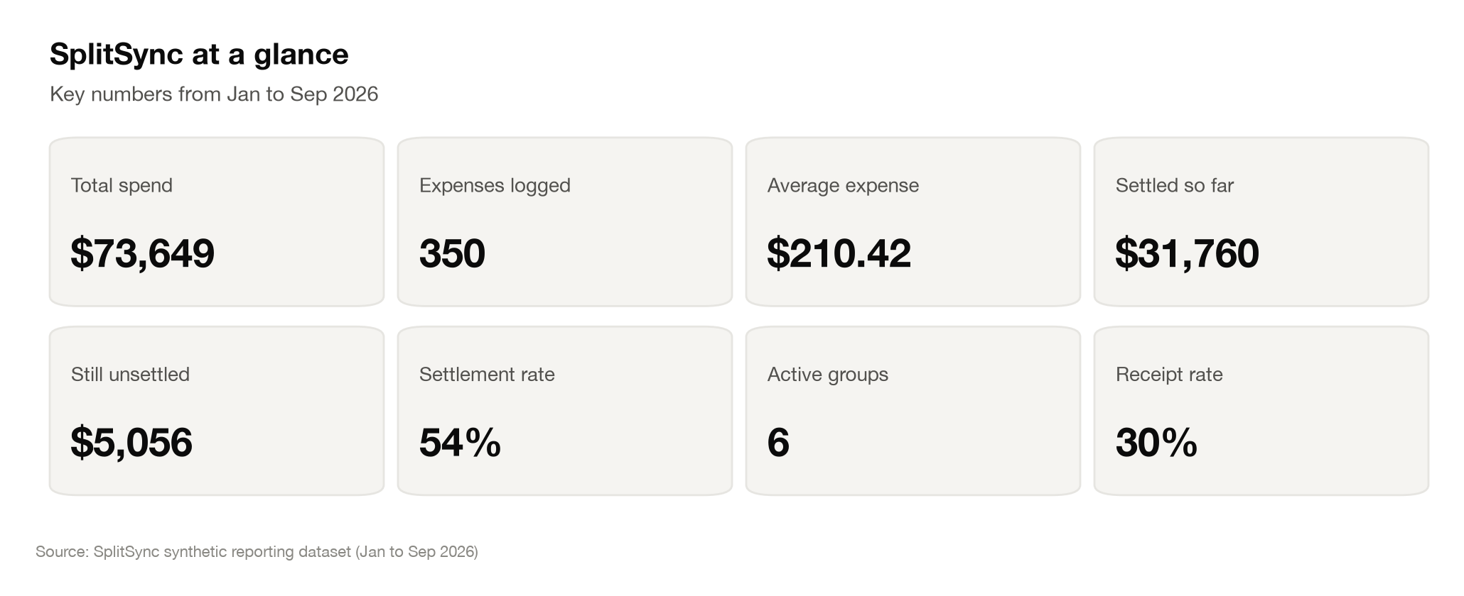
SplitSync at a glance: key totals across the sample period.
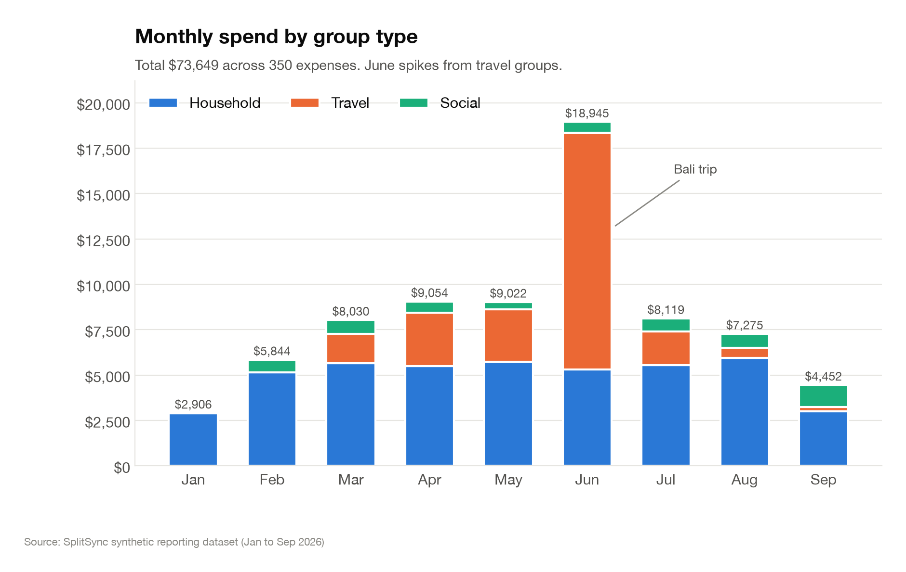
Monthly spend by group type. June spikes from travel groups.
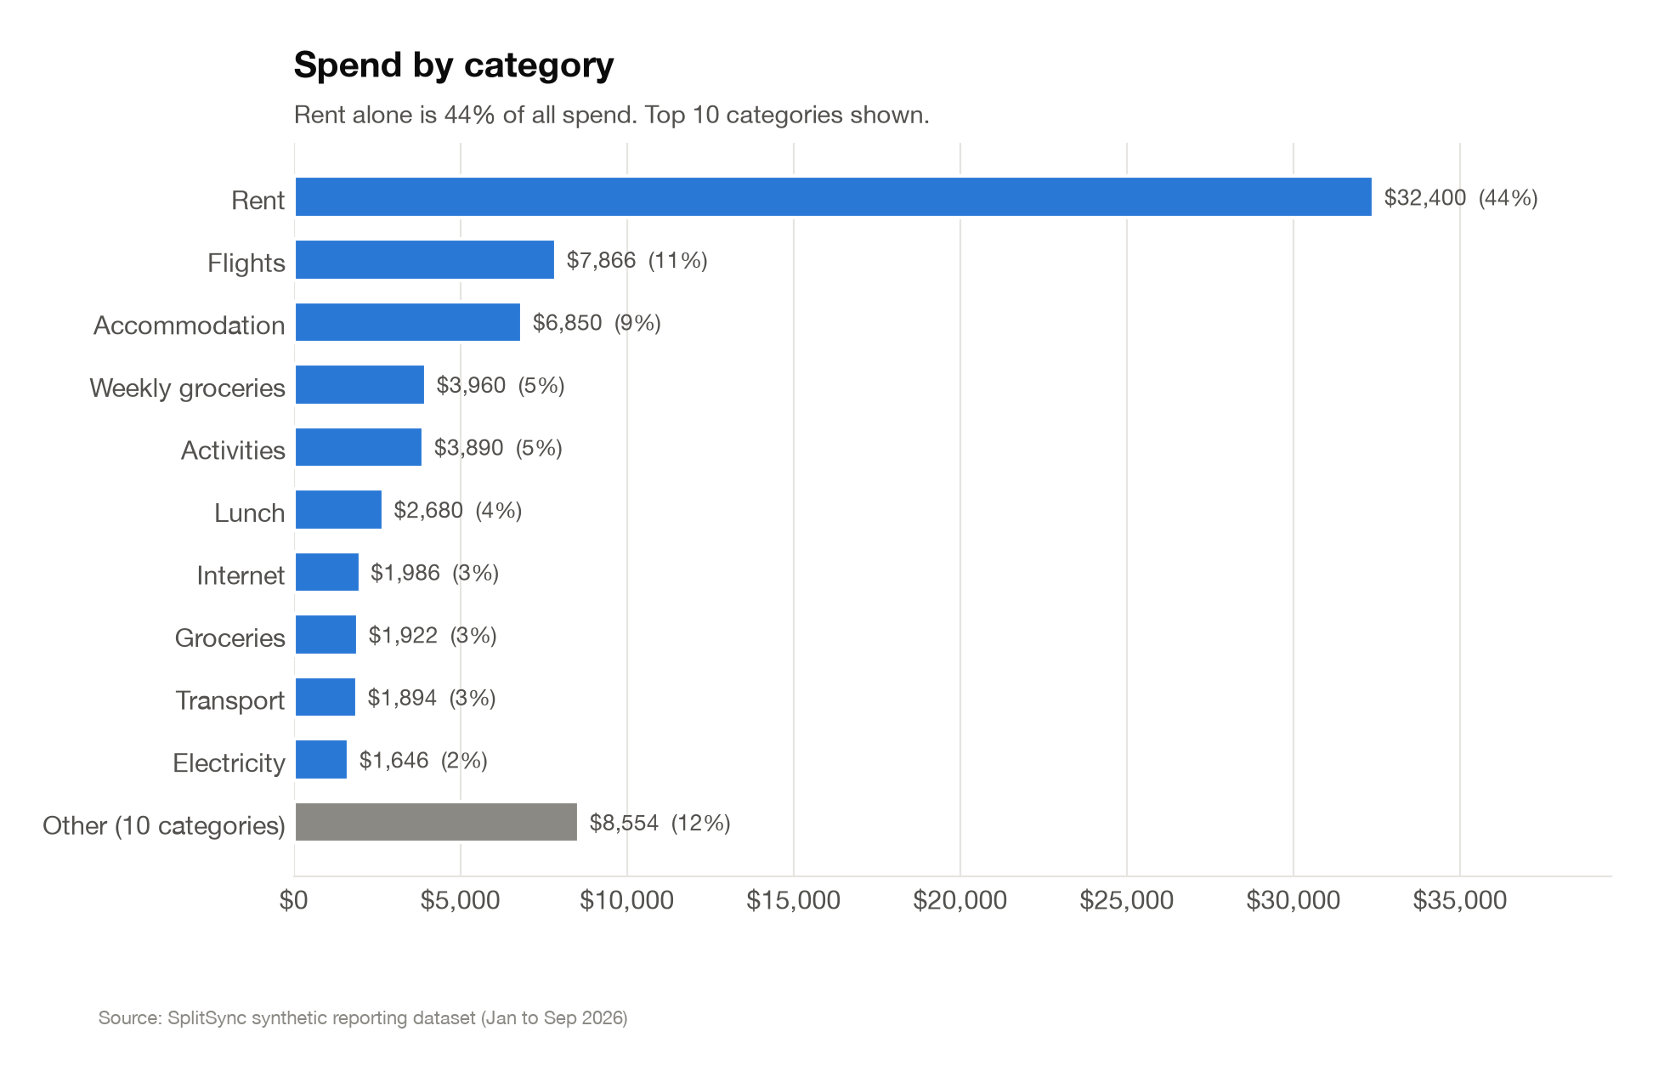
Spend by category, top 10 shown.
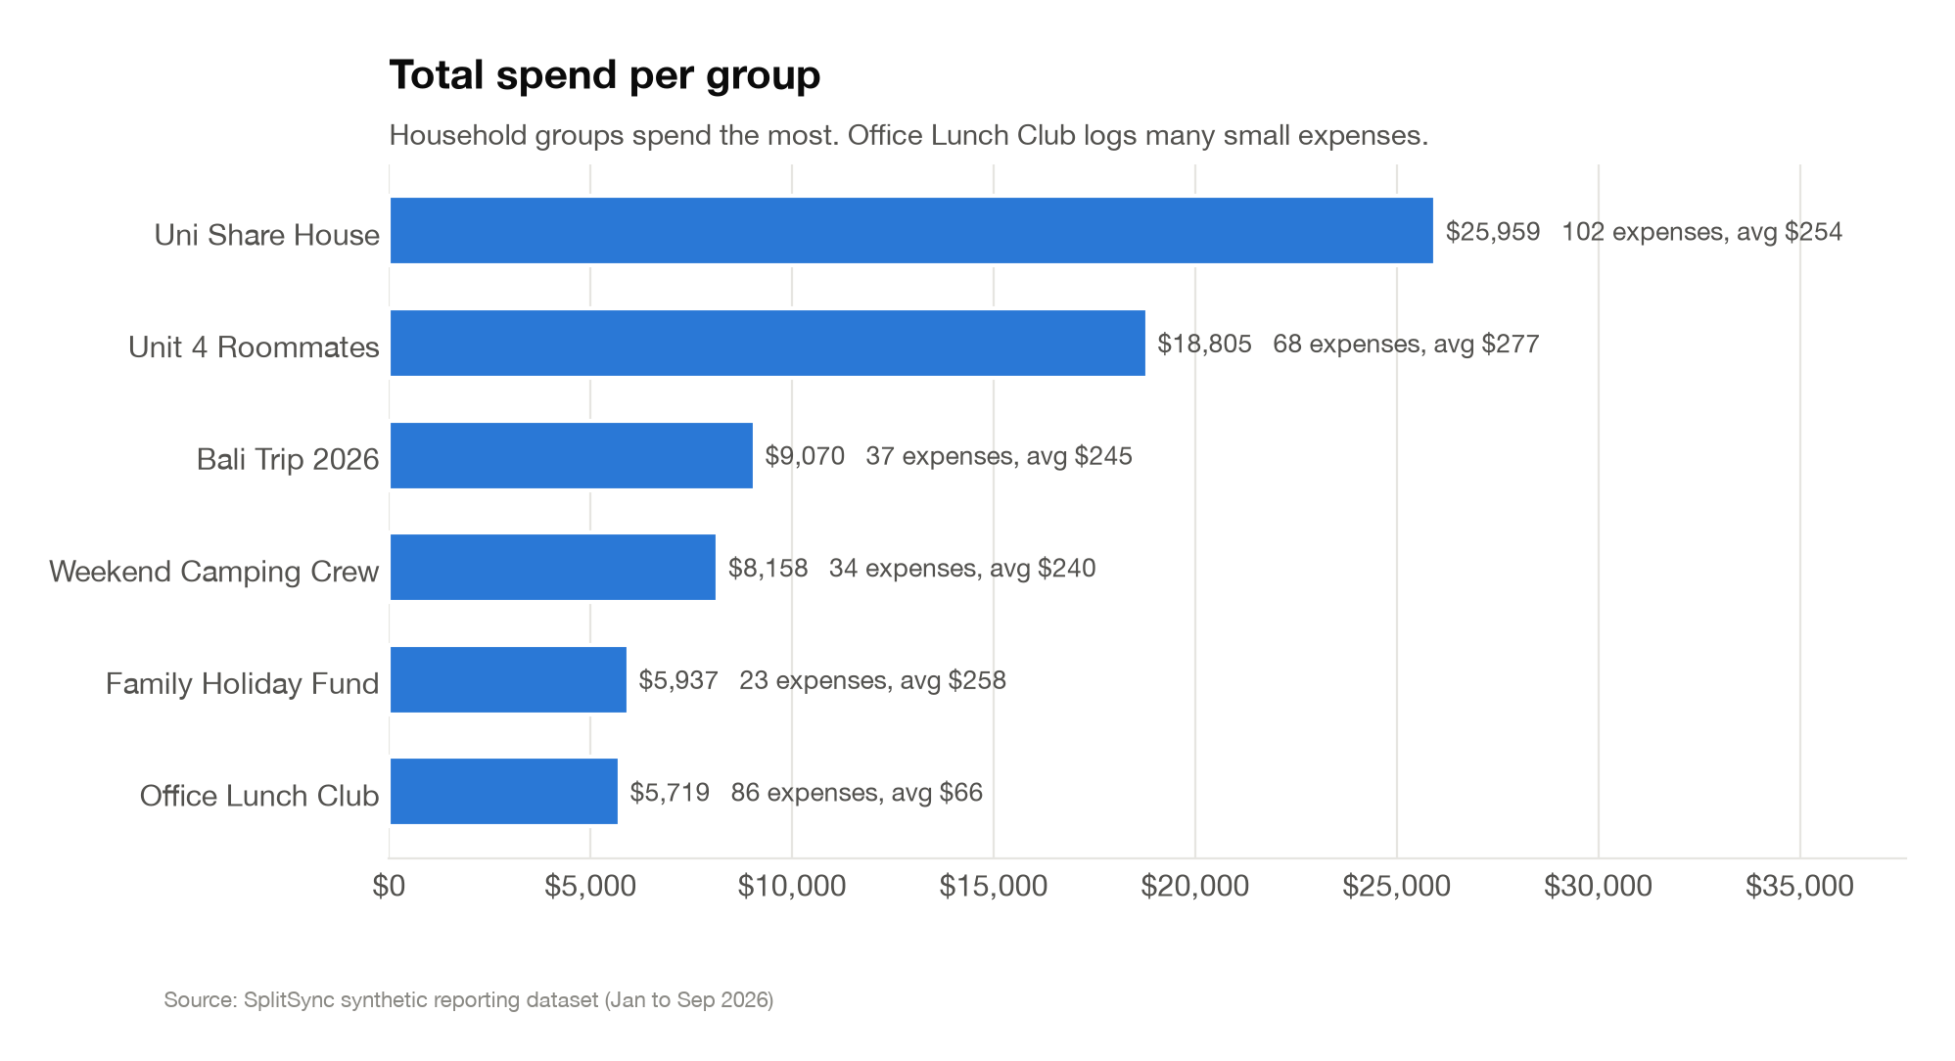
Total spend per group, with expense count and average.
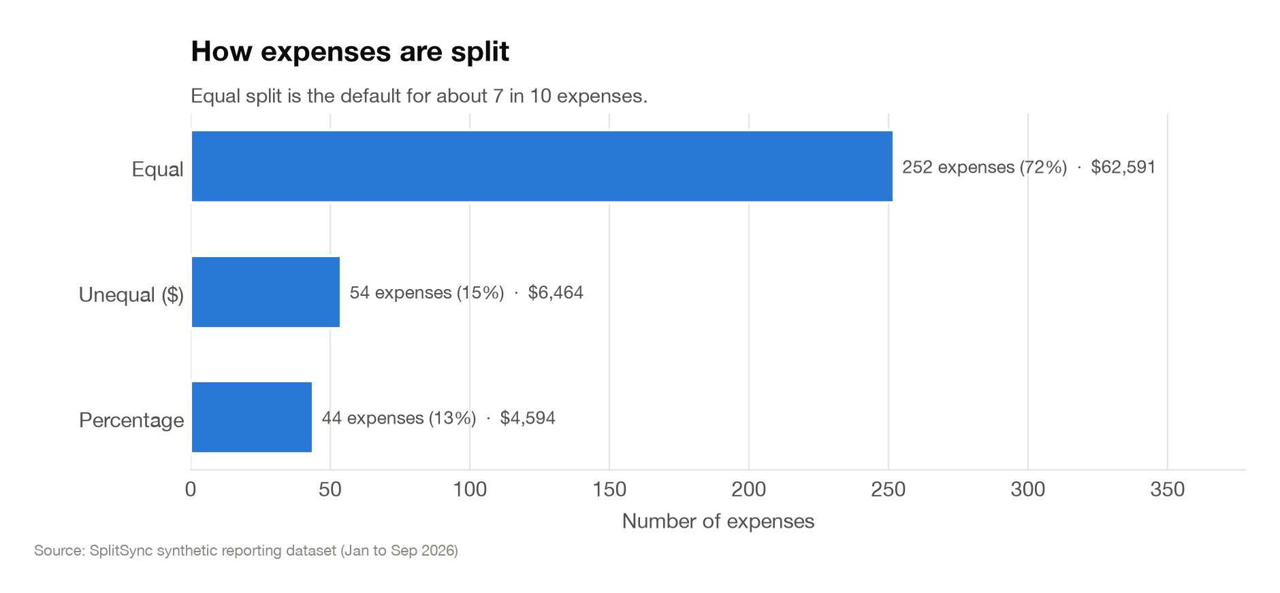
How expenses are split: equal, unequal, or percentage.
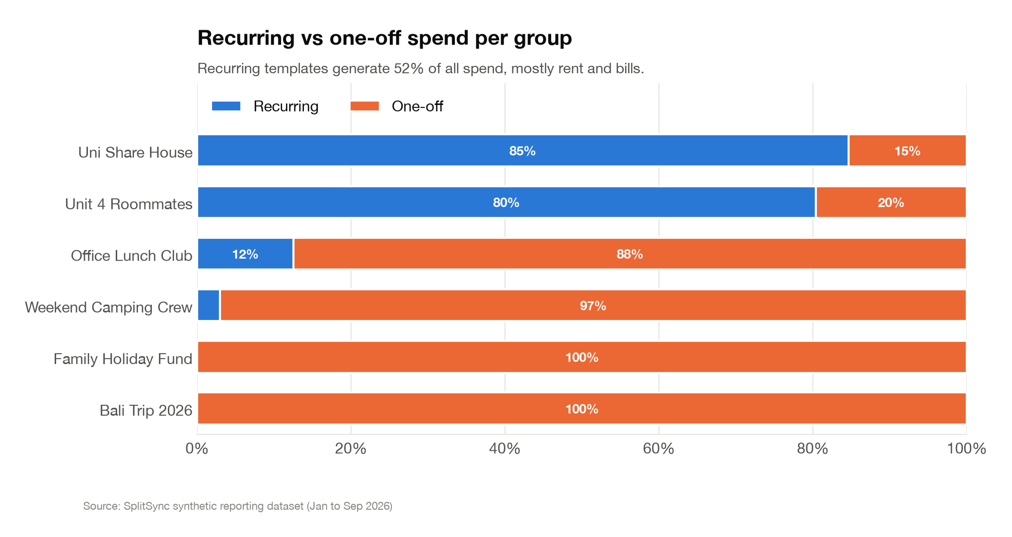
Recurring vs one-off spend per group. Models the recurring-expenses feature from the SRS, which isn't built yet (Section 9).
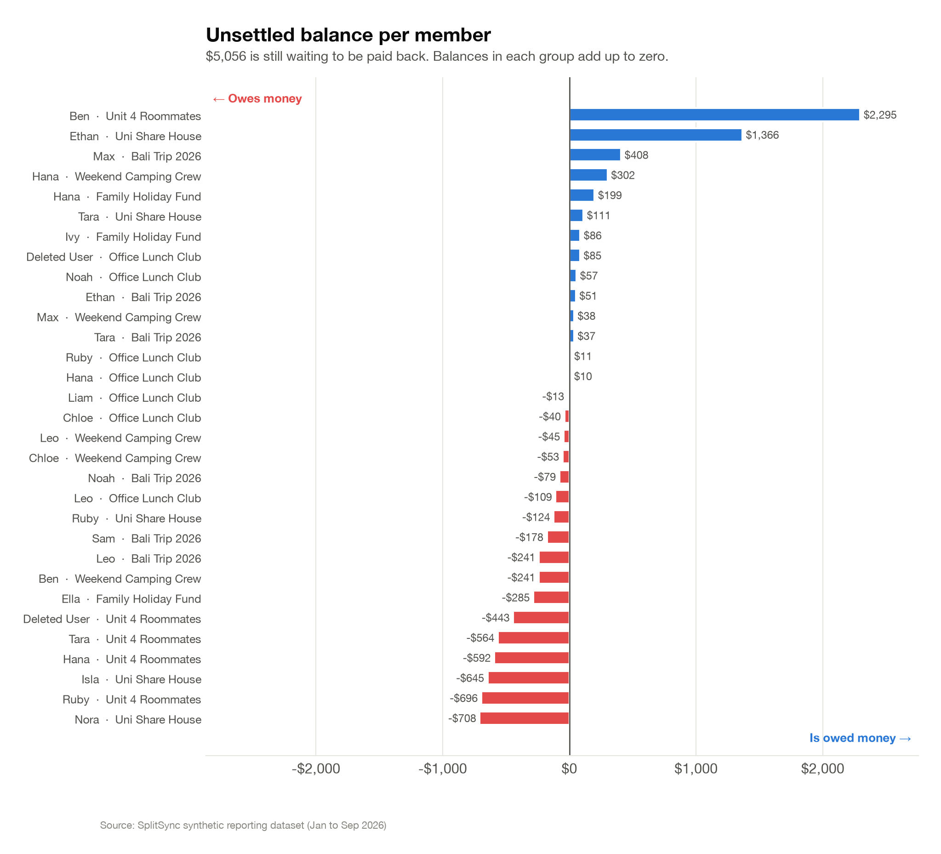
Unsettled balance per member, who owes who across all groups.
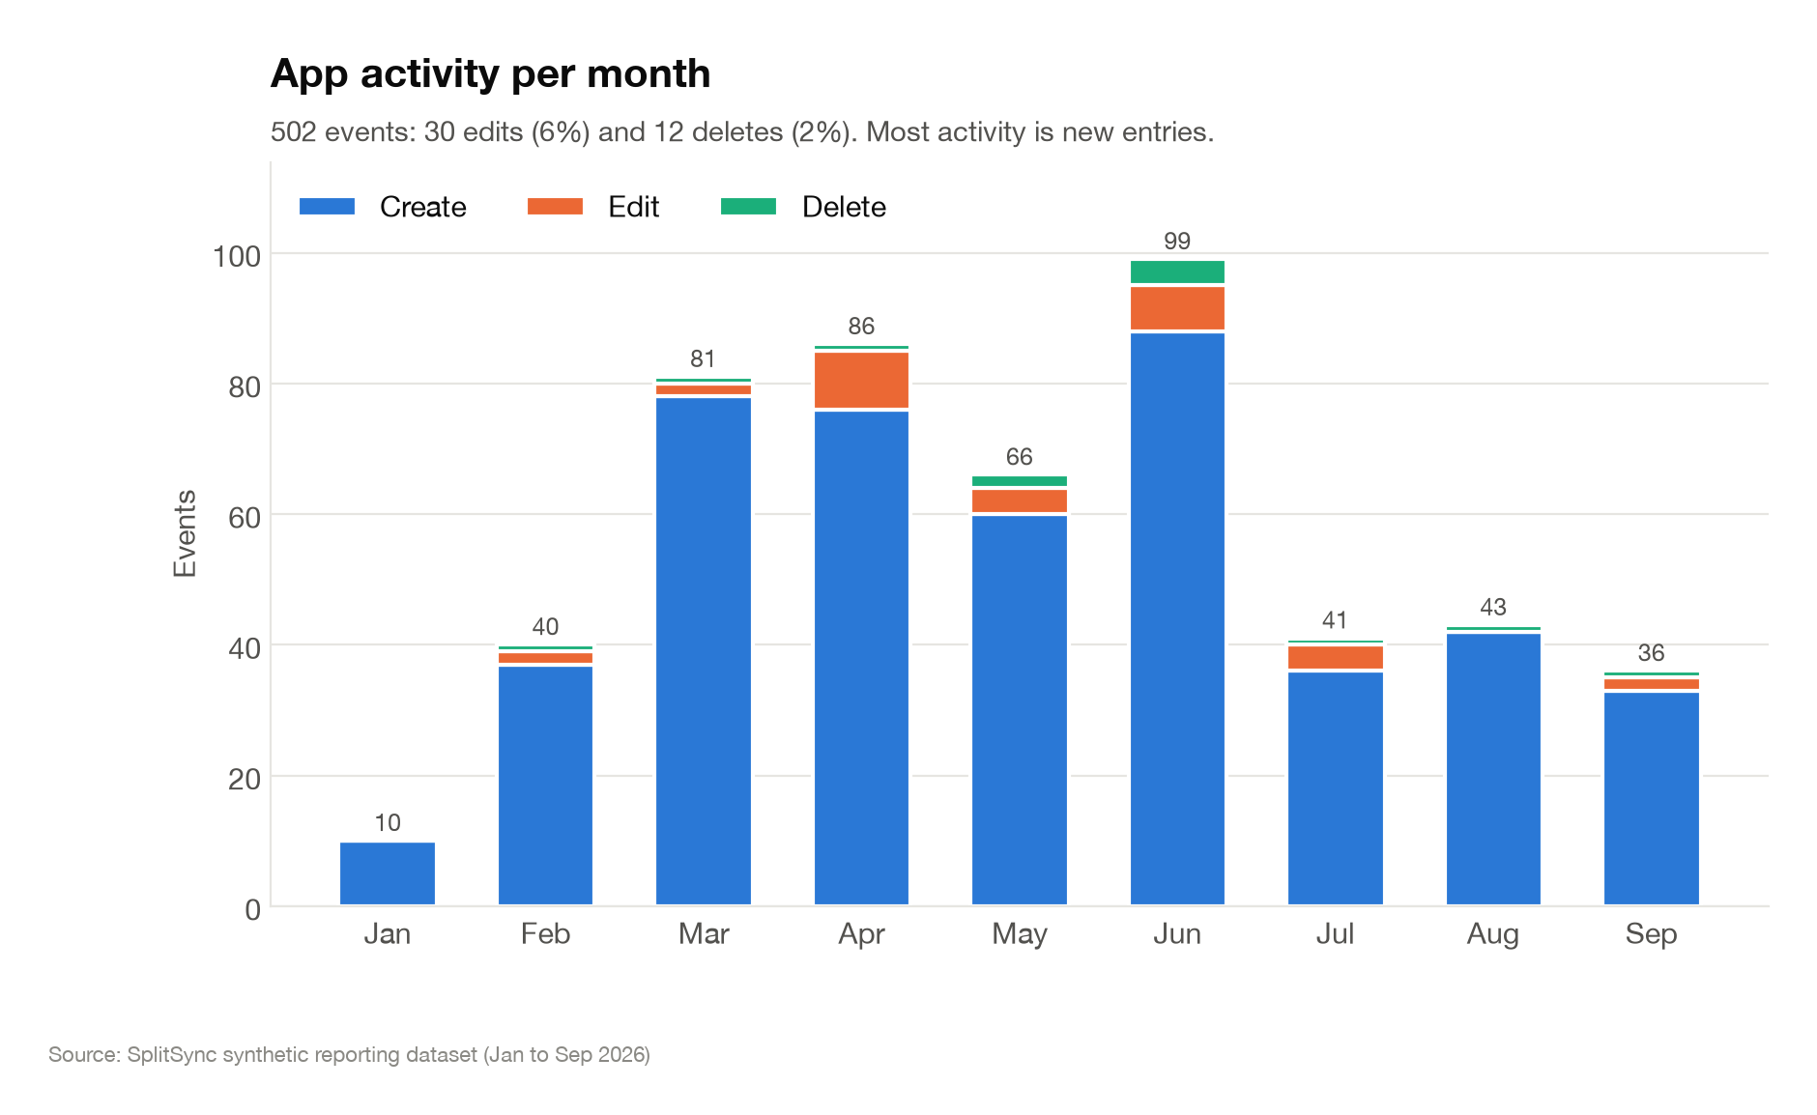
App activity per month by event type. Models the activity log from the SRS, which isn't built yet (Section 9).
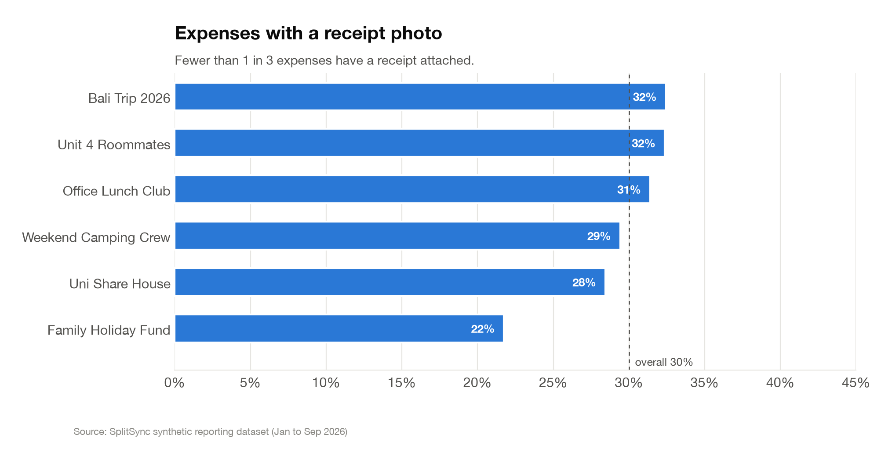
Share of expenses with a receipt photo attached, per group.

11. Conclusion
SplitSync meets the aim and objectives from Section 2 and 3. Groups, expense splitting (equal, unequal, percentage), balances, settlements, notifications, receipt photos, and editing/deleting an expense are all built and working, which covers the core of what the SRS asked for. Recurring expenses and the activity log are the two SRS features that didn't make it in, and the newer features (editing, receipts, the group dashboard) still need more frontend test coverage, both already listed in Section 9.
The app is set up to deploy on Render (Dockerfile and render.yaml in splitsync/), with CORS, environment based secrets, and migrations that run automatically on startup. What's left before final submission is running through that deployment, a full QA pass against the live build, and writing up the remaining report sections (see the Trello board for the up to date task list).

