**Vupiter Interface Design Trade Study**

**Goal:**

* Identify best components for dc power supply user interface.

**I/O:**

* Voltage and current feedback to user, some display type.
* Control to adjust variables of power supply; knobs, keypad, or touchscreen.

**Options:**

* Feedback
  + 7-segment displays
  + TFT Screen
* Control
  + Keypad
  + Quadrature encoders
  + Touchscreen

**Comparisons:**

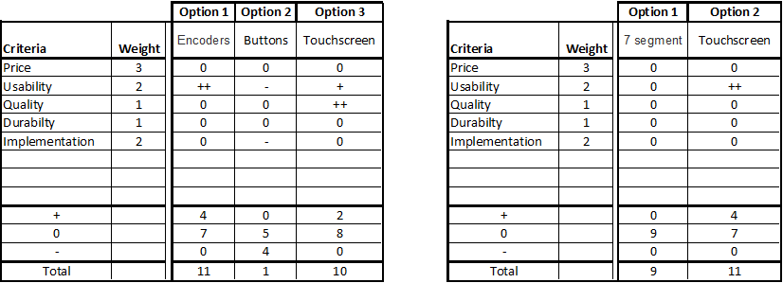 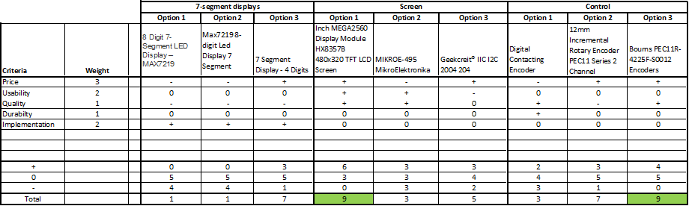

* Touchscreen could perform complete interface but quadrature encoder adds ease of use and quick adjustment. Using both should be considered for best user function and experience.