1.Project Overview:
This project analyses the distribution of Scheduled Commercial Banks across India.This project overview examines the structural and geographical imbalance in India Banking sector.
2.Project Objective:
To analyse trends over time in the growth of Scheduled Commercial Bank office,accounts and deposits.
To analyse underbanked districts and regions with low banking presence and usage.
To compare banking access across different regions of india.
3.Data Source:
This data source is fetched from India Data Portal and here is the link.
IDP | Population-group Wise Deposits
Domain:Banking and Financial
4.Attribute:

ATTRIBUTE NAME | DESCRIPTION | DATA TYPE
Year | The reference year for which the banking data is recorded | Date
State Name | The Indian state to which the District belongs | Text
State Code | The code that refers to the State name. | Number
District Name | The district level administrative unit where the banking data is collected | Text
District Code | The code that refers to the District name. | Number
Region | The geographical region of India | Text
Population Group | Classification of the area based on the population characteristics | Text
Number of SCB offices | Total number of Scheduled Commercial Bank branches operating in the district during the given year. | Number
Number of Accounts | Total number of bank accounts held with Scheduled Commercial Banks in the district. | Number
Amount Deposited | Average deposit amount per bank account in the district. | Currency

5.Tools and technologies:
Excel:Data cleaning,Transformation and Pivot Tables
Power BI:Data Modelling,DAX Calculations,Visualization and interactive dashboard creation.
6.Data Pre-processing:Excel
Data cleaning and Transformation:
Year column done with sorted new to old(2022,2021,2020&2019)
Applied clean & Trim function to the State name,District name,region,Population group.
Creating calculated columns:
1.Account per office =Number of accounts /Number of office
2.Deposit per account =Amount Deposited/Number of accounts
3.Deposit Category =IF([@[Deposit per account]]<=1,"Very Low",IF([@[Deposit per account]]<=7,"Low",IF([@[Deposit per account]]<=12,"Medium","High")))
Data Model: Establishing relationship between fact table and dimensional tables.
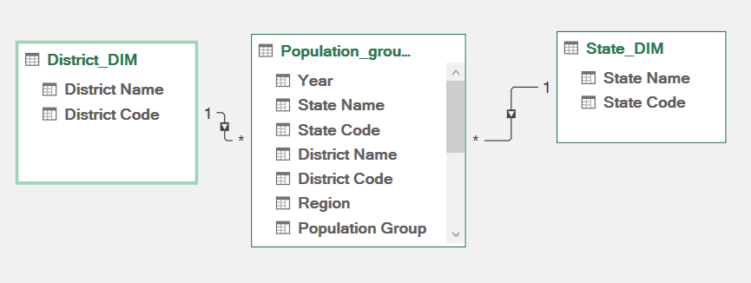
Created two dimensional tables:
District_DIM
State_DIM
Fetch the Mean,Median,Mode,Standard Deviation,Sample Variance,Kurtosis,Skewness,Range,Minimum,maximum,Sum,Count values by using Analysis Toolpak Method.
Using sum,count and average functions Descriptive statistics are calculated(total number of SCB offices,total number account with SCB,s,average amount deposited,average number of accounts per office,total number of records
Pivot charts:
Creating four pivot charts for the following.
1.Number of SCB offices in each State.
2.Number of accounts with SCB’s in each district.
3.Average amount deposited by population group.
4.Number of offices by region.
7.Data Modeling and DAX :(Using Power BI)
Data Model:Establishing relationship between the tables,defined cardinality and create the lookup tables.
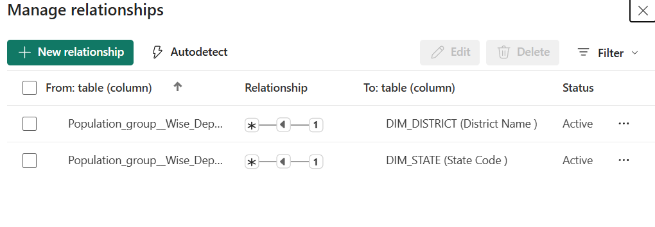
Calculated column and DAX Measures:
Implemented DAX formulas for key metrics,such as
- Totalnumberof_offices = sum(Population_group__Wise_Deposits_Sample_Data__1[Number of SCB Offices ])
- Totalnumberof_accounts = sum(Population_group__Wise_Deposits_Sample_Data__1[Number of Accounts with SCBs ])
- Total_Deposits = sum(Population_group__Wise_Deposits_Sample_Data__1[Amount deposited])
- Depositper_office = DIVIDE([Total_Deposits],[Totalnumberof_offices],0)
- Deposit_share = DIVIDE([Total_Deposits],calculate([Total_Deposits],all(DIM_DISTRICT[District Name ])),0)
- Accountper_office = DIVIDE([Totalnumberof_accounts],[Totalnumberof_offices])
- Previousyear_deposit = calculate([Total_Deposits],FILTER(ALL(Population_group__Wise_Deposits_Sample_Data__1),Population_group__Wise_Deposits_Sample_Data__1[Year ]-1))
- Deposit_growth = DIVIDE([Total_Deposits]-[Previousyear_deposit],[Previousyear_deposit])

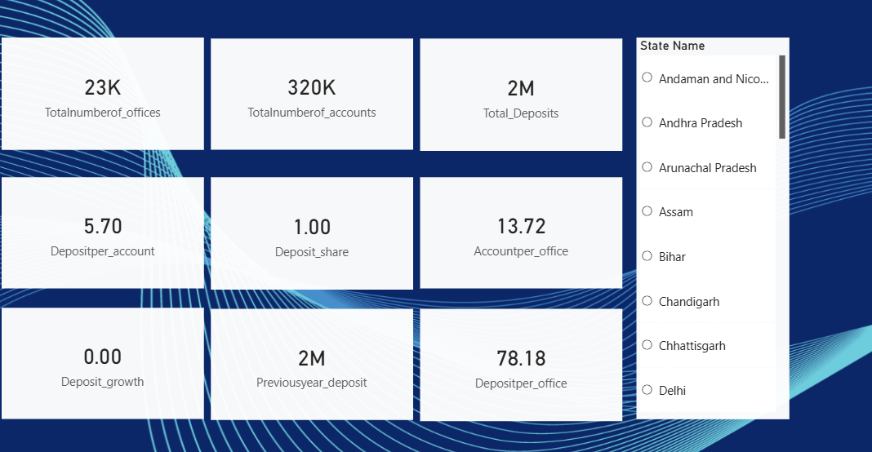

8.Analysis and Visualization:
Dashboard features:
Multiple visualization based on problem

Total deposit by district using bar chart
By using bar chart , we analyse how the total amount deposit over district level.
This is easy to find which district has more deposited amount and which has low level according to the order.

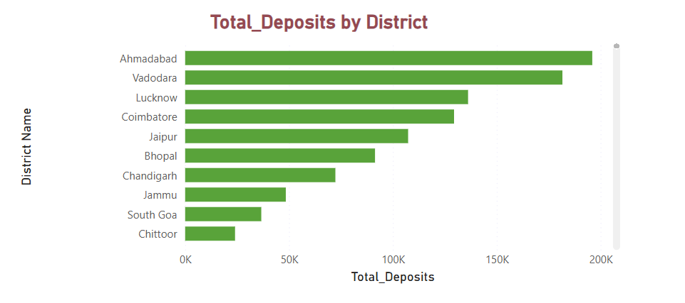
Total deposit by population group
By using donut chart ,we analyse the total deposit distributed towards the population group
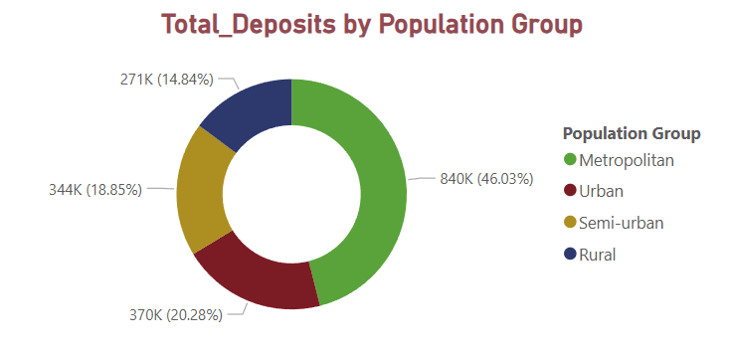
Total deposit by region
By using clustered column chart,we visualize the deposits spreaded over the region
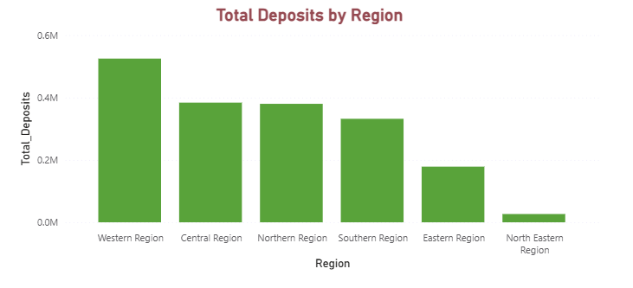
Geographical Distribution of Banking Deposits Across Indian States
Map visualization helps understanding the geographical view of deposits across Indian states.
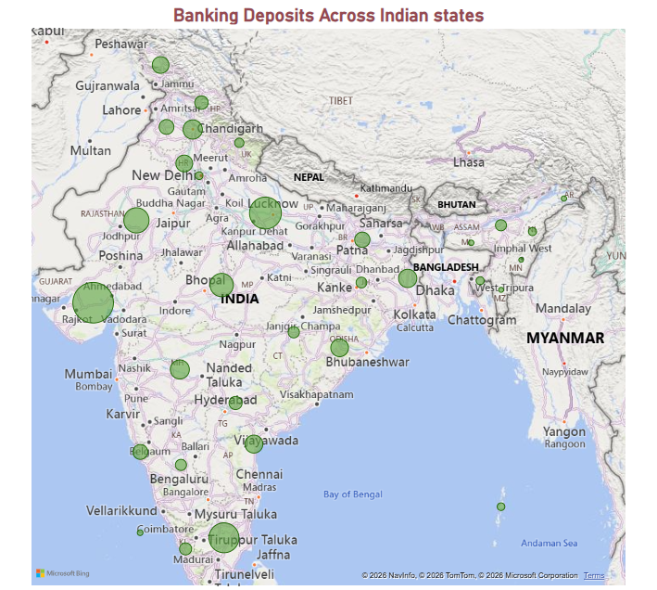
Account per office by region
Using bar chart ,we analyse how the accounts distributed over the region.
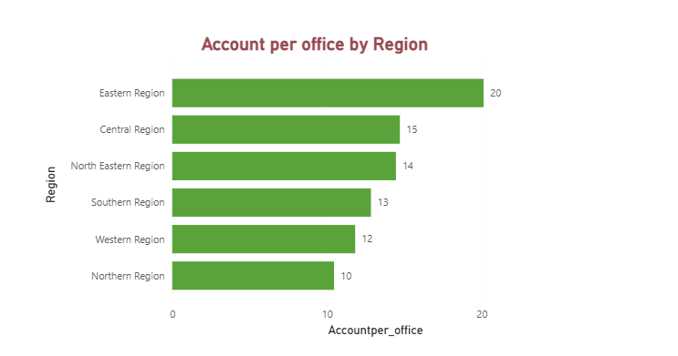
Matrix visualization for the analysis
Matrix visualization helps to find the efficiency comparrision and regional inequality.
In matrix visualization we create hierarchy over region,state an district.
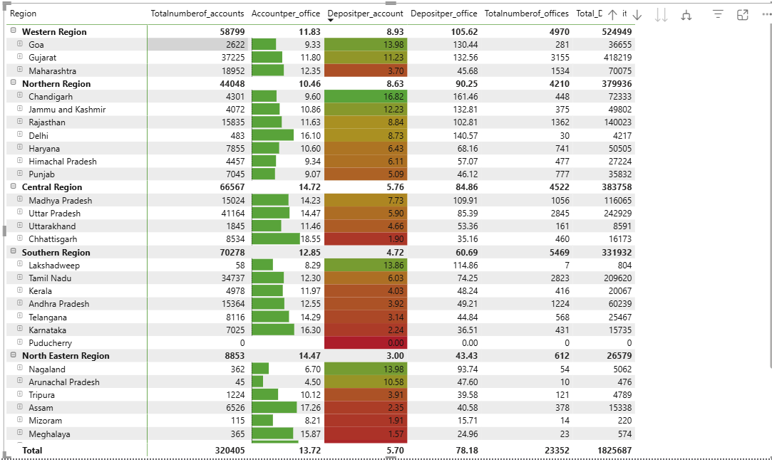

Regional Deposit Growth Trend Over Time
This shows which region is growing faster

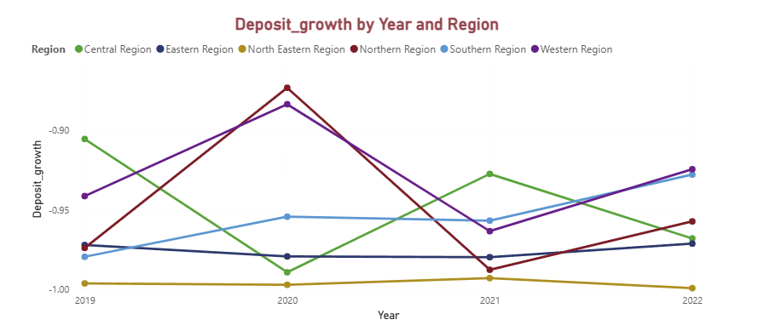
Reports:
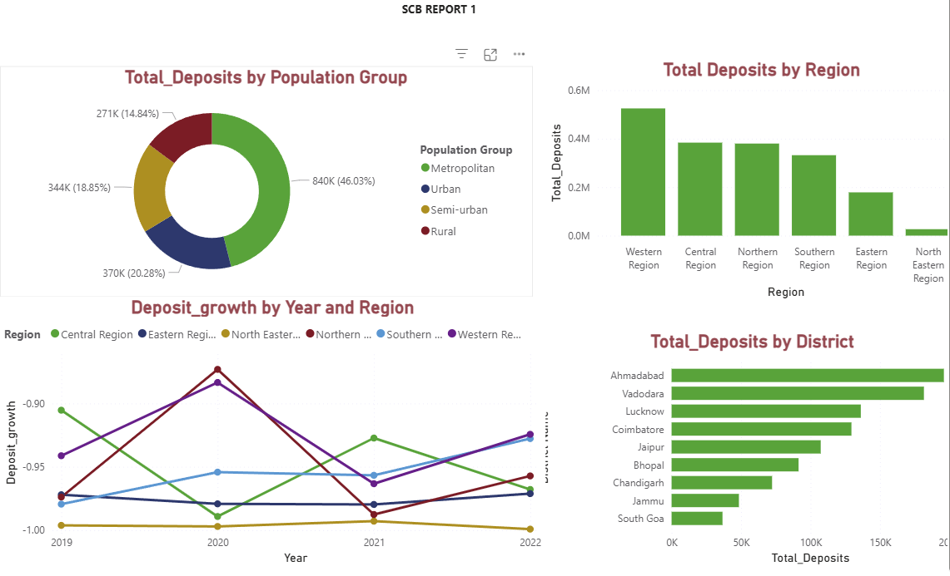
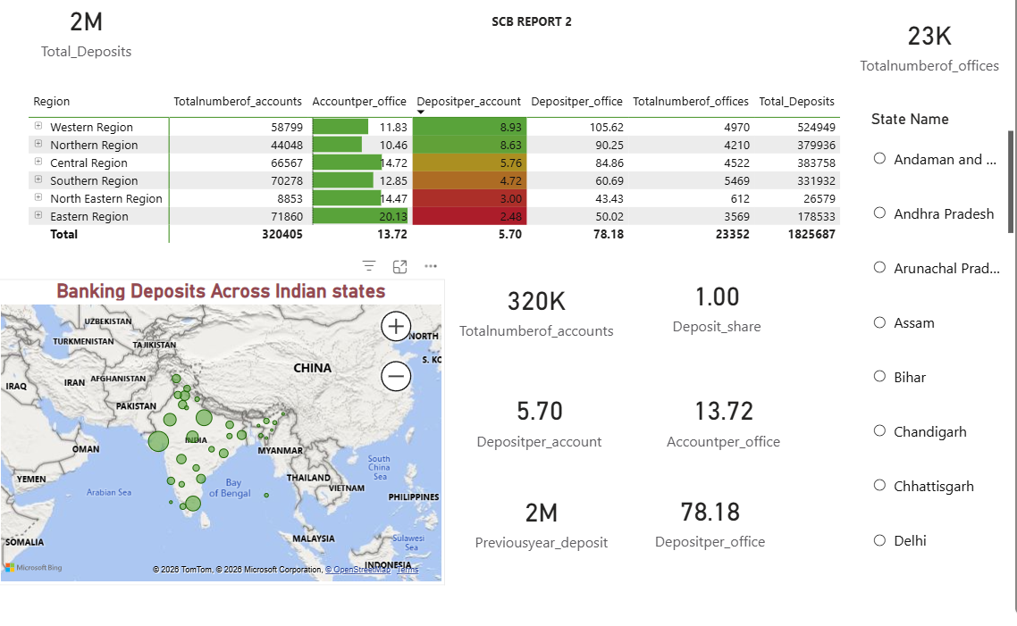
9.Insights:
Key findings:
Western region leads in deposits.
Metropolian area dominates deposit.
Ahmedabhad is top performing district.
Eastern and Northeastern region shows loweer efficiency.
Banking infrastructure is large but uneven.
Deposit growth trend is fluctuating.
Analysis findings:
Western region has highest deposit-524k and northeastern region contributes least.
Metropolian area contributes 46%,urban and metro contributes majority shares and rural contributes very low 15%.
Ahmedabad is top-performing district.Deposit concentration skewed towards few major cities.
Deposit growth fluctuated from 2019–2022.Drop observed around 2020–2021.Slight recovery seen in 2022.
Due to smaller banking peneteration and lower deposit per account in eastern region.
High population density,disposable income and more corporate banking activity leads the metropolian areas contribution.
Ecnomic slowdown,pandemic impact and reduced business activity causes thegrowth dropped in 2020-2021.
Based on trends and pattern,deposit concentratiom will continue,urban contribution will grow further and If economic recovery continues, deposit growth may stabilize and increase gradually.
Expand branches in low performing regions and improve deposit per office and account penetration.
Promote financial inclusion in rural areas such as digital banking campaign,awarness programs
Digital banking expansion, to improve deposit per account and financial inclusion.

10.Conclusion:
The analysis reveals that while the overall banking system shows strong deposit mobilization (₹2M total deposits), performance is regionally concentrated. Although deposit growth shows recovery after economic slowdown, regional disparities indicate the need for targeted policy intervention and banking expansion strategies in underperforming regions.

