Quest 1 – Answer

Quest 2- Answer

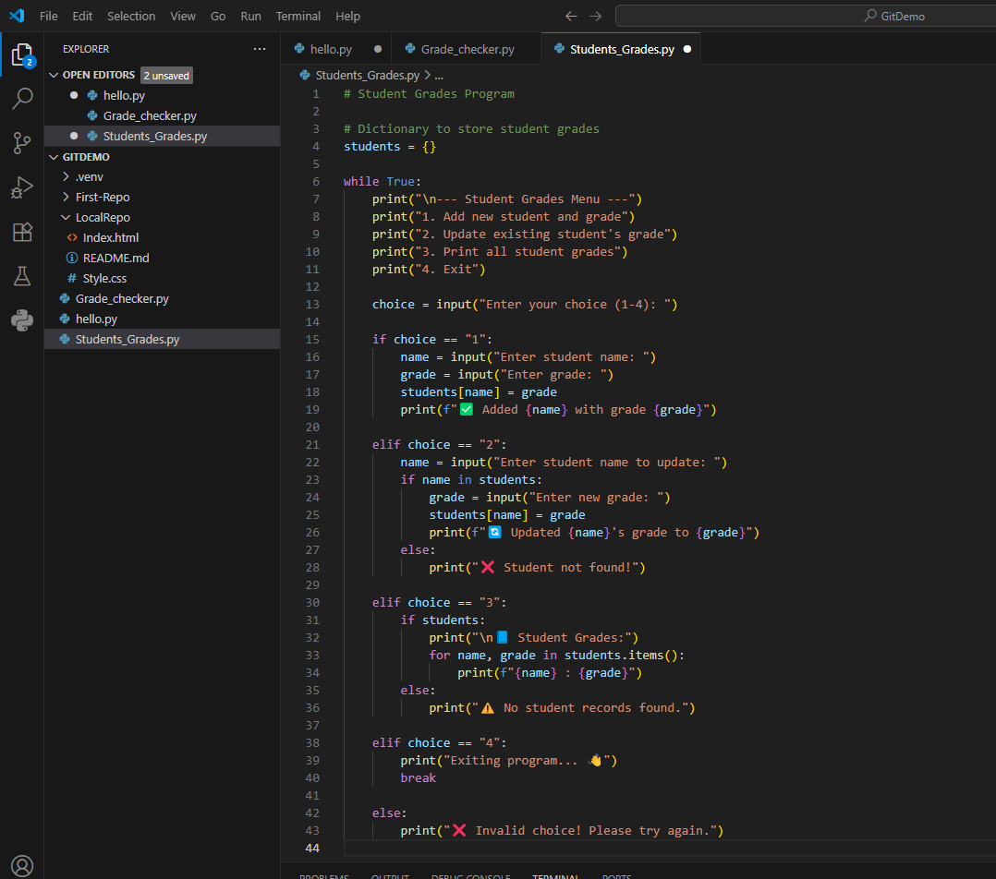

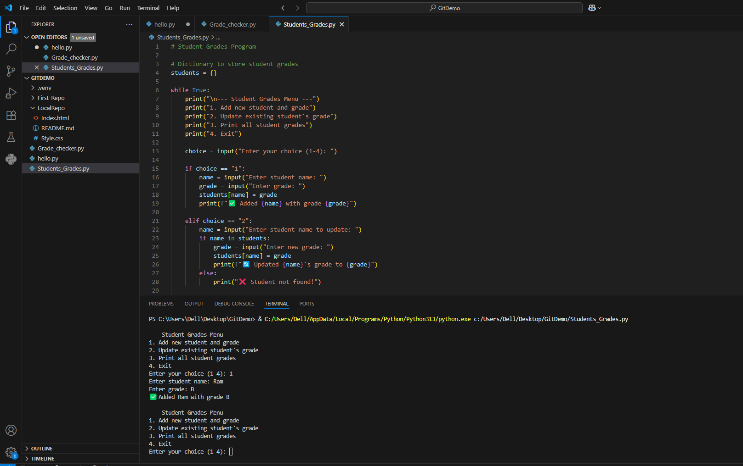

Quest 3 – Answer

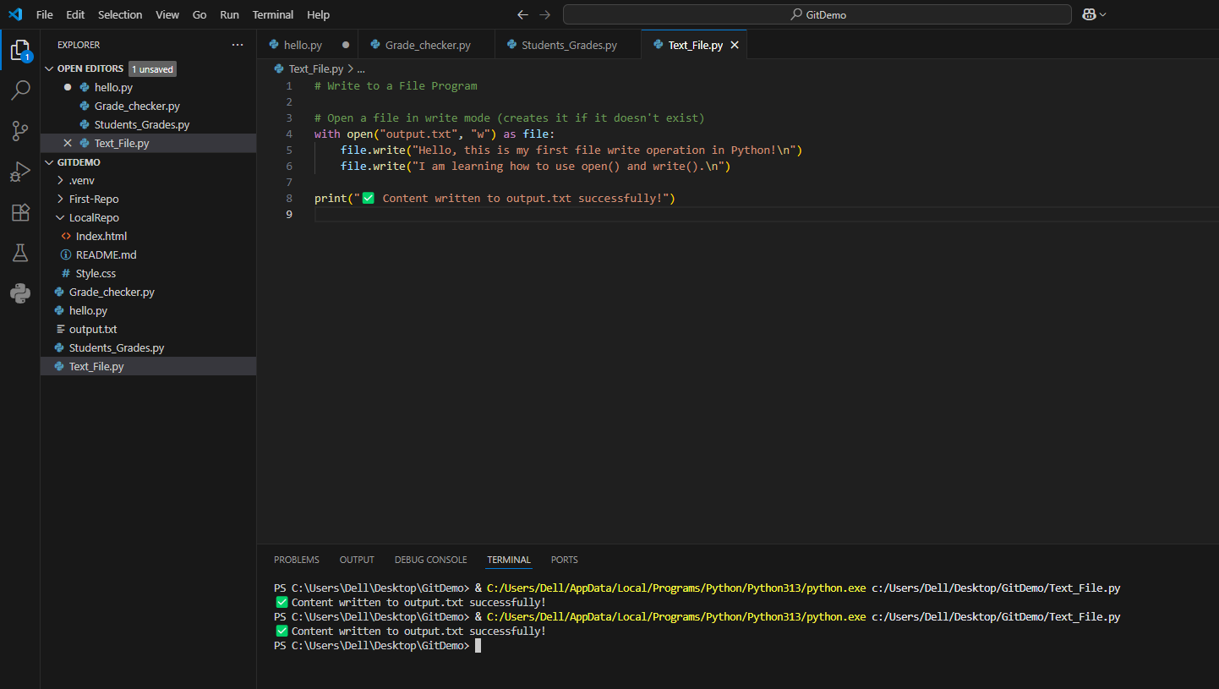

Quest 4 – Answer

