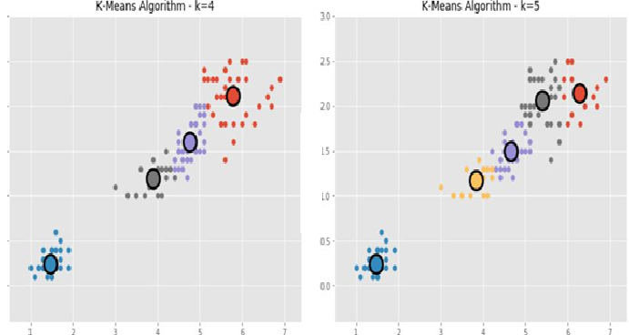

Where k is the number of accident prone area and data points are the pin codes near to that area