

**WALCHAND INSTITUTE OF TECHNOLOGY, SOLAPUR**

**ELECTRONICS AND COMMUNICATION ENGINEERING**

**Year 2019-2020**

Project Synopsis

Name of the course: BE E&TC

1. Name of Students :

Sr No. Name Signature

1. Ankita M . Salunke (GL)

2. Pooja B . Garshakurti

3. Ashwini Yerguntla

1. Name of the Guide: Prof. PDR Patnaik sir .
2. Name of the Project :
3. Whether Project is Sponsored : No
4. PROBLEM STATEMENT :

Conventional ovens operate with a fixed algorithm or operate on average surrounding environment. This method is unsatisfactory because it cannot reflect diverse user requirement and temperature conditions. In this project, therefore, we propose a temperature controller based on machine learning that can improve the required temperature need the proposed method learns the actual temperature based on supervised learning and allows the learning result to be reflected in temperature control. This project will maintain the temperature up to the time provided. Hence the better for with the desired temperature can be delivered .

1. SCOPE OF THE PROJECT:.

|  |  |  |  |  |
| --- | --- | --- | --- | --- |
|  | The proposed system performs machine learning based on the user's choice (preferred  temperature according to the each situation) and controls the temperature of the  food through learning contents. However, it is difficult to find out the user's preferred  Temperature directly for all possible situations. Therefore, this system has one year learning  period to notice user's tendency and preference temperature, and user's manual temperature  Control results are used as training data during learning period. In this project we are going to maintain the  temperature from 40 o C to 120 o C   |  |  | | --- | --- | |  |  | |  |

1. BRIEF DESCRIPTION OF THE PROJECT

* Working principle:

Working principle of the project is to maintain the temperature inside the oven . As we know the electric ovens are having flexibly to select the temperature, so as we set the temperature the food get arm up to that point and once set temperature achieved then it well beeps. So the expected temperature for the food is not maintained . Through this project we are going to maintain that temperature up to user time time .

* 1. Hardware Diagram:

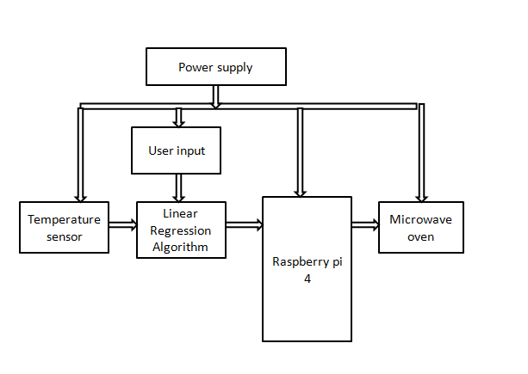

Fig 1: Hardware Diagram

* DESCRIPTION:

1. TEMPERATURE SENSOR :

An RTD, also known as a resistance thermometer, [measures temperature by correlating the resistance of the RTD element with temperature.](https://en.wikipedia.org/wiki/Resistance_thermometer) An RTD consists of a film or, for greater accuracy, a wire wrapped around a ceramic or glass core. The most accurate RTDs are made using platinum but lower-cost RTDs can be made from nickel or copper. However, nickle and copper are not as stable or repeatable. Platinum RTDs offer a fairly

linear output that is highly accurate (0.1 to 1 **°**C) across -200 to 600 **°**C. While providing the greatest accuracy, RTDs also tend to be the most expensive of temperature sensors.

1. LINEAR REGRESSION :

This algorithms well be beneficial for the analyze the user requirement and produce the predicted output

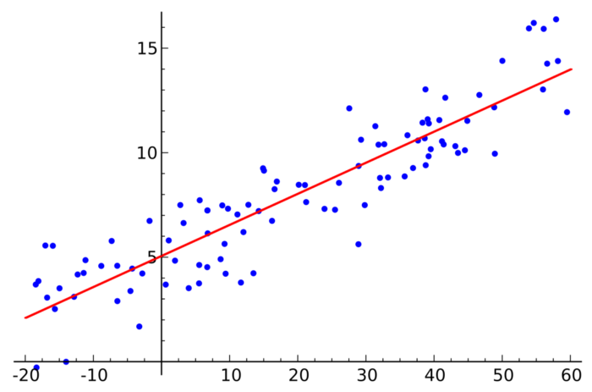

Fig 2: Linear Regression Graph

Linear regression is a type of regression analysis where the number of independent variables is one and there is a linear relationship between the independent(x) and dependent(y) variable. The red line in the above graph is referred to as the best fit straight line.

The cost function helps to figure out the best possible values for a_0 and a_1 which would provide the best fit line for the data points. Since we want the best values for a_0 and a_1, algorithm convert this search problem into a minimization problem where it would like to minimize the error between the predicted value and the actual value.

**Equation for linear regression**:

**y = a_0 + a_1 \***

**Flowchart of linear regression:**

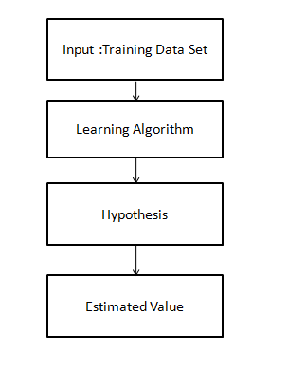

1. RASPBERRY PI 4:

The Raspberry Pi 4 offers ground-breaking increases in processor speed, multimedia performance, memory, and connectivity compared to the prior-generation boards, while retaining backwards compatibility and similar power consumption. The Raspberry Pi 4 provides desktop performance comparable to entry-level x86 PC systems. The Raspberry Pi 4 comes in three on-board RAM options for even further performance benefits: 1GB, 2GB and 4GB.  
This product's key features include a high-performance 64-bit quad-core processor, dual-display output via two Micro HDMI ports, up to 4K resolution, hardware video decoding at up to 4Kp60, up to 4GB of RAM, dual-band 2.4/5.0 GHz wireless LAN, Bluetooth 5.0, Gigabit Ethernet, USB 3.0, and PoE capability.Due to the higher power requirements, the Raspberry Pi 4 requires a 3.0A USB-C supply power(sold separately). If you have an existing power supply that is rated at 3.0A, you may utilize a microUSB to USB-C adapter to utilize your existing MicroUSB power supply to power the Raspberry Pi 4.  
The standard HDMI port that were part of previous generation Raspberry Pi generation boards is replaced on the Raspberry Pi 4 by two Micro HDMI ports to provide dual monitor support. A 4K60P Micro HDMI to HDMI cable is required (or two cables for dual monitor operation).  
  
**Note: Raspberry Pi 4 compatible operating system is required for operation.**

1. Power supply :

Our system will require both a AC supply as well as DC supply . AC supply is for oven and DC supply for the circuit.

* COMPONENTS REQUIRED:

1. Hardware Requirements:

* Raspberry pi 4- 4GB RAM with adapter
* Temperature sensor (RTD)
* 16 GB class 10 SD card
* Microwave oven

1. Software Required:

* Raspbian OS.
* Python
* Approximate Budget of the Project :INR 8000

Name & Signature Dr. Dube R.R.

Project Guide Head, E&TC Department