Incentives for Registered Reports from a risk-sensitivity perspective
Anne M. Scheel¹, Leo Tiokhin², & Daniël Lakens³
¹ Utrecht University
² Deciding Better
³ Eindhoven University of Technology

Author note
Correspondence concerning this article should be addressed to Anne M. Scheel, Padualaan 14, 3584 CH Utrecht, The Netherlands. E-mail: a.m.scheel@uu.nl

Abstract
Registered Reports are a publication format designed to reduce publication bias by guaranteeing publication before results are known. This guarantee is thought to be attractive for researchers in the prevailing ‘publish or perish’ culture. But would researchers always prefer such a low-risk option? That standard publications depend partly on study results can also be an advantage for authors, for example when strong results lead to publication in a prestigious journal. Given this trade-off, the choice between formats represents decision making under risk, and researchers may not always prefer risk-averse choices. To better understand when Registered Reports may or may not be the popular choice, we draw on risk-sensitivity theory from behavioural ecology and develop an agent-based model that explores how four factors of academic careers shape publication strategies: whether additional publications yield diminishing or increasing career returns, empirical pace (the number of studies completed before career evaluation), absolute publication targets (e.g., for a PhD or tenure), and competition for positions or funding. We find that many realistic configurations lead researchers to avoid Registered Reports even when they are nearly as valuable as the best possible standard publication. Intense competition and low empirical pace can make the format virtually unviable, while high empirical pace attenuates most other effects. These results can help identify research areas, career stages, and institutional conditions where Registered Reports may not take hold without additional incentives or interventions, such as increasing their weight in hiring decisions or supporting journal-independent review models.

Incentives for Registered Reports from a risk-sensitivity perspective
Registered Reports are an article format designed to reduce publication bias and ‘questionable research practices’ (QRPs), which distort the published record of research findings in many scientific disciplines (Chambers, 2013; Franco, Malhotra, & Simonovits, 2014; Fraser, Parker, Nakagawa, Barnett, & Fidler, 2018; Gopalakrishna et al., 2022; John, Loewenstein, & Prelec, 2012). In this format, peer review takes place before data collection and the decision to publish is made before authors, reviewers, and editors know the study results. In addition to preventing editors from selectively rejecting unfavourable results (in particular negative or null results), this is thought to remove incentives for authors to hide, embellish, or misrepresent results because publication no longer depends on them (Chambers, Dienes, McIntosh, Rotshtein, & Willmes, 2015). Initial evidence from psychology and neighbouring disciplines shows that Registered Reports indeed contain much higher rates of negative results than the standard literature (Allen & Mehler, 2019; O’Mahony, 2023; Scheel, Schijen, & Lakens, 2021).
Advocates of the format have argued that the pre-data publication guarantee should make Registered Reports particularly attractive to researchers (e.g., Chambers & Tzavella, 2022) because it reduces uncertainty about whether and where a study will be published before authors have invested in conducting it. This provides relative safety in a research climate that involves substantial publication pressure (Gopalakrishna et al., 2022; Miller, Taylor, & Bedeian, 2011; Tijdink, Vergouwen, & Smulders, 2013; van Dalen & Henkens, 2012). However, if strategic concerns about publishability indeed influence researchers’ format choices, it is unlikely that they would always cause risk aversion. Researchers’ willingness to take risks may instead vary depending on factors such as available resources, time pressure, or competition, creating situations in which Registered Reports remain unpopular without additional incentives or interventions. And indeed, although uptake is growing exponentially (Chambers & Tzavella, 2022), the market share of Registered Reports is currently still much smaller than one might expect if authors saw them as unreservedly beneficial for their careers. Here, we examine these possibilities with an agent-based simulation, modelling authors’ choices between publication formats as decision making under risk to identify circumstances in which Registered Reports might be used highly selectively, or not at all.

Design and intended functions of Registered Reports
The review process of Registered Reports is split into two stages. At Stage 1, reviewers evaluate a pre-study protocol containing the research questions, hypotheses, methods, and analysis plan. In case of a positive decision, the journal issues an ‘in-principle acceptance’ and commits to publishing the eventual report regardless of the eventual results. Only after in-principle acceptance, authors move on to data collection and analysis. At Stage 2, the final report is subjected to a second round of peer review to verify adherence to the protocol, data quality, and whether conclusions are justified by the evidence. Manuscripts can still be rejected at Stage 2, but only for substantial violations of the protocol or uninformative data (e.g., caused by equipment failure), not for the direction or significance of results.
Through this process, Registered Reports address publication bias as well as so-called ‘questionable research practices’ (QRPs), both of which skew scientific evidence and contribute to poor replicability and research waste (Chalmers & Glasziou, 2009; Ferguson & Heene, 2012; Wagenmakers, Wetzels, Borsboom, van der Maas, & Kievit, 2012). Publication bias can result from editors and reviewers disproportionately rejecting submissions with negative results (‘reviewer bias,’ Atkinson, Furlong, & Wampold, 1982; Mahoney, 1977) or from researchers failing to submit negative results for publication (‘file-drawering,’ Ensinck & Lakens, 2023; Franco et al., 2014; Rosenthal, 1979). Registered Reports’ in-principle acceptance issued at Stage 1 addresses both issues: Editors and reviewers cannot reject the Stage-2 report based on the results, which also reduces the incentives for authors to file-drawer negative outcomes. QRPs are practices that exploit undisclosed flexibility in data collection and analysis, such as selective reporting of favourable results or presenting post hoc inferences as predicted a priori (Gopalakrishna et al., 2022; John et al., 2012; Simmons, Nelson, & Simonsohn, 2011). Registered Reports minimise the risk of QRPs via the two-stage review process, in which the Stage-1 protocol acts as a preregistration and reviewers’ task during Stage-2 review is to flag any undisclosed deviations from it.

Efficacy of Registered Reports
Registered Reports were first launched in 2013 at the journal Cortex (Chambers, 2013) and are now offered by over 300 journals, predominantly in the behavioural sciences and life sciences (see cos.io/rr). Nearly 600 Registered Reports had been published by 2021, with uptake growing exponentially (Chambers & Tzavella, 2022). Published Registered Reports show markedly lower rates of positive results than standard reports: $44\%$ vs $96\%$ in psychology (Scheel et al., 2021), $39.5\%$ in psychology and neuroscience (Allen & Mehler, 2019), and $50.1\%$ across several disciplines (O’Mahony, 2023). These findings suggest that Registered Reports reduce the biases that inflate positive result rates in the standard literature. The existing evidence is observational, however, and may be confounded by systematic differences between formats. A study comparing Registered Reports with matched controls found they have larger sample sizes and higher methodological quality (Soderberg et al., 2021), suggesting the lower positive result rate is not an artefact of lower statistical power. A more plausible confound is that researchers might selectively use Registered Reports for hypotheses they expect to yield negative results, while reserving the standard route for hypotheses they are more confident will produce (publishable) positive results.
This consideration highlights the importance of understanding the costs and benefits of Registered Reports from the authors’ perspective: If current incentives cause selective use, meta-scientists would need to account for this, and over time such patterns could associate the format with negative results and make it unattractive to the broader community.

Author incentives for Registered Reports
Registered Reports are generally thought to ‘[neutralise] bad incentives’ (Chambers, 2013, p. 609): Once authors have committed to the format, they can improve their publication chances only via the proposed research question and methods, and results are no longer a target to ‘hack’ or select on.
The incentives for choosing the Registered Reports route in the first place, however, are less clear. Advocates of the format have argued that it ‘serve[s] the interests of individual scientists’ (p. 12, Chambers & Tzavella, 2022) because it reduces the risk of investing in research projects whose results turn out to be difficult to publish: Under publication pressure, the pre-data publication guarantee removes what Chambers has called the ‘p-value lottery’ (Chambers, 2021) of the standard route . The argument assumes that researchers a) are under pressure to amass journal publications (which remain a central currency for hiring and promotion decisions, R. Müller, 2014; van Dalen & Henkens, 2012) and b) face shortfalls in publication output when their studies yield negative results.
But would researchers ever prefer the lottery? Typically, authors care not only about their studies being published at all, but also about the reputation of the publishing journal and citation rates (which are causally influenced by journal rank, Traag, 2021). In standard reports, career-relevant payoffs per study thus vary from very low — when authors file-drawer a manuscript because the publication chances do not justify the costs (Ensinck & Lakens, 2023) — to very high, when a manuscript is published in a high-impact journal and frequently cited. Compared to this, the payoffs from Registered Reports have lower variance. They reduce variance at the lower end of the range by minimising the chances of no publication at all, but also at the upper end: Upon receiving in-principle acceptance, most authors know that their study will not be published in a high-impact journal because very few such journals currently offer the format. For standard-report authors, in contrast, the chance of a high-impact publication persists — at least in theory — until the results are in. Therefore, as long as the payoff associated with a published Registered Report is not always on par with the best possible outcome of the standard route, there will be situations in which playing the lottery is more beneficial for researchers.

Publication strategies as decision making under risk
Which are those situations? Because Registered Reports and the standard publication route differ in payoff variance, authors’ choice between them represents decision making under risk. Here, we draw on risk-sensitivity theory from behavioural ecology to model factors that influence risk preferences and simulate their effects on researchers’ publication strategies. Following Winterhalder, Lu, & Tucker (1999), we define risk as ‘unpredictable variation in the outcome of a behavior, with consequences for an organism’s fitness or utility’ (p. 302). Risk aversion thus means preferring a low-variance option over a high-variance option, and risk proneness the reverse. Organisms are risk sensitive when they are sensitive not only to the average of outcomes of different options, but also to their variance.
Risk-sensitivity theory is a normative theory originally developed to determine optimal foraging strategies for animals choosing between low-variance and high-variance food sources (Kacelnik & Bateson, 1996). Organisms are predicted to be sensitive to such differences when payoffs have non-linear consequences for survival or reproductive fitness, for example when additional food yields diminishing returns or when amounts below a threshold cause starvation. The predictions of risk-sensitivity theory overlap substantially with those of expected utility theory and prospect theory, but it uses fitness instead of utility as its central currency. Despite its initially narrow scope, risk-sensitivity theory has proven itself as a powerful framework for explaining risk-sensitive behaviour across a wide range of situations and species, including humans (Mishra, 2014; Winterhalder et al., 1999).

The present study
In the following, we apply risk-sensitivity theory to the situation of researchers choosing between Registered Reports and the standard publication route. Using a simulation model, we explore how four risk-relevant aspects of academic careers affect publication strategies: (1) whether additional publications yield linear, decreasing, or increasing returns for career success, (2) empirical pace (the frequency at which studies can be completed), (3) publication targets that must be met to continue or further one’s career, and (4) competition. Our goal is to understand in which circumstances Registered Reports should be particularly attractive, particularly unattractive, or particularly prone to selective use. The results of this analysis may help anticipate research fields and career stages in which the format is unlikely to take foot without additional changes to norms, incentives, or policy, and flag situations in which the results of published Registered Reports may be particularly difficult to compare to the normal literature.

Conceptual application of risk-sensitivity theory to publication decisions
In the context of academic careers, risk-sensitivity theory’s focus on reproductive fitness as the central outcome may be seen as misguided. But as argued by Smaldino & McElreath (2016), academic research satisfies the three requirements for natural selection: variation (e.g., in research practices), consequences of this variation for survival and reproduction (e.g., some practices increase the chances of staying in academia and of being copied by others), and heritability (e.g., PhD students copying the research practices of their advisors). A competitive job market will by definition select for individuals whose past behaviour increased their prospects, regardless of their intentions. Such competition creates bottlenecks between early-career and tenured positions that induce selection pressure for career-promoting behaviours (Smaldino & McElreath, 2016; for a similar approach, see also Higginson & Munafò, 2016).
We therefore conceptualise fitness as career success. This does not imply that career success is the only or the proximal motivation for researchers’ behaviour, just as evolutionary theory does not imply that reproductive success is the only motivation for human behaviour. However, we do assume that selection for career-promoting behaviours has a noticeable impact on research practice.
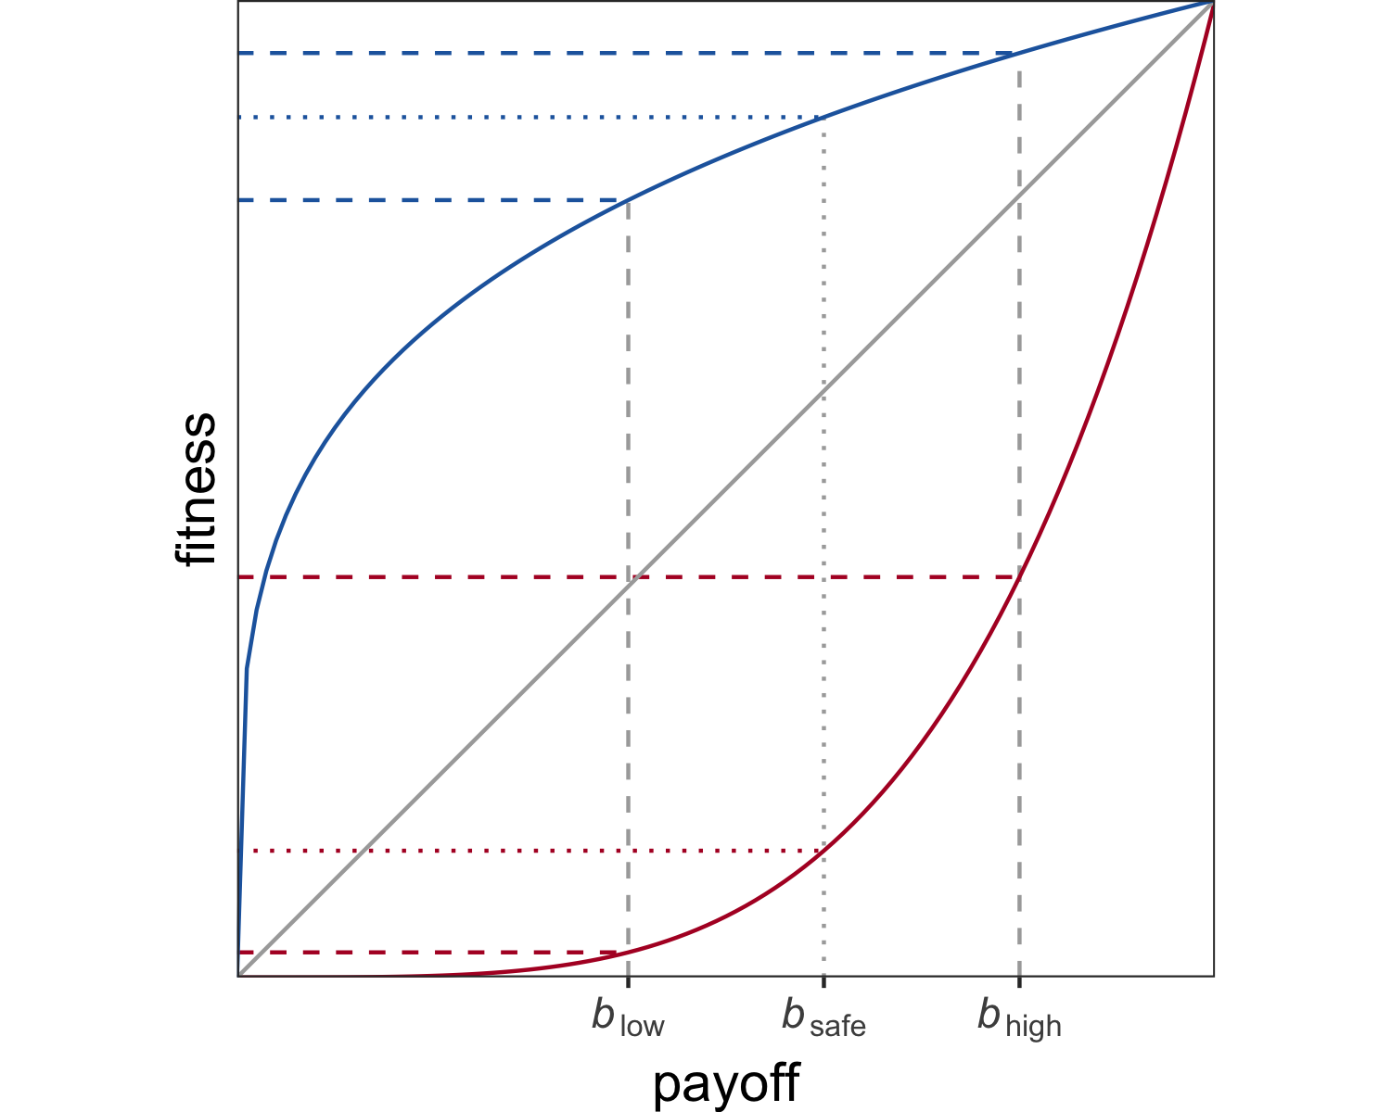
Figure 1. Consequences of non-linear fitness functions. Payoffs $b_{low}$, $b_{safe}$, and $b_{high}$ are converted into fitness with a diminishing (blue), linear (grey), or increasing (red) returns function.

Non-linear fitness functions.
The first and perhaps most ubiquitous factor leading individuals to be risk sensitive are non-linear relationships between behavioural outcomes (e.g., harvested food items, publications) and fitness (Kacelnik & Bateson, 1997). Consider two options, $O_{safe}$ and $O_{risky}$. $O_{safe}$ always gives the same payoff $b_{safe}$, whereas $O_{risky}$ gives either a low payoff $b_{low}$ or a high payoff $b_{high}$, each with probability $\frac{1}{2}$. When $b_{safe}=\frac{\left(b_{low}+b_{high}\right)}{2}$, $O_{safe}$ and $O_{risky}$ have the same expected payoff. However, an individual should be indifferent between the two options only if the consequences of their payoffs for fitness are linear. As illustrated in Figure 1, $O_{safe}$ provides greater expected fitness than $O_{risky}$ when the fitness function is concave (diminishing returns), but lower expected fitness when the function is convex (increasing returns). Preferences should thus shift towards risk aversion when returns are diminishing and towards risk proneness when returns are increasing.
Non-linear relationships are arguably the norm in the natural world and linear relationships the exception. This plausibly holds for academia as well: Any additional publication may have an accelerated effect on career success for early-career researchers, but seem negligible for established professors.

Number of decision events before evaluation.
A second risk-relevant factor is the number of decision events taking place before an individual’s fitness is evaluated. When a risky option is chosen repeatedly, the average of accumulating payoffs approaches the long-run expected payoff. The risky option then becomes relatively more attractive because the danger of only ever acquiring the lowest possible payoff diminishes. However, this only holds for repeated decisions before fitness is evaluated: When fitness is evaluated after a single decision event, extreme outcomes leading to zero fitness (i.e., death or an ultimate failure to reproduce) are more likely and risk-averse strategies may be more adaptive, even when risk-prone strategies produce better outcomes within any one generation (Haaland, Wright, & Ratikainen, 2019).
For the purpose of the present study, ‘decision events’ refer to researchers’ choices of whether to conduct a Registered Report or pursue the standard publication route. The number of decision events before evaluation reflects the number of empirical projects that a researcher can complete before their publication record is considered for hiring, promotion, or grant funding decisions. We call this parameter ‘empirical pace’. Empirical pace may differ between research areas that vary in the speed and cost of data collection (e.g., online questionnaires vs fMRI studies), between labs that vary in funding and manpower, and even between career stages, as seniority often comes with increased resources (R. Müller, 2014), while junior researchers face short contracts that limit the time for producing output before their next job application.
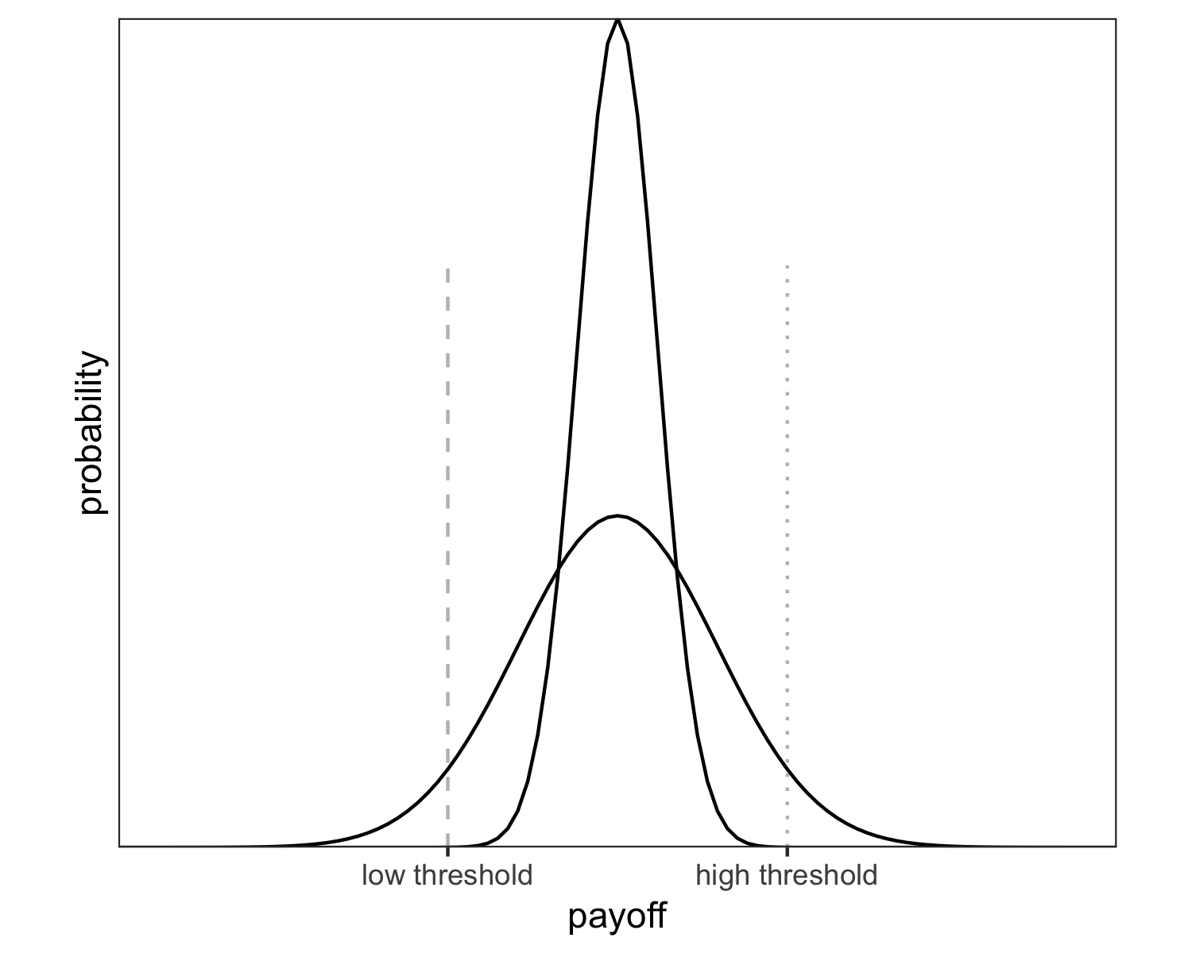
Figure 2. Survival thresholds. When fitness drops to zero below the low threshold (dashed line), the low-risk option (narrow distribution) reliably meets the threshold, favouring risk aversion. When fitness drops to zero below the high threshold (dotted line), only the high-risk option (wide distribution) offers a chance of passing the threshold, favouring risk proneness.

Survival thresholds and competition.
A final important factor for risk-sensitive behaviour are thresholds for survival and reproduction (Hurly, 2003; Winterhalder et al., 1999). Survival thresholds are cutoff points below which an individual’s fitness drops to zero, for example due to starvation. Individuals should be risk-averse when a low-variance option reliably meets the threshold, and risk-prone when only a higher-variance option offers a chance of reaching it (Figure 2).
Comparable cutoff points exist in academic careers: Publication records are explicit criteria in decisions such as being awarded a PhD (Altenberger, Leischik, Vollenberg, Ehlers, & Strauss, 2024; Muijrers, 2000), grant funding (Simsek, de Vaan, & van de Rijt, 2024; van den Besselaar & Leydesdorff, 2009), tenure-track hiring (van Dijk, Manor, & Carey, 2014), and promotion (Schimanski & Alperin, 2018). Some of these cut-offs are absolute (e.g., PhD regulations or tenure contracts specifying minimum publication numbers), while others are relative and depend on the pool of competitors (when a job goes to the best candidate, one individual’s success diminishes another’s chances). Such relative thresholds represent competition. In the following, survival thresholds (absolute) and competition (relative) are treated as separate concepts.

Simulation model
We develop an evolutionary agent-based model which simulates a population of researchers who test hypotheses, (attempt to) publish the results either as Registered Reports or as standard reports, accumulate the payoffs for successful publications, and pass their publication strategies on to the next generation of researchers.

Research phase.
Consider a population of $n=500$ researchers. Each researcher has a fixed publication strategy $s$, the so-called submission threshold. In each round of the research phase, researchers randomly choose a hypothesis to test in a study. Hypotheses are true with prior probability $p$, which is uniformly distributed between 0 and 1 and known to the researcher. Before testing their chosen hypothesis, a researcher compares the prior $p$ of their hypothesis with their publication strategy $s$. When $p<s$, the researcher chooses to play it safe and conduct a Registered Report to test the hypothesis. When $p≥s$, the researcher chooses to gamble and test the hypothesis in a regular study which is then submitted as a standard report.
For simplicity, we assume that $p$ is an ideal objective prior and that hypothesis tests are free from additional sources of error. Thus, when a researcher tests hypothesis $i$, they obtain a positive result with probability $p_{i}$ and a negative result with probability $1−p_{i}$. If the researcher chose to submit a Registered Report, their study is published regardless of the result and the researcher receives a payoff $b_{R}$. However, if the researcher chose to submit a standard report, they face rampant publication bias: Only positive results are publishable as standard reports and yield a payoff $b_{pos}=1$, whereas negative results are rejected or file-drawered and yield no payoff, $b_{neg}=0$.
For all variations of the model tested here, we assume that the payoff for a Registered Report falls between these bounds, such that $b_{neg}<b_{R}<b_{pos}$, for two reasons. First, publication bias makes negative standard reports less valuable than Registered Reports ($b_{neg}<b_{R}$): Negative results may not be published at all or require costly resubmissions and revisions in the standard route, whereas Registered Reports are published regardless of the results. Second, positive standard reports remain on average more valuable than Registered Reports ($b_{R}<b_{pos}$) because many high-impact journals do not yet offer Registered Reports, because the flexibility of the standard route allows authors to present results in ways that maximise impact, and because the stricter quality criteria of Registered Reports may increase costs and lower net rewards.
This entire research cycle — choosing a hypothesis, choosing a publication route by comparing its prior $p$ to one’s publication strategy $s$, testing the hypothesis, and receiving payoff $b_{R}$ for a Registered Report or $b_{neg}$ or $b_{pos}$ for a positive and negative standard report, respectively — is repeated $m$ times.

Evaluation phase.
At the end of the research phase, researchers’ accumulated publication payoffs $b_{1}+b_{2}+...+b_{m}$ are translated into fitness $f$. Fitness is calculated with a function characterised by exponent $ϵ$, which determines the shape of the function. $ϵ=1$ yields a linear function, $0<ϵ<1$ yields a concave function with diminishing returns, and $ϵ>1$ yields a convex function with increasing returns (illustrated in Figure 1):
$$\begin{matrix}f={\left(\sum_{i=1}^{m}{b_{i}}\right)}^{ϵ}\end{matrix}$$
However, two situations may cause a researcher’s fitness to fall to zero even when their accumulated payoffs are non-zero. First, the sum of their payoffs may fall below an absolute survival threshold $δ$, for example when a researcher fails to meet an agreed publication target by the time their ‘tenure clock’ runs out. Thus, when $\sum_{i=1}^{m}{b_{i}}<δ$, $f=0$. Second, the sum of their payoffs may fall below a relative threshold $γ$, which reflects the intensity of competition (e.g., for scarce research grants or positions). $γ$ is the proportion of researchers who are considered for reproduction. When $γ=1$, all researchers in the population are considered for reproduction and their fitness is calculated according to Eq. 1. When $γ<1$, the $\left(1−γ\right)*500$ least successful researchers receive zero fitness and cannot reproduce. For example, $γ=0.1$ means that only researchers with accumulated payoffs in the top $10\%$ of the population can reproduce.

Reproduction phase.
Finally, the researchers in the current population retire and a new (non-overlapping) generation of researchers is created. A researcher in the new generation inherits their publication strategy $s$ from a researcher in the previous generation with the probability of the previous researcher’s fitness (i.e., the new generation’s publication strategies are sampled with replacement from the previous generation, probability-weighted by fitness). The new generation’s publication strategies are inherited with a small amount of random noise, such that $s_{new}=s_{old}+w$, with $w∼N\left(μ=0,σ=0.01\right)$. Such hereditary transmission can be interpreted as social learning in which successful researchers are more likely to be imitated (Smaldino & McElreath, 2016; Tiokhin, Yan, & Morgan, 2021), but its primary purpose in the model is technical — it simply provides the machinery for determining which publication strategies are optimal under different conditions.
Parameter definitions
values
Parameter | Definition | Value [range]
$n$ | population size | 500
$g$ | number of generations | 250
$p$ | prior probability of hypotheses | uniform [0–1]
$b_{neg}$ | payoff for negative standard report | 0
$b_{pos}$ | payoff for positive standard report | 1
$b_{R}$ | payoff for Registered Report | [.1, .2, …, .9]
$ϵ$ | fitness function exponent | [0.2, 1, 5]
$m$ | research cycles per generation (‘empirical pace’) | [1, 2, 4, 8, 16, 32]
$δ$ | survival threshold below which fitness = 0, expressed as a proportion of $m$ | [0, .25, .5, .75]
$γ$ | proportion of most successful researchers selected for reproduction (competition) | [1, .9, .5, .1, .05, .01]

Outcome variable $s$.
We study how the evolution of researchers’ publication strategies $s$ is affected by $b_{R}$, $ϵ$, $m$, $δ$, and $γ$ (see Table 1). Importantly, $s$ is not an absolute decision but determines how the choice between formats is made, indicating the amount of risk a researcher is willing to take. Very low values of $s$ reflect risk proneness (the researcher nearly always gambles on standard reports, except when hypotheses have extremely low priors), and very high values reflect risk aversion (the researcher nearly always conducts Registered Reports, except when hypotheses have extremely high priors).

Simulation approach.
We use the evolutionary mechanism of this agent-based model as a means for identifying optimal behaviour under different conditions. One non-evolutionary alternative is to calculate expected fitness for a wide range of $s$ and determine which strategy maximises it in each condition. However, this approach cannot easily account for population dynamics and is thus poorly suited for simulating competition effects. We therefore base our study on the evolutionary model, but validate all non-competition analyses against the expected-fitness model and show that both produce virtually identical results (see Appendix).
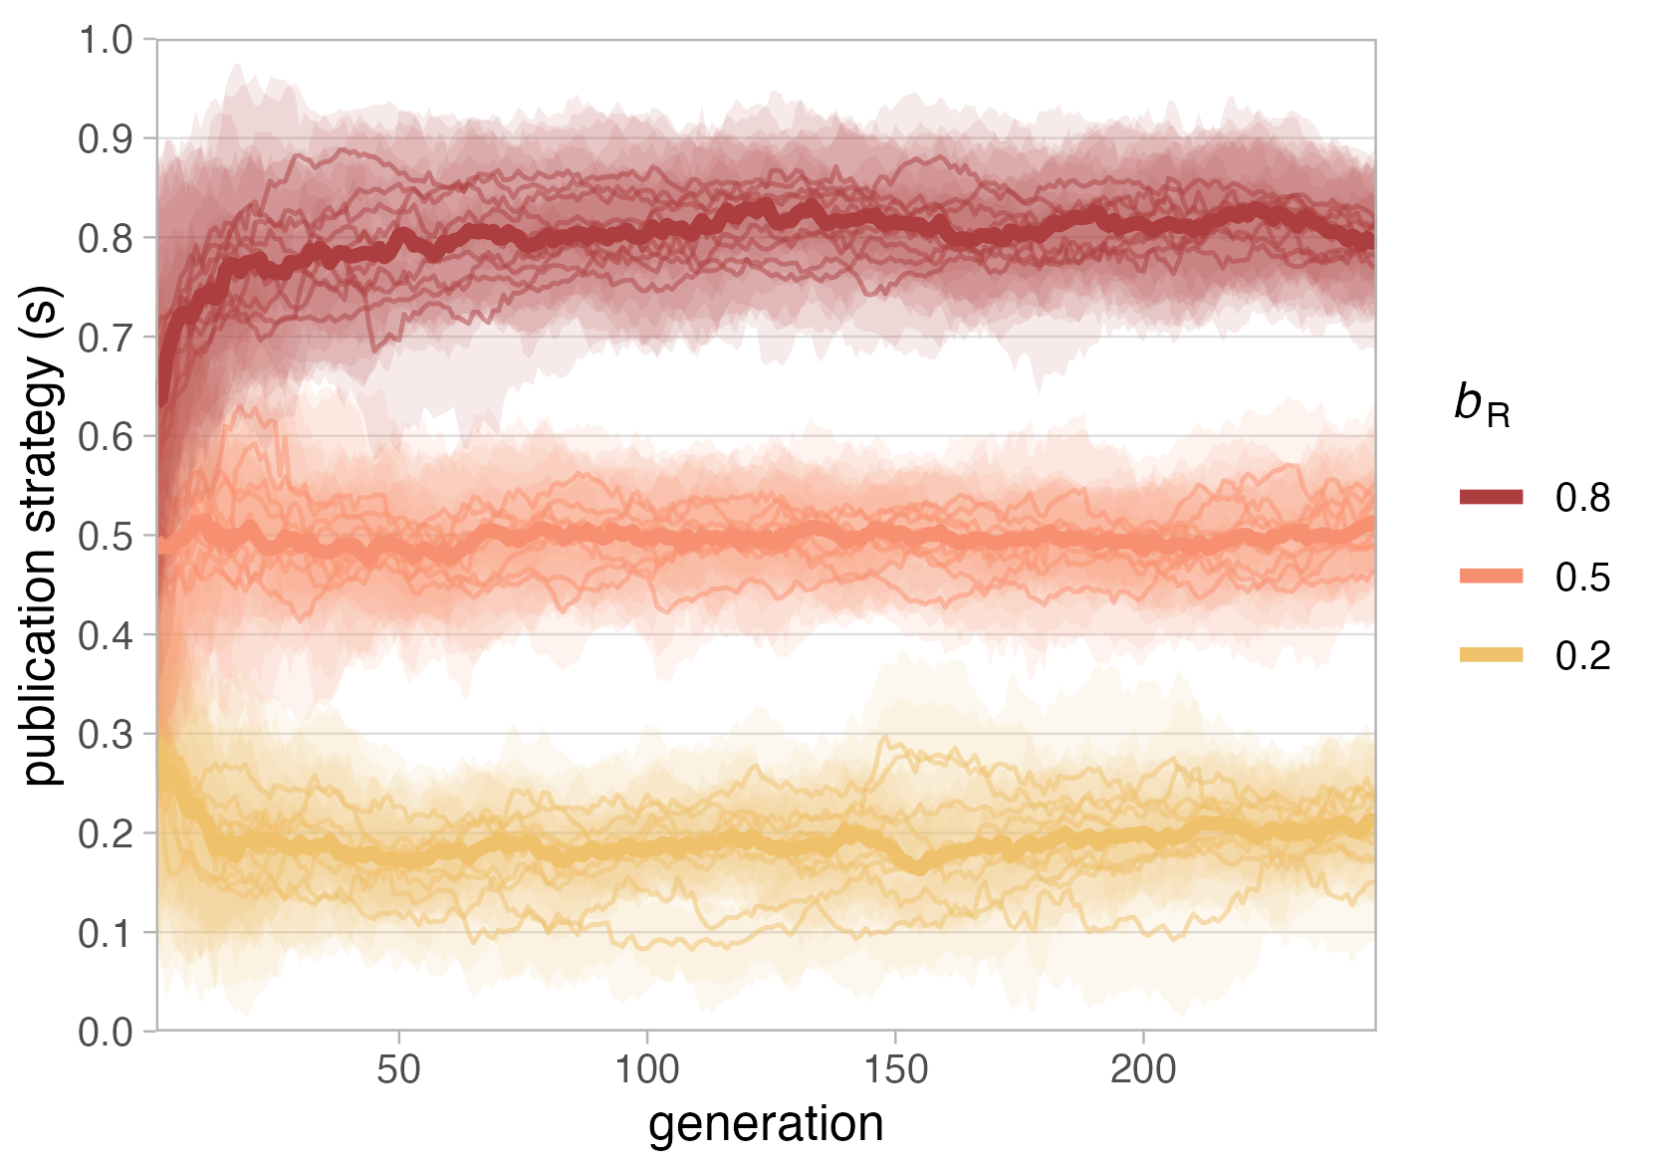
Figure 3. Evolution of publication strategy $s$ with 3 different payoffs for Registered Reports ($b_{R}$). Parameters: $n=500$, 250 generations, $b_{neg}=0$, $b_{pos}=1$, $ϵ=1$, $m=1$, $δ=0$, $γ=1$ (10 runs per condition). Thin lines: median population $s$ per run; shaded areas: inter-quartile range per run; thick lines: median of run medians per condition.

Simulation results
We present results in order of increasing model complexity, beginning with simple scenarios to explain the basic functioning of the model before moving to less intuitive results. The analysed parameter values are inherently arbitrary and do not represent real-world units; results are only meaningful in relation to each other.

Single research cycle per generation, linear fitness function
The first generation of researchers is initialised with randomly distributed publication strategies $s$ (uniform [0–1]), which are then allowed to evolve. Figure 3 shows the effect of varying $b_{R}$ with a linear fitness function ($ϵ=1$), no survival threshold ($δ=0$), no competition ($γ=1$), and one research cycle per generation ($m=1$). Evolved strategies approximate $b_{R}$ in each condition ($s_{optimal}=b_{R}$). The reason is that with a linear fitness function and payoffs $b_{neg}=0$, $b_{pos}=1$, the expected fitness from a standard report equals the prior of the tested hypothesis:
$$\begin{matrix}E\left[f_{SR}\right]={\left(p*b_{pos}+\left(1−p\right)*b_{neg}\right)}^{1}=p*1+\left(1−p\right)*0=p\end{matrix}$$
The optimal strategy is therefore to submit a Registered Report whenever $E\left[f_{SR}\right]<b_{R}$, i.e., whenever $p<b_{R}$. This ensures that researchers get the best of both worlds: when $b_{R}=0.5$, for instance, submitting Registered Reports for all hypotheses with $p<0.5$ protects against losing a bad bet, while gambling on standard reports for hypotheses with $p>0.5$ maximises winning chances. Every alternative is inferior because researchers with $s>b_{R}$ forgo winnable gambles and researchers with $s<b_{R}$ take unnecessary risks.
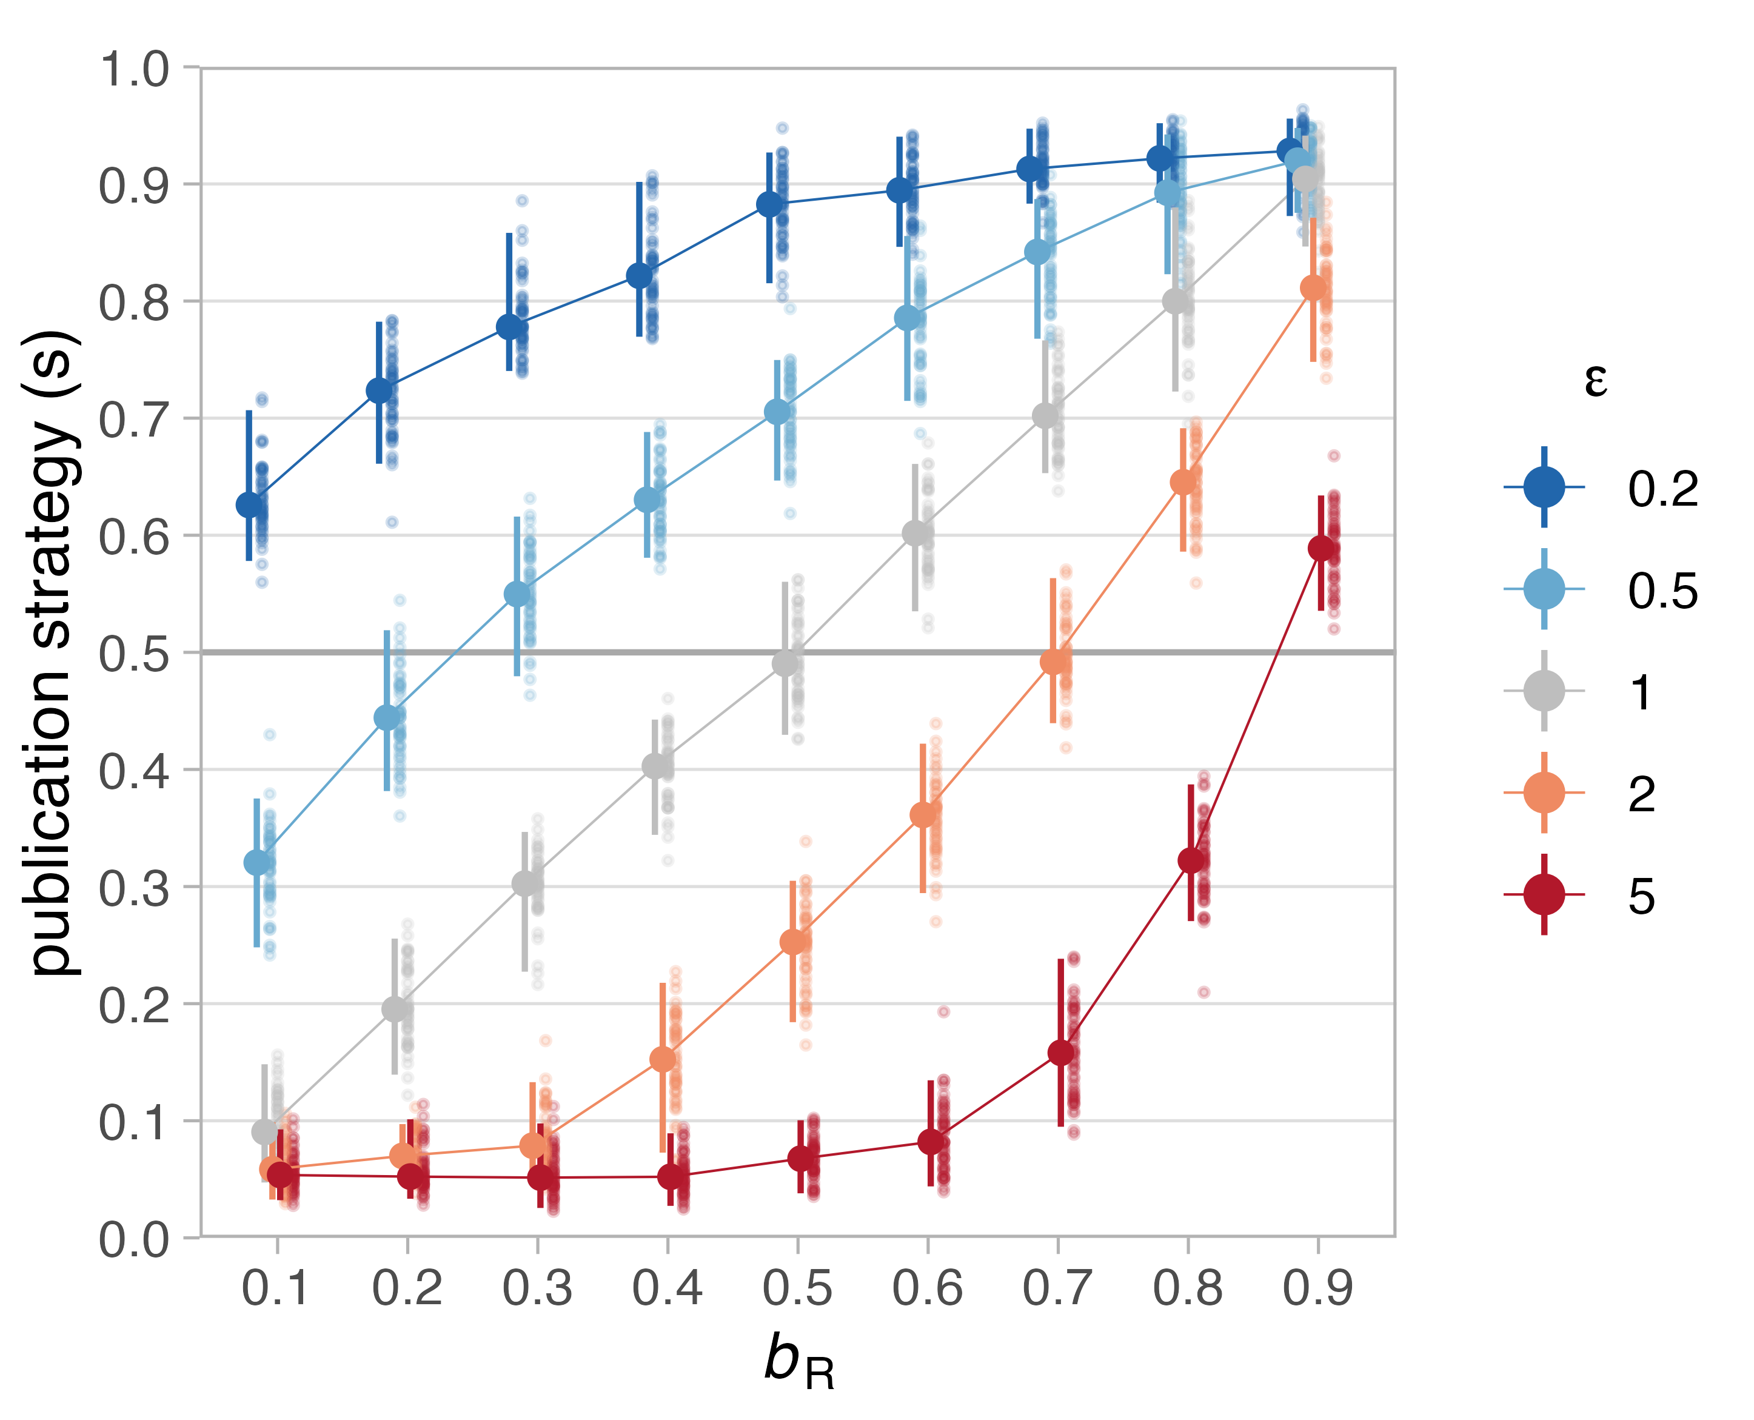
Figure 4. Effect of fitness functions on evolved publication strategies. Median publication strategies after 250 generations (50 runs) for different values of $b_{R}$ and fitness functions ($ϵ$), with $m=1$, $δ=0$, $γ=1$. Blue lines: concave (diminishing returns, $ϵ=0.2$ and $0.5$); red lines: convex (increasing returns, $ϵ=2$ and $5$); grey: linear ($ϵ=1$). Large dots: median of 50 run medians; error bars: $95\%$ capture probability around median of medians.

Allowing for non-linear fitness functions
Arguably, the career benefits researchers receive from publications in the real world are rarely, if ever, linear. In early career, we may assume a convex fitness function, with each addition to the short publication record of a young researcher yielding increasing returns for their prospects on the job market and their ability to obtain grant funding. A notable exception may be PhD students who plan to leave academia after their degree, and for whom the career returns of publications exceeding the PhD requirements are strongly decreasing (concave fitness function). Researchers who stay in academia may experience that the career returns for each additional publication decrease as their publication record grows, meaning that advanced career stages may also be characterised by a concave fitness function.
Figure 4 contrasts the effects of two concave and two convex fitness functions with a linear function for different payoffs for Registered Reports, in the same simple scenario with only one research cycle per generation. Non-linear fitness functions deviate from the linear baseline ($s_{optimal}=b_{R}$) exactly as expected: When additional payoffs yield diminishing returns ($ϵ<1$), Registered Reports become more attractive even when worth less than the expected payoff for standard reports (risk aversion). Conversely, when additional payoffs yield increasing returns ($ϵ>1$), Registered Reports are unattractive unless their payoffs are almost as large as those for published standard reports (risk proneness).
When different fitness functions are taken to reflect different career stages, this pattern suggests that Registered Reports should be more attractive for senior researchers and a tough sell for early-career researchers. Interestingly, preliminary empirical evidence suggests the opposite: Registered Reports appear to be more likely to have early-career researchers as first authors than standard reports (77% vs 67% in the journal Cortex, Chambers & Tzavella, 2022). This could reflect factors not captured in our model (e.g., younger researchers being more likely to adopt new methods) or the fact that some early-career researchers intend to leave academia and thus have a concave fitness function. Another interesting possibility is that before obtaining their PhD, early-career researchers have not yet been subject to the selection pressures that our model simulates. Many junior researchers’ publication strategies may thus be poorly adapted to the system, but have not yet led to failure because their publication success has never been assessed. If true, this would imply that the results of our model are more valid for mid-career and senior researchers, who have undergone (and passed) several selection events. However, as we will see below, the effects of different fitness functions produce more complicated results in interaction with other risk-related factors.
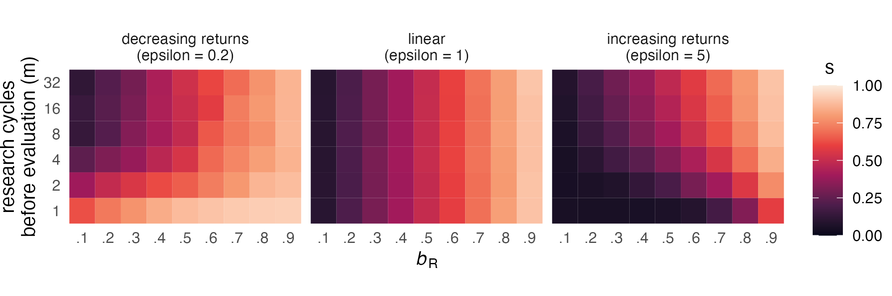
Figure 5. Effect of empirical pace on evolved publication strategies. Tile colour represents median $s$ of 50 run medians after 250 generations depending on research cycles per generation ($m$), $b_{R}$, and fitness function ($ϵ$), with $δ=0$ and $γ=1$.

Varying the number of research cycles per generation (empirical pace)
Increasing numbers of decision events prior to evaluation may make individuals more risk-prone because single negative outcomes are less catastrophic (Haaland et al., 2019). However, Figure 5 shows that this is not universally true — rather, the effect of $m$ depends on the shape of the fitness function. Moving up on the y-axis of each panel, $s$ decreases (greater risk proneness) only when the fitness function is concave ($ϵ=0.2$, left panel) but stays constant when it is linear ($ϵ=1$, middle panel) and even increases when it is convex ($ϵ=5$, right panel).
Why does $m$ appear to have opposite effects for concave and convex fitness functions? At $m=1$ (bottom rows), the panels show risk aversion for $ϵ=0.2$, risk proneness for $ϵ=5$, and a linear strategy for $ϵ=1$. As $m$ increases, both non-linear panels converge towards the linear case, reflecting the idea that fitness is better captured by the geometric mean when $m$ is low and by the arithmetic mean when $m$ is high (Haaland et al., 2019).
To illustrate this dynamic, consider two researchers with extreme strategies: Regina Register conducts only Registered Reports ($s=1$), Darren Daring conducts only standard reports ($s=0$), with $b_{R}=0.5$. With $m=1$ and $ϵ=0.2$, Regina’s fixed payoff of 0.5 converts to fitness ${0.5}^{0.2}≈0.87$, while Darren’s payoff is 0 or 1 with equal probability (fitness 0 or 1). In a population of 100 Reginas and 100 Darrens, roughly 50 lucky Darrens will narrowly beat all Reginas (1 vs 0.87), while 50 unlucky Darrens are far behind (0 vs 0.87). On average, the Regina strategy is thus more successful. But as $m$ increases, Darrens are no longer split between two extreme outcomes. The law of large numbers causes Darrens’ total payoffs to cluster around the same average as Reginas’, making extreme outcomes rare and optimal strategies converge to the linear case. The same logic applies in reverse when $ϵ=5$, where Reginas start at a disadvantage ($f={0.5}^{5}≈0.03$) but Darrens’ average payoffs approximate Reginas’ as $m$ increases. Consequently, the top rows ($m=32$) of the non-linear panels in Figure 5 resemble the linear case.
In terms of academic careers, this pattern indicates that higher empirical pace — e.g., from fast and cheap data collection or greater resources — can cancel out the effects of different career stages. This could partly explain why Registered Reports appear to be less popular among senior researchers (Chambers & Tzavella, 2022) than the effects of diminishing returns alone would predict: academic seniority often comes with resources that boost output per time. Conversely, junior researchers may be especially reluctant to use Registered Reports when they have very limited time or resources before an important selection event, such as on short-term postdoc contracts (R. Müller & de Rijcke, 2017).
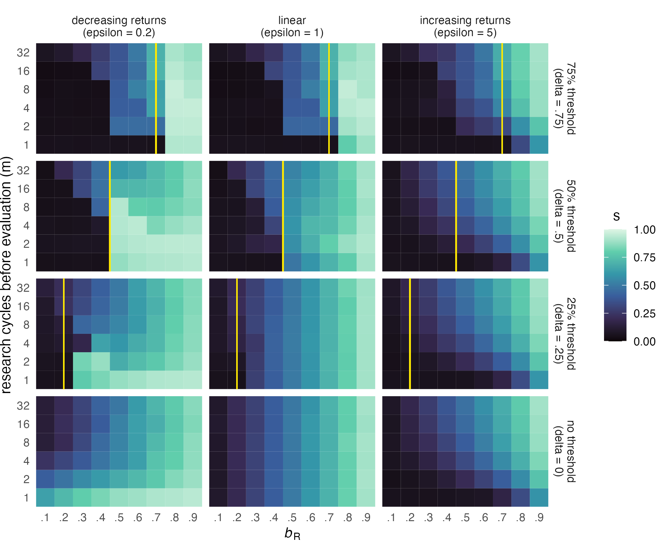
Figure 6. Effect of survival thresholds on evolved publication strategies. Tile colour as in Fig. 5, depending on survival threshold ($δ$, shown as vertical yellow line), $ϵ$, $m$, and $b_{R}$, with $γ=1$. Thresholds are set as a proportion of $m$; to reproduce, researchers must accumulate a total payoff exceeding $δ*m$.

Absolute survival thresholds
The survival thresholds ($δ$) in our model represent absolute publication targets, such as PhD regulations requiring a minimum number of published thesis chapters (Altenberger et al., 2024; Muijrers, 2000) or tenure agreements specifying minimum numbers of publications (Liner & Sewell, 2009; Schimanski & Alperin, 2018).
We investigate thresholds of 25%, 50%, and 75% of the maximum possible payoff per generation. When $δ>b_{R}$, Registered Reports alone cannot meet the threshold ($b_{R}$ values to the left of the yellow line in Figure 6). For example, at $m=4$ and $δ=.75$, researchers need at least 3 points; four Registered Reports with $b_{R}=.7$ yield only 2.8 points, but with $b_{R}=.8$ they yield 3.2 and ensure reproduction. One may thus expect Registered Reports to be popular whenever $δ≤b_{R}$ and unpopular otherwise.
Figure 6 shows that this holds in many, but not all conditions. Survival thresholds have the biggest effect when $m$ is low. At high values of $m$, publication strategies are virtually unaffected. The effects are also stronger when the fitness function is linear or concave. In these conditions, the Registered Report route is almost never chosen when $b_{R}$ is too low to meet the threshold, and this effect tapers off as $m$ increases. The change is particularly striking for the concave fitness function ($ϵ=0.2$), where Registered Reports are normally preferred at low $m$. When the threshold is high or the fitness function concave, Registered Reports become more popular than baseline when they are worth just enough to pass the threshold. For the convex fitness function ($ϵ=5$), only a high threshold of 75% has a visible effect, making Registered Reports even less popular when they have low value ($b_{R}<.04$), especially at low $m$.
In real-world terms, survival thresholds are almost irrelevant when empirical pace is high. Researchers with a convex fitness function (e.g., PhD candidates pursuing an academic career) are only affected by high thresholds, which lead them to choose Registered Reports even less often than normal when their value is low. Researchers with a concave fitness function (e.g., tenure candidates) are highly sensitive to $b_{R}$: They virtually never conduct Registered Reports when $b_{R}$ is too low to meet the threshold, but strongly prefer them when it is sufficient.
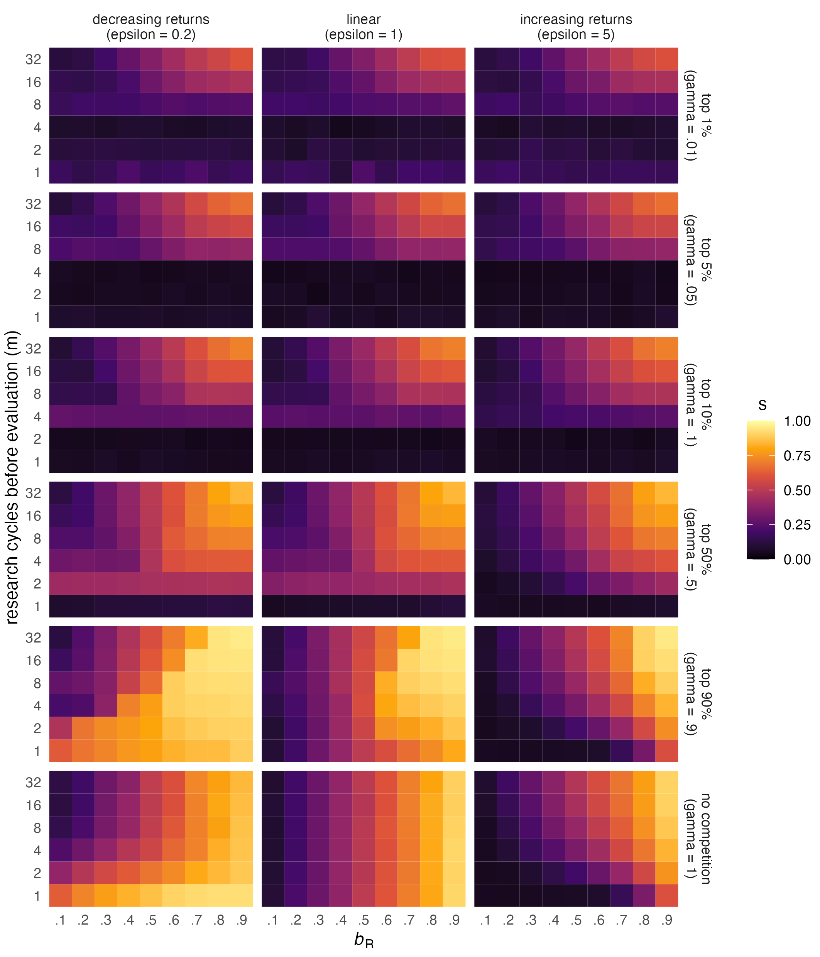
Figure 7. Effect of competition on evolved publication strategies. Tile colour as in Fig. 5, depending on competition intensity ($γ$), $m$, $b_{R}$, and $ϵ$, with $δ=0$.

Competition
Competition occurs whenever the demand for academic positions or grant funding exceeds the supply. Figure 7 shows that competition generally leads to an avoidance of Registered Reports, as can be seen by the darkening of the plots when moving up from the bottom row of panels. The only exception to this rule is very low competition: When the top 90% are allowed to reproduce (and only the bottom 10% are rejected, $γ=.9$), Registered Reports become more popular than they are in the absence of competition. This effect is strongest for the concave fitness function ($ϵ=0.2$), where it holds for almost all values of $b_{R}$ at very low numbers of $m$ and for high values of $b_{R}$ at high numbers of $m$. When the fitness function is linear or convex, Registered Reports are chosen more often only when both $b_{R}$ and $m$ are high.
At higher levels of competition ($γ>.5$), the differences between the fitness functions disappear. In all three cases, Registered Reports are essentially wiped out for low numbers of research cycles ($m$), and this effect increases with competition (the higher the competition, the higher $m$ must be for Registered Reports to remain viable at all). Intense competition also negatively affects Registered Reports at high numbers of $m$, but here the general pattern of the baseline condition (a linear increase of Registered Reports popularity with $b_{R}$) remains intact.
In the academic world, researchers compete for tenured positions and grants, and the intensity of competition varies across fields, countries, grant programmes, etc. Our findings suggest that intense competition may be a significant threat for the viability of Registered Reports, regardless of career stage. This effect is particularly extreme when empirical pace is low. In such situations, strategies involving Registered Reports are only viable when competition is so extreme that success requires extraordinary luck. In contrast, very low but non-zero competition increases the popularity of Registered Reports, especially when their value is high or the fitness function is concave.

Discussion
In our model, the standard publication route is a coin toss — the probability of obtaining a publishable result is 50% on average, translating to an expected payoff of 0.5 per study. One might expect payoff-maximising researchers to prefer Registered Reports whenever they are worth more than this expected payoff. This intuition, however, rests on the assumption that career benefits from publications are linear and involve no step changes. We argue that this assumption is violated in many, if not all, real-world situations. Our results show that when it is, many configurations would lead career-maximising researchers to avoid Registered Reports even when they are worth more than the expected payoff from standard reports.
To summarise, it is useful to take the middle panel of Figure 5 ($ϵ=1$) as a baseline, where preferences are exactly proportional to $b_{R}$ and unaffected by empirical pace. Compared to this baseline, Registered Reports are less popular when a) additional publications yield increasing returns and empirical pace is low, b) researchers face a survival threshold that cannot be met with Registered Reports alone, especially with decreasing returns and low empirical pace, and c) when there is substantial competition (the most extreme effect, causing complete avoidance at low empirical pace). Conversely, Registered Reports are more popular when a) returns are decreasing and empirical pace is low, b) $b_{R}$ is just high enough to reach a survival threshold and returns are decreasing, especially with low empirical pace, and c) competition is very low but non-zero, especially with decreasing returns or high empirical pace.
Three interaction effects stand out. First, high empirical pace attenuates the effects of all other factors, with high competition as the only exception. Second, the effect of survival thresholds depends strongly on the fitness function, suggesting that publication targets may hit hardest in advanced career stages. Third, the opposite is true for competition, which cancels out fitness-function differences and thus affects all career stages equally.

Implications
Our model predicts Registered Reports to be least popular when low empirical pace is combined with intense competition or with publication targets that cannot be met with Registered Reports alone. Translated to real-world academia, this suggests that fields or labs in which productivity is limited by lacking resources or the cost or speed of data collection (e.g., research relying on expensive or rare equipment, research on populations that are difficult to access) deserve special attention. Researchers in such situations may avoid Registered Reports when they must achieve publication targets that ask for a minimum number of publications in high-impact journals (e.g., as part of a tenure agreement), or when facing substantial competition for job positions or pressure to obtain competitive grants (e.g., if salary or research time depend on bringing in grants). When competition is high, such researchers may favour standard reports even if Registered Reports are almost as valuable as the best possible outcome from a standard report. Given that the last decades have seen vast increases in PhD students but relatively stable numbers of tenured positions in many countries (Cyranoski, Gilbert, Ledford, Nayar, & Yahia, 2011), substantial competition may in fact be the default in many research fields, which could be one explanation for the currently low market share of Registered Reports.

Possible interventions to increase the popularity of Registered Reports.
What would make Registered Reports more attractive? With the exception of tenure agreements and PhD regulations, the situational factors that suppress their popularity in our model — competition and empirical pace — are difficult to change. A more feasible approach is to change the payoff structure of Registered Reports relative to standard reports. Because we treat payoffs as net values (benefits minus costs), the payoff for Registered Reports can be raised by increasing their benefits, lowering their costs, or increasing their payoff variance, each relative to standard reports.

Increasing the benefits of Registered Reports.
Author benefits associated with journal prestige and impact could be raised if more high-impact journals offered the format. Such journals may currently be reluctant for fear of being forced to publish studies with ‘uninteresting’ results, and even when offering the format, may be prohibitively selective during Stage-1 review. Perhaps reflecting such dynamics, the journal Nature launched a Registered-Reports track in February 2023 (Nature, 2023) but appears to have published at most one Registered Report by August 2024. Journals willing to support the format should thus design editorial processes that, if ambitious, do not set unrealistic standards.
The value of Registered Reports can also be raised by faculty committees responsible for hiring and promotion. Placing a premium on Registered Reports in tenure agreements and hiring processes could increase their attractiveness substantially, in line with recent calls for emphasising rigorous methods in academic evaluation (e.g., Moher et al., 2018; Schönbrodt et al., 2018). Explicitly highlighting Registered Reports in job ads and weighting them more heavily than (even preregistered) standard reports could therefore be a promising strategy.

Decreasing the costs of Registered Reports.
Registered Reports may be more costly due to the additional stage of peer review and stricter requirements for methodological rigour and sample size. Since many of these are ‘good costs’ that increase the quality of the resulting publications (see also Tiokhin et al., 2021), cost-cutting should be confined to removing unnecessary inefficiencies. Alternatively, costs can be decreased in relative terms: Journals could plausibly demand the same methodological rigour from standard reports as from Registered Reports, reducing the marginal advantage of the standard route.

Increasing payoff variance.
In the classic Registered Reports model, the pre-data publication guarantee caps not only the worst possible outcome but also the best, because authors must choose a journal before knowing the value of the study. Another approach is to remove this upper cap. In April 2021, the platform Peer Community In (PCI) introduced a journal-independent Registered Reports model in which the review process yields a ‘recommended’ preprint rather than a commitment to a specific journal. Authors are then free to publish in one of several PCI-partnered journals or submit their manuscript to any other journal, which retains the chance of a high-impact publication. As of March 2026, 41 journals accept PCI-recommended Registered Reports without further review. With the growth of this list, and particularly the inclusion of more high-impact journals, the PCI model has the potential to change the incentive structure of the format in a profound way.

Limitations and future directions
By design, our model simplifies and exaggerates some aspects of real-world academia and ignores many others. First, we use an extreme, one-dimensional concept of publication bias: all positive results are published, all negative results remain unpublished, and results are determined only by the prior probability of the hypotheses. Real-world publication decisions of course depend on many other factors as well (and many not always favour positive results). Another approach is to model publication bias as favouring results that shift prior beliefs (Gross & Bergstrom, 2021). Compared to this alternative, our model allows a conservative interpretation in which the prior probability of hypotheses simply reflects authors’ predictions of the eventual publication value of different research questions. This interpretation is congruent with Registered Reports and standard reports differing in risk, because publication value depends more strongly on the study results in standard reports than in Registered Reports.
Second, we assume that authors have perfect knowledge of the probability that they will obtain positive (or publishable) results. The assumption that authors have some prior knowledge of likely study outcomes is the starting point of our study, because it enables strategic publication behaviour. As long as this assumption holds, adding noise and even bias to authors’ priors would have a diluting effect, but should leave the general pattern simulation pattern intact. More interesting complications arise with individual differences: In our model, researchers who are better at predicting publishability would outperform their peers. In reality, though, certain biases may actually be beneficial, for example if overconfident individuals are also better at convincing editors and reviewers of the value of their work.
Third, researchers in the model cannot choose which hypotheses to test, whereas real researchers routinely choose their own research questions. Researchers who are skilled at identifying hypotheses that are more likely to yield high-impact publications may find Registered Reports less attractive. This would be an example of ability-based risk taking: Individuals with traits or abilities that increase their expected payoff from a risky option should be more risk-prone (Barclay, Mishra, & Sparks, 2018). A more concerning version of this idea is that Registered Reports may be relatively unpopular among researchers inclined to use questionable research practices (or even fraud).
Fourth, we assume that researchers work alone, whereas most real-world publication decisions are made by teams of researchers with different career-related needs. For example, senior researchers may take their PhD students’ needs into account, effectively behaving more in line with a convex fitness function. Real-world strategies can thus be mixtures of the individual strategies in our model. A related consideration is that researchers may compensate for low empirical pace by forming larger teams, sharing payoffs from a limited number of projects. Such behaviour could cause strategies in fields with slow or costly data collection to resemble those expected under higher empirical pace.
Finally, our model ignores publication delays. Because humans discount delayed rewards (Odum et al., 2020), researchers who perceive the standard route as faster may show a stronger preference for it than our model predicts.
Finally, our model ignores publication delays. A common concern is that Registered Reports take longer to publish because authors must await Stage-1 review before collecting data. Standard reports, on the other hand, may have greater delay variance because delays through rejection at multiple journals or reviewer demands for additional studies may create a longer distribution tail. Formats differences in delay mean or variance could affect researchers’ behaviour, in particular because humans discount delayed rewards (Odum et al., 2020). Researchers who perceive the standard route as faster may prefer it more strongly than our model predicts. Data on the actual distribution of publication delays for both formats, and on researchers’ beliefs about these delays, would be valuable for investigating this possibility.

Conclusion
Registered Reports are currently the most convincing proposal for curbing publication bias because they ‘[align] what is beneficial for individual scientists with what is beneficial for science’ (Chambers & Tzavella, 2022, p. 29). However, the incentives for choosing the format in the first place may be less well aligned with the interests of scientists. We examined how the pre-data publication guarantee — which reduces the variance of publication outcomes for authors — affects the attractiveness of Registered Reports under different conditions. Our results show that many common features of the academic ecosystem, such as publication targets and competition for tenured positions, promote risk-prone strategies and may lead researchers to avoid the format.
This suggests that the spread of Registered Reports is not simply a matter of time. In psychology, where the format is most popular, a generous estimate puts the annual rate of published Registered Reports at less than $0.1\%$ of the literature — much lower than the estimated $7\%$ prevalence of preregistration (Hardwicke et al., 2024), despite both reforms being introduced around the same time. Increasing uptake may require additional interventions, such as increasing the value of Registered Reports in hiring and tenure decisions, raising methodological requirements for standard reports, or supporting the journal-independent PCI Registered Reports model. To the extent that scientific communities have a demand the kind of low-bias, high-quality evidence that Registered Reports can offer, such measures may be a worthwhile investment.

Disclosures

Data, materials, and online resources.
Simulated data, code for reproducing all simulations and figures, and the Appendix are available at github.com/amscheel/rr-model. This manuscript was created using RStudio (RStudio 2026.01.1+403, RStudio Team, 2019), R (Version 4.5.2; R Core Team, 2019) and the R-packages bookdown (Version 0.46; Xie, 2016), data.table (Version 1.18.2.1; Barrett et al., 2024), ggplot2 (Version 4.0.2; Wickham, 2016), here (Version 1.0.2; K. Müller, 2017), knitr (Version 1.51; Xie, 2015), papaja (Version 0.1.4; Aust & Barth, 2018), rmarkdown (Version 2.30; Xie, Allaire, & Grolemund, 2018), stringr (Version 1.6.0; Wickham, 2023), and tinylabels (Version 0.2.5; Barth, 2022).

Model development and reporting.
The development of the simulation model and the analysis of the simulated data were not preregistered. We report all substantive versions of the model and all parameters that were considered. Parameter values other than those reported here were considered for all parameters except for the prior probability of hypotheses and the payoffs for standard reports and Registered Reports. The values used in the final version of the model were chosen to maximise information value while keeping the number of factor level combinations to a manageable amount. None of the omitted parameter values produced results that contradict the reported results and conclusions. Interested readers are invited to explore alternative settings using the open model code.

Author Contributions.
Conceptualisation: A.S., L.T., & D.L.; data curation, formal analysis, and software: A.S. & L.T.; investigation, methodology, and validation: A.S. & T.L; supervision: T.L. & D.L.; visualisation and writing — original draft: A.S; writing — review and editing: A.S., T.L., & D.L.

Conflicts of Interest.
The authors declare that they have no conflicts of interest with respect to the authorship or the publication of this article.

Acknowledgements.
This work was funded by VIDI grant 452-17-013. We thank Julia Rohrer, Wybo Houkes, and Chris Chambers for valuable comments that helped improve this manuscript.

References
Allen, C., & Mehler, D. M. A. (2019). Open science challenges, benefits and tips in early career and beyond. PLOS Biology, 17(5), e3000246. https://doi.org/10.1371/journal.pbio.3000246
Altenberger, S., Leischik, R., Vollenberg, R., Ehlers, J. P., & Strauss, M. (2024). A comparative analysis of the doctoral regulations at the medical faculties in Germany. International Journal of Medical Sciences, 21(4), 732–741. https://doi.org/10.7150/ijms.92167
Aslett, K., Sanderson, Z., Godel, W., Persily, N., Nagler, J., & Tucker, J. A. (2024). Online searches to evaluate misinformation can increase its perceived veracity. Nature, 625(7995), 548–556. https://doi.org/10.1038/s41586-023-06883-y
Atkinson, D. R., Furlong, M. J., & Wampold, B. E. (1982). Statistical significance, reviewer evaluations, and the scientific process: Is there a (statistically) significant relationship? Journal of Counseling Psychology, 29(2), 189–194. https://doi.org/10.1037/0022-0167.29.2.189
Aust, F., & Barth, M. (2018). papaja: Create APA manuscripts with R Markdown.
Barclay, P., Mishra, S., & Sparks, A. M. (2018). State-dependent risk-taking. Proceedings of the Royal Society B: Biological Sciences, 285(1881), 20180180. https://doi.org/10.1098/rspb.2018.0180
Barrett, T., Dowle, M., Srinivasan, A., Gorecki, J., Chirico, M., & Hocking, T. (2024). Data.table: Extension of ‘data.frame‘. Retrieved from https://CRAN.R-project.org/package=data.table
Barth, M. (2022). tinylabels: Lightweight variable labels. Retrieved from https://cran.r-project.org/package=tinylabels
Ceausu, S., Borda-de-Água, L., Merckx, T., Sossai, E., Sapage, M., Miranda, M., & Pereira, H. M. (2018). High impact journals in ecology cover proportionally more statistically significant findings. bioRxiv. https://doi.org/10.1101/311068
Chalmers, I., & Glasziou, P. (2009). Avoidable waste in the production and reporting of research evidence. The Lancet, 374(9683), 86–89. https://doi.org/10.1016/S0140-6736(09)60329-9
Chambers, C. D. (2013). Registered reports: A new publishing initiative at Cortex. Cortex, 49, 606–610. https://doi.org/10.1016/j.cortex.2012.12.016
Chambers, C. D. (2021). Registered Reports. Virtual conference.
Chambers, C. D., Dienes, Z., McIntosh, R. D., Rotshtein, P., & Willmes, K. (2015). Registered Reports: Realigning incentives in scientific publishing. Cortex, 66, 1–2. https://doi.org/10.1016/j.cortex.2015.03.022
Chambers, C. D., & Tzavella, L. (2022). The past, present and future of Registered Reports. Nature Human Behaviour, 6(1), 29–42. https://doi.org/10.1038/s41562-021-01193-7
Cyranoski, D., Gilbert, N., Ledford, H., Nayar, A., & Yahia, M. (2011). Education: The PhD factory. Nature, 472(7343), 276–279. https://doi.org/10.1038/472276a
Ensinck, E., & Lakens, D. (2023). An Inception Cohort Study Quantifying How Many Registered Studies are Published. PsyArXiv. https://doi.org/10.31234/osf.io/5hkjz
Ferguson, C. J., & Heene, M. (2012). A Vast Graveyard of Undead Theories: Publication Bias and Psychological Science’s Aversion to the Null. Perspectives on Psychological Science, 7(6), 555–561. https://doi.org/10.1177/1745691612459059
Franco, A., Malhotra, N., & Simonovits, G. (2014). Publication bias in the social sciences: Unlocking the file drawer. Science, 345(6203), 1502–1505. https://doi.org/10.1126/science.1255484
Fraser, H., Parker, T., Nakagawa, S., Barnett, A., & Fidler, F. (2018). Questionable research practices in ecology and evolution. PLOS ONE, 13(7), e0200303. https://doi.org/10.1371/journal.pone.0200303
Gopalakrishna, G., Wicherts, J. M., Vink, G., Stoop, I., Akker, O. R. van den, Riet, G. ter, & Bouter, L. M. (2022). Prevalence of responsible research practices among academics in The Netherlands. 11(471). https://doi.org/10.12688/f1000research.110664.2
Gross, K., & Bergstrom, C. T. (2021). Why ex post peer review encourages high-risk research while ex ante review discourages it. Proceedings of the National Academy of Sciences, 118(51). https://doi.org/10.1073/pnas.2111615118
Haaland, T. R., Wright, J., & Ratikainen, I. I. (2019). Bet-hedging across generations can affect the evolution of variance-sensitive strategies within generations. Proceedings of the Royal Society B. https://doi.org/10.1098/rspb.2019.2070
Hardwicke, T. E., Thibault, R. T., Clarke, B., Moodie, N., Crüwell, S., Schiavone, S. R., … Vazire, S. (2024). Prevalence of transparent research practices in psychology: A cross-sectional study of empirical articles published in 2022. OSF. https://doi.org/10.31234/osf.io/t2zs9
Higginson, A. D., & Munafò, M. R. (2016). Current Incentives for Scientists Lead to Underpowered Studies with Erroneous Conclusions. PLOS Biology, 14(11), e2000995. https://doi.org/10.1371/journal.pbio.2000995
Hurly, A. T. (2003). The twin threshold model: Risk-intermediate foraging by rufous hummingbirds, Selasphorus rufus. Animal Behaviour, 66(4), 751–761. https://doi.org/10.1006/anbe.2003.2278
John, L. K., Loewenstein, G., & Prelec, D. (2012). Measuring the Prevalence of Questionable Research Practices With Incentives for Truth Telling. Psychological Science, 23(5), 524–532. https://doi.org/10.1177/0956797611430953
Kacelnik, A., & Bateson, M. (1996). Risky Theories—The Effects of Variance on Foraging Decisions. Integrative and Comparative Biology, 36(4), 402–434. https://doi.org/10.1093/icb/36.4.402
Kacelnik, A., & Bateson, M. (1997). Risk-sensitivity: Crossroads for theories of decision-making. Trends in Cognitive Sciences, 1(8), 304–309. https://doi.org/10.1016/s1364-6613(97)01093-0
Liner, G. H., & Sewell, E. (2009). Research requirements for promotion and tenure at PhD granting departments of economics. Applied Economics Letters. https://doi.org/10.1080/13504850701221998
Mahoney, M. J. (1977). Publication Prejudices: An Experimental Study of Confirmatory Bias in the Peer Review System. Cognitive Therapy and Research, 1(2), 161–175. https://doi.org/10.1007/BF01173636
Miller, A. N., Taylor, S. G., & Bedeian, A. G. (2011). Publish or perish: Academic life as management faculty live it. Career Development International, 16(5), 422–445. https://doi.org/10.1108/13620431111167751
Mishra, S. (2014). Decision-Making Under Risk: Integrating Perspectives From Biology, Economics, and Psychology. Personality and Social Psychology Review, 18(3), 280–307. https://doi.org/10.1177/1088868314530517
Moher, D., Naudet, F., Cristea, I. A., Miedema, F., Ioannidis, J. P. A., & Goodman, S. N. (2018). Assessing scientists for hiring, promotion, and tenure. PLOS Biology, 16(3), e2004089. https://doi.org/10.1371/journal.pbio.2004089
Muijrers, J. (2000). Same degree, same effort? A patchwork of differing PhD requirements throughout Europe disadvantages graduate students and compromises the quality of science. EMBO Reports, 1(6), 463–464. https://doi.org/10.1093/embo-reports/kvd119
Müller, K. (2017). Here: A simpler way to find your files.
Müller, R. (2014). Postdoctoral Life Scientists and Supervision Work in the Contemporary University: A Case Study of Changes in the Cultural Norms of Science. Minerva, 52(3), 329–349. https://doi.org/10.1007/s11024-014-9257-y
Müller, R., & de Rijcke, S. (2017). Thinking with indicators. Exploring the epistemic impacts of academic performance indicators in the life sciences. Research Evaluation, 26(3), 157–168. https://doi.org/10.1093/reseval/rvx023
Nature. (2023). Nature welcomes Registered Reports. Nature, 614(7949), 594–594. https://doi.org/10.1038/d41586-023-00506-2
O’Mahony, A. (2023). Comparative analysis of Registered Reports and the standard research literature (PhD thesis). Cardiff University.
Odum, A. L., Becker, R. J., Haynes, J. M., Galizio, A., Frye, C. C. J., Downey, H., … Perez, D. M. (2020). Delay discounting of different outcomes: Review and theory. Journal of the Experimental Analysis of Behavior, 113(3), 657–679. https://doi.org/10.1002/jeab.589
R Core Team. (2019). R: A language and environment for statistical computing. Vienna, Austria: R Foundation for Statistical Computing.
Rosenthal, R. (1979). The “File Drawer Problem” and tolerance for null results. Psychological Bulletin, 86(3), 638–641. https://doi.org/10.1037/0033-2909.86.3.638
RStudio Team. (2019). RStudio: Integrated development environment for r. Boston, MA: RStudio, Inc.
Scheel, A. M., Schijen, M. R. M. J., & Lakens, D. (2021). An Excess of Positive Results: Comparing the Standard Psychology Literature With Registered Reports. Advances in Methods and Practices in Psychological Science, 4(2), 251524592110074. https://doi.org/10.1177/25152459211007467
Schimanski, L. A., & Alperin, J. P. (2018). The evaluation of scholarship in academic promotion and tenure processes: Past, present, and future. F1000Research, 7, 1605. https://doi.org/10.12688/f1000research.16493.1
Schönbrodt, F. D., Schramm, L. F. F., Etzel, F. T., Bergmann, C., Mellor, D. T., Schettino, A., … Wiehr, M. (2018). Academic job offers that mentioned open science. OSF. https://doi.org/10.17605/OSF.IO/7JBNT
Simmons, J. P., Nelson, L. D., & Simonsohn, U. (2011). False-Positive Psychology: Undisclosed Flexibility in Data Collection and Analysis Allows Presenting Anything as Significant. Psychological Science, 22(11), 1359–1366. https://doi.org/10.1177/0956797611417632
Simsek, M., de Vaan, M., & van de Rijt, A. (2024). Do grant proposal texts matter for funding decisions? A field experiment. Scientometrics, 129(5), 2521–2532. https://doi.org/10.1007/s11192-024-04968-7
Siontis, K. C., Evangelou, E., & Ioannidis, J. P. (2011). Magnitude of effects in clinical trials published in high-impact general medical journals. International Journal of Epidemiology, 40(5), 1280–1291. https://doi.org/10.1093/ije/dyr095
Smaldino, P. E., & McElreath, R. (2016). The natural selection of bad science. Royal Society Open Science, 3, 160384. https://doi.org/10.1098/rsos.160384
Snyder, R. E., Ellner, S. P., & Hooker, G. (2021). Time and Chance: Using Age Partitioning to Understand How Luck Drives Variation in Reproductive Success. The American Naturalist, 197(4), E110–E128. https://doi.org/10.1086/712874
Soderberg, C. K., Errington, T. M., Schiavone, S. R., Bottesini, J., Thorn, F. S., Vazire, S., … Nosek, B. A. (2021). Initial evidence of research quality of registered reports compared with the standard publishing model. Nature Human Behaviour, 5(8), 990–997. https://doi.org/10.1038/s41562-021-01142-4
Tijdink, J. K., Vergouwen, A. C. M., & Smulders, Y. M. (2013). Publication Pressure and Burn Out among Dutch Medical Professors: A Nationwide Survey. PLOS ONE, 8(9), e73381. https://doi.org/10.1371/journal.pone.0073381
Tiokhin, L., Yan, M., & Morgan, T. J. H. (2021). Competition for priority harms the reliability of science, but reforms can help. Nature Human Behaviour, 5(7), 857–867. https://doi.org/10.1038/s41562-020-01040-1
Traag, V. A. (2021). Inferring the causal effect of journals on citations. Quantitative Science Studies, 2(2), 496–504. https://doi.org/10.1162/qss_a_00128
van Dalen, H. P., & Henkens, K. (2012). Intended and unintended consequences of a publish-or-perish culture: A worldwide survey. Journal of the American Society for Information Science and Technology, 63(7), 1282–1293. https://doi.org/10.1002/asi.22636
van den Besselaar, P., & Leydesdorff, L. (2009). Past performance, peer review and project selection: A case study in the social and behavioral sciences. Research Evaluation, 18(4), 273–288. https://doi.org/10.3152/095820209X475360
van Dijk, D., Manor, O., & Carey, L. B. (2014). Publication metrics and success on the academic job market. Current Biology, 24(11), R516–R517. https://doi.org/10.1016/j.cub.2014.04.039
Wacholder, S., Chanock, S., Garcia-Closas, M., El Ghormli, L., & Rothman, N. (2004). Assessing the Probability That a Positive Report is False: An Approach for Molecular Epidemiology Studies. JNCI Journal of the National Cancer Institute, 96(6), 434–442. https://doi.org/10.1093/jnci/djh075
Wagenmakers, E.-J., Wetzels, R., Borsboom, D., van der Maas, H. L. J., & Kievit, R. A. (2012). An Agenda for Purely Confirmatory Research. Perspectives on Psychological Science, 7(6), 632–638. https://doi.org/10.1177/1745691612463078
Wallach, L., & Wallach, M. A. (1994). Gergen versus the mainstream: Are hypotheses in social psychology subject to empirical test? Journal of Personality and Social Psychology, 67(2), 233–242. https://doi.org/10.1037/0022-3514.67.2.233
Wickham, H. (2016). Ggplot2: Elegant graphics for data analysis. Springer-Verlag New York.
Wickham, H. (2023). Stringr: Simple, consistent wrappers for common string operations. Retrieved from https://CRAN.R-project.org/package=stringr
Winterhalder, B., Lu, F., & Tucker, B. (1999). Risk-senstive adaptive tactics: Models and evidence from subsistence studies in biology and anthropology. Journal of Archaeological Research, 7(4), 301–348. https://doi.org/10.1007/BF02446047
Xie, Y. (2015). Dynamic documents with R and knitr (2nd ed.). Boca Raton, Florida: Chapman and Hall/CRC.
Xie, Y. (2016). Bookdown: Authoring books and technical documents with R markdown. Boca Raton, Florida: Chapman and Hall/CRC.
Xie, Y., Allaire, J. J., & Grolemund, G. (2018). R markdown: The definitive guide. Boca Raton, Florida: Chapman and Hall/CRC.

Of course authors may still prefer certain results over others, but the two-stage review process is designed to minimise the influence of such biases on the analysis and interpretation of results.
High-impact journals appear to select more strongly on results and are thus more strongly affected by publication bias (Ceausu et al., 2018; Siontis, Evangelou, & Ioannidis, 2011).
When fitness is evaluated after a single decision event, average fitness across generations is best described by the geometric mean, which is more sensitive to variance than the arithmetic mean because one failure to reproduce can end a lineage. This produces bet-hedging: Risk-averse strategies may be more adaptive across generations even when risk-prone strategies yield better outcomes in any one generation (Haaland et al., 2019). As the number of decision events per generation increases, the arithmetic mean (reflecting additive accumulation of payoffs within a generation) becomes relatively more important, shifting optimal behaviour from risk aversion towards risk proneness.
A realistic cross-disciplinary distribution of prior probabilities is hard to establish. For example, molecular epidemiologists may deal with predominantly false hypotheses (Wacholder, Chanock, Garcia-Closas, El Ghormli, & Rothman, 2004), whereas social scientists may commonly test hypotheses that are trivially true (e.g., hypotheses based on hidden tautologies, Wallach & Wallach, 1994). The uniform distribution represents a pragmatic, agnostic choice useful for understanding the basic mechanisms at play.
This paper is predicated on the assumption that most researchers currently view Registered Reports this way — once this changes, the present investigation may become redundant.
Counterintuitively, the extreme effect of competition at low $m$ appears to decrease slightly when competition is highest ($γ=.01$). This is explained by competition becoming so extreme that selection operates more on luck than on strategy: Only individuals who happen to choose hypotheses with high priors ($p$) in every round can reproduce, and the publication strategy $s$ becomes relatively unimportant. The relaxed selection on $s$ is reflected in greatly increased variance of evolved publication strategies in these conditions (see Figure A4 in the Appendix). This effect of relaxed selection is commonly observed in natural populations (Snyder, Ellner, & Hooker, 2021).
Because prior probabilities are uniformly distributed between 0 and 1.
Linearity is violated when $ϵ≠\left|1\right|$, and also by survival thresholds and competition, which introduce step-changes in the fitness function.
Based on a search for ‘Registered Report’ in research articles on Nature’s website since February 2023, only one article (Aslett et al., 2024) was potentially consistent with the format.
We estimate 600,000 journal publications per year in psychology and assume that fewer than 600 are Registered Reports (Chambers & Tzavella, 2022). Total publications estimated via https://lens.org with filters Year Published = 2020--2023, Publication Type = journal article, Field of Study = Psychology.

