# 4- One Class SVM and Maximum Enclosing Ball

We chose to implement the SVDD Problem under the form of an optimization problem on MatLab because we were able to find toolbox which simplify the optimization task. The implemented version of the SVDD problem is the one with slack variables, in this way our maximum enclosing ball is going to make errors.

We are going to start with a low C to see if the kernels manage to classify in a better way our data.

C = 0.1

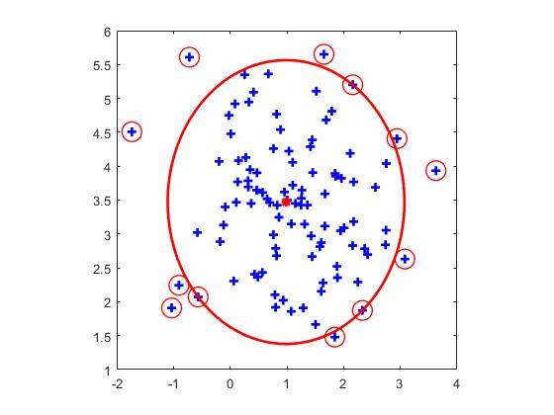

*No kernel*

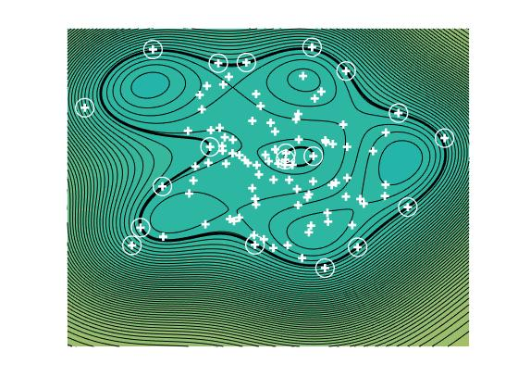

*Gaussian kernel*

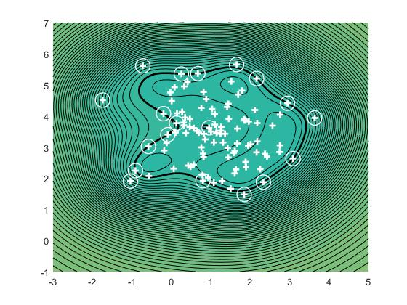

*Rational kernel*

In this case we can see that the gaussian kernel manage better than the rational one to not do any error, but the Rational kernel manage to regroup better the data together than the others.

C = 10

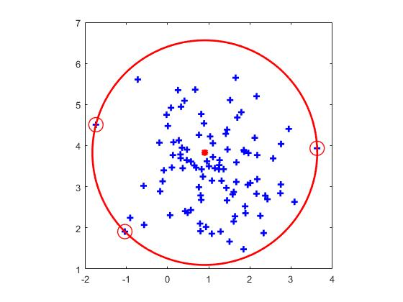

*No kernel*

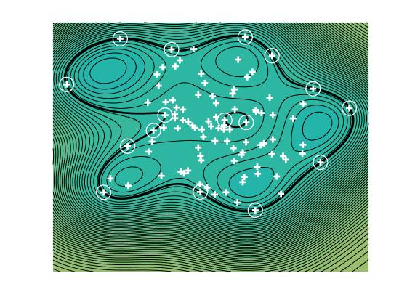

*Gaussian Kernel*

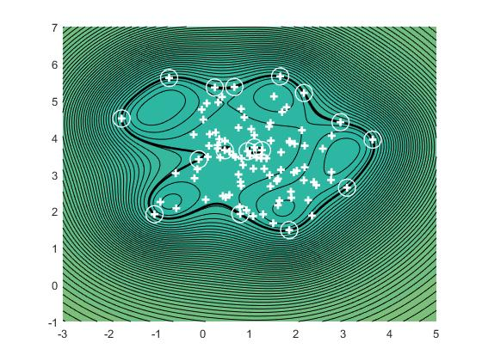

*Rational Kernel*

Because of a large C the SVDD does not need any kernel to classify every of his example, and the gaussian does not give any improvement, while the rational one is not doing any mistake and regroup all the data together.

As a conclusion we can say that the Rational kernel should be better that the gaussian or no kernel. Indeed, even if it is doing some mistakes it can regroup the data together and at test time it is going to be more accurate.