

CS471 – Web Technologies

Lab 1: Network Traffic Analysis Using Wireshark
Student Name: Amsha Aali Alrashidi
Student ID: 431201367
Section: 5529

Part 1: Capturing HTTP Traffic.
Task 1: Start Wireshark and capture packets.
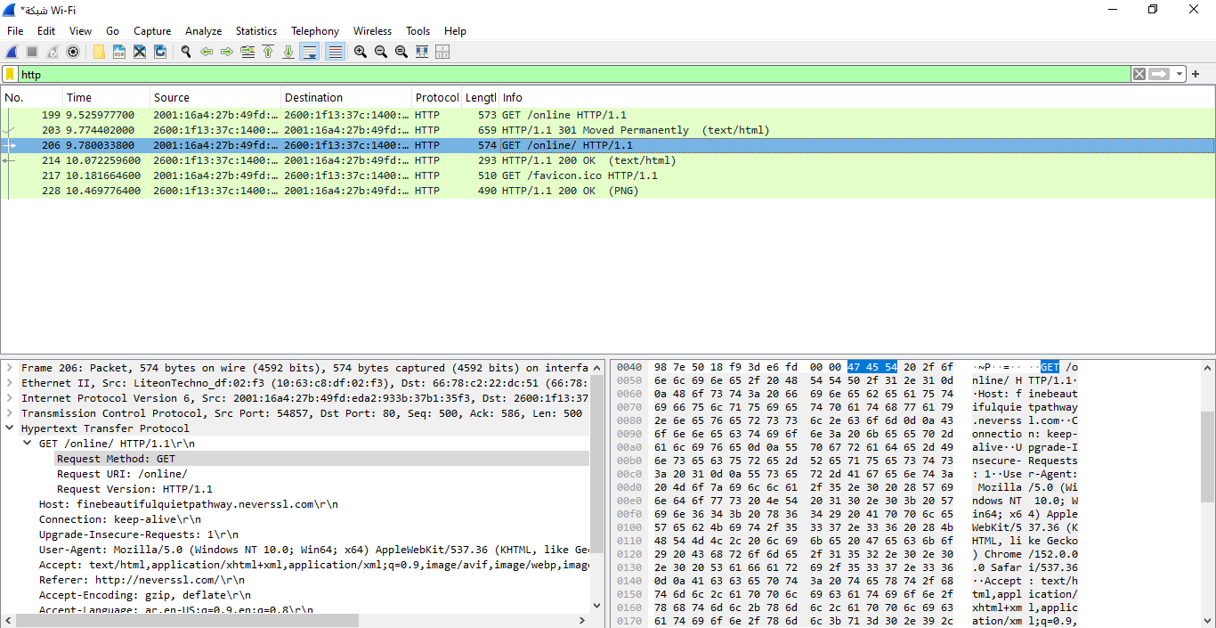
Task 2: Filter HTTP packets and analyze them
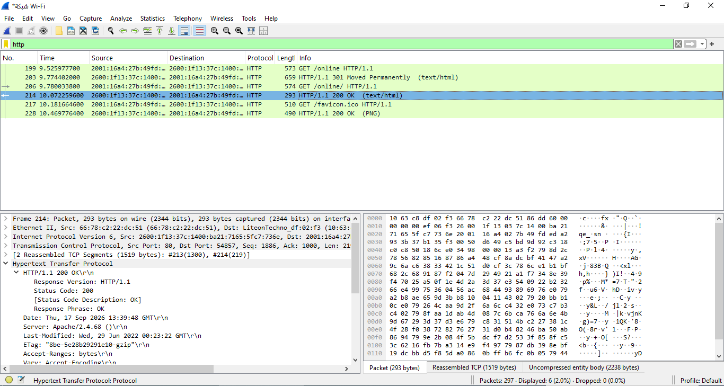
An HTTP packet was selected and analyzed.
The following information was observed:
- HTTP Method: GET
- Request URI: /online
- HTTP Version: HTTP/1.1
- Response Status: 200 OK
Part 2: Analyzing TCP/IP Traffic.
Task 1: Filter TCP packets
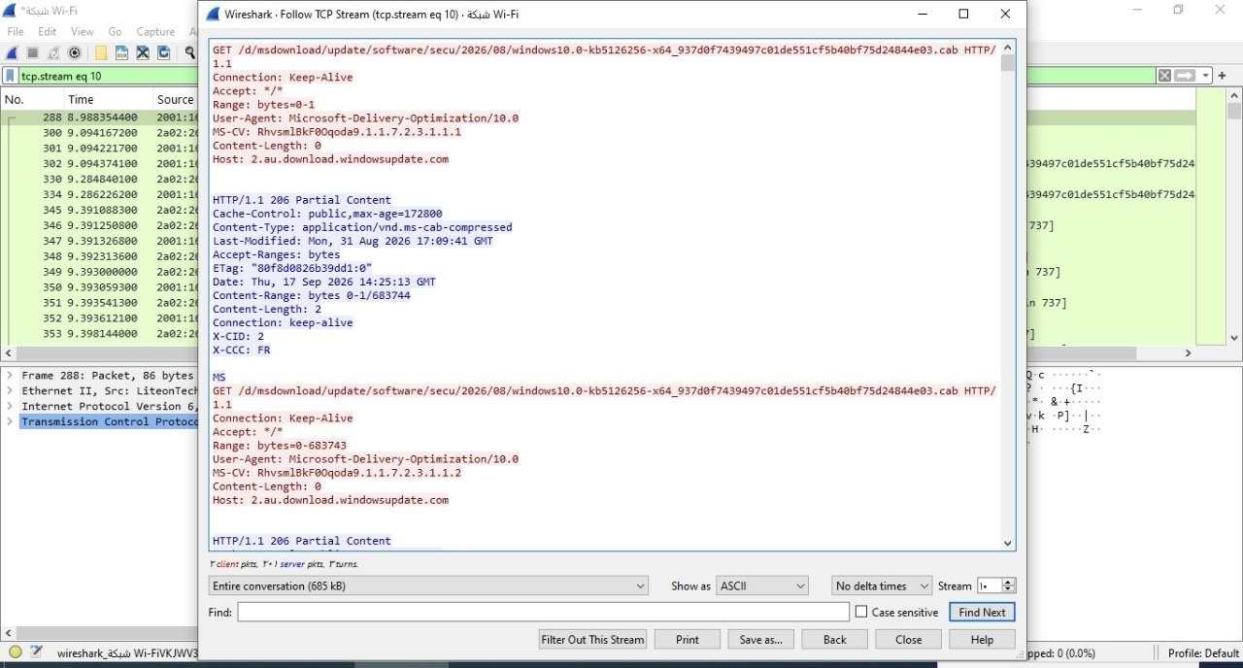
Task 2: Analyze TCP handshake and investigate Data Transfer and Termination.
Step 1: Find and select packets related to the TCP three-way handshake:
Step 2: Note the sequence and acknowledgment numbers.
SYN: Initiates a connection. SYN: Seq = 0, ack = 0
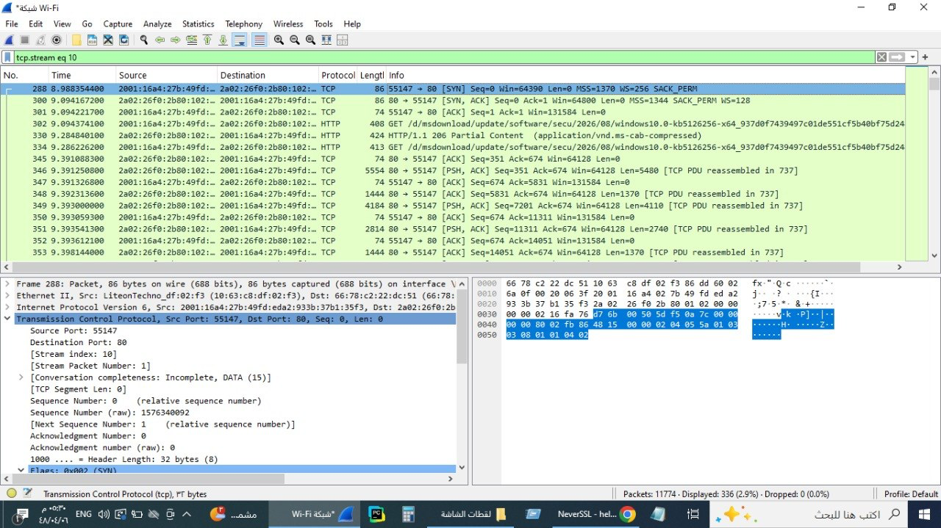
SYN-ACK: Acknowledges and responds to the SYN. SYN-ACK: Seq = 0, Ack = 1
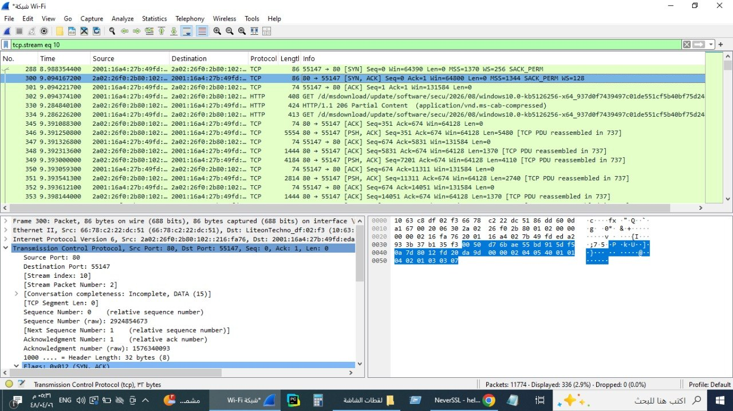
ACK: Acknowledges the SYN-ACK and establishes the connection. ACK: Seq = 1, Ack = 1
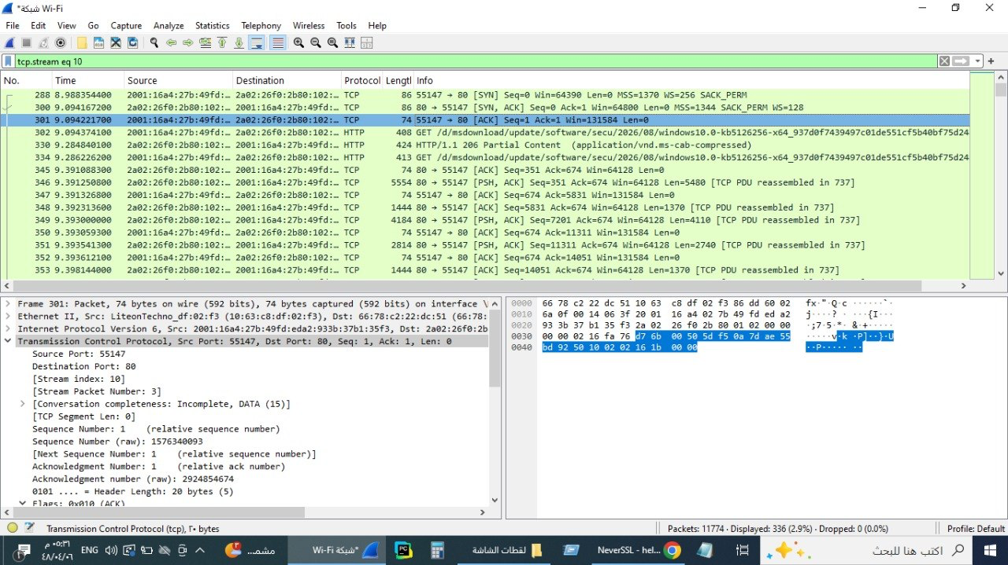

Step 3: Observe the data packets exchanged between the client and server.
The data packets were marked with PSH, ACK flags, indicating actual data being pushed between client and server.
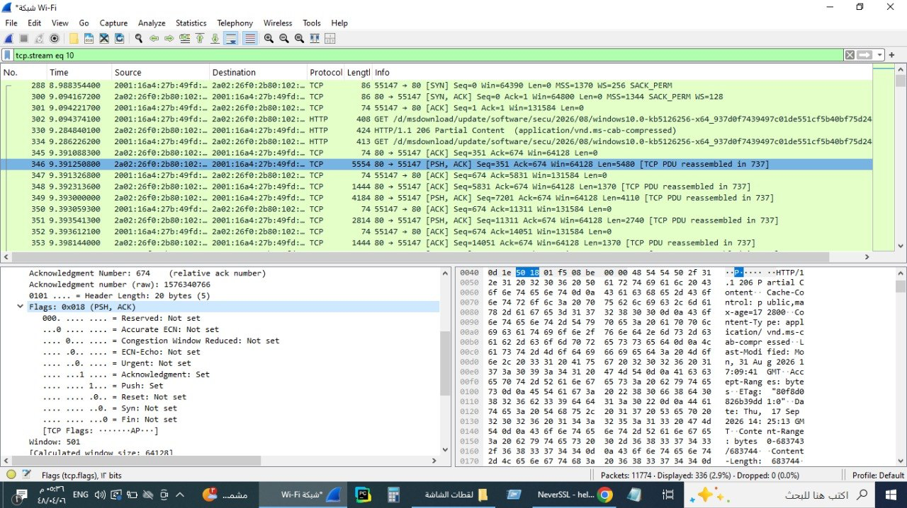

Step 4: Look at the TCP termination process (FIN, ACK packets).
The connection was closed using FIN, ACK packets.
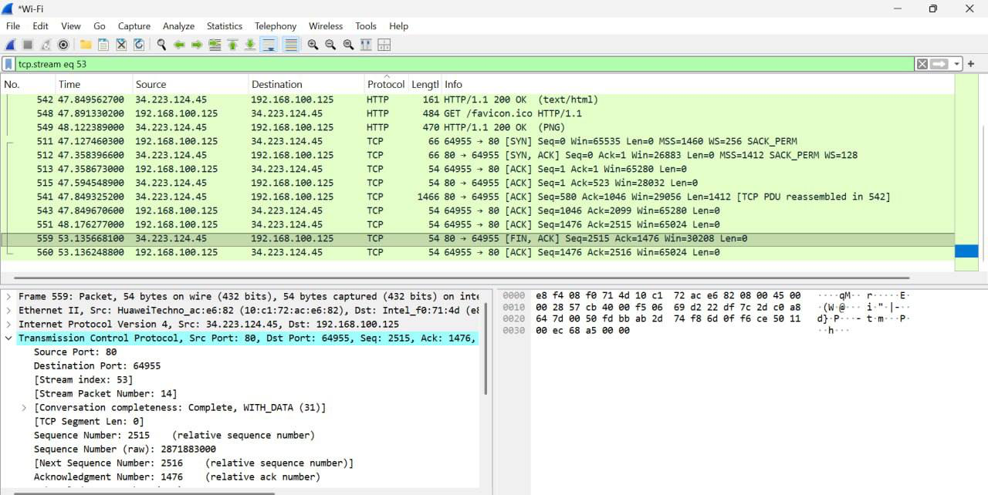

Part 3: Capturing and Analyzing UDP Traffic
Task 1: Generate UDP traffic and capture packets
UDP traffic was generated by streaming a video on YouTube while Wireshark was capturing packets on the active network interface.

Task 2: Filter and analysis UDP Packets
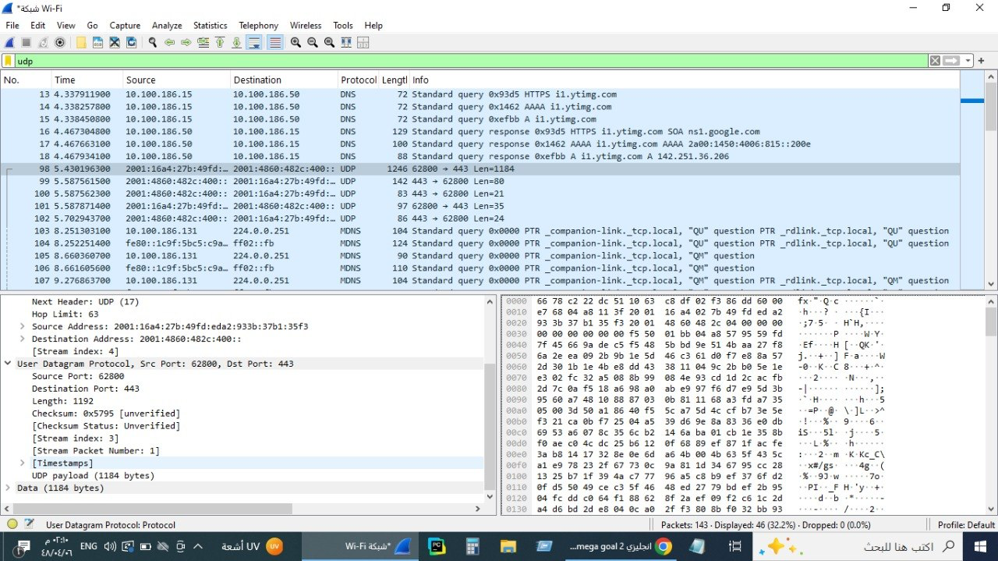

Step 4: Observe the source and destination ports, length, and data.
A UDP packet was selected and analyzed. The following information was observed:
• Source Port: 62800
• Destination Port: 443
• Length: 1192
• Data: 1184 bytes of payload data, associated with HTTPS/QUIC traffic over UDP."

Step 5: Compare UDP and TCP Headers
UDP has a simpler header than TCP.
The UDP header contains only four main fields: Source Port,Destination Port, Length, Checksum
TCP has a larger and more complex header because it contains additional fields for connection management, sequencing, acknowledgments, flags, and flow control.

Part 4: Comparing TCP and UDP by filling in the following tables.
Task 1: Fill in the following table and provide reasons.
 | TCP or UDP | Reasons
Reliability and Connection Establishment | TCP | TCP establishes a connection and provides reliable delivery using acknowledgments and retransmission.
Data Integrity and Ordering | TCP | TCP ensures reliable delivery and delivers data in the correct order.

Task 2: Identify the use Cases and Performance of TCP and UDP.
 | TCP | UDP
Use cases | - HTTP/HTTPS, web browsing, email, file transfer  - Applications that need reliable delivery | - DNS, streaming, VoIP, online gaming  - Applications that prioritize speed over reliability
Performance | - Slower than UDP due to connection setup (Three-Way Handshake), acknowledgments, retransmissions, and flow control.  - Reliable but higher overhead. | - Faster than TCP because it is connectionless and has minimal header overhead.  - Unreliable, packets may be lost or arrive out of order.

