In case of the sample circuit provided by you sir (last line in this image)

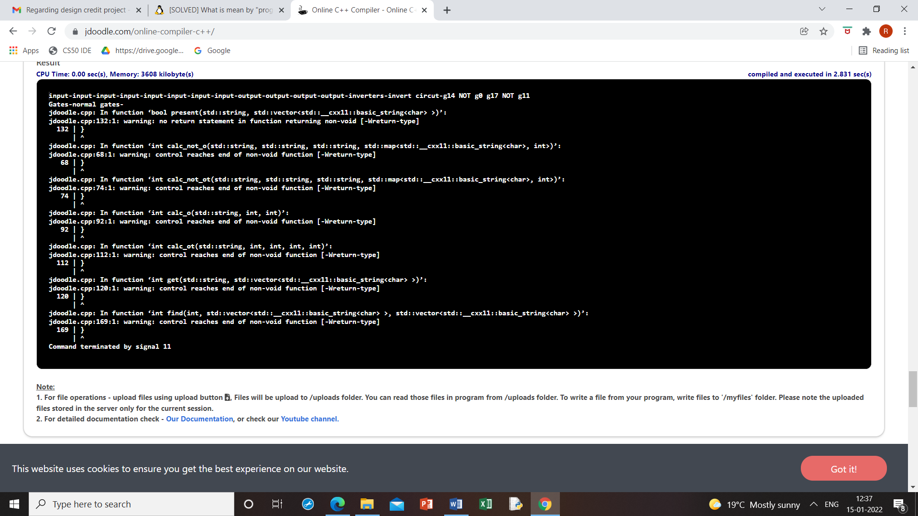

Sample circuit taken by me

Input-g0, g1; out-g2, g3

G4=not (g0)

G3=AND (g1, g0)

G2=OR (g4, g1)

Order -g0 g1 g0t g1t g2 g2t g3 g3t

Input format

2

Input-g0

Input-g1

2

Output-g2

Output-g3

Inverters-1

Invert circuit-g4

NOT

g0

gates- 2

normal gates-g3

AND

g1

g0

g2

OR

g4

g1

