DSP LAB TEST 1 report:

M Amshunath

22EE10042

Experiment 1 set 1:

1.

Integ1(N) function code:

function I=Integ1(N)

I=0;

t=linspace(0,2\*pi,N+1);

dt=(2\*pi)/N;

x=(sin(7\*t)).^2;

I=sum(x.\*dt);

% for i= 1:N

% I=I+x(i)\*dt;

% end

end

code to plot the values:

n=1:1:100;

y=1:1:100;

for i=1:100

y(i)=Integ1(n(i));

end

figure;

plot(n,y);

title('Integ1(N) vs N')

ylabel('Integ1');

xlabel('values of N');

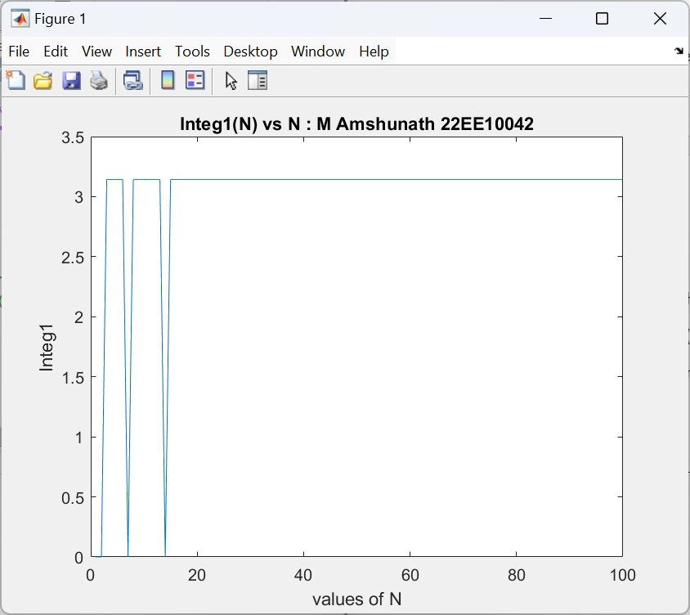

Above is the plot of Integ1(N) for the values of N ranging from 0 to 100.

Results:

We can see that a and b are both zero as the integral always takes the

value of sin(2\*k\*pi) in case of N=7 and sin(k\*pi) in case of N=14

(The values of a and b are displayed as some very small numbers exponent -30)

2.

Matlab code:

t1=-10:0.1:10;

x=sin(t1);

figure;

plot(x);

title('plot of x');

xlabel('indices of vector x');

ylabel('x');

figure;

plot(t1,x);

title('plot of t1,x')

xlabel('t1');

ylabel('x');

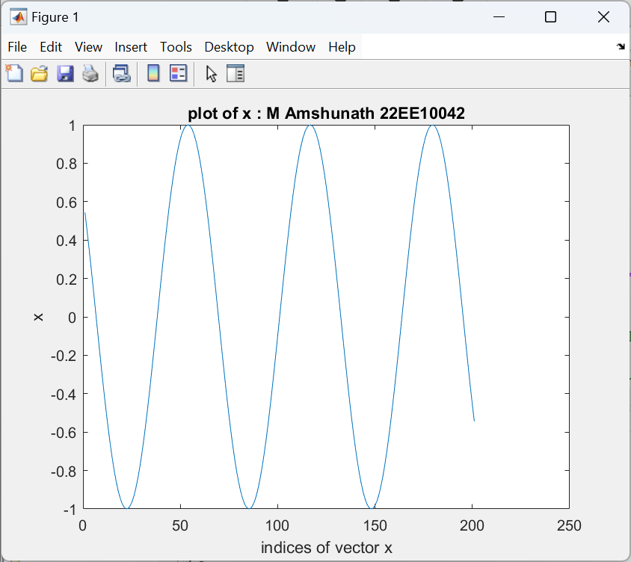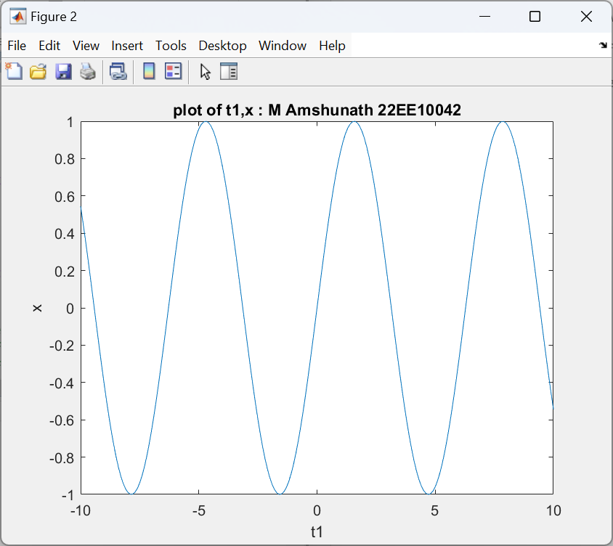

At first glance both the figures show similar graphs but the x-axis of the figures is different

In the first figure the x-axis is by default the index of the vector x. We can see the indices from 0 to 200.

In the second figure the x-axis represents the vector t1 as we can see in the labels from -10 to 10